**Project Biding for Sensory Management Recommendation System(P09)**

Contents

Team Outline 1

Detailed Expertise & Experience 2

Ideas of the Project 3

Timeline 5

# Team Outline

The smart home (home automation) is evolving with the fast development of the 5G communication system, creating a more comfortable and easy-adaptive living environment for the resident. However, according to the project brief, the ways we interact with all the smart furniture (air conditioning, lights, humidifier) are limited, and the majority of them are accomplished by borrowing the help of voice assistants (Alexa, Xiaomi, etc.) or Apps on the smartphone.

To help improve the above situation, our team will be dedicated to the development of the new wearable devices. And we believe that our team can innovate and fully devoted to the study and improving the technology. Here are our main reasons and beliefs about satisfyingly accomplishing the project.

First of all, we are fully attracted to the actual implementation of the technology, due to the fact that this is a combination of hardware communication and data analysis, which is an exciting opportunity for us to put what we learned from the class into real-life use cases and build something that might help change people’s lifestyle at home.

Secondly, three of our teammates already have the relevant development/project experiences like adopting Arduino kits to gather information from the environment. And we are passionate about learning the underlying mechanisms of the smart home system such that we can gain relatively thorough and solid background knowledge to better perfect the product.

Besides, the team has related using the experience of the smart home system and is aware of the existing problems embedded in it, therefore, we can improve the product from the user's perspective and build a more user-friendly system or smartphone app.

# Detailed Expertise & Experience

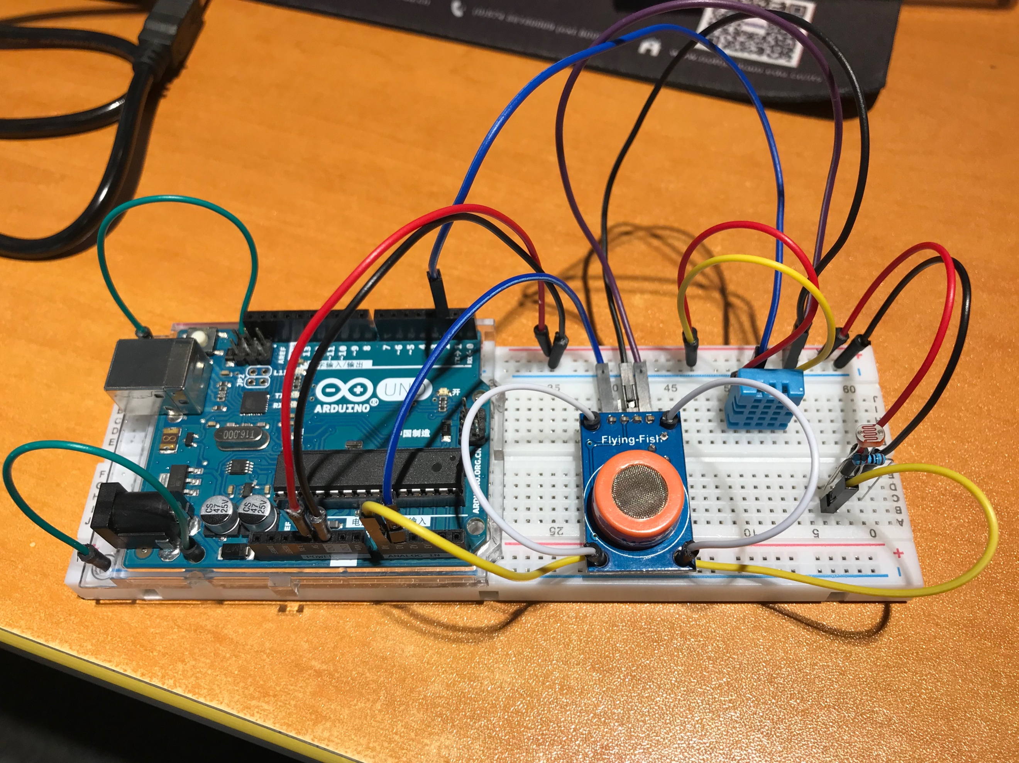All three members who had taken a year's NAA module named Mechatronics had related experience of using the Arduino board to build their projects. And one of them had made an environmental sensor that can detect the surrounding temperature, Humidity, Dew Point, Brightness, etc. which aims to give a precise and real-time measurement of the environment. Below are some demos and pictures from the developer.

Figure1. Environment Sensor (With Arduino Board)

The below image is the sensor data read by the small electric components.

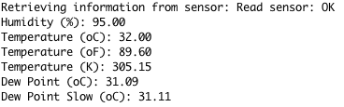

Figure2. Sensor Data(demo)

The above experience is only for one the member, and two more of them had related experiences. In short, this will be a good start for the plan if our team is selected for this project because one of the requirements from the project briefing indicates that we need to gather information from the environment. And to do so, stable functioning tools need to be developed and we have the faith of doing it well.

The knowledge and skills involved in the development of this application are familiar to most of the teammates. For example, one of our teammates has had the experience of developing web-based apps (Wechat Small App). And another teammate has the ability of handling data in the backend and presenting them on the front end with a well-designed UI. Although almost all the students from computer science have the experience of C or java programming practices, our team has more actual experiences of applying what we have learned to the real-life use case. It’s undoubted that for us to successfully build a great app there’s much more to learn, but we believe we have the ability to solve the problems encountered on the road.

# Ideas of the Project

1. Collect information about the users.

1) Devices are not necessarily limited to bracelets and watches which are popular on the market, they can also be hats, glasses, collars and even clothes.

2) Use sensory equipment to collect test data e.g. Apple Watch.

3) Use questionnaires to collect data from people of different ages.

2. Collect info from the environment

1) Use the system of mobile phone or Arduino Kits for environmental data collection. Environmental data collection of the Arduino Kits can be transmitted through the Bluetooth module to avoid the test space limitations caused by the transmission of the data line.

3. Develop an iOS App to view and adjust gathered information.

1) The app which has a visual interface to display user-related information such as body temperature, heart rate, blood pressure access to the health data in the mobile phone

2) The implementation of the app can be used in Java or Swift programming language.

3) In addition to the above functions, the App also has privacy protection (database encryption processing), individual targeting and comprehensiveness.

4) The app can provide certain suggestions for making the environment comfortable according to current environmental conditions and the user.

4. Collect user's qualitative feedback

1) Prepare a questionnaire before software development to collect enough sample information about the environmental comfort requirements of people of different ages.

5. process the collected information

1) In the software development process, based on user feedback, the function of the improved program is continuously improved.

2) Use machine learning to process the collected data and determine the comfort range to different ages of people.

3) According to the sample production training set, the user’s corresponding prompt is given according to the training set when the user is using it.

6. Select different volunteers to test the comfort assessment of the

environment for volunteers under different environmental conditions

(control variables: temperature, humidity, etc.)

# Timeline

