MJ

Since our dataset has been set up for modelling I decided to create a predictive model on our data set. I checked which columns were numeric and used these columns in my study. Since sklearn requires no missing values in the dataset I checked for missing values, luckily there wasn't any null values. I defined my classification function which is an algorithm that maps input data to a category.
I recorded the Accuracy and Cross-Validation scores using 10 folds.

I started my Jupyter project making a logistic regression model on ‘loan_condition_cat’ (loan condition category). Logistic Regression is used to describe data and to explain the relationship between one dependent binary variable and one or more other variables. The loan condition category shows a list of good and bad loans. The more bad loans the less chance of a loan being given, and vice versa. Therefore, my first model was on loan condition. My Accuracy was: 92.401% and my Cross-Validation was: 92.401%.
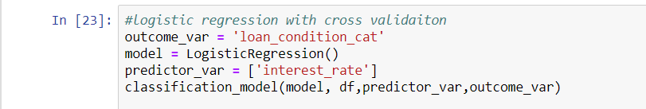

Adding more variables should increase accuracy, I tested this with less important variables and it only changed my results slightly for accuracy: 92.504% and cross-validation: 92.504% .
Feature engineering where I could derive new information could change these results or using different modelling techniques. Using a decision tree where my predictor variables were (interest payment cat, interest rate and loan amount) I managed to get an accuracy of: 93.254% and a cross validation score of: 91.081%.
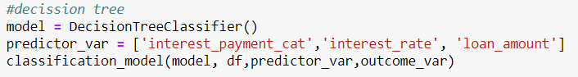

It can be seen here my accuracy went up but by cross-validation went down. I tried this again using different variables (total payment, instalment and term category) and my results were as shown: accuracy: 99.157% and a cross validation score of: 58.025%. This is the result of model over-fitting the data. Over-fitting is a modelling error which occurs when a function is too closely fit to a limited set of data points.
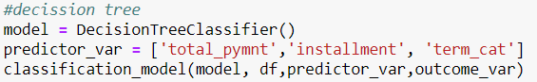

So for my next step I used Random forest ML algorithm which is even more sophisticated than my previous decision trees. Results for my random forest were as follows: accuracy: 99.988% with a cross validation of: 91.678%, giving us a better result than the decision trees. Seeing as the accuracy is 99.988% this is very close to the ultimate case of over fitting and can be resolved by reducing the number of predictors.
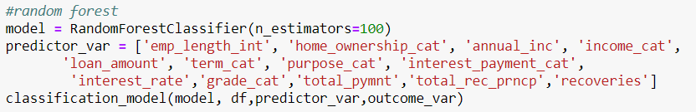
However to reduce the number of predictors we need to know which ones to use that are most important to us, we can see this by using a matrix importance table and taking the top 5 and creating a model. Results of using the top 5 more important predictors gave an accuracy of: 95.182% and a cross validation of: 93.207%. Although accuracy reduced the cross validation score improved meaning that the model is generalizing well.
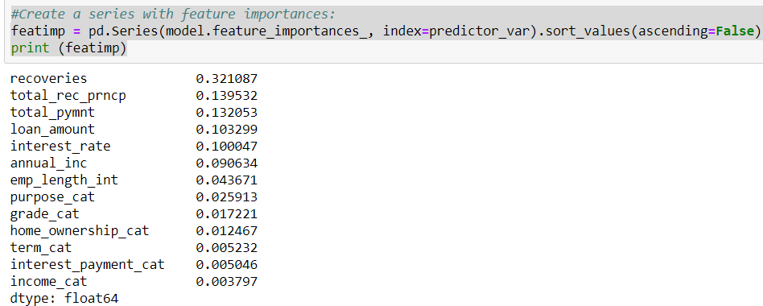
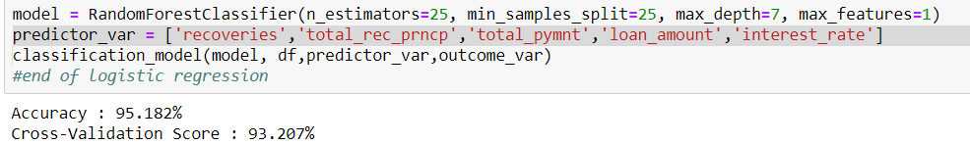

I continued my project by using linear regression on the loan dataset. I made a scatter plot with loan condition category against annual income as a test, as you can see in my Jupyter notebook this was not very useful as loan condition isn't really effected by or relevant to a persons annual income.
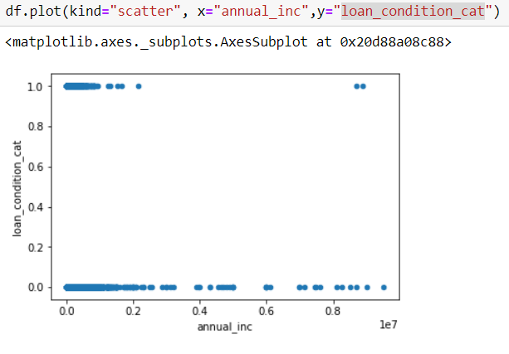

I then spit my dataset by taking 5% of the dataset without replacing anything. I took random selected values from interest rate and instalment and plotted them on a graph to show fit, intercept and slope of data.

