Secure Boot Specification

Document Version: 0.1
Document Status: Draft
Author: Ranga Rao

Table of Contents
1. Introduction 3
1.1. Limitations of Specification 3
2. References: 3
3. Secure Boot: 4
3.1. Enable SecureBoot in Coreboot and Payload 4
3.2. key process 5
3.3. Key generation 5
3.4. Sign OS loader and executables: 6
3.5. Adding Public Key to Coreboot BIOS build and database: 7
3.6. Notes: 8
4. Summary 9

Introduction
secure the boot process so it’s not possible to change the boot image or corrupt it. The following components are proposed to achieve this:

BIOS: Core Boot BIOS is upgraded to implement UEFI Secure Boot. This means that BIOS will only load an approved boot loader. Any application that BIOS executes must be signed.
BIOS Programming/ Upgrade: CoreBoot BIOS and Payload are upgraded to use SecureBoot drivers and libraries from EDK2. BIOS image is upgraded from OS with flashrom, once Image is signed with platform keys, BIOS cannot make a upgrade with flashrom unless the tool is also signed

This Functional Specification describes operation of BIOS Secure Boot method that could use to generate and manage keys for this activity.

Limitations of Specification
This specification only addresses what is needed for BIOS Secure Boot. This is just a section of the chain of Trust. Hardware, operating system & application software much also be made secure to complete the chain of trust.

Tools and a method of key management are outlined as part of this specification. However they are only examples and while this method does work, can change how keys are created and managed without having any impact on BIOS.

In general, also note:
- Secure boot does not protect flash based code in the system ROM. Its our understanding that plan to pot the flash to protect this.

- Secure boot only protects pre-operating system driver code from malicious modification. Its our understanding that will add protection to Linux and post boot applications.

- Secure Boot when enabled only supports booting to EFI supported Operating systems (e.g. Ubuntu 18_04.)

References:
[1] https://docs.fedoraproject.org/en-US/Fedora/18/html/UEFI_Secure_Boot_Guide/chap-UEFI_Secure_Boot_Guide-What_is_Secure_Boot.html
[2] https://wiki.ubuntu.com/UEFI/SecureBoot
[3] UEFI Secure Boot in Modern Computer Security Systems
http://www.uefi.org/sites/default/files/resources/UEFI_Secure_Boot_in_Modern_Computer_Security_Solutions_2013.pdf

[4] UEFI Specification (Chapter 28 is Secure Boot and Driver Signing)
http://www.uefi.org/sites/default/files/resources/2_4_Errata_B.pdf

[5] Making UEFI Secure Boot Work With Open Platforms
http://www.linuxfoundation.org/sites/main/files/lf_uefi_secure_boot_open_platforms.pdf

Secure Boot:

“Secure Boot is a technology where the system firmware checks that the system boot loader is signed with a cryptographic key authorized by a database contained in the firmware. With adequate signature verification in the next-stage boot loader(s), kernel, and, potentially, user space, it is possible to prevent the execution of unsigned code.” [1]
To implement this, BIOS (system firmware) will be built with one or more Public Keys in its database. At the end of BIOS boot time it will check if the bootloader (or other application) has been signed with a Private Key that corresponds to any Public Key in its database. If this check fails, the application will not be allowed to take control of the system and the following error message will be displayed to screen:
┌────────── Secure Boot Violation ──────────-┐
│ │
├───────────────────────────────────────────-┤
│ Image failed to verify with *ACCESS DENIED*│
│ Press any key to continue │
│ │
│ │
│ [OK] │
└───────────────────────────────────────────-┘

BIOS with Secure Boot Enabled and Keys Enrolled would show the Setup as

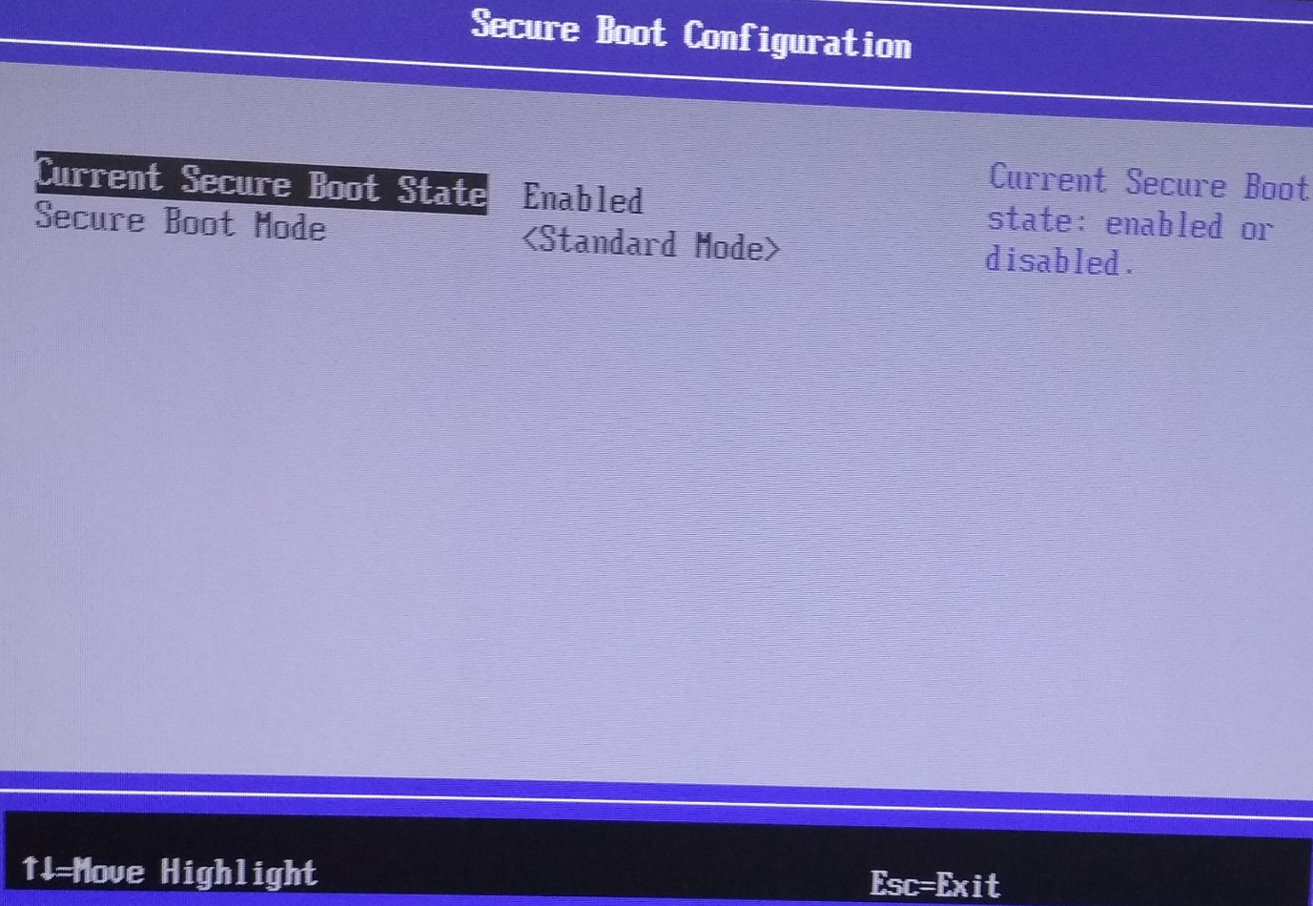

Enable SecureBoot in Coreboot and Payload
Enable
1. CorebootPayloadPkgIa32X64d.dsc
SECURE_BOOT_ENABLE= TRUE
2. coreboot-acela\configs\config.kblrvp3\CONFIG_SB=Y

Disable
1. CorebootPayloadPkgIa32X64d.dsc
SECURE_BOOT_ENABLE= FALSE
2. coreboot-acela\configs\config.kblrvp3\CONFIG_SB=n

key process
- will generate a Public-Private Key-pair.
- The Public Key will be provided will build it into the BIOS release. (All other Public Keys in the database e.g. the Microsoft Key will be removed)
- The Private Key should be kept safe. It is used by to sign any executable they trust to run on their hardware.
- sign OS loader before enabling Secure Boot in BIOS.
- Once the board has booted to a trusted environment, secure boot can no longer protect the system. It is up to the trusted OS to implement its own security and ensure that only trusted software can be run. Secure boot is simply the ‘first link’ in a ‘chain of trust’ to the OS.

Key generation
- Generating Public-Private Keys:
can use whatever tools they want to generate a public-Private key pair. The following keys will need to be generated:
- 2048-bit RSA key (Private key to keep safe)
- DER encoded x509 self-signed certificate (Public key for inclusion in BIOS)
have used the following tools and steps to generate a Public-Private key pair in Ubuntu [2]. The names used for the keys are examples only. should choose whatever names are appropriate for their application.
The Steps:
- Install Openssl (apt-get install)

Creating, using and installing your own keys
============================================

To create PEM files with the certificate and the key for PK for example, do

- openssl req -new -x509 -newkey rsa:2048 -subj "/CN=PK/" -keyout PK.key -out PK.crt -days 3650 -nodes -sha256

will generate 1078 byte .crt

- Which will create a self signed X509 certificate for PK in PK.crt (using
unprotected key PK.key with the subject common name PK (that's what the CN=PK
is doing).

You need to create at least three sets of certificates: one for PK, one for
KEK and one for db.

- Now you need to take all the efi binaries in /usr/share/efitools/efi and sign
them with your own db key using

sbsign --key db.key --cert db.crt --output HelloWorld-signed.efi HelloWorld.efi

- To install your new keys on the platform, first create your authorised update
bundles:

cert-to-sig-list PK.crt PK.esl
will generate 800 byte PK.esl

sign-efi-sig-list -k PK.key -c PK.crt PK PK.esl PK.auth
will generate 2216 byte PK.auth

- And repeat for KEK and db. In setup mode, it only matters that the PK update
PK.auth is signed by the new platform key. None of the other variables will
have their signatures checked.

Now on your platform update the variables, remembering to do PK last because
an update to PK usually puts the platform into secure mode

UpdateVars db db.auth
UpdateVars KEK KEK.auth
UpdateVars PK PK.auth

Link to sign the grub bootloader

https://www.wzdftpd.net/blog/tag/uefi.html

can create as many of these key pairs as needed for their own process and can put all the public keys into the BIOS build. That means that the BIOS will boot any tool that has been signed with any of private keys.

Sign OS loader and executables:
All applications that would like BIOS to execute must be signed with one of Vendor Private keys. We expect that Vendor would want to execute, and therefore sign the following applications:
- grubx64.efi (For Ubuntu will be at following path or similar: /boot/efi/EFI/ubuntu/) - used to boot linux
- flashromi - Used to flash new BIOS images.
Note: grubx64.efi (or alternative OS loader) should be signed first in Ubuntu before enabling Secure Boot in BIOS. Otherwise if Secure Boot is enabled in BIOS first, user will not be able to boot to OS to sign the loader. User should then reset system and enter setup menu to very SecureBoot is enabled
To sign an executable, that a Secure BIOS should boot, the following are the steps involved using Ubuntu tools : (should complete these steps for all executable they want to execute)
- Open a terminal window in Ubuntu.
- apt-get install sbsigntool
To sign Grub loader:

Adding Public Key to Coreboot BIOS build and database:

will add all public keys to the BIOS source. The keys must be in format db.auth. This key will be supplied by vendor.

The next few steps must be completed by:

- db.auth should be placed in the BIOS source at:
coreboot-acela\
- KEK.auth should be placed in the CoreBoot source at
coreboot-acela\
- PK.auth should be placed in the CoreBoot source at
coreboot-acela\

CorebootPayloadPkgIa32X64.dsc

Adding more than one DB and KEK keys
gUEfiCorebootPayloadPkgTokenSpaceGuid.PcdFlashNvDBBase | 0xFFD80000
gUEfiCorebootPayloadPkgTokenSpaceGuid.PcdFlashNvDBXBase | 0xFFD86000
gUEfiCorebootPayloadPkgTokenSpaceGuid.PcdFlashNvKEKBase | 0xFFD88000
gUEfiCorebootPayloadPkgTokenSpaceGuid.PcdFlashNvPKBase | 0xFFD8C000
gUEfiCorebootPayloadPkgTokenSpaceGuid.PcdMaxDBNum | 0x2
gUEfiCorebootPayloadPkgTokenSpaceGuid.PcdMaxKEKNum | 0x2
gUEfiCorebootPayloadPkgTokenSpaceGuid.PcdMaxDBXNum | 0x1

chromeos.fmd
RO_DB@0x70000 0x2000
RO_DB1@0x72000 0x2000
RO_DB2@0x74000 0x2000
RO_DBX@0x76000 0x2000
RO_KEK@0x78000 0x2000
RO_KEK1@0x7A000 0x2000
RO_PK@0x7C000 0x2000
RO_PAD@0x7E000 0x72000
Makefile.inc
$(CBFSTOOL) $@.tmp write -u \
-r RO_VPD \
-f VpdBlock_SecBoot.bin
$(CBFSTOOL) $@.tmp write -u \
-r RO_DB \
-f db.auth
$(CBFSTOOL) $@.tmp write -u \
-r RO_KEK \
-f KEK.auth
$(CBFSTOOL) $@.tmp write -u \
-r RO_KEK1 \
-f KEK1.auth
$(CBFSTOOL) $@.tmp write -u \
-r RO_PK \
-f pk.auth
$(CBFSTOOL) $@.tmp write -u \
-r RO_DB1 \
-f db1.auth
$(CBFSTOOL) $@.tmp write -u \
-r RO_DBX \
-f db2.auth

Notes:
- Vendor will be responsible for signing all executables that their customers will be allowed to run from BIOS. Vendor will also need to ensure that measures are taken to extend the chain of trust into the OS. Ideally, a similar key-pairing system should be implemented in the OS to ensure that only trusted applications can be launched.
- Vendor need not enable SecureBoot via the BIOS setup menu and control it via any Supervisor Password
- Similarly, if the Private Key is compromised, a user can sign an executable using it and launch whatever they like, including tools to replace the BIOS on the board with a non-Secure boot variant.
- Lastly, if a user has physical access to the BIOS flash pins or XDP connector, they can simply reprogram the board with non-SecureBoot BIOS.

Summary

Vendor need to:
 | Activity | Store and Maintain
 | Create Public-Private keys For Secure Boot | Keep secret VendorPrivateKey.rsa  Maintain vendorPublic keys in the following formats:  db.auth  kek.auth  pk.auth
 | Sign all EFI applications which Vendor wants to run from EFI Shell
 | Prior to shipping systems to your customers, verify SecureBoot enabled in EFI Setup under SecureBootConfiguration | Secure Boot State -> Enabled
 | Extend Chain of Trust to all Vendor Applications and OS.

