Machine Learning Implementation on Prediction of Customer Acquisition Cost

Shardul Kulkarni | Gulam Rasool | Karan Bhutani
Student: CS&AI | Student: CS&AI | Student: CS&AI
Great Learning | Great Learning | Great Learning
Mallika Yeturi | Devi Charan Guduru | Ushna Ahmed
Student: CS&AI | Student: CS&AI | Student: CS&AI
Great Learning | Great Learning | Great Learning
 | Anwesh Reddy Paduri
 | Senior Data Scientist
 | Great Learning
 | Hyderabad, India

Abstract: This research focuses on the development of an advanced predictive model tailored for estimating the costs associated with media campaigns within a prominent food mart chain across the United States. By harnessing a comprehensive and intricate dataset encompassing a wide array of customer attributes, nuanced product details, in-depth store characteristics, and varied promotion specifics, the study aims to shed light on the essential role of robust Customer Acquisition Cost (CAC) prediction methodologies in the realm of contemporary marketing strategies. Through a meticulous exploration of both traditional regression models and cutting-edge machine learning algorithms, including Support Vector Machines, sophisticated time series analysis, and the application of Artificial Neural Networks, the research seeks to not only establish the most effective and accurate predictive frameworks for anticipating media campaign costs but also to underline the significance of leveraging data-driven insights to optimize and streamline marketing investments. By delving into the complexities of diverse cost estimation methods and conducting a comprehensive performance analysis of a spectrum of predictive models, the research endeavors to contribute valuable insights and strategic recommendations for enhancing cost forecasting precision and promoting data-driven decision-making processes within the marketing domain.
Keywords : Customer Acquisition Cost (CAC), Support Vector Machines, Artificial Neural Network (ANN), Time Series Analysis, Regression Models, Machine Learning.
I. Introduction
Customer Acquisition : Introduction & Problem Definition
In today’s world as businesses are growing day by day, they spent large amount of money for acquiring customers through media campaigns. These funds are invested in order to increase sell by acquiring customers. Hence it is called as Customer Acquisition Cost (CAC). The main intention behind media campaigns is to gain profit. So organizations need to be careful about investing appropriate amount of money for acquiring new customers on board. If CAC is too high or low, then it may turn into huge losses to businesses. Hence it is their primary need to predict their customer acquisition cost by analyzing customer behavior , product details, store details, promotion details etc.
Food mart X is a chain of convenience stores in the United States. The private company’s headquarters are in Mentor, Ohio, and currently, approximately 325 stores are in the US. Convenient food mart operates on the franchise system. The dataset includes information about:
Cost: cost of acquiring customers in dollars (target).
Customer details: marital status, gender, no. of children, education, occupation, and member card type. etc.
Product details: brand name, SRP/MRP of the product, gross weight, net weight, and whether the food item has a recyclable package or not etc.
Store details: store sales, cost, store type, city, state, grocery, frozen food, and meat area available in sqft Etc.
Promotion details: name of the promotion done on the media.
Here we need to design an ML-based algorithm for predicting the cost of the media in acquiring customers.
Data science and machine learning can be used to solve majority of retail and marketing problems. Data science can assist in analyzing marketing strategy and discover hidden patterns in data. Whereas machine learning can be used to forecast CAC and classification tasks. The main challenge here is to find most effective and optimal model to predict customer acquisition cost for food mart X. The next challenge will be to evaluate performance of the model on the basis of appropriate parameters. After selecting best suitable model we need to tune all the hyperparameters to get optimal results. The main objective here is to predict customer acquisition cost with the help of machine learning based algorithm to provide solution to retail and marketing domain.
II. Literature Review
In the literature review conducted for the project, various regression models were explored to forecast the cost of customer acquisition. The initial choice for the base model was Linear Regression, given its suitability for predictive modeling. However, due to the complexity of the data and the non-linearity between dependent and independent variables, alternative models were considered. These alternative models included Multiple Linear Regression, Polynomial Regression, Gradient Boosting Regression, Decision Tree Regressor, Random Forest Regressor, and Support Vector Regression (SVR).
The project assessed the performance of these models using key metrics such as Mean Absolute Error (MAE), Mean Squared Error (MSE), Root Mean Squared Error (RMSE), and R2 Score. Among these models, Decision Tree and Random Forest emerged as top performers, demonstrating high accuracy levels, particularly when tuned with specific hyperparameters.
Customer Acquisition Cost (CAC) Prediction in Marketing:
Customer Acquisition Cost (CAC) plays a pivotal role in marketing as it quantifies the financial investment required to acquire a new customer. Understanding CAC is essential for evaluating the efficiency of marketing campaigns and ensuring a sustainable return on investment. This review explores existing literature on CAC prediction, various cost estimation methods, and the application of machine learning in marketing analytics.
Importance of CAC in Marketing:
The concept of CAC as a metric for assessing marketing performance has gained prominence in recent years (Chen & Hitt, 2000). Businesses, especially in the e-commerce sector, aggressively invest in customer acquisition, aiming for customer loyalty to generate profits (Pei-Yu Chen & Lorin Hitt, 2000). In addition to acquisition costs, factors such as customer switching costs and brand loyalty significantly impact CAC (Klemperer, 1989). Customer acquisition is time-consuming and costly, making it more profitable to retain existing customers than acquire new ones (Reinartz & Kumar, 2003).
Cost Estimation Methods:
A range of methods exists for estimating CAC and other cost-related metrics. These methods are broadly categorized into qualitative and quantitative approaches (Niazi et al., 2006). Qualitative methods are intuitive and analog, while quantitative methods are analytical and parametric (Niazi et al., 2006). Traditional methods, such as regression models, fall into the quantitative category (Yasser Elfahham, 2019).
Regression Algorithms:
Regression-based techniques are popular for cost prediction due to their simplicity and ease of use. Simple Linear Regression assumes a linear relationship between the target variable and a single independent variable (Chen, 2020). Multiple Linear Regression extends this to multiple independent variables. Polynomial Regression, on the other hand, fits a curve to nonlinear data (Chen, 2020). Ridge Regression helps overcome overfitting by adding bias (Chen, 2020). Decision Tree Regressors and Random Forest Regressors are also commonly used for cost prediction (Chen, 2020).
Machine Learning in CAC Prediction:
In recent years, machine learning techniques have gained traction in predicting CAC and related marketing metrics. Support Vector Machines (SVMs) are capable of handling both classification and regression problems, making them versatile tools for CAC estimation (K. Kim, 2003). Time series analysis, including techniques like Autoregressive Integrated Moving Average (ARIMA), is well-suited for forecasting marketing costs (Choudhury & Nur, 2022). Artificial Neural Networks (ANNs) inspired by the human brain have shown promise in CAC prediction, especially for long-term forecasts (Gwang-Hee Kim, 2004).
The literature review highlights the growing significance of CAC prediction in marketing and the various methods employed for estimating acquisition costs. Traditional regression techniques provide a foundation for cost prediction, while machine learning methods offer advanced capabilities for modeling complex relationships and improving accuracy. The choice of method depends on the specific dataset and the goals of the analysis. As marketing continues to evolve, the integration of machine learning and data science into CAC prediction remains a dynamic area of research.
3.Sample data:
The dataset that we have chosen is from Food Mart X () a chain of convenance stores in USA, trusted by the customers to predict the cost of media camping’s for customer acquisition. To collect the data, we used different source of internet such as Kaggle. from resources we came across the dataset of Food Mart X and stared working on it. The dataset link as follows:
The challenges we faced were performing data cleaning to address in any inconsistences or errors as the dataset was large. Apart from that handling missing values in the dataset to appropriate imputation methods was also one. The next step included gaining inside into the distributions and characteristics of data and visualizing the data followed by the feature selection by utilizing technique like corelation analysis.
The next task was model selection where we had to choose appropriate machine learning algorithms followed by model training which included splitting the data into training and testing tests. After, model training we did the evaluation of the model performance using various metrics and comparing them to get the most accurate one. Hyperparameter was the stage that included the experimental runs to find the best performing model. Then the interpretation was conducted to analyse the feature important course from train model to understand the factors driving media camping cost. https://www.kaggle.com/datasets/ramjasmaurya/medias-cost-prediction-in-foodmart
III. Materials & Methods
After performing the feature engineering and feature extraction process using the information obtained from the EDA, we proceeded with training our models to predict our response variable. We planned to start with the base estimators and develop them by learning from errors and weak predictors.
Data Split
We split our data into train and test data sets, with 70% of the records in the training dataset and 30% in the test dataset.
Linear Regression
Description: Using Linear Regression with the intent to predict the cost figures by fitting a linear equation to the data. We aimed to find the best-fitting line that minimizes the difference between the predicted values and actual data points.
Evaluation Metrics: After feeding our data to the model, we calculated 4 evaluation metrics.
Multi Linear Regression Using ANN
Description: Employing a Multi-linear Regression Artificial Neural Network (ANN) to forecast cost figures. This involves using a neural network with multiple input features to predict costs. The model adapts its weights to capture complex relationships between inputs and costs, aiming to minimize the
difference between predicted and actual values.
Evaluation Metrics: Evaluation metrics were computed to assess its predictive performance. With CPU times: total: 46.9 ms Wall time: 25.2 ms.

Random Forest
Description: Using Random Forest for cost prediction involves constructing an ensemble of decision trees to collectively predict cost figures. The model leverages multiple trees to capture complex relationships between input features and costs. It aims to minimize prediction errors by averaging the outputs of these trees.
Evaluation Metrics: After inputting our data into the model, we calculated five evaluation metrics to assess its predictive performance.
Gradient Boost Regressor
Description: Employing Gradient Boost Regressor for cost forecasting entails iteratively improving the model's predictive ability. It combines multiple weak learners (typically decision trees) to predict cost figures. The model focuses on minimizing prediction errors in a stepwise manner.
Evaluation Metrics: After feeding our data to the model, we computed five evaluation metrics to gauge its predictive performance.
Support Vector Machine (SVM)
Description: Using Support Vector Machine (SVM) for cost prediction involves finding a hyperplane that best separates data points, aiming to minimize prediction errors. SVM can handle complex relationships between input features and costs by mapping data into higher dimensions.
Evaluation Metrics: After training our data with the SVM model, we calculated five evaluation metrics to assess its predictive performance.
Decision Tree Regressor
Description: Decision Tree Regressor is used to predict cost figures by creating a tree-like structure that makes decisions based on input features. The model recursively splits the data into subsets to minimize prediction errors.
Evaluation Metrics: After inputting our data into the model, we calculated five evaluation metrics to evaluate its predictive performance.
GridSearchCv:
To optimize the performance of our predictive models, we employed Grid Search Cross-Validation (Grid Search CV) to find the best hyperparameters. Grid Search CV is a technique that systematically explores various combinations of hyperparameters to determine the most effective set. This process helps fine-tune the model's performance and enhances its predictive capabilities.

Exploratory Data Analysis :
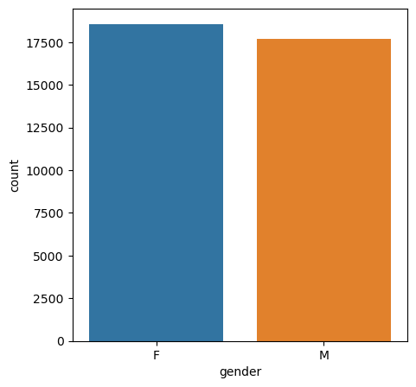
Fig. 1 : Gender vs Count
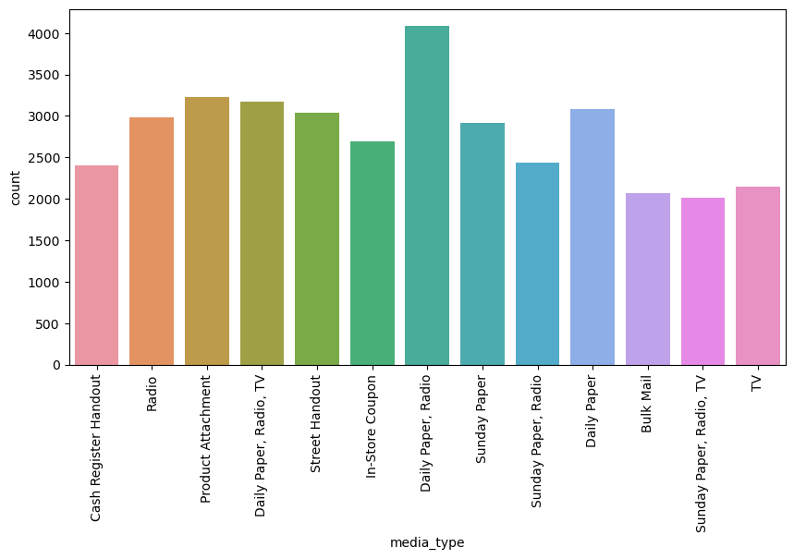
Fig. 2 : Media type vs Count
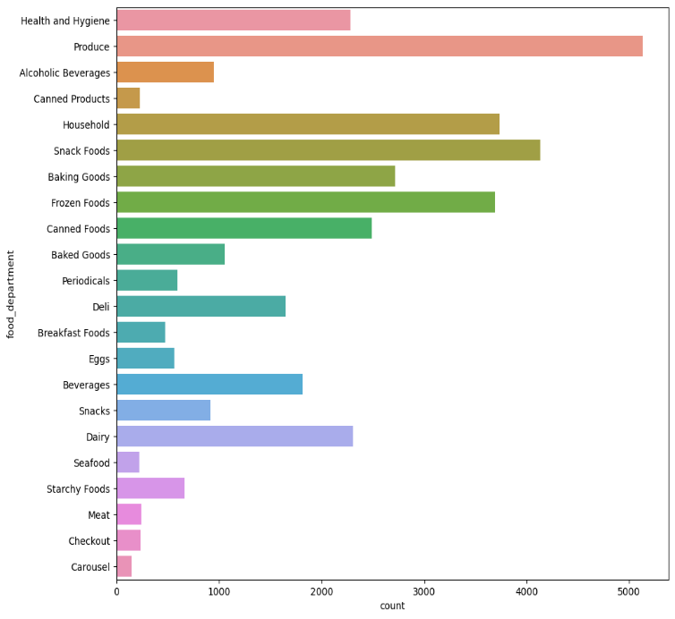
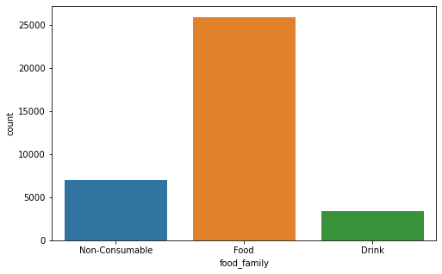
Fig. 3 : Food category vs count
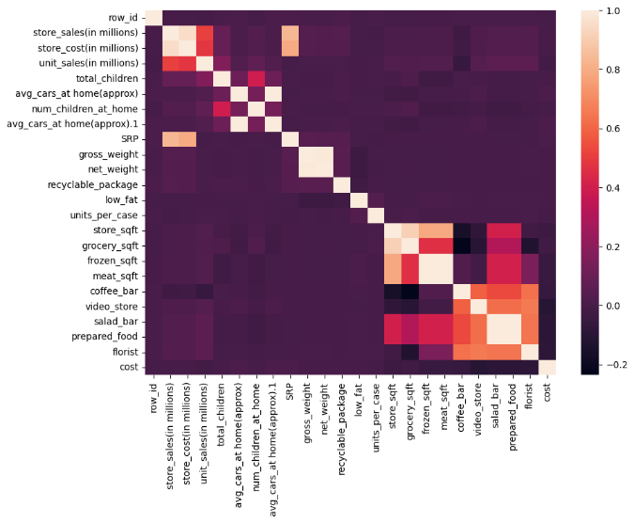
Fig. 4 Heatmap
IV. Results
A. Base model :
We have considered linear regression as a base model for predictive analysis of customer aquisition cost.The data is passed through vrious stages like data cleaning,data preprocessing which mainly involves labelling/encoding.The independant and dependant variables are separated and data is sampled into train and test data for learning and evaluation respectively.Then we implemented linear regression algorithm on data. For evaluation purpose following parameters were considered.
R2 Score - R-squared (R2) is a statistical measure that represents the proportion of the variance for a dependent variable that’s explained by an independent variable in a regression model.
MSE - It represents difference between predicted value and actual value.
MAE - It measures amount of error in statistical models.
RMSE - It provides an estimation of how well the model is able to predict the target value (accuracy).
1. Linear Regression : It is a supervised machine learning algorithm which assumes linear relationship between independant and target variable. After implementation following results were found, showing very less R2 score.The model was failing in both training and testing phase due to underfitting.This shows that there might not be a linear relationship between variables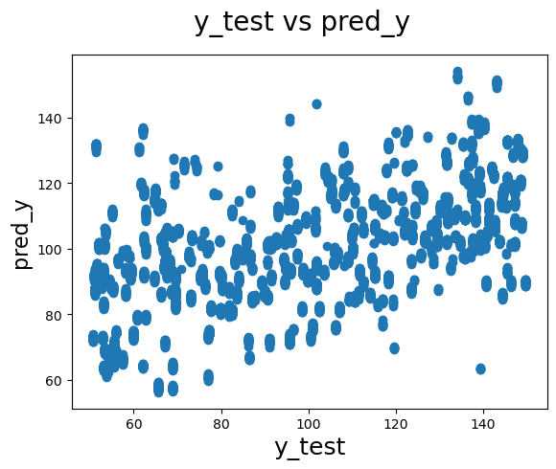
Fig. 5 y_test vs pred_y
Performance metric | Value
R2 Score | 0.3286
MSE | 20.0369
MAE | 605.4526
RMSE | 4.4762
Table 1 : Performance metric for Linear Regression
B. Alternate models :
1. Decision Tree Regressor : It is a supervised learning algorithm used for making decisions based on the concept of flow chart like tree structure .
Performance metric | Value
R2 Score | 0.9773
MSE | 0.3015
MAE | 20.4103
RMSE | 0.5491
Table 2 : Performance metric for Decision Tree Regressor
2. Random Forest regressor : It is a bagging technique that uses an ensemble learning method for regression in machine learning.
Performance metric | Value
R2 Score | 0.9869
MSE | 0.3224
MAE | 11.7422
RMSE | 0.5678
Table 3 : Performance metric for Random Forest Regressor
3. Support vector machine : Support Vector Regression (SVR) is a type of machine learning algorithm used for regression analysis.Its primary aim is to find a function that approximates the relationship between the input variables and a continuous target variable, while minimizing the prediction error.
Performance metric | Value
R2 Score | 0.0489
MSE | 24.9563
MAE | 857.6918
RMSE | 4.9956
Table 4 : Performance metric for SVM
4. Gradient Boosting regression Boosting is one kind of ensemble Learning method which trains the model sequentially and each new model tries to correct the previous model.
Performance metric | Value
R2 Score | 0.5066
MSE | 17.6681
MAE | 444.8648
RMSE | 4.2033
Table 5 : Performance metric for Gradient Boosting Regressor
5. Multi Linear Regression using ANN : Multiple linear regression (MLR), also known simply as multiple regression, is a statistical technique that uses several explanatory variables to predict the outcome of a response variable.
Performance metric | Value
R2 Score | 0.9862
MSE | 0.8848
MAE | 12.5542
RMSE | 0.9406
Table 6 : Performance metric for Multi Linear Regression
Feature Selection : Feature Selection is the method of reducing the input variable to the model by using only relevant data and getting rid of noise in data. It is the process of automatically choosing relevant features for machine learning model based on the type of problem we are trying to solve.
Feature Scaling : Feature scaling is a method used to normalize the range of independent variables or features of data. In data processing, it is also known as data normalization and is generally performed during the data preprocessing step.
Hyperparameter Tuning : It is one of the tricky task in model building. Hyperparameters are those parameters whose values are to be decided by data scientist/programmer for performance optimization. Models can have many hyperparameters and finding the best combination of parameters can be treated as a search problem.
C. Pipeline :
After finding the best suitable model,the next task is to build a pipeline in order to automate the data mining and extraction process. If additional data is added or any degradation in model performance happen, then model need to be retrained due to which feedback loops are generated. We build pipeline by including Feature scaling,selection and hyperparameter tuning.
V. Discussion & Conclusion
One of the main challenges of this project is to select the right algorithm for the project. We have found that Decision Tree and Random Forest Regressors are outperforming other models,which is a good start. However, it is important to continue evaluating different algorithms and hyperparameters to find the best possible solution. Another challenge is to evaluate the performance of the model on real-world data. It is important to test the model on a held-out test set that is representative of the actual customer base. This
will help us to ensure that the model is generalizable and will perform well in practice.

Machine learning is a powerful tool that can be used to predict customer acquisition cost (CAC). CAC is the total cost of acquiring a new customer, and it is an important metric for businesses to track. By using machine learning to predict CAC, businesses can optimize their marketing campaigns and reduce their costs.There are a number of different machine learning algorithms that can be used to predict CAC. Some of the most popular algorithms include decision trees, random forests, gradient boosting machines, and neural networks. These algorithms can be trained on historical data to identify patterns that can predict the likelihood of a customer making a purchase. Once a machine learning model has been trained, it can be used to predict the CAC for new customers. This information can then be used to target marketing campaigns more effectively. For example, businesses can target customers who are more likely to convert and who have a lower CAC. Machine learning can also be used to identify new marketing opportunities. For example,businesses can use machine learning to identify potential customers who have not yet been reached by their marketing campaigns. Overall, machine learning is a powerful tool that can be used to improve customer acquisition in a number of ways. By using machine learning to predict CAC and target marketing campaigns more effectively, businesses can reduce their costs and acquire more customers.

VI. References
[1] McVey, H. On-line Financial Services, presentation by Morgan Stanley Dean Witter, August 2000.
[2] Chen, Pei-Yu, and Lorin Hitt. "Switching cost and brand loyalty in electronic markets: Evidence from on-line retail brokers." ICIS 2000 Proceedings (2000): 13.
[3] Klemperer, Paul. "Price wars caused by switching costs." The Review of Economic Studies 56.3 (1989): 405-420.
[4] Reinartz, Werner J., and Vita Kumar. "The impact of customer relationship characteristics on profitable lifetime duration." Journal of marketing 67.1 (2003): 77-99.
[5] Thorleuchter, Dirk, Dirk Van den Poel, and Anita Prinzie. "Analyzing existing customers’ websites to improve the customer acquisition process as well as the profitability prediction in B-to-B marketing." Expert systems with applications 39.3 (2012): 2597-2605.
[6] Elfahham, Yasser. "Estimation and prediction of construction cost index using neural networks, time series, and regression." Alexandria Engineering Journal 58.2 (2019): 499-506.
[7] Kim, Gwang-Hee, Sung-Hoon An, and Kyung-In Kang. "Comparison of construction cost estimating models based on regression analysis, neural networks, and case-based reasoning." Building and environment 39.10 (2004): 1235-1242.
[8] Kandananond, Karin. "A comparison of various forecasting methods for autocorrelated time series." International Journal of Engineering Business Management 4 (2012): 4.
[9] K. Kim, Financial time series forecasting using support vector machines. Neurocomputing, 55, pp. 307–319, 2003.
[10] Skitmore, R. Martin, and S. Thomas Ng. "Forecast models for actual construction time and cost." Building and environment 38.8 (2003): 1075-1083.
[11] Kone, Estelle RS, and Mark H. Karwan. "Combining a new data classification technique and regression analysis to predict the Cost-To-Serve new customers." Computers & Industrial Engineering 61.1 (2011): 184-197.
[12] N. Darapaneni et al., "Movie Success Prediction Using ML," 2020 11th IEEE Annual Ubiquitous Computing, Electronics & Mobile Communication Conference (UEMCON), New York, NY, USA, 2020, pp. 0869-0874, doi: 10.1109/UEMCON51285.2020.9298145.
[13] Janet, B., and Annasha Ghosh. "End-to-End Encryption and Prediction of Medical Insurance Cost." 2022 6th International Conference on Trends in Electronics and Informatics (ICOEI). IEEE, 2022.
[14]https://www.kaggle.com/datasets/ramjasmaurya/medias-cost prediction-in-foo.

