**Introduction:**

Automated Teller Machine enables the clients of a bank to have access to their account without going to the bank. This is achieved only by development the application using online concepts.

When the product is implemented, the user who uses this product will be able to see all the information and services provided by the ATM, when he enters the necessary option and arguments. The product also provides services like request for cheques, deposit cash and other advanced requirement of the user. The data is stored in the database and is retrieved whenever necessary. The implementation needs ATM machine hardware to operate or similar simulated conditions can also be used to successfully use the developed product.

To develop this ATM system the entire operation has been divided into the following step:

1. verification process

2. language, service and account selection

3. Banking services

4. Transactions

5. Special services

The program is designed in such a way that the user has to card and pin number. Once verified, he is provided a menu and he/she had to enter the option provided in the menu. For example, when the user wants to view the list of payment history than he/she had to enter the option for payment history provided in the main menu. When the option is entered alone with the respective argument, then the payment history is displayed on the screen.

The user also must be given option to browse through the pages like previous page, next page, etc. The user may experience a delay in retrieving or viewing the data, when there are many users logged on to the same bank branch system.

### **Features of the ATM Machine project:**

The Program will do some tasks below to operate the ATM Machine:

* The C Program can display the ATM Transaction.
* It has a PIN verification system to login to ATM Machine.
* Users can Check the balance from this ATM Machine Project.
* User can withdraw Cash from ATM Machine.
* User can deposit Cash from ATM Machine.

Defining Our System

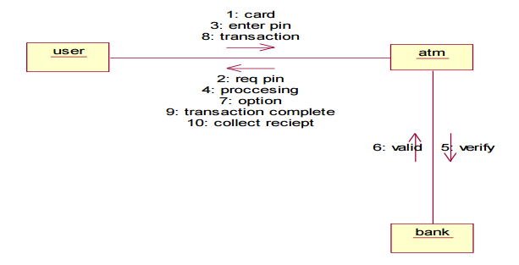

Research:

It shows the research design, the study area, population, the sampling design, data collection methods, instruments and analytical technique.

Research Design:

* The study adopted a quantitative survey design, nonexperimental and cross sectional in nature. The unit of analysis was bank customers found within the bank vicinity.
* Quantitative research design was adopted because it describes the study phenomena in terms of numbers and nonexperimental design which allows analysis using statistical methods to generate descriptive statistics (Creswell, 2009).
* Nelly (2010) defined quantitative design as an approach which quantifies responses in numbers instead of explanations.
* The design was considered appropriate for the study due to the need to collect data from the larger sample to establish the effect of ATM use on customer satisfaction.

Justification of the research study:

* The research agenda was to assess the effects of ATM use on customer satisfaction at Stanbic bank Mbarara Brach.
* ATM use is the latest technology adopted by banking industry to effectively serve their customers.
* Thus, necessitate an assessment on ATM use and its effect on customer satisfaction.

Areas for further research:

* Impact of ATM services on performance of commercial banks in Uganda.
* The rationale of ATM use on the growth of commercial banks in Uganda.
* The same study can be reaped using triangulation method of data collection, to establish the effects of ATM use on customer satisfaction.

4W's and 1'H:

Who:

* Bank Provide the ATM Services.
* ATM Services are used by Respected account holders of the bank.

What:

* An ATM is a computerised machine that provides customers of banks the facility of accessing their accounts for dispensing cash and to carry out other financial & non-financial transactions without the need to visit the bank branch.

When:

* On **September 2, 1969**, America's first automatic teller machine (ATM) makes its public debut, dispensing cash to customers at Chemical Bank in Rockville Centre, New York.

Where:

* This application gives the money as well as the information about the bank accounts eg: (check balance, deposit, with drawl).

How:

* This project can perform various calculations at the same and make user's task smooth and effortless.

Detail Requirements:

High Level Requirements:

|  |  |  |
| --- | --- | --- |
| ID | Description | Status(implemented/future) |
| HLR-1 | ATM system shall provide the customer a receipt for deposits and withdrawals. | Implemented |
| HLR-2 | ATM system shall accept customer requests and provide feedback. | Implemented |
| HLR-3 | The ATM system shall determine ATM responses to inputs received. | Future |

Low Level Requirements:

|  |  |  |
| --- | --- | --- |
| ID | Description | Status |
| LLR-1 | ATM communicate with the bank computer to get customer information. | Future |