Computer Science INSTRUCTION using Drones
Authors – Rareș-Ioan GRĂDINARIU, Bianca-Anastasia PĂVĂLOIU,
Andrei TIMISICĂ, Alexandru-Mihai Andrei , Maria-Viorica ȘAPCALIU
Scientific Coordinator – Bujor PĂVĂLOIU
Abstract: Digitalizarea și mobilitatea sunt repere ale existenței noastre actuale. Dronele au devenit accesibile în ultimii ani și sunt extrem de provocatoare pentru programare, deschizând perspective interesante pentru predarea disciplinelor academice.
Digitalization and Mobility are landmarks of our current existence. Drones become affordable in the last years and they are extremely challengeable to program, opening interesting perspectives for academic subjects teaching.
Keywords: Drone, Programming, STEM, Internet of Things, Neural Networks,

Introduction
Today, technology is evolving at a rapid pace, influencing everything from everyday household electronics to advanced technological innovations. This progress is driven by the need for our society to adapt and modernise. The latest advances in information and communication technology have enabled us to digitalise various fields, significantly easing individual workloads and opening up profitable new market opportunities. Drones are a prime example of this trend, which is gradually but permanently reshaping our daily lives.
Drones are small or medium-sized unmanned aerial vehicles (UAVs). They’re unique in that they can drive remotely and autonomously, and they’re capable of maintaining a controlled, sustained level of flight.[7] Until recently, commercial drone design and implementation faced significant challenges due to strict safety and privacy regulations. However, thanks to technological advances, there are now many drone designs that overcome these barriers. These drones are not only programmable but also versatile in their applications. Drones are becoming omnipresent, and their design is increasingly prominent in various applications—from search and rescue and monitoring traffic, to recording audiovisual productions of scenes that were previously impossible or very costly to capture. They are also used in military technologies, such as Drone-on-Drone Combat in Ukraine, which brings a new era of aerial warfare.
Furthermore, drones can play a significant role in education, serving as interactive tools that enhance learning through programming. Coding with drones provides a dynamic way to creatively develop problem-solving and critical thinking skills, engaging students with technology that connects them to real-world applications. This method is perfectly aligned with the goals of STEM education, which aims to integrate such innovative approaches to learning.
STEM (science, technology, engineering and mathematics) education allows the pupils to become familiar with the new technologies and drone programing can be performed nowadays even at primary and secondary education [1]. This paper inspired us to explore how drone programming can be used in higher education. We will present in Chapter 2 the drones which can be used directly for training and some basic concepts, in Chapter 3 the Tello drones we have used for programming, while the rest of the chapters we will show some use cases for computer science instruction using drone programming as a part of university education. We are students in Computer Science at the Faculty of Engineering in Foreign Languages from University POLITEHNICA of Bucharest and all the coding was used either for real subjects projects or to be shown at the University fairs to the audience

Programable drones suitable for education
Any drone can be programmed, but just some are made to be programmable and very few are designed to be programmed simple, without dedicated APIs and high-level coding.

- Airblock by MakeBlock [2]
  - A modular drone that is notable for its ability to also function as a hoverboard.
  - Versatility is achieved through its design, which includes a main module and six additional hexagon-shaped modules that attach using magnets, allowing for various configurations.
  - It is specifically designed for educational purposes, focusing on safety and simplicity.
  - Can be programmed via a mobile app compatible with iOS and Android devices.
  - It is notable for its lack of a camera, avoids GDPR complications, and its high-quality foam construction makes it highly impact-resistant and safe for indoor use.

- Ryze Tech - Tello
  - An affordable drone that, while not designed primarily for educational purposes, can be used to teach programming via the Tello Edu app.
  - The app allows for block-based programming, allowing students to execute a range of commands and use functions such as loops, variables and sensors.
  - Its affordability makes it a popular choice for educational institutions, providing a hands-on introduction to drone programming without a significant financial investment.

- Elecfreaks micro:bit drone:bit kit
  - Uses the popular micro:bit device for programming, with users having to operate through a dedicated website to add the necessary coding extensions.
  - This setup allows programming of a custom game controller that communicates with the drone via radio signals, enhancing the interactive learning experience.
  - Although it offers unique educational opportunities, its reliance on web-based programming limits its accessibility in environments without constant internet access.

- Robolink CoDrone
  - Drone tailored specifically for beginners
  - Features a simple Arduino-based controller with a drag-and-drop programming interface.
  - This setup makes it a great choice for introductory programming courses, allowing easy startup and customization with various sensors and accessories.
  - Although it has a shorter flight time and range, its durability and ability to customize with additional components make it a versatile educational drone, especially suited for demonstrations and light shows.

In Table 1 we are presenting the important details of the interesting programmable drones. We started from [2], [6] and updated with current meaningful information.
Table 1
Programmable drones for education
 | Tello (2018) | Tello EDU/ Talent | CoDrone | Parrot Mambo | Airblock | LiteBee Wing | Drone:bit
Dimensions | 98×92.5×41 mm | 98×92.5×41 mm | 3.7 x 2.6 x 2.8 in. | 6 x 3 x 0.4 in. | 230 x  222 x 53 mm | 210 x 180 x  50 mm | 410 x 410 x 51 mm
Weight | 80 g | 80 g | 36 g | 63 g | 141 g | 128g | 509 g
Battery life | 13min | 13min | 6 min | 9 min | 6-8  min | 10 min | 8 min
Camera | HD | HD | no | 4K | no | HD | no
Microcontroller | - | ESP32 Controller | - | - | DIY Kit  For ESP32 | - | -
Prog. Languages | block based  language,  JavaScript, Python | Scratch, Python  Swift | Python, Blockly, Arduino | Swift Playground  Tynker.  Workbench  Simulink.  Python.  Javascript. | block  based  language | block based language | block based  language,  JavaScript,  MicroPython
Extensions | yes | yes | no | yes | no | yes | yes
Price | 113 € | 133€ | 93 € | 103 € | 179 € | 190 € | 177 €

Tello drones
While the Tello drone is often associated with names like "DJI Drone" or "Ryze Tello", it is a product made in collaboration with Ryze Technology, not just a DJI creation. Founded in 2017 in Shenzhen, China, Ryze aims to make drone flight both fun and educational, as embodied in their first product, Tello.[4]
The Tello combines a DJI flight control system with an Intel processor, making it an easy-to-use drone that's easy to transport thanks to its compact size. It's also VR compatible for an enhanced flight experience. The drone has a nose-mounted camera that takes 5 MP photos and streams 720p video, making it great for indoor use and attractive to beginners.
Though it incorporates DJI technology, Tello is actually manufactured by Ryze Technology. This collaboration has produced a budget-friendly camera drone that doubles as an educational tool, incorporating an integrated Scratch programming system in Tello’s companion app. This allows users of all ages to learn coding basics in a fun, engaging way [5].

Tello comes in three different variants:[3]
  - Tello Quadcopter (2018)
  - Tello Edu (2018)
  - Tello Talent (2021)

3.1 Tello Quadcopter
- Manual Flight Control: Fly around manually
- Supports Block Coding: Can drag and drop in order to make the drones fly
- Supports Script Languages: Python and Javascript
- It has Front Facing Camera
- DroneBlocks App supports: PC, MAC, IOS, Android, Chrome Books
- No storage: Cannot take pictures or film videos

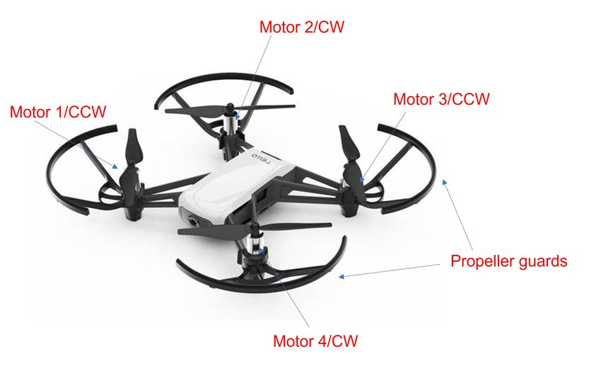
Fig. 1. Tello Quadcopter
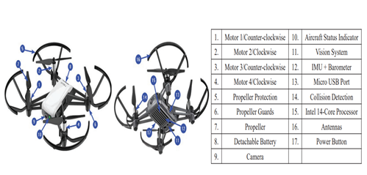
Fig. 2. Specifications of Tello quadcopter drone[9]

3.2 Tello Edu
The Tello EDU drone is a versatile educational tool for learning about programming and robotics. It’s small size, and lightweight design makes it easy to use indoors, while its sensors and high-resolution camera provide various options for experimentation. [8]
- Everything Tello Does Everything Tello Does
- Open-source educational drone
- Supports Swarm mode: Connect multiple drones in order to do a designated task
- Supports the Advanced System Development Kit (SDK) 2.0
- Supports Mission Pads : The drone flies over them, it can trigger certain actions
- Support Expansion Kits
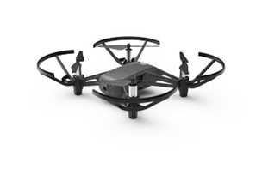
Fig. 3. Tello EDU
Moreover, the quadrotor drone can be controlled by predetermined gestures using an AI-based human gesture tracking system, with different gesture algorithms to detect various gestures and control drones [9]. The importance of the field is shown by the large number if papers treating this, as shown in Fig. 4 (just a part, from the last 3 years), reproduced from [9].
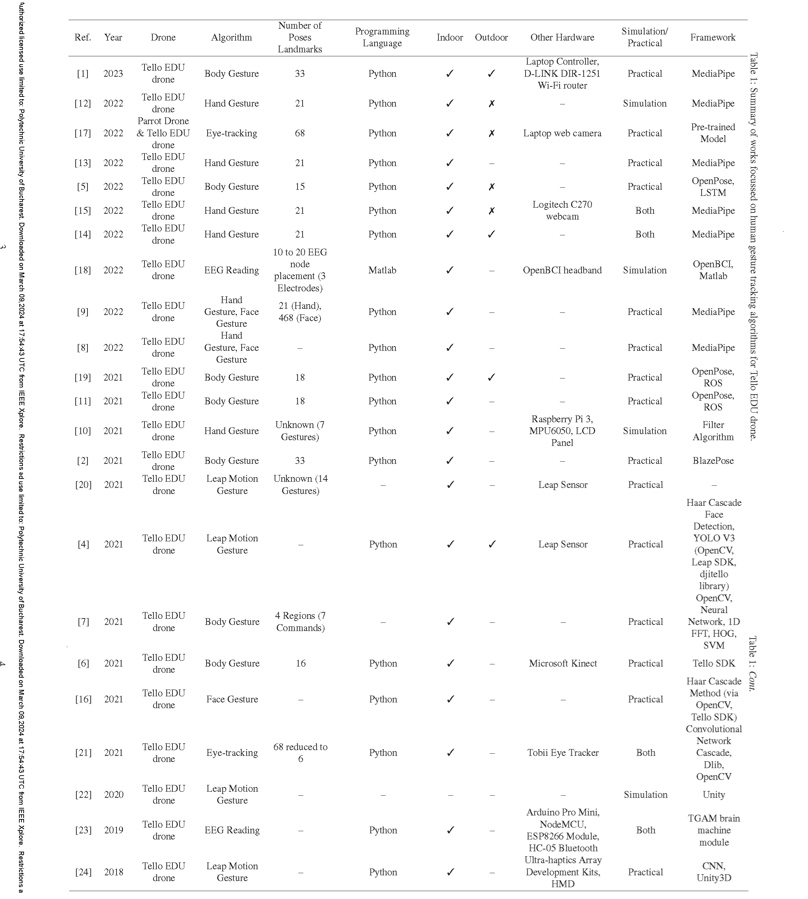
Fig. 4 Summary of works focussed on human gesture tracking algorithms for Tello EDU drone.

3.3 Tello Talent
The Tello EDU quadrotor drone’s advanced programming capabilities make it an excellent choice for students learning Scratch, Python, and Swift programming languages, as well as for those seeking to integrate artificial intelligence (AI) functionality such as a fly-in swarm, updating to SDK 2.0, incorporating DJI’s flight control technology, and supporting electronic image stabilization [8].

- Everything Tello Edu Does
- Add-On : RGB LED
- Add-On : 8x8 Red/Blue Display Matrix – can draw pictures or scroll text
- Built-in Open Source ESP32 Controller – improved Wi-Fi and the embedded esp32 module which allows you to connect an extension board to this drone and lets you plug in things like a temperature sensor
- Arduino Compatible

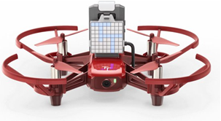
Fig. 5. DJI RoboMaster TT Tello Talent

All three have the universal gear in common:
- Batteries
- Propellers
- Propellers Guards
- USB Cable
Despite the good general feedback, these programmable drones for education has brought to the STEM education and for overall users, the tello drones series are now discontinued.

For this research, we use the Tello quadcopter drone as well as the DJI RoboMaster TT Tello Talent for programming and we will continue to show some applications that can be used as an active learning-based instructional approach.
Table 2
Other software and hardware components
Item | Description
DJI Tello Talent/ Tello quadcopter | Drone Drone equipped with System Development Kit (SDK)
djitellopy Package | Python-based library to help connect and control  DJI Tello EDU Drone
easyTello | Python-based library to provide users to interface and send commands to the DJI Tello drone using Python3 and threading
OpenCV Package (CV2 in Pycharm) | Open-source computer vision library that helps with image processing using machine learning
NumPy | Python-based package for advanced scientific computing, with an extended set of tools for fast array operations, mathematical functions and statistical analysis.
Thread | Library for threading
Torch | A Tensor library like NumPy, with strong GPU support and a deep learning research platform that provides maximum flexibility and speed.[13]
Pygames | Python-based package for development of multimedia applications, especially for game controller and testing drone
PyCharm IDE | Python language-based IDE
Webcam | Just for testing purposes

Programming instruction– from Drag and drop to Python
The integration of drones into computer science education at different educational levels serves as a gradual approach to teaching programming and robotics.

4.1. Introduction to Drone Programming for Beginners
In primary education, drones are used to introduce young students to STEM fundamentals. Research indicates that engaging students with drone technology increases their understanding and enthusiasm for science topics. For beginners, especially in primary schools, drone programming involves easy-to-use, block-based programming platforms.[1]
An ideal tool for this is the RoboMaster TT, which is compatible with DFRobot's graphical programming software, Mind+, recognizable in Fig. 6.
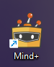
Fig. 6 Mind+ Application icon
Mind+ is a Scratch 3.0-based programming software that supports various open-source hardware such as Arduino, micro: bit, mPython-esp32 and all kinds of controller boards. You can build a program by dragging and snapping coding blocks, or using advanced programming language like python, c, c++.
Furthermore it is assigned as the official graphics programming platform for RoboMaster TT. It supports a wide range of hardware libraries and allows extension functions to user-defined libraries.[10]
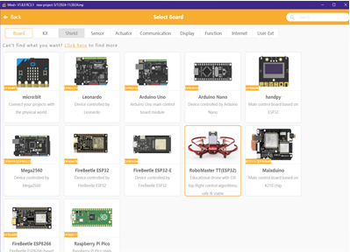
Fig. 7 Mind+ Selection Boards

4.1.1 Programming with Mind+
Mind+ facilitates real-time control of the Tello EDU via WIFI on a computer or programming of the ESP32 controller on the extension module to operate Tello EDU. This environment allows students to visually assemble code, which is then translated into actions performed by the drone. This approach not only simplifies the learning process but also embeds essential programming concepts in a fun and interactive manner.
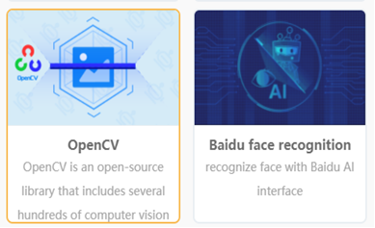
Fig. 8 Mind+ also integrates machine learning software library
There are four ways to engage with RoboMaster TT using Mind+, but in our research the two that interests us the most are:
  - Offline Mode – ArduinoC Programming: Program needs to be uploaded to the ESP32 to run.
  - Offline Mode – MicroPython Programming: Similar to ArduinoC, but using MicroPython.
The RoboMaster TT uses an ESP32 chip as the main controller. The accompanying software, Mind+, supports two programming languages: ArduinoC and MicroPython. ArduinoC offers a wider range of functions, and its extensions are particularly easy to use for beginners. On the other hand, although MicroPython offers relatively fewer features, it is a great option for users interested in learning Python.
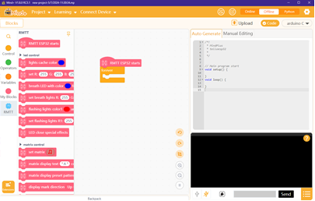
Fig. 9 Interface for programming the Tello EDU Talent drone
left side: block code - right side: ArduinoC

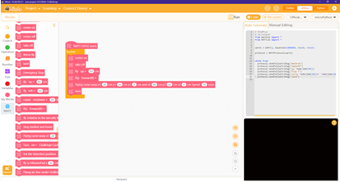
Fig. 10 Programming the Tello EDU Talent drone to execute flying commands
left side: block code - right side: MicroPython

4.2 Advanced drone programming for secondary and higher education
The complexity of programming tools and tasks related to drones rises as students advance through high school and university. Currently, they are using libraries like DJITelloPy and OpenCV-Python and programming languages like Python to enable more sophisticated tasks like object identification and semi-autonomous navigation. Additionally, libraries that support machine learning techniques, like Torch, are being released for more complex applications that are aimed at computer science and engineering students.
Lobo et al. report in their research an active learning-based instructional approach that prepares students for careers in the drone industry (drone programming using Python, designing and fabricating drones using Computer-Aided Design (CAD)). Their research was implemented in an undergraduate class that engineering and computer science students attended. Quantitative assessments indicated that most students excelled at the technical subjects covered in the class.[1]

Computer Networks instruction
Drones are using communication modules such as RF (radio frequency), Bluetooth and Wi-Fi(Wireless Fidelity) .The remote-control system of a drone is typically based on wireless communications, such as 2.4 GHz, 5.8 GHz, or WiFi (IEEE 802.11 a/b/g/n) [11]
In order to connect to them, there are several methods to do it.

5.1 Technical Setup
For the purpose of testing, due to the absence of a wireless adapter on the server laptop, an old router is used as a wireless extender. This router connects to the laptop via an Ethernet cable, which in turn connects to another adapter to the laptop’s Type-C port, establishing a network framework that supports both drone management and internet access.
On a usual local network setting, after connecting the drone to the personal computer (PC), the communication setup between the drone and PC must be established. As shown in Fig. 11, Wi-Fi network is used to connect the Tello drone to a PC. The three purposes of this connection are shown in the figure, and the steps to establish this connection are explained underneath.[12]
- Sending Commands and Receiving Responses: It is necessary to establish a UDP client on a PC to send commands to Tello’s UDP port 8889 and receive responses. To send any other commands, first, the command command must be sent to Tello’s UDP port 8889 to activate Tello’s SDK mode
- Receive Tello State: It is necessary to establish a UDP server on the computer to collect messages from IP 0.0.0.0 through UDP port 8890.
- Receiving Tello Video Streams: The user must set up a UDP server on their PC, Mac, or mobile device. This will allow them to receive messages from Tello’s IP address 0.0.0.0 through UDP port 11111. Once the user has sent the command command, they can send the streamon command to Tello’s UDP port 8889 to receive video streams from the drone.
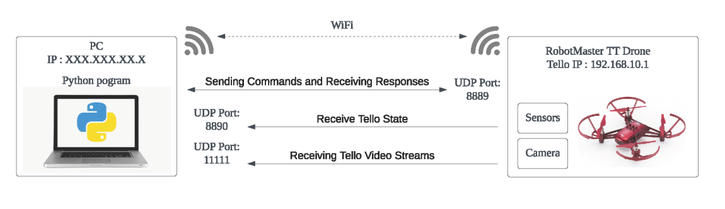
Fig. 11 General Principle of Communication between drone and PC [12]

Internet of Things instruction
The Internet of Things (IoT) can be described as the common physical objects that are digitally connected and refers to all the physical objects like sensors that can be used to be embedded with software.
Drones can also be handled by smart devices like smart phones. They are used to communicate to other drones, through networks, satellites using technologies like GPS.
This chapter explores the application of Internet of Things (IoT) principles in the context of drone technology, highlighting a Python-based client-server model that enables remote control and communication with a drone. This instructional segment focuses on the development and execution of a drone remote control system using advanced programming and network communications techniques, providing a hands-on demonstration of IoT in action.

6.1 System overview
The system consists of a server connected to a drone and a client that receives video streams and sends commands to the drone. This setup demonstrates real-time interaction with the drone via a Python-based application using sockets for network communication. The server, running on a PC connected to the drone, requires dual network interfaces to connect to the drone and the internet simultaneously.

6.2 Technical Setup for IoT application
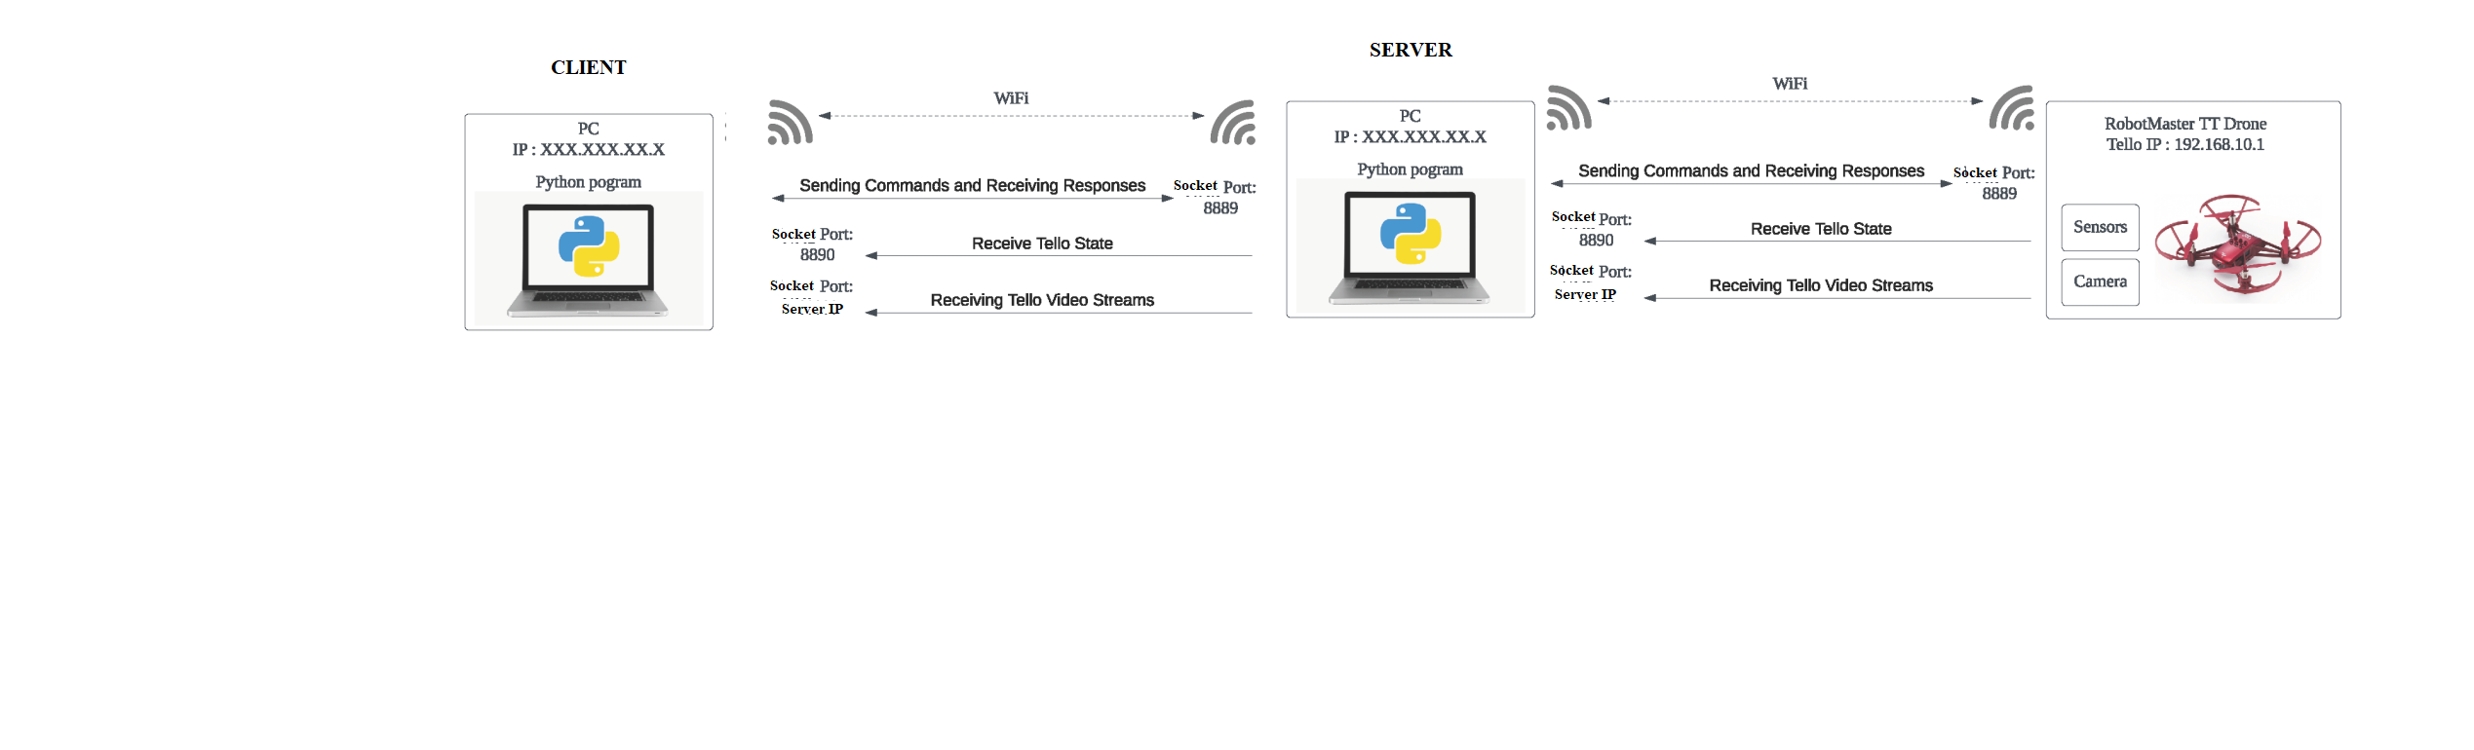Fig. 12 Our IoT Principle of Communication between drone, PC (Server) and PC (Client)
In IoT, devices use their internet connections to collect and transmit data remotely. A practical example is when students engage in remote laboratory courses, allowing them to operate drones from distant locations to conduct experiments or collect data as part of their academic studies. Using computer networking principles, these drones operate on IoT concepts, sending remote data, including video and executing remote commands. This setup allows students to control the drones as if they were physically present in the lab, using the principles of communication between a drone and a PC as outlined in the previous chapter on computer networking.
To facilitate this, the standard UDP connection has been adapted to work over the Internet. By applying fundamental concepts from computer networking, we enabled direct transmission of commands to the drone. Although various methods are available to establish this type of communication, we chose this approach to simplify conceptual understanding for students. This adaptation demonstrates how traditional local area network connections can be extended into IoT systems, enabling remote learning and experimental control from anywhere in the world.

6.3 Programming Components

6.3.1 Video Transmission:
The server uses OpenCV to capture video frames from the drone’s camera.
These frames are encoded and serialized before being sent over the network to the client, which decodes and displays them in real-time.
This allows the client to visually monitor the drone’s environment from a remote location.

6.3.2 Command Transmission:
The client uses a keyboard listener to capture key presses, which are sent to the server as commands using socket programming.
These commands are interpreted by the server to control the drone’s movements, such as takeoff, landing, and directional control.
This setup effectively turns the client into a remote control unit, capable of directing the drone’s actions from afar.

6.3.3 Drone Command Execution:
Upon receiving a command, the server translates it into specific drone actions using predefined functions mapped to drone controls.
This method showcases the application of function mapping and event-driven programming in controlling IoT devices.
6.4 System Operation
The server starts by connecting to a specified IP address and listening for connections from the client.
Once a connection is established, separate threads handle video transmission and command reception simultaneously, illustrating the use of multiple threads in network programming.
The system remains operational until manually terminated, demonstrating both the robustness and real-time capabilities needed for effective IoT implementations.
For a more interactive way to explore the application of Internet of Things (IoT), we also implemented a graphical interface for the drone server and client, using python graphics library.

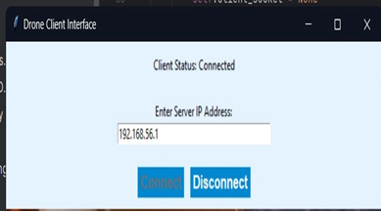
Fig. 13 Drone Client Interface

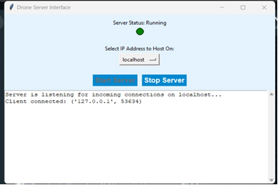
Fig. 14 Starting the server in the Drone Server Interface

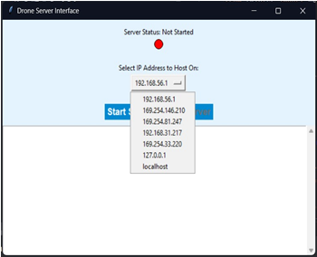

Fig. 15 Selection of the Internet interface of the computer and their IP

Computer Vision instruction
Computer vision is a field of artificial intelligence that enables machines to interpret and understand visual information from the surrounding environment. In the context of our project, we utilized computer vision techniques to enable our drones to recognize colors and faces, enhancing their capabilities for various applications.

7.1 Object tracking using colors
One of the base applications of computer vision in our project was object tracking using colors. By leveraging the OpenCV library, we developed algorithms that allowed our drones to identify and track objects based on their color signatures. This capability is particularly useful for tasks such as following predefined paths, locating objects of interest, and maintaining visual contact with specific targets during autonomous flight.
The process involved capturing live video feed from the drone's camera and applying color filtering techniques to isolate regions of interest corresponding to the target objects. We then implemented algorithms to track the movement of these objects in real-time, adjusting the drone's flight path accordingly. This functionality proved invaluable for scenarios such as surveillance, monitoring, and search-and-rescue operations, where visual tracking of objects is critical.

Microcontrollers instruction
Microcontrollers serve as the brain of many electronic devices, providing computational power and control capabilities in a compact and cost-effective package. In our project on computer science instruction using drones, we utilized microcontrollers, particularly the ESP32, to implement various functionalities, including the display of text messages on a matrix display.

8.1 The ESP32 Microcontroller
The ESP32 is a versatile microcontroller developed by Espressif Systems, featuring a dual-core processor, built-in Wi-Fi and Bluetooth connectivity, ample memory, and a rich set of peripheral interfaces. Its powerful capabilities make it well-suited for a wide range of applications, from IoT (Internet of Things) devices to robotics and automation systems.

8.2 Implementation details
In our project, we utilized the ESP32 microcontroller to display the name of our faculty, to entertain the public during PoliFest. We integrated the ESP32 with a matrix display to showcase text messages and engage the audience.
Our implementation involved the following steps:
  - Programming with MindPlus: We utilized MindPlus, a graphical programming platform based on the Arduino IDE, to program the ESP32 microcontroller. MindPlus provides an intuitive interface for designing and coding interactive projects, making it accessible to users of all skill levels.
  - Displaying Text Messages: We programmed the ESP32 to display text messages on the matrix display. This involved specifying the content of the messages, as well as the timing and animation effects.
  - Integration with Matrix Display: We connected the ESP32 microcontroller to the matrix display, establishing communication and control interfaces to enable the display of text messages. The ESP32 interfaced with the display hardware to send commands and data for rendering the messages accurately.
Deployment: During PoliFest, we deployed the ESP32-powered matrix display to showcase entertaining and informative messages to the public. The display served as an engaging attraction, drawing attention and sparking conversations among attendees.

Image Processing Instruction
Image processing plays a crucial role in enhancing the capabilities of drones by enabling them to interpret visual information from their surroundings. In our project, we utilized image processing techniques to track objects based on their colors, thereby enhancing the drone’s perception and tracking abilities.

9.1 Image Processing
Image processing involves the manipulation and analysis of digital images to extract useful information or enhance their visual quality. In the context of our project, image processing served as a foundational component for enabling our drones to interpret and respond to their environment effectively.

9.2 Object tracking using OpenCV and color detection
One of the primary image processing techniques we employed was object tracking using OpenCV (Open-Source Computer Vision Library). This library provided a comprehensive set of tools for image manipulation, feature extraction, and object tracking, enabling us to develop robust tracking algorithms for our drones.
Our approach to object tracking using OpenCV involved the following steps:
  - Color Detection: We implemented color detection algorithms to identify objects of interest based on predefined color thresholds. By specifying target colors and tolerance levels, we were able to isolate regions of the image corresponding to the desired objects.
  - Object Localization: Once the target color regions were identified, we employed techniques such as contour detection and bounding box estimation to localize and delineate the objects within the image.
  - Tracking Algorithm: We developed custom tracking algorithms to monitor the movement of the detected objects over consecutive frames. By analyzing the spatial and temporal characteristics of the tracked objects, we were able to adjust the drone's flight path accordingly.

9.3 Implementation details
In our implementation, we utilized OpenCV's extensive functionality to streamline the object tracking process. By leveraging the library's built-in functions for image processing, feature detection, and motion analysis, we were able to develop efficient and reliable tracking algorithms capable of operating in real-time.
Furthermore, we integrated the object tracking functionality with our drone control system, enabling seamless interaction between image processing and drone navigation. This integration allowed the drones to autonomously track and follow objects of interest, enhancing their capabilities for applications such as surveillance, tracking, and reconnaissance.

Neural Networks Instruction – Object Detection and Classification
Neural networks are a fundamental component of deep learning and machine learning, enabling machines to learn from data and perform complex tasks such as object detection and classification. In our project on computer science instruction using drones, we delved into neural networks to empower our drones with the ability to detect and classify objects in their environment.

10.1 Neural Networks
Neural networks are computational models inspired by the structure and function of the human brain. They consist of interconnected layers of artificial neurons that process input data, learn patterns, and generate output predictions. Deep learning, a subset of machine learning, utilizes deep neural networks with multiple layers to extract hierarchical representations from data, enabling more sophisticated learning and decision-making.
In our project, we embraced the power of neural networks to equip our drones with the capability to detect and classify people in real-time, enhancing their autonomy and situational awareness.

10.2 YOLO for Object Detection
One of the key neural network architectures we employed for object detection was YOLO (You Only Look Once). To integrate YOLO into our drone systems, we followed a multi-step approach:
  - Model Training: We trained the YOLO model on a labeled dataset of images containing various objects of interest. The training process involved optimizing the model's parameters to minimize the detection errors and maximize accuracy.
  - Model Deployment: Once trained, we deployed the trained YOLO model onto our drone systems, allowing them to perform real-time object detection tasks directly onboard.
  - Live Image Processing: We implemented algorithms to process live video feed from the drone's camera in real-time, applying the YOLO model to detect objects within the captured frames.
  - Low-Latency Processing: To ensure minimal latency and enable responsive drone movement, we utilized multi-threading techniques to parallelize the object detection process and optimize resource utilization.
  - Fail-Safe Mechanisms: In scenarios with poor network connectivity or degraded video quality, we implemented fail-safe mechanisms to handle frame processing errors gracefully, ensuring the stability and reliability of the object detection system.
  - Pre-processing Techniques: To enhance the robustness of object detection in diverse environments, we applied pre-processing techniques such as normalization and resizing of input frames to standardize image characteristics and improve detection accuracy.

By leveraging the capabilities of YOLO and implicitly of Deep Learning Neural Networks, our drones were able to autonomously detect and classify objects in their surroundings, opening a wide range of applications in fields such as surveillance, reconnaissance, and environmental monitoring.

10.3 Face Recognition Using YOLO (You Only Look Once)
In addition to color-based object tracking, we integrated advanced face recognition capabilities into our drone systems using the YOLOv5 (You Only Look Once) model. YOLO is a state-of-the-art deep learning algorithm that enables real-time object detection and classification with good accuracy and efficiency.
To implement face recognition using YOLO, we trained the model on a dataset of facial images, allowing it to learn distinctive features and patterns associated with human faces. Once trained, the model could accurately detect and localize faces within the drone's field of view, even in complex environments with varying lighting conditions and occlusions.
The integration of YOLO-based face recognition expanded the potential applications of our drones, enabling functionalities such as targeted surveillance. Drones could autonomously identify and track individuals of interest based on their facial characteristics, providing valuable situational awareness in security and law enforcement scenarios.
In order to properly integrate a custom YOLO set into our project we used the roboflow platform for preparing our data for training. This procedure included the following steps:
  - Annotating each picture to its corresponding person
  - Splitting our data into training, validating and testing
By using the power of computer vision techniques like object tracking and face recognition, our project demonstrated the transformative potential of integrating AI technologies into drone systems for educational and practical purposes. These capabilities not only enrich the learning experience for students but also pave the way for innovative applications in various domains, from robotics and automation to human-computer interaction and beyond.

10.4 Image Augmentation
Image augmentation represents the techniques used to enlarge the quantity and the quality (hopefully) of the training data by canny altering the existing images [14]. The results are
  - Increased Dataset Size: from one existing image there are created multiple variants through transformations.
  - Improved Generalization: the training data will be more variate, reducing the overfitting improving the generalization.
  - Robustness to Variations: some transformations are corresponding to different viewing conditions, object orientations, deformations, and lighting conditions, increasing the model robustness.
Augmentation is present in all main Python libraries: OpenCV, TensorFlow and Keras, PyTorch and there are also libraries dedicated to it: Augmentor, Imgaug, etc..

10.5 Transfer Learning
Transfer learning is a machine learning technique that uses the knowledge learned from previous tasks to improve the performance on a similar new task. YOLOv5 is the world's most loved vision AI, representing Ultralytics open-source research into future vision AI methods, incorporating lessons learned and best practices evolved over thousands of hours of research and development [15]. It is pre-trained on the COCO dataset [16,17] and it is one of most used CNN models - YOLOv8 is faster and more accurate, but YOLOv5 is simpler and easier to use.
The simplest way to do it is to use a pretrained model and to trained it for a new task. In this case, we have used the YOLOv5 model and used it for two sets of real people images. When the data was scarce, we have used image augmentation. Another way was to add just new classes to the model and train just the output layer parameters, which we intend to do in the future.

Conclusions
Through our exploration of advanced STEM applications and above using drones, we have investigated several key areas including basic programming, the Internet of Things (IoT), computer vision, microcontrollers, image processing and neural networks. Each of these areas has demonstrated the potential of integrating drone technology with innovative educational strategies, improving both teaching and learning outcomes.
Our research has clearly shown that using drones as educational tools in these areas not only boosts student engagement, but also significantly deepens their understanding of advanced STEM topics. This project highlighted the value of practical applications in education, effectively bridging the gap between theoretical knowledge and real-world technological implementations.

Drone programming introduces new possibilities and raises the interactive dimension of programming education. Beyond simply learning to code, this approach endows students with understanding of the interaction between hardware and software, the integration of different systems, and the application of innovative problem-solving methods to tackle complex challenges. As an interactive learning tool, drone programming is exceptionally effective in making sophisticated programming concepts both accessible and engaging, thus preparing students for the challenges of an increasingly technology-driven world.

R E F E R E N C E S
[1]. P. Voštinár, Using Drones in Teaching Computer Science, MIPRO 2023 IEEE Conference, Opatija, Croatia, May 22 - 26, 2023
[2] Propel RC, 10 Best Programmable Drones | Updated List April 2024, https://www.propelrc.com/best-programmable-drones/, accessed 28 April 2024.
[3] Drone Blocks, Which Tello is Which? Explore the Tello, Tello EDU, & Tello Talent (Robomaster TT), https://www.youtube.com/watch?v=mybMdJnTi4g, accessed 28 April 2024
[4] Ryze Tech, Company Introduction, https://www.ryzerobotics.com/about, accessed 28 April 2024
[5] Sally French, Tello Drone Discontinued?, https://www.thedronegirl.com/2023/12/29/tello-drone-discontinued/, accessed 28 April 2024
[6] Cd-Soft, Dji Ryze Tello Edu Drone Review, https://cdsoft.com.au/blogs/news/tello-drone-review, accessed 28 April 2024
[7] Ferrovial, What are drones?, https://www.ferrovial.com/en/resources/drones/, accessed 28 April 2024
[8] Mohd Iskandar, Kishore Bingi, Rosdiazli Ibrahim, Madiah Omar, P. Arun Mozhi Devan, Hybrid Face and Eye Gesture Tracking Algorithm for Tello EDU RoboMaster TT Quadrotor, 2023 Innovations in Power and Advanced Computing Technologies (i-PACT) IEEE
[9] Mohd Iskandar, Kishore Bingi, B Rajanarayan Prusty, Madiah Omar, and Rosdiazli Ibrahim, Iskandar Puteri,, Artificial Intelligence-Based Human Gesture Tracking Control Techniques of Tello EDU Quadrotor Drone Malaysia International Conference on Green Energy, Computing and Intelligent Technology (GEn-CITy 2023) 10–12 July 2023
[10] MindPlus, RoboMaster TT, https://mindplus.cc/en.html, accessed 28 April 2024
[11] Krunal Intwala, Sunita Jatav, Kishor Kolhe, System to capture WiFi based Drones using IoT, 2022 6th International Conference On Computing, Communication, Control And Automation (ICCUBEA)
Pimpri Chinchwad College of Engineering (PCCOE), Pune, India. Aug 26-27, 2022
[12] Abdulmonim Kasraoui, Kishore Bingi, Rosdiazli Ibrahim, Madiah Omar, P. Arun Mozhi Devan, B Rajanarayan Prusty. Tracking Control of Tello EDU Quadrotor Drone Using Image Thresholding, 2023 Innovations in Power and Advanced Computing Technologies (i-PACT)
[13] PyPI, torch 2.3.0, https://pypi.org/project/torch/, accessed 28 April 2024
[14] Xu, M., Yoon, S., Fuentes, A., & Park, D. S. A comprehensive survey of image augmentation techniques for deep learning, Pattern Recognition, 109347, (2023)
[15] Ultralytics, yolov5, https://github.com/ultralytics/yolov5, accessed 28 April 2024
[16] COCO, Common objects in context, https://cocodataset.org/#home, accessed 28 April 2024
[17] Tsung-Yi Lin, Michael Maire, Serge Belongie, Lubomir Bourdev, Ross Girshick, James Hays, Pietro Perona, Deva Ramanan, C. Lawrence Zitnick, Piotr Dollár, Microsoft COCO: Common Objects in Context, https://arxiv.org/abs/1405.0312.

Student, group 1231E, Faculty of Engineering in Foreign Languages (FILS), e-mail: rares.gradinariu@stud.fils.upb.ro
Student, group 1231E, FILS, e-mail: bianca.pavaloiu@stud.fils.upb.ro
Student, group 1231E, FILS, e-mail: andrei.timisica@stud.fils.upb.ro
Student, group 1231E, FILS, e-mail: mihai.andrei3105@stud.fils.upb.ro
Student, group 1231E, FILS, e-mail: maria.sapcaliu@stud.fils.upb.ro
Prof., Department of Engineering in Foreign Languages

