AdvancedText2SpeechEditor

Sprint Report

Guardians of the Galaxy

Iliopoulos Panagiotis 4060

Katsi Athanasia 4077

Papadopoulos Xenofon-Rafail 4141

**Versions History**

|  |  |  |  |
| --- | --- | --- | --- |
| **Date** | **Version** | **Description** | **Author** |
| 10/05/2021 | alpha | Created a JFrame, added a JTextArea, JMenu and Open/Save buttons. Implemented a command factory and added the functionality to open a .txt file and display the contents in the JTextArea. | Xenofon, Athanasia |
| 12/05/2021 | Pre-release 0.1 | Downloaded POI and added support for Opening and Saving word and excel documents. Added a JTextField to display the path of the opened document. Moved the buttons to better positions. | Xenofon, Athanasia |
| 14/05/2021 | Pre-release 0.3 | Fixed bugs. Downloaded FreeTTS and created a button to Play the contents of the opened document. The JTextArea is disabled by default and is toggling with the Edit button. If no document is opened but JTextArea has text in it, the contents will be stored to temporary document in memory. | Xenofon, Athanasia |
| 15/05/2021 | Pre-release 0.5 | Fixed bugs. Added Play Selected Text and Play Line functionalities. Implemented the Volume, Pitch, Rate settings. Added labels and moved buttons to better positions. | Xenofon, Panagiotis |
| 16/05/2021 | Pre-release 0.8 | Added support for Rot13, AtBsash and None encryption. The user can open or save a document with either. | Xenofon, Panagiotis |
| 25/05/2021 | 1.0 | Fixed bugs. Tweaked the code to implement the record/replay commands functionality. | Xenofon |

# Introduction

## Text2speech is an advanced text to speech application that converts text from a file or the build-in editor to speech. The user can open a word (.docx) or an excel (.xslx) document, edit and save the contents of it with no, rot13 or atbash encryption and convert it to speech. The voice is fully customizable, the volume, pitch and rate can be adjusted with sliders. The user can select to play the whole contents of the document, highlight specific text or select a line by pressing the button corresponding to the action. The app also allows the user to record the button presses or actions and replay them at a later time.

## Document Structure

The rest of this document is structured as follows. Section 2 describes out Scrum team and specifies the this Sprint's backlog. Section 3 specifies the main design concepts for this release of the project.

# Scrum team and Sprint Backlog

<For the user stories included in this release specify below corresponding tests using a typical tabular form.>

## Scrum team

|  |  |
| --- | --- |
| **Product Owner** | Apostolos Zarras |
| **Scrum Master** | Papadopoulos Xenofon - Rafail |
| **Development Team** | Papadopoulos Xenofon - Rafail  Katsi Athanasia  Iliopoulos Panagiotis |

## Sprints

**<List below the sprints that you performed and the user stories that have been realized in each Sprint>**

|  |  |  |  |  |
| --- | --- | --- | --- | --- |
| **Sprint No** | **Begin Date** | **End Date** | **Number of days** | **User stories** |
| **1** | **10/05/2021** | **12/05/2021** | **3** | **US1, US3** |
| **2** | **13/05/2021** | **14/05/2021** | **2** | **US2, US4** |
| **3** | **15/05/2021** | **16/05/2021** | **2** | **US5, US6** |
| **4** | **22/05/2021** | **25/05/2021** | **4** | **US7, US8, US9** |

## User Stories Tests

|  |  |
| --- | --- |
| **Test No** | **Description** |
| **1** | For this test we create in the test code an OpenDocument command, associate it with a particular Document object, execute the command, and then check if the contents of the Document object are equal to the contents of the file that has been opened. We do this for every extension and encryption. |
| **2** | For this test we create an EditDocument command, associate it with a particular Document object, execute the command to perform some pre-defined changes to the contents of the Document object and then checks if the contents of the Document object after the command have changed as expected. |
| **3** | For this test we create in the test code a SaveDocument command, associate it with a particular Document object, execute it to save the contents of the Document object to a file and then read the contents of the file back to verify that they are equal with the contents of the Document object that has been saved. |
| **4** | For this test we create a FakeTTSFacade subclass of the TTSFacade class that has a private field named playedContents that is used for storing the text that is given an input to the play method each time the method is. In the test code, we create FakeTTSFacade object, a Document object that uses the FakeTTSFacade object and a DocumentToSpeech command that is associated with the Document object. After executing the command, we can check if the value of playedContents is equal with the contents of the Document object a that is involved in the execution of the command. |
| **5** | To test this story, we proceed as in the case of US4. |
| **6** | To test this story, we can proceed as in the case of US4, using additional fields in the FakeTTSFacade subclass for keeping the values of the audio tuning parameters (pitch, volume, rate). |
| **7** | For this test we create a StartRecording command, associate it with a particular ReplayManager, emulate the pressing of start recording button, and then check if the recordingStatus of the ReplayManager object is enabled. |
| **8** | To test this story, we create a StartRecording command, associate it with a Document object, a ReplayManager object, execute the command, create and execute a number of commands that transform text to speech, create a Replay command, execute it and finally check if playedContents contains the text that has been played by the replayed commands. |
| **9** | For this test we create a StartRecording command, associate it with a particular ReplayManager, emulate the pressing of end recording button, and then check if the recordingStatus of the ReplayManager object is disabled. |

# Use Cases

<Specify the concrete Use Cases that describe the interaction of the user with the applications, as derived from the abstract user stories. Give a **UML Use Case diagram** and the **detailed use case descriptions**.>

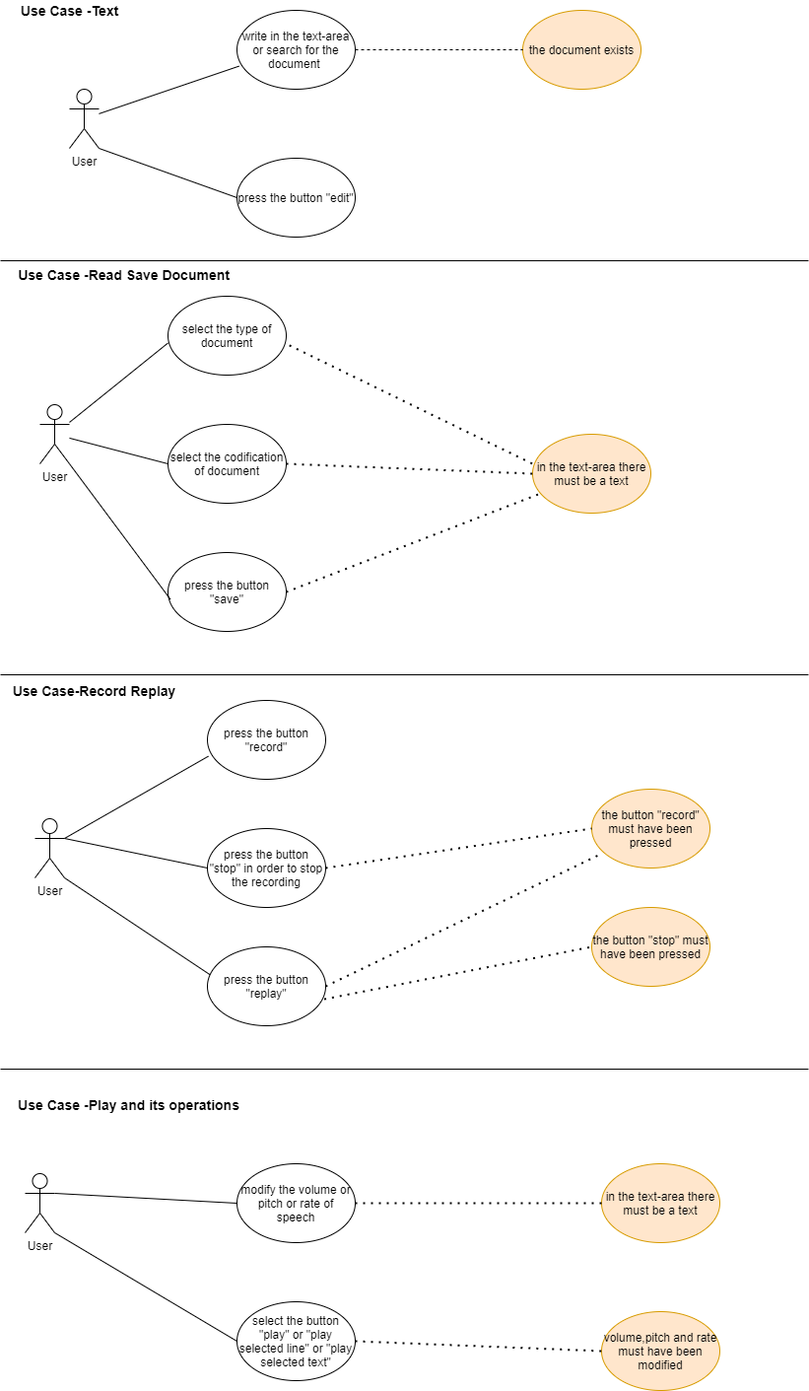

## <Use Case Text>

|  |  |
| --- | --- |
| **Use case ID** | 1 |
| **Actors** | The user |
| **Pre conditions** | The user must have opened the application.  The document searched must exist. |
| **Main flow of events** | 1. User writes in text-area or searches file from path. 2. User presses the edit button to edit the document. |
| **Alternative flow 1** | If the user presses the edit button and no document is opened, a temporary will be created in memory. |
| **Post conditions** | After the document is opened its contents will be displayed in the TextArea.  After editing the document, the contents are updated. |

## <Use Case Read-Save document>

|  |  |
| --- | --- |
| **Use case ID** | 2 |
| **Actors** | The user |
| **Pre conditions** | There must be text in the text area. |
| **Main flow of events** | 1.User chooses the encryption method, if any, of the text  2.User chooses the extension/type of the file to open/save.  3.User chooses to save text to file. |
| **Alternative flow 1** | If the user forgets to write an extension of the saved file, one will be added automatically. |
| **Post conditions** | After saving the file, the file will be displayed to the correct path the user specified. |

## <Use Case Record-Replay>

|  |  |
| --- | --- |
| **Use case ID** | 3 |
| **Actors** | The user |
| **Pre conditions** | User has to press the record button.  User has to press the stop button and then the replay. |
| **Main flow of events** | 1.User presses record and the recording of the commands start.  2.User presses stop to stop the recording.  3. User presses replay and the recorded commands are replayed. |
| **Alternative flow 1** | If the buttons record and stop haven’t been the record button won’t do anything. |
| **Post conditions** | If everything went right the replay button will replay all the recorded commands. |

## <Use Case Play and its operations >

|  |  |
| --- | --- |
| **Use case ID** | 4 |
| **Actors** | The user |
| **Pre conditions** | Text area must contain text.  The user must adjust the volume, volume or speed for the speaking to start. |
| **Main flow of events** | 1. The user adjusts the volume or the voice or the speed of the speech by selecting the corresponding keys.  2. The user selects “play all”, “play selected line” or “play selected text”. |
| **Alternative flow 1** | The user cannot change the volume or speed or tone of voice once a text has been spoken. |
| **Alternative flow 2** | If the user selects one of the play buttons without text in the text area, nothing will be spoken. |
| **Post conditions** | If all goes well, the text in the text area (or part of it) should be spoken. |

# Design

## Architecture

<Specify the overall architecture for this release in terms of a **UML package diagram**.>

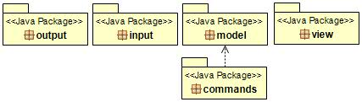

## Design

<Specify the detailed design for this release in terms of **UML class diagrams**.>

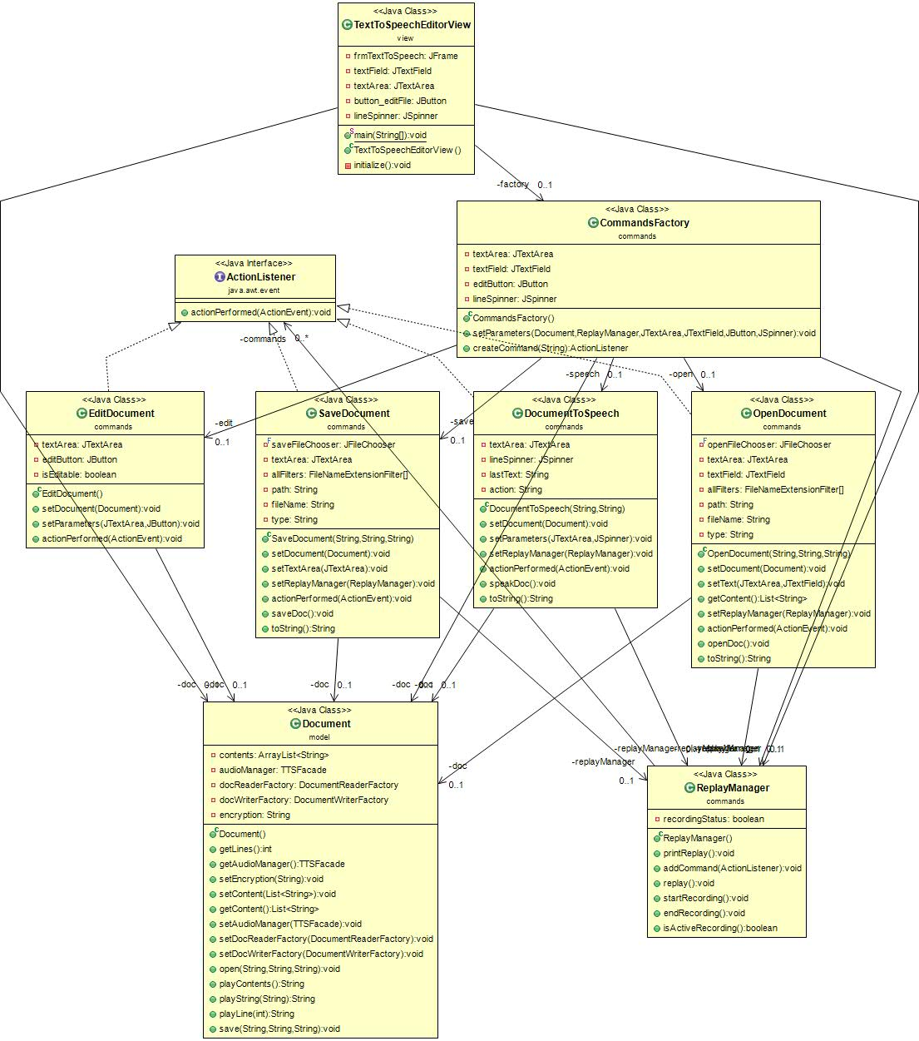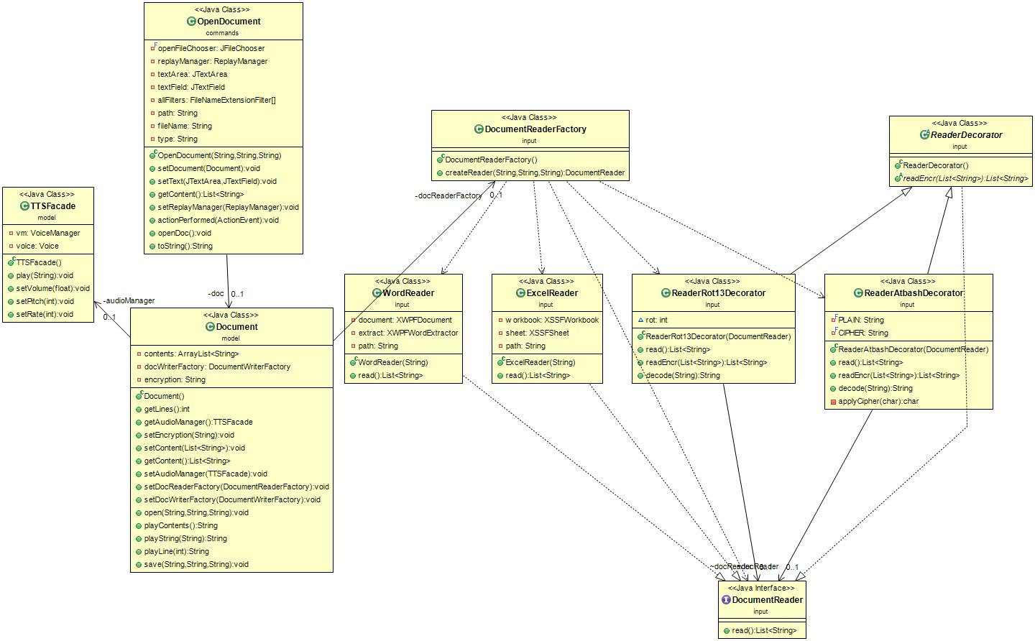

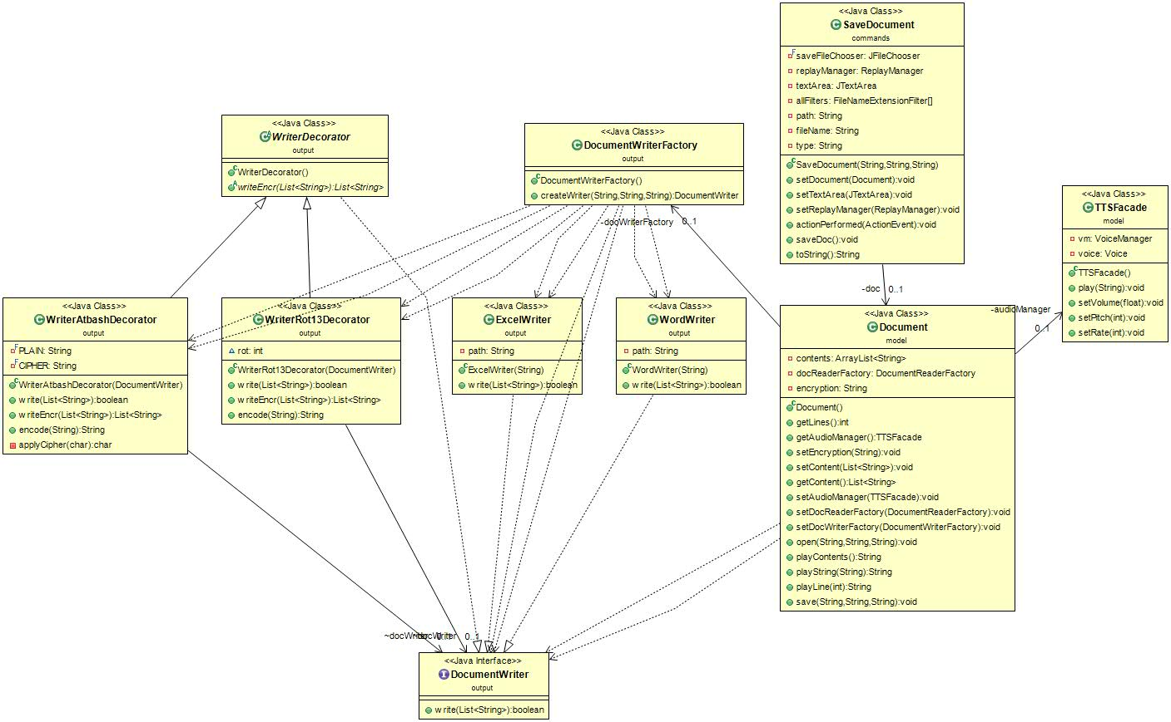

<Document the classes that are included in this release in terms of CRC cards according to the template that is given below.>

|  |  |
| --- | --- |
| **Class Name: DocumentReaderFactory** | |
| **Responsibilities:**   * Return the correct Document Reader object. | **Collaborations:** |

|  |  |
| --- | --- |
| **Class Name: ExcelReader** | |
| **Responsibilities:**   * Read the contents of an excel (.xlsx) document. | **Collaborations:** |

|  |  |
| --- | --- |
| **Class Name: WordReader** | |
| **Responsibilities:**   * Read the contents of a word (.docx) document. | **Collaborations:** |

|  |  |
| --- | --- |
| **Class Name: ReaderAtbashDecorator** | |
| **Responsibilities:**   * Decode the text given from readers with atBash encryption. | **Collaborations:** |

|  |  |
| --- | --- |
| **Class Name: ReaderRot13Decorator** | |
| **Responsibilities:**   * Decode the text given from readers with Rot13 encryption. | **Collaborations:** |

|  |  |
| --- | --- |
| **Class Name: ReaderDecorator** | |
| **Responsibilities:**   * Abstract class. | **Collaborations:** |

|  |  |
| --- | --- |
| **Class Name: DocumentWriterFactory** | |
| **Responsibilities:**   * Return the correct Document Writer object. | **Collaborations:** |

|  |  |
| --- | --- |
| **Class Name: ExcelWriter** | |
| **Responsibilities:**   * Write the contents to an excel (.xlsx) document. | **Collaborations:** |

|  |  |
| --- | --- |
| **Class Name: WordWriter** | |
| **Responsibilities:**   * Write the contents to a word (.docx) document. | **Collaborations:** |

|  |  |
| --- | --- |
| **Class Name: WriteAtbashDecorator** | |
| **Responsibilities:**   * Encode the text and then give it to writers with atBash encryption. | **Collaborations:** |

|  |  |
| --- | --- |
| **Class Name: WriterRot13Decorator** | |
| **Responsibilities:**   * Encode the text and then give it to writers with Rot13 encryption. | **Collaborations:** |

|  |  |
| --- | --- |
| **Class Name: WriterDecorator** | |
| **Responsibilities:**   * Abstract class. | **Collaborations:** |

|  |  |
| --- | --- |
| **Class Name: CommandsFactory** | |
| **Responsibilities:**   * Return the correct ActionListener command. * Pass the correct parameters to this ActionListener object. | **Collaborations:** |

|  |  |
| --- | --- |
| **Class Name: DocumentToSpeech** | |
| **Responsibilities:**   * Detect which play button was pressed. * Play the correct content according to that button. | **Collaborations:** |

|  |  |
| --- | --- |
| **Class Name: StartRecording** | |
| **Responsibilities:**   * Detect which record button was pressed. * Start, stop or replay actions accordingly. | **Collaborations:** |

|  |  |
| --- | --- |
| **Class Name: EditDocument** | |
| **Responsibilities:**   * Toggle the text area as editable and not. * Save the contents of text area to document contents. | **Collaborations:** |

|  |  |
| --- | --- |
| **Class Name: OpenDocument** | |
| **Responsibilities:**   * Make user select a valid document path. * Open a document from the selected path. | **Collaborations:** |

|  |  |
| --- | --- |
| **Class Name: SaveDocument** | |
| **Responsibilities:**   * Make user select a valid location and name to save document. * Save the document. | **Collaborations:** |

|  |  |
| --- | --- |
| **Class Name: ReplayManager** | |
| **Responsibilities:**   * Store to an array all actions recorded. * Start / End recording. * Replay recorded commands. | **Collaborations:** |

|  |  |
| --- | --- |
| **Class Name: TTSFacade** | |
| **Responsibilities:**   * Voice allocation. * Specific Text to Speech. | **Collaborations:** |

|  |  |
| --- | --- |
| **Class Name: Document** | |
| **Responsibilities:**   * Store all contents of a document. * Use the reader / writers to open / save the document. | **Collaborations:** |

|  |  |
| --- | --- |
| **Class Name: TextToSpeechEditorView** | |
| **Responsibilities:**   * GUI * Initialize the document, replayManager and JComponets. | **Collaborations:** |