<Date>

**Version <X.x>**

**NOTES TO THE AUTHOR/TEMPLATE INSTRUCTIONS**

This template includes instructions and boilerplate text for this document. The author should note that:

* Each section provides instructions or describes the intent, assumptions, and context for content included in that section. Instructional text appears in *blue italicized text* throughout this template.
* Replace instructional text in each section with project specific information.
* Use or modify boilerplate examples of wording and formats for text and tables as appropriate.
* Search and replace all text enclosed in angle brackets - < > - with project specific information (e.g., <Project Name> or <Project Acronym>.

Follow these steps when using this template:

1. All documents must be compliant with Section 508 requirements. Refer to [FNS 504-508 Compliance Reference Library](https://fncspro.usda.net/offices/oit/Documents/Forms/AllItems.aspx?RootFolder=%2Foffices%2Foit%2FDocuments%2F504%2D508%20Compliance%20%2D%20Accessibility&View=%7BB47848DF%2D6059%2D4D43%2DAB0C%2D8ECEDC92AD4C%7D) or [Section508.gov](https://section508.gov/) for more information.
2. Modify any boilerplate text, as appropriate, for your specific project.
3. Use Styles for new sections such as Heading 1, Heading 2 and Std Para.
4. Place Table captions and descriptions *above* the table and centered. All tables must have an associated tag providing appropriate alternative text for Section 508 compliance.
5. Place Figure captions and descriptions *below* the figure and centered. All figures must have an associated tag providing appropriate alternative text for Section 508 compliance.
6. Update the Table of Contents and any List of Tables or List of Figures by right-clicking it and selecting Update field / Update entire table.
7. Delete this “Notes to the Author/Template Instructions” page and all instructional text to the author before finalizing the draft of the document.

**COST BENEFIT ANALYSIS TEMPLATE REVISION HISTORY**

| VERSION | DATE | CHANGE DESCRIPTION |
| --- | --- | --- |
| 1.0 | 03/12/2013 | Created the document. |
| 1.1 | 09/09/2013 | Re-formatted the document. |
| 1.2 | 04/05/2017 | Updated the document to reflect changes |
| 2.0 | 11/02/2020 | Updated to reflect new FNS Agile SDLC processes and comply with Section 508 standards. |

**COST BENEFIT ANALYSIS TEMPLATE CONTACT INFORMATION**

| RESPONSIBILILTY | CONTACT PERSON | EMAIL ADDRESS |
| --- | --- | --- |
| Portfolio Management Division Director, Chief Portfolio Officer | Joe Shaw | [Joseph.Shaw@usda.gov](mailto:Joseph.Shaw@usda.gov) |
| IT Governance Manager | Kevin Russ | [Kevin.Russ@usda.gov](mailto:Kevin.Russ@usda.gov) |
| SDLC Lead | Max Mounger | [Max.Mounger@usda.gov](mailto:Max.Mounger@usda.gov) |

*Complete the below table to track the version history of this document.*

**DOCUMENT REVISION HISTORY**

| **VERSION** | **DATE** | **AUTHOR** | **CHANGE DESCRIPTION** |
| --- | --- | --- | --- |
| x.x |  |  |  |
| x.x |  |  |  |
| x.x |  |  |  |

*List the relevant area of responsibility, contact person and email address for this document.*

**CONTACT INFORMATION**

| **RESPONSIBILILTY** | **CONTACT PERSON** | **EMAIL ADDRESS** |
| --- | --- | --- |
| <organizational area> |  |  |

Table of Contents

1. OBJECTIVES 1

2. cURRENT PROCESS 1

3. ESTIMATE FUTURE REQUIREMENTS 1

4. COLLeCT COST DATA 3

5. ALTERNATIVES 3

6. DOCUMENT ALTERNATIVES AND COST BENEFIT ANALYSIS ASSUMPTIONS 3

7. ESTIMATE COSTS 3

8. ESTIMATE BENEFITS 5

9. DISCOUNT COSTS AND BENEFITS 7

10. EVALUATE ALTERNATIVES 8

11. PERFORM SENSITIVITY ANALYSIS 9

12. COMPARE INVESTMENTS 10

13. EXECUTIVE SUMMARY 11

14. Appendix A: References 1

*List the acronym reference and definition or description for each acronym contained in this document.*

**ACRONYM LIST**

| **REFERENCE** | **DEFINITION** |
| --- | --- |
| BCR | Benefit-Cost Ratio |
| CBA | Cost-Benefit Analysis |
| CCA | Clinger Cohen Act |
| GWAC | Government Wide Agency Contract |
| GPRA | Government Performance Results Act |
| NPV | Net Present Value |
| OMB | Office of Management and Budget |
| RFP | Request For Proposal |
| ROI | Return On Investment |
| UPI | Unique Project Identifier |

# OBJECTIVES

The Alternative Analysis should include a problem definition; pertinent background information such as staffing, system history, and customer satisfaction data; and a list of investment objectives that identify how the system will improve the work process and support the mission.

# cURRENT PROCESS

The current process should be thoroughly documented and address these areas:

* *Customer Service—Each customer’s role and services required should be clearly documented and quantified, if possible (e.g., in an average month, a customer inputs two megabytes (MB) of data and spends 10 hours on database maintenance).*
* *System Capabilities—Resources required for peak demand should be listed. For example, 100 MBs of disk storage space and Help Desk personnel to support 50 users.*
* *System Architecture—The hardware, software, and physical facilities required should be*

*documented, including information necessary for determining system costs, expected future utility of items, and the item owner/lessor (i.e., government or contractor). Table E-1—displays the information desired.*

* *System Costs—Current costs provide the Cost Benefits Analysis (CBA) baseline. Table E-2—Cost Elements for Systems addresses the cost elements for most systems. However, a particular system may not include all elements identified within a category and may include some activities not shown.*

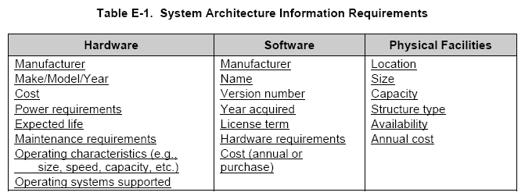

# ESTIMATE FUTURE REQUIREMENTS

Future customer requirements determine the system capabilities and architecture, and ultimately affect system costs and benefits. Items to consider:

* *Lifecycle Time—Determine the system lifecycle, or when the system is terminated and replaced by a system with significant changes in processing, operational capabilities, resource requirements, or system outputs. Large, complex systems should have a lifecycle of at least five years, and no more than ten years.*
* *Lifecycle Demands—Identify the most appropriate demand measures and use the measures to determine previous years’ demands, calculate the change in demand from year to year, average the demand change, and use the average to make predictions. In a complex situation, more sophisticated tools, such as time-series and regression analysis, may be needed to forecast the future.*

Table E-2 Cost Elements For Systems

From TBM Cost Pools

# COLLeCT COST DATA

Data can be collected from the following sources to estimate the costs of each investment alternative:

* *Historical Organization Data—If contracts were used to provide system support in the past, they can provide the estimated future cost of leasing and purchasing hardware and hourly rates for contractor personnel. Contracts for other system support services can provide comparable cost data for the development and operation of a new system.*
* *Current System Costs—Current system costs can be used to price similar alternatives.*
* *Market Research—Quotes from multiple sources, such as vendors, Gartner Group, IDC Government, and government-wide agency contracts (GWACS), can provide an average, realistic price.*
* *Publications—Trade journals usually conduct annual surveys that provide general cost data for IT personnel. Government cost sources include the General Services Administration (GSA) pricing schedule and the OMB Circular A-76, “Performance of Commercial Activities” supplemental listing of inflation and tax rates.*
* *Analyst Judgment—If data is not available to provide an adequate cost estimate, the CBA team members can use judgment and experience to estimate costs. To provide a check against the estimates, discuss estimated costs with other IT professionals.*
* *Special Studies—Special studies can be conducted to collect cost data for large IT investments. For example, the Federal Aviation Administration (FAA) used three different in-house studies to provide costs for software conversion, internal operations, and potential benefits. These data sources became the foundation for a CBA.*

# ALTERNATIVES

An Alternatives Analysis should present at least three viable alternatives. “Do nothing” or “Continue current operations” should not be considered as an alternative. Each viable technical approach should be included as an alternative. However, the number of technical approaches may be limited if only one or two are compatible with the architecture or if some approaches are not feasible for reasons other than costs and benefits.

# DOCUMENT ALTERNATIVES AND COST BENEFIT ANALYSIS ASSUMPTIONS

It is important to document all assumptions and, if possible, justify them on the basis of prior experiences or actual data. This can be an opportunity to explain why some alternatives are not included. If an alternative is eliminated because it is not feasible, the assumption should be clearly explained and justified.

# ESTIMATE COSTS

Many factors should be considered during the process of estimating costs for alternatives. Full lifecycle costs for each competing alternative should be included, and the following factors should be addressed:

* *Activities and Resources—Identify and estimate the costs associated with the initiation, design, development, operation, and maintenance of the IT system.*
* *Cost Categories—Identify costs in a way that relates to the budget and accounting processes. The cost categories should follow current USDA object class codes.*
* *Personnel Costs—Personnel costs are based on the guidance in OMB Circular A-76, “Supplemental Handbook, PART II—Preparing the Cost Comparison Estimates.” Government personnel costs include current salary by location and grade, fringe benefit factors, indirect or overhead costs, and General and Administrative costs.*
* *Depreciation—The cost of each tangible capital asset should be spread over the asset’s useful life (i.e., the number of years it will function as designed). OMB prefers that straight-line depreciation be used for capital assets.*
* *Annual Costs—All cost elements should be identified and estimated for each year of the system lifecycle. This is necessary for planning and budget considerations. Table E-3—illustrates the cost estimates for an investment initiation activity.*

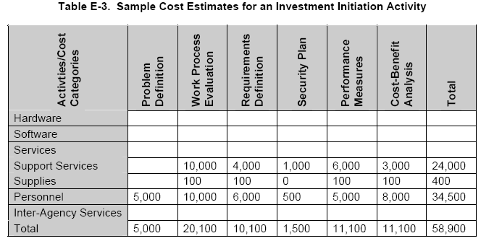

The costs for each year can be added to provide the estimated annual costs over the investment’s life. For example, Table E-4—Sample System Lifecycle Cost Estimates provides the total estimated costs for a 10-year investment. In the first year, in-house staff and contractors define the problem, evaluate the work process, define processing requirements, prepare the CBA, develop a request for proposals (RFP), and issue a contract for the system development. In the second year, a contractor designs and implements the system. The next eight years reflect operational and maintenance costs for equipment, software, in-house personnel, and contractor personnel. Years five and six also reflect in-house acquisition costs for establishing a new five-year contract for system maintenance and help desk support.

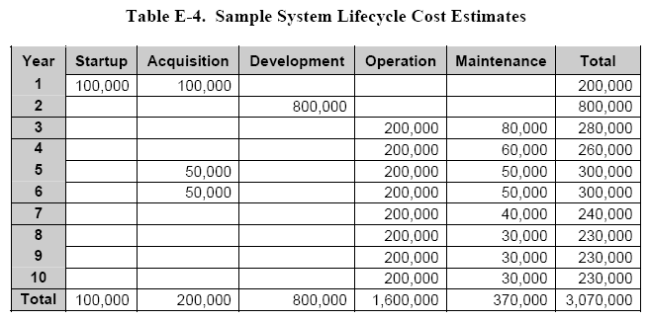

# ESTIMATE BENEFITS

The following six activities are completed to identify and estimate the value of benefits:

Define Benefits—Benefits are the services, capabilities, and qualities of each alternative, and can be viewed as the return from an investment. The following questions will help define benefits for IT systems and enable alternative comparisons:

* *Accuracy—Will the system improve accuracy by reducing data entry errors?*
* *Availability—How long will it take to develop and implement the system?*
* *Compatibility—How compatible is the proposed alternative with existing procedures?*
* *Efficiency—Will one alternative provide faster or more accurate processing?*
* *Maintainability—Will one alternative have lower maintenance costs?*
* *Modularity—Will one alternative have more modular software components?*
* *Reliability—Does one alternative provide greater hardware or software reliability?*
* *Security—Does one alternative provide better security to prevent fraud, waste, or abuse?*

Identify Benefits—Every proposed IT system should have identifiable benefits for both the organization and its customers. Organizational benefits could include flexibility, organizational strategy, risk management and control, organizational changes, and staffing impacts. Customer benefits could include improvements to the current IT services and the addition of new services. Customers should help identify and determine how to measure and evaluate the benefits.

Establish Measurement Criteria—Establishing measurement criteria for benefits is crucial because the Government Performance and Results Act (GPRA) and the Clinger-Cohen Act (CCA) emphasize tangible measures of success (benefits) related to the organization’s overall mission and goals.

Classify Benefits—Benefits that are “capable of being appraised at an actual or approximate value” are called tangible benefits. Benefits that cannot be assigned a dollar value are called intangible benefits.

Estimate Tangible Benefits—The dollar value of benefits can be estimated by determining the fair market value of the benefits. An important economic principle used in estimating public benefits is the market value concept. Market value is the price that a private sector organization would pay to purchase a product or service.

Quantify Intangible Benefits—Intangible benefits can be quantified using a subjective, qualitative rating system. A qualitative rating system might evaluate potential benefits against the following:

* *Provides Maximum Benefits (2 points)*
* *Provides Some Benefits (1 point)*
* *Provides No Benefits (0 points)*
* *Provides Some Negative Benefits (-1 point)*
* *Provides Maximum Negative Benefits (-2 points).*

Once the rating system is selected, each benefit is evaluated for each alternative. This should be done by a group of three to five individuals familiar with the current IT system and the alternatives being evaluated. The numerical values assigned to the ratings then can be summed and averaged to obtain a score for each benefit. Table E-5—shows the scores for benefits A to D from four reviewers using a scale of 1 to 5.

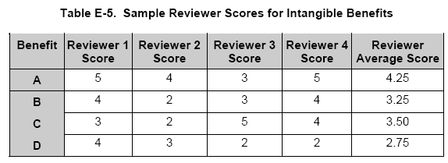

An option that can be used in a qualitative assessment is to “weight” each benefit criteria with regard to importance. The more important the benefit, the higher the weight. The advantage of weighting is the more important benefits have a greater influence on the benefit analysis outcome. The weighting scale can vary between any two predetermined high and low weights. An example of calculating a weighted score is provided in Table E-6—and demonstrates using weighting factors makes Alternative 1 the clear winner.

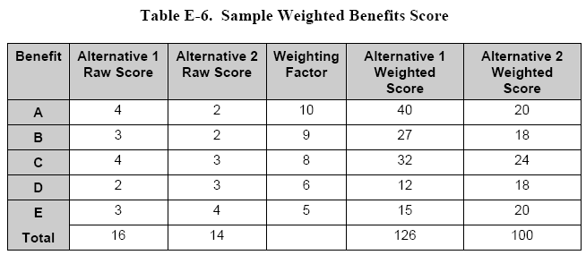

# DISCOUNT COSTS AND BENEFITS

After costs and benefits for each system lifecycle year have been identified, convert them to a common measurement unit by discounting future dollar values and transforming future benefits and costs to their “present value.” Present values are calculated by multiplying the future value times the discount factors published in the OMB Circular A-94.

*Table E-7—shows annual costs and benefits for a system lifecycle, along with the discount factor, the discounted costs and benefits (present values), and the discounted net present value [NPV]. The discounted costs and benefits are computed by multiplying costs and benefits by the discount factor. The net benefit without discounting is $380,000 ($3,200,000 minus $2,820,000) while the discounted NPV is less than $60,000 because the biggest costs are incurred in the first two years, while the benefits are not accrued until the third year. When evaluating costs and benefits, be cautious of returns that accrue late in the investment’s lifecycle. Due to discounting, benefits that accrue in later years do not offset costs as much as earlier-year benefits. Also, these later-year benefits are less certain. Both the business and IT environments may experience significant changes before these later-year benefits are realized.*

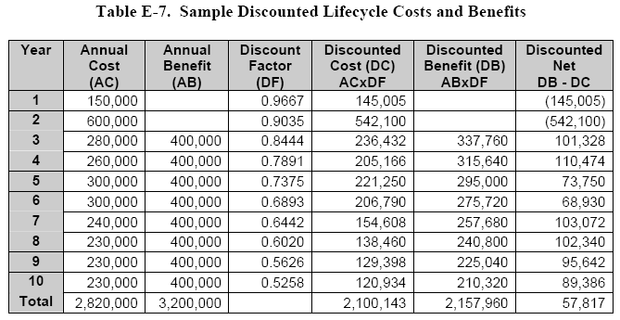

# EVALUATE ALTERNATIVES

Many benefits cannot be quantified in dollar terms. As a result, evaluating alternatives cannot always be done using present values, but valid evaluations can be made using a combination of dollar values and quantified relative values (values that are numeric, but do not represent dollar values).

Evaluate All Dollar Values—Once all the costs and benefits for each competing alternative have been assigned dollar values and discounted, the Net Present Value (NPV) of the alternatives should be compared and ranked.

When the alternative with the lowest discounted cost provides the highest discounted benefit, it is the clear winner, as shown in Table E-8.

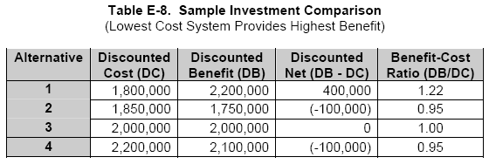

*Discounted Net—There will probably be very few cases where the alternative with the lowest discounted cost provides the highest discounted benefit. The next number to consider is the Discounted Net (Discounted Benefit minus Discounted Cost). If one alternative clearly has the highest Discounted Net, it is considered the best alternative; however, it is usually advisable to look at other factors.*

*Benefit-Cost Ratio—When the alternative with the highest discounted net is not a clear winner, the benefit-cost ratio or BCR (discounted benefit divided by discounted cost) may be used to differentiate between alternatives with very similar or equal Discounted Nets. In Table E-9— Alternative 4 would be the winner because it has a higher BCR than Alternative 5. Alternatives 4 and 5 are clearly superior to other alternatives because they have the highest discounted net.*

*Evaluate with Intangible Benefits—When all the benefits are intangible, evaluation will be based on quantifying relative benefits.*

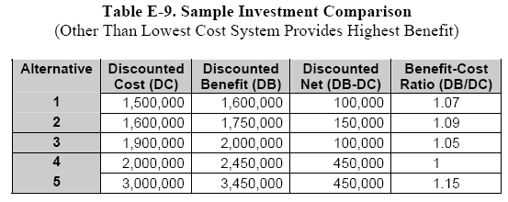

# PERFORM SENSITIVITY ANALYSIS

*Sensitivity analysis tests the sensitivity of input parameters and the reliability of the CBA result. Sensitivity analysis should assure reviewers the CBA provides a sound basis for decisions. The sensitivity analysis process requires the following:*

*Identify Input Parameters—The assumptions documented earlier in the CBA are used to identify the model inputs to test for sensitivity. Good inputs to test are those that have significant (large) cost factors and a wide range of maximum and minimum estimated values. Some common parameters include:*

* *System requirement definition costs*
* *System development costs*
* *System operation costs*
* *Transition costs, especially software conversion*
* *System lifecycle*
* *Peak system demands.*

*Repeat the Cost Analysis—For each parameter identified, determine the minimum and maximum values. Then, choose either the minimum or maximum value as the new parameter value (the number selected should be the one that most differs from the value used in the original analysis). Repeat the CBA with the new parameter value and document the results. Prepare a table like Table E-10—to summarize the different outcomes and enable the results to be quickly evaluated.*

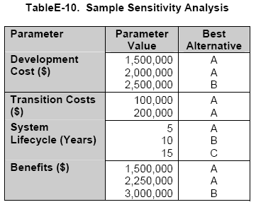

Evaluate Results—Compare the original set of inputs and the resulting outcomes to the outcomes obtained by varying the input parameters. In the previous table, the original values are the first value listed for each parameter. Sensitivity is measured by how much change in a parameter is required to change the alternative selected in the original analysis. The sensitivity guidelines include the following:

* *A parameter is not considered sensitive if it requires a decrease of 50 percent or an increase of 100 percent to cause a change in the selected alternative.*
* *A parameter is considered sensitive if a change between 10 and 50 percent causes a change in the selected alternative.*
* *A parameter is considered very sensitive if a change of 10 percent or less causes a change in the selected alternative.*

In the previous example, the analysis would appear to be somewhat sensitive to the development costs, but not sensitive to the transition costs and benefits.

# COMPARE INVESTMENTS

Even if the CBA shows that benefits will outweigh costs, using Payback Period and Return on Investment (ROI) analysis help demonstrate an investment is a better utilization of funds than other proposed investments.

Table E-11—illustrates that the money invested in the system’s development, installation, and operation is not offset by the benefits until the 10th year. In other words, the payback period for the system is 10 years, which is generally unacceptable, making it difficult for this investment to obtain funding.

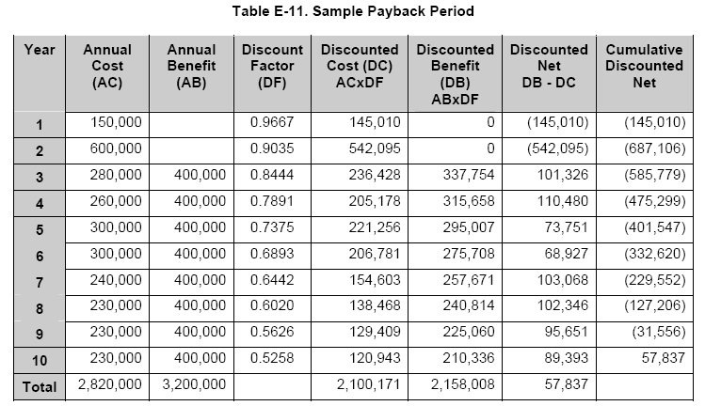

# EXECUTIVE SUMMARY

To select the best capital asset, identify and consider at least three viable alternatives, one of which may be the current baseline, i.e., the status quo.

1. *Did you conduct an Alternatives Analysis for this investment?*

* *If “yes,” provide the date the analysis was completed.*
* *If “no,” what is the anticipated date this analysis will be completed?*
* *If no analysis is planned, please briefly explain why.*

1. *Alternatives Analysis Results*

*Use the results of your alternatives analysis to complete the following table:*

|  |  |  |  |
| --- | --- | --- | --- |
| **Alternative Analyzed** | **Description of Alternative** | **Risk Adjusted Lifecycle Costs Estimate** | **Risk Adjusted Lifecycle Benefits Estimate** |
| Baseline | Status quo |  |  |
|  |  |  |  |
|  |  |  |  |

1. *Which alternative was selected by the Agency’s Executive/Investment Committee and why was it chosen?*
2. *What specific qualitative benefits will be realized?*
3. *Will the selected alternative replace a legacy system in part or in whole? Yes/No*

* *If “yes,” are the migration costs associated with the migration to the selected alternative included in this investment, the legacy investment, or in a separate migration investment?*
* *If “yes,” please provide the following information:*

| **List of Legacy Investment or Systems** |  |  |
| --- | --- | --- |
| **Name of Legacy Investment or Systems** | **UPI (if available)** | **Date of System Retirement** |
| [Insert Name of System] | [Insert UPI] | [dd/mm/yyyy] |

# Appendix A: References

*Insert the name, version number, description, and physical location of any documents referenced in this document. Add rows to the table as necessary.*

*The following table summarizes the documents referenced in this document.*

|  |  |  |
| --- | --- | --- |
| **Document Name** | **Description** | **Location** |
| Document Name and Version Number | Document description | URL or Network path where document is located |
|  |  |  |
|  |  |  |
|  |  |  |