# ANNEX 9 – GOVERNMENT-FURNISHED PROPERTY PREAWARD COMPLIANCE CHECKLIST

Per SECNAVINST 5200.43, the Government-Furnished Property Preaward Compliance Checklist, SECNAV 5200/2, is to be included with the Business Clearance Memorandum (BCM).

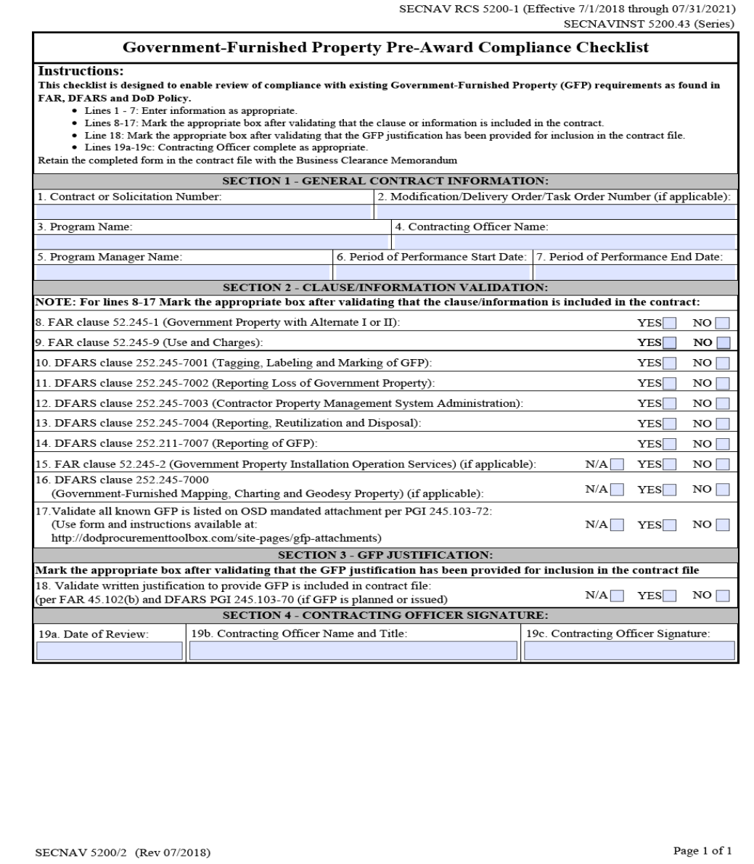

Form Instructions: In addition to the instructions at the top of the form, the following instructions apply.

Block 1: Contract/Solicitation #. Insert the contract/solicitation number.

Block 2: Mod/TO/DO. Insert the modification number, delivery order (DO) number or task order (TO) number as appropriate. If the action is a modification of a DO or TO, insert the DO/TO number followed by the modification number.

Block 3: Program Name. A short description of the program name the GFP is supporting.

Block 4: Contracting Officer Name. Insert the contracting officer name.

Block 5: Program Manager (PM) Name. Insert the PM name.

Block 6: Period of Performance (POP) Start Date. Insert the POP start date.

Block 7: POP End Date. Insert the POP End Date

Block 8-16: Indicate if the clause was included in the Block 1 solicitation/contract number reported, as required by FAR and DFARS. Use the pull-downs on the right side of the right-hand column to fill the entries. Only the following phrases are to be used; Included, Not Included, Not Applicable (N/A). When “Not Included” is used, provide an explanation for the contract file as to why the required clause was not included in the solicitation, contract, modification, DO or TO.

Block 17: Indicate that the OSD form containing the GFP requirements has been completed and validated per PGI 245.103-72. Only use "N/A" if no GFP is planned.

Block 18: Indicate that a written justification to provide GFP was provided by the requiring official and is included in the contract file per FAR 45.102(b) and PGI 245.103-70. Only use "N/A" if no GFP is planned.

Block 19a: Date of Review. Insert Date of Review.

Block 19b: Contracting Officer Name and Title. Insert the Contracting Officer name and title.

Block 19c: Contracting officer signature. The form includes electronic signature provisions.