|  |  |  |
| --- | --- | --- |
|  | **The Changing World of the “C Suite”**  **Executive Fellows (CXF) Seminar #2**  **Date: Thursday,**  **February 23, 2017**  **Location: Fort McNair, Washington, DC**  **Lincoln Hall, Room 1107** | **CFO.PNG** |

|  |  |  |
| --- | --- | --- |
| **Time** | **Lesson Title** | **Facilitator/Speaker** |
| 9:00 – 9:30AM | Arrival (Meet and Greet) of CXO Fellows in Lincoln Hall | Professor Adrienne Ferguson, CFO Academy  and  Ms. Josie Beets, Acting CXO Fellows Coordinator |
| 9:30 – 10:00AM | Emerging Issues for the CXO – Introduction and Overview | Professor Ferguson |
| 10:00 – 12:00PM | Lesson 1: Federal Budgeting Process – Past, Present & Future | Professor Ricardo Aguilera, CFO Academy |
| 12:00 – 1:00PM | Lunch |  |
| 1:00 – 2:30PM | Lesson 2: GAO Fraud Risk Management Framework | Ms. Linda Miller, Director – Grant Thornton LLP |
| 2:30 – 3:00PM | Closing Remarks/Wrap-up | Professor Ferguson and Ms. Beets |

BIOGRAPHY FOR LINDA S. MILLER

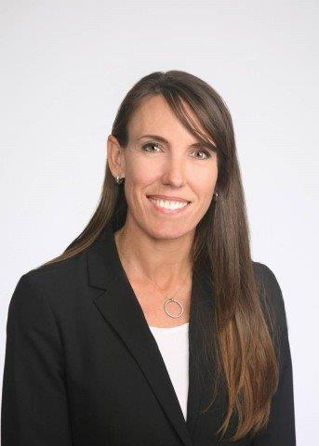Linda S. Miller is a director at Grant Thornton LLP. Ms. Miller, a veteran of the U.S. Government Accountability Office (GAO), leads the fraud risk and forensics practice in the public sector.

While working at the GAO, Ms. Miller was the assistant director of Forensic Audits and Investigative Service for 10 years. She was the principal author of the GAO’s *Framework for Managing Fraud Risks in Federal Programs*, which is the first-ever guidance for federal program managers to help develop a strategic, risk-based approach to assessing and mitigating fraud in their programs. Ms. Miller’s efforts led to the passage of the Fraud Reduction and Data Analytics Act of 2015, which requires federal agencies to take steps to reduce fraud and establish better internal controls.

Ms. Miller received a bachelor’s degree from George Washington University and a master’s degree in public policy from the University’s Trachtenberg School of Public Policy and Public Administration. She is also a former Olympic athlete in the sport of rowing.

BIOGRAPHY FOR RICARDO AGUILERA

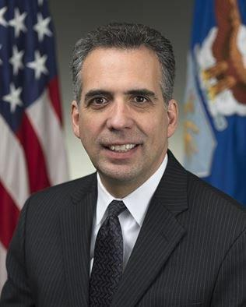Ricardo A. Aguilera is the director of the Chief Financial Officer’s Academy and Professor of Practice at the National Defense University. He served in this capacity from 2010, but recently returned after he was appointed in January 2016 by the Obama Administration and approved by the Senate to serve as the Assistant Secretary of the Air Force for Financial Management and Comptroller. As the Air Force's comptroller and chief financial officer, he served as the principal adviser to the Secretary and Chief of Staff of the Air Force on all financial matters. He was responsible for providing the financial management and analytical services necessary for the effective and efficient use of Air Force resources, to include nearly 700,000 military and civilian personnel and a budget of about $167 billion. This included directing the development of the Air Force program and budget, overseeing the Air Force Cost Analysis Agency's acquisition and operational cost analysis, providing analytical services necessary for the effective and efficient use of Air Force resources and conducting Air Force accounting and finance operations.

Earlier in his career, Mr. Aguilera was promoted into the Senior Executive Service, and from 2006 until 2008 he served as the associate director for contingencies and international affairs in the Office of the Under Secretary of Defense (Comptroller) where he oversaw all funding for military operations in Iraq and Afghanistan. From 1998 until 2006 Mr. Aguilera was the deputy chief of the Operations and Personnel Support Branch of the Office of Management and Budget’s National Security Division.

Mr. Aguilera received a Bachelor of Arts degree from New York University and a Master of Arts degree from The George Washington University.