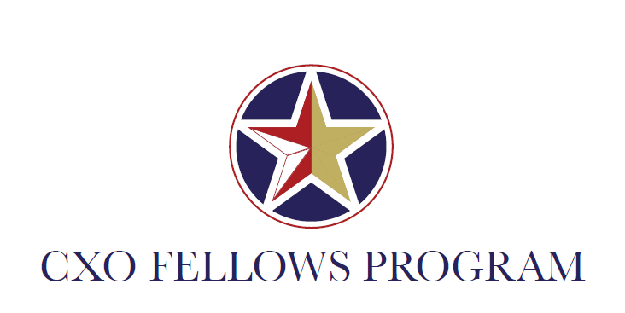

Inside Government Event

Eisenhower Executive Office Building

Indian Treaty Room 474

July 11, 2017

8:30 AM-2:30 PM

**AGENDA**

8:30-9:00 AM: Enter Building and Networking

9:00-9:30 AM: Mick Mulvaney

*Director, Office of Management and Budget*

* Brief Bio
* Administration vision of a more efficient and effective government
* Leadership to support Reform and workforce efforts
* One or two recommendations from personal experience that would make mid-career employees successful

9:30-9:45 AM: Discussion

9:45-10:30 AM: Emily Murphy

*Senior Advisor to the Administrator, GSA*

* Overview of GSA and how provide support Government-Wide
* Personal career path
* Recommendations for mid-career federal employees:
  + Detail opportunities?
  + Training?
  + Leadership recommendations?

10:30-11:00AM: Working Group Discussion

11:00-12:00 PM: Lunch

12:00-1:00 PM: David Feit

*Chief Financial Officer, Executive Office of the President*

* Request to hear from his professional journey and reasons for joining the Federal Government.
* Budget formulation for the EOP.

Donald Hertig

*Deputy Chief Financial Officer, Executive Office of the President*

* Importance of service in the federal workforce and how the career staff can support the vision of the Administration
* Role of the CFO office at the EOP
* Personal leadership story

1:00-1:15PM: Break

1:15-2:00PM: Althea Kireilis

*Chief Procurement and Contract Management Officer,*

*Executive Office of the President*

2:00-2:30 PM Tour of the Eisenhower Executive Office Building