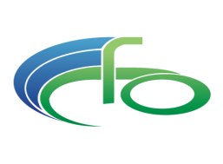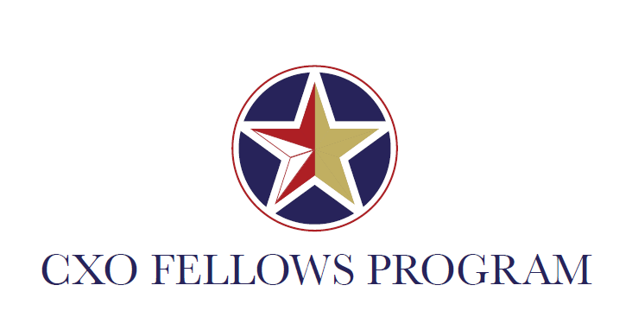 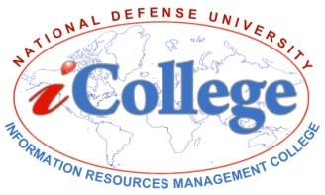

**The Changing World of the “C Suite” CXO Fellows Seminar**

**Thursday, December 8, 2016**

Fort McNair, Washington, DC

Lincoln Hall, Room 1107

|  |  |  |
| --- | --- | --- |
| **Time** | **Lesson Title** | **Facilitator/Speaker** |
| 9:00 – 9:30AM | **Arrival (Meet and Greet) of CXO Fellows in Lincoln Hall** | CFO Academy, Professor Adrienne Ferguson and  CXO Program Manager, Ms. Amy Bontrager |
| 9:30 – 10:00AM | **Challenges of the CXO – Introductions and Overview** | Professor Adrienne Ferguson |
| 10:00 – 12:00PM | **Lesson 1: Leadership for the Future** | Dr. Gerry Gingrich |
| 12:00 – 1:00PM | **Lunch**  -There is a cafeteria inside NDU. You are also welcome to bring your lunch.  - CXO Fellows Book Club will meet in classroom | Book Club Discussion led by Carrie Lopez  Book: *How to Run a Government* by Michael Barber |
| 1:00 – 3:00PM | **Lesson 2: Cyber-security Strategies for Leaders** | Professor Mark Duke |
| 3:00 – 3:30PM | **Closing Remarks/Wrap-up** | Professor Ferguson and Ms. Bontrager |