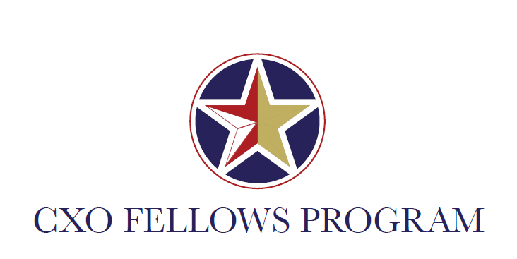

**Inside Government Event: The Presidential Transition**

GSA Headquarters, 1800 F Street NW

November 4, 2016

**AGENDA**

*Morning Session:* **Panel Discussion with The Partnership for Public Service**

|  |  |
| --- | --- |
| 10:30 - 10:35AM | Welcome and Opening Remarks |
| 10:35 - 11:05AM | Presidential Transition – Updates |
| 11:05 - 11:55AM | Panel Discussion and Q&A |
| 11:55AM - 12:00PM | Critical Resources and Wrap-Up |

12:00-1:00PM**Break for Lunch**

*Afternoon Session:* **Professional Development**

1:00-2:30PM Employee Engagement: “From Workplace Misery to Joyous Productivity”

Robin Talmadge, Department of Transportation

2:30-2:45PM Break

2:45-3:45PM Network Visualization: Mapping Your “Village”

Kate Hudson, CXO Fellows Program Director