Volume X - Parts xxxx to xxxx

Navy Marine  
 Corps  
 Acquisition  
 Regulation  
 Supplement

**Issued Fiscal Year 2019 by the:**

**GENERAL SERVICES ADMINISTRATION**

**DEPARTMENT OF DEFENSE**

**NAVY MARINE CORPS ACQUISITION REGULATIONS SYSTEM**

**TITLE#-NAVY MARINE CORPS ACQUISITION REGULATIONS SYSTEM**

**Chapter#**

**Navy Marine Corps Acquisition Regulation System**

**Volume #**

**Table of Contents**

No table of contents entries found.

# ANNEX 8 - PEER REVIEW ROLLING FORECAST

**Reporting requirements**. DON Contracting Activities shall submit quarterly, by March 10, June 10, September 10, and December 10, a rolling forecast of acquisitions requiring peer reviews by DASN(P) or DPC. Use the DON Peer Review Rolling Forecast spreadsheet format when submitting reports. Submit reports via email to with the subject: “DFARS 201.170 – Peer Review Rolling Forecast.” The electronic version of this template is available on the website .aspxidentified at NMCARS .

**DON Peer Review Rolling Forecast Spreadsheet**

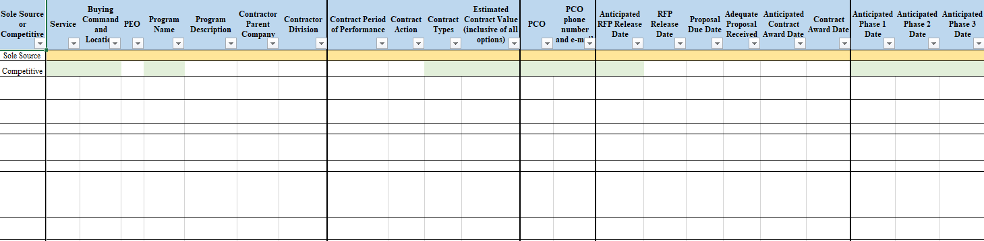

*-continued columns on spreadsheet*

