Volume X - Parts xxxx to xxxx

Navy Marine  
 Corps  
 Acquisition  
 Regulation  
 Supplement

**Issued Fiscal Year 2019 by the:**

**GENERAL SERVICES ADMINISTRATION**

**DEPARTMENT OF DEFENSE**

**NAVY MARINE CORPS ACQUISITION REGULATIONS SYSTEM**

**TITLE#-NAVY MARINE CORPS ACQUISITION REGULATIONS SYSTEM**

**Chapter#**

**Navy Marine Corps Acquisition Regulation System**

**Volume #**

**Table of Contents**

No table of contents entries found.

# Annex 11 - DEFENSE COMMERCIAL SOLUTIONS OPENING DETERMINATION & FINDING TEMPLATE

Pursuant to 5212.290, the template below contains the required Determination & Finding format for approval of a contract in excess of $100 million pursuant to a Commercial Solutions Opening (CSO) authorized by Section 803 of National Defense Authorization Act (NDAA) for Fiscal Year 2022 as implemented in Class Deviation 2022-O0007 dated February 2, 2022.

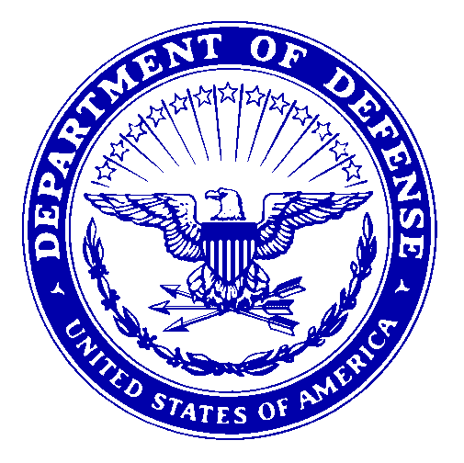

**DEPARTMENT OF THE NAVY**

**OFFICE OF THE SECRETARY**

**1000 NAVY PENTAGON**

**WASHINGTON DC 20350-1000**

DETERMINATION TO AWARD A CONTRACT IN EXCESS OF $100 MILLION PURSUANT TO COMMERCIAL SOLUTIONS OPENING

In accordance with Class Deviation 2022-O0007 dated February 2, 2022, I hereby make the following determination concerning the award of a contract in excess of $100 million pursuant to a commercial solutions opening to meet the mission needs of the [insert name] program.

FINDINGS

1. Section 803 of the National Defense Authorization Act (NDAA) for Fiscal Year (FY) 2022 (Pub. L. 117-81), as implemented in Class Deviation 2022-O0007 dated February 2, 2022, states that contracting officers shall not award contracts in excess of $100 million pursuant to a commercial solutions opening (CSO) without written approval from the Service Acquisition Executive.

2. The [insert name of contracting activity] intends to award a contract pursuant to CSO in excess of $100 million for [identify specific item at prime contract level] under Solicitation/Contract [insert number]. In accordance with Class Deviation 2022-O0007, the following details are provided:

3. Summarize the market research conducted and the rationale supporting a conclusion that the requirements of the class deviation have been satisfied.

4. The contracting officer shall include an affirmative statement that the contract file documents the market research and rationale supporting the conclusion that the requirements of the class deviation have been satisfied.

DETERMINATION

Based on the findings above, I hereby determine that the requirements of Class Deviation 2022-O0007 dated February 2, 2022 have been met regarding the efficacy of the effort to meet mission needs of the Department of the Navy, therefore; [insert Contract Activity Name] is authorized to award a contract in excess of $100 million using a CSO.