

**GSA Digital Service Implementation Plan**

GSA IT, Office of the CIO

U.S. General Services Administration

2/27/15

**Purpose**

This document serves as GSA’s implementation plan for its newly created Digital Service team. It includes the rationale for Digital Service at GSA, FY15 milestones, planned FY16 milestones, budget including personnel and digital tools, and projects.

**Background**

Digital services improve when agencies acquire and utilize digital service experts with modern digital product design, software engineering, and product management skills. In the President’s FY16 budget, additional funding for staffing and digital tools is included to enable agency leaders to manage digital services that have the greatest impact to citizens and businesses[1].

**Strategies and tactics taken in FY15**

* Held management team meeting with senior business and IT leadership across the agency to determine potential project list.
* Collaborated with OMB eGov Deputy Administrator and Unit Chiefs, SSA, ED, and other agencies to determine best practices of establishing the new team.
* Working with GSA IT program managers to identify resource needs and project ROI.
* Working with 18F on PDs and possible candidates; equipment and facilities.

**Key FY15 Milestones**

* Designated Executive to manage the new GSA Digital Service team - Sonny Hashmi, GSA CIO; appointed program manager - Joseph Castle, GSA IT, Lead for Digital Innovation and Strategy.
* Identified projects of high impact for citizens/businesses; identified type of resources needed including personnel, equipment, and facilities.
* Meeting with OMB USDS and GSA to discuss Digital Service program across agencies and where USDS can assist.
* Program plan briefing deck for OMB completed January 2015; program plan document for 2/27 submission to OMB.
* Facility space and equipment to be procured by Summer 2015 - mimic 18F facility and equipment.
* Review position descriptions, identify personnel, prepare onboarding and plan kick-off projects by Summer 2015.

**Key FY16 Milestones**

* Receive funding, onboard personnel, and kick-off projects on 10/1.
* Complete milestones based on specific projects; determine ROI.

**Resources**

See Appendix 1 for estimated resources to create the GSA Digital Service team. Personnel resources include seven geographically-diverse people with general makeup of one Agile coach, two senior systems engineers/solutions architects, two developers, and two UX designers. Equipment is comparable to USDS and 18F equipment with HW and SW, and has been reviewed by 18F operations director for accuracy of needs. Facilities and program management are overhead operating expenses already accounted for in the agency.

**Projects**

See Appendix 2 for the projects where GSA Digital Service experts will be incorporated to provide Agile, user-centered design and support, for most citizen and business impact.

**Appendix 1 - Resource Estimate**

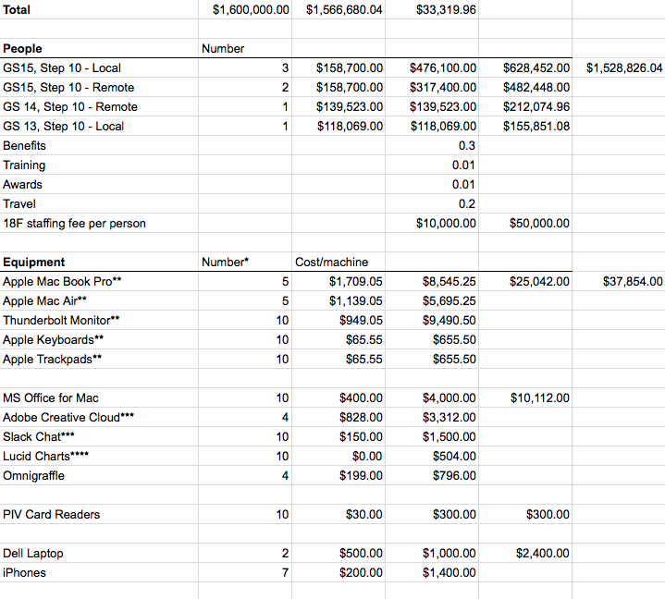

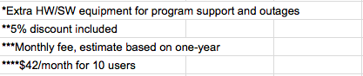

**Appendix 2 - Projects**

|  |
| --- |
| **Project:** Integrated Acquisition Environment (IAE) - SAM.gov |
| **IT Director:** Navin Vembar |
| **Description:** IAE is the data steward for award data throughout the federal government. It includes SAM.gov (the registry of entities seeking to do business with the federal government), FPDS.gov (the store of all contract actions above the simplified acquisition threshold), and FBO.gov (the site which displays opportunities for contracts with the federal government). IAE is modernizing all these systems and bringing together data and improving the UX. |
| |  |  |  |  | | --- | --- | --- | --- | | **Solution** | **Duration** | **Resources** | **ROI** | | Contracting Officer’s Dashboard (v1) | 3 months | UX Designer, Developer,  Agile Coach | Burden Reduction for Contracting Officers during Award Process; save 1 minute per award (note, many actions do not require significant research by the CO) | | “TurboSAM” - Natural Language Redesign of SAM.gov - Wireframes only (note: implementation would follow) | 3 months | 2x UX Designers | Burden Reduction for all entities registering in SAM (currently 600,000 entities, 450,000 of which are contractors) - Goal: reduce average time for a contractor to register in SAM by between 30 minutes to an hour thus saving 225,000 hours by vendors yearly - assuming a $50/hr rate, this saves $11,250,000 for taxpayers | | DevOps Engineering towards Continuous Improvement | 3 months | 2x System Engineers | Reduce the time required between production releases | |

|  |
| --- |
| **Project:** Common Acquisition Platform (CAP) |
| **IT Director:** April Kestyn and Matt McGuire |
| **Description:** CAP is charged with changing the way government does acquisition. It includes the Acquisition Gateway (the government-wide portal to content and tools enabling better acquisitions across government), Data Management and Analytics as a Service (the management of acquisition data and a robust environment and set of analytics tools offered to agencies as a service), and Contract Management systems (the suite of systems to manage acquisitions through the full acquisition life-cycle which can be offered to agencies as a service). CAP is building and modernizing systems, bringing together data and improving the UX. |
| |  |  |  |  | | --- | --- | --- | --- | | **Solution** | **Duration** | **Resources** | **ROI** | | Architect CAP solution | 3 Months | System Engineer | Increase application interoperability | | Optimize category hallways | 3 Months | 2x Developer | Enhance and open source code | | UX design standards | 3 Months | UX Designer | Increased customer participation | |

|  |
| --- |
| **Project:** GSA Advantage! eTools Platform |
| **IT Director:** Keith Machen |
| **Description:** The GSA Advantage! platform provides a digital marketplace for the Government to purchase more than 48 million products and services offered by the Federal Acquisition Service; offers the Federal Government, a vehicle (GSA eBuy) for posting requests for solicitations, using the FAS contract vehicles (awards made through eBuy in FY14 were 9.4 billion); and it includes a user base of more than 950k registered users, and more than 20K Vendors. |
| |  |  |  |  | | --- | --- | --- | --- | | **Solution** | **Duration** | **Resources** | **ROI** | | Increase user experience and capabilities | 4 months | UX Designer, Developer | Increase ease of use | | Migrate to the Cloud | 2 months | System Engineer | Cost savings | | Expand data services and analytics | 3 months | System Engineer, Developer | Increase openness and future revenue | | Replacement of Schedule Input Program (SIP) | 6 months | Agile Coach, UX Designer, Developer | Cost savings | |

|  |
| --- |
| **Project:** PBS Offerer Portal (G-REX and AAAP) |
| **IT Director:** Paul Butler |
| **Description:** Develop an integrated Offeror Portal solution by leveraging existing internal end to end lease processes from G-REX and external offer submission capability from AAAP. This is intended to enable electronic submission of lease offer data and documents, bidirectional communication with offerors to streamline the external leasing process and to reduce cycle time of lease processing and award. |
| |  |  |  |  | | --- | --- | --- | --- | | **Solution** | **Duration** | **Resources** | **ROI** | | API development | 3 months | System Engineer | Develop API to perform data exchange between G-REX and AAAP which can be utilized by the systems to give offeror access to project and award information seamlessly | | Connectivity from system to Cloud | 2 months | System Engineer | Align with GSA Enterprise Architecture and achieve cost saving with increased Cloud-on premise integration | |

|  |
| --- |
| **Project:** BIM-CFR for PB-ITS |
| **IT Director:** Charles Matta |
| **Description:** BIM-CFR is a building technology that touches all PBS business lines: it houses and manages all ‘current’ building information through the facility lifecycle. This allows PBS’s business lines to effectively and efficiently execute the PBS strategic core mission to ‘Plan, Build, Lease, Operate’. |
| |  |  |  |  | | --- | --- | --- | --- | | **Solution** | **Duration** | **Resources** | **ROI** | | Application development, API, Data Interchange, System integration with PBS key application (N-CMMS, eSmart,....) | 3 months | Developer  System Engineer | Measurable efficiency gains in accuracy, reliability, access, control, and security | | BIMql queries/reports to automate IFC data extraction for common information needs | 3 months | Developer | Measurable efficiency gains in speed and reliability of information access, ease of use | |

1. [FY16 -- Agency Digital Services Teams and U.S. Digital Service Support](https://community.max.gov/display/Egov/FY+2016+Budget+--+Agency+Digital+Services+Teams+and+U.S.+Digital+Service+Support), OMB Guidance, February 2015.