# Tables Presentation

## Welcome

Introduction

When I first began…

## Experience with tables:

0: I do not know anything about tables

1: I do it occasionally, but need to refer to my notes

2: I could teach this workshop

## Agenda:

Creation of 2 different tables in Word

Best Practices for Microsoft

Convert Word Doc to PDF

And work on remediation

Questions

## Why use tables?

## Header row

## Creation of tables

### Simple Data Table

Marra’s Weekday Pizzeria

|  |  |  |  |  |
| --- | --- | --- | --- | --- |
| Monday | Tuesday | Wednesday | Thursday | Friday |
| Cheese | Cheese | Olives | Mushrooms | Pineapple |
| Pepperoni | Sausage | Sausage | Bacon | Ham and Pineapple |

1. Picture
2. Tab for order
3. Headers 1st row. Not first column.

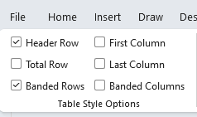

### Complex tables

Cannot be made accessible in Word.

|  |  |  |  |  |
| --- | --- | --- | --- | --- |
| Monday | Tuesday | Wednesday | Thursday | Friday |
| Cheese | | Olives | Mushrooms | Pineapple |
| Pepperoni | Sausage | | Bacon | Ham and Pineapple |

Monthly Movie Club

|  |  |  |  |  |
| --- | --- | --- | --- | --- |
|  | Student | | Adult | |
| Monthly Price | Annual Price | Monthly Price | Annual Price |
| One movie per month | $10 | $100 | $20 | $200 |
| Discount for Auto Debit | Yes | | | |
| One family pass per month (4 passes) | $20 | $200 | $50 | $500 |

Break up in separate tables as a solution for Word

## Best Practices for Microsoft:

### Merged Cells

|  |  |  |  |  |
| --- | --- | --- | --- | --- |
| Monday | Tuesday | Wednesday | Thursday | Friday |
| Cheese | | Olives | Mushrooms | Pineapple |
| Pepperoni | Sausage | | Bacon | Ham and Pineapple |

### Blank Cells

|  |  |  |  |  |
| --- | --- | --- | --- | --- |
| Monday | Tuesday | Wednesday | Thursday | Friday |
| Cheese | | Olives | Mushrooms | Pineapple |
| Pepperoni | Sausage | |  | Ham and Pineapple |

### Caption

|  |  |  |  |  |
| --- | --- | --- | --- | --- |
| Marra’s Weekday Pizzeria | | | | |
| Monday | Tuesday | Wednesday | Thursday | Friday |
| Cheese | Cheese | Olives | Mushrooms | Pineapple |
| Pepperoni | Sausage | Sausage | Bacon | Ham and Pineapple |

1. Right click on table, then Insert Caption

Color Usage contrast/designation webaim.org

|  |  |  |  |  |
| --- | --- | --- | --- | --- |
| Monday | Tuesday | Wednesday | Thursday | Friday |
| Cheese | Cheese | Olives | Mushrooms | Pineapple |
| Pepperoni | Sausage | Sausage | Bacon | Ham and Pineapple |

items are gluten free

### Tables properties

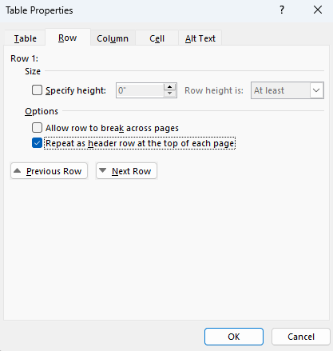

### Single Table Per Sheet -Sheet 1 (Excel)

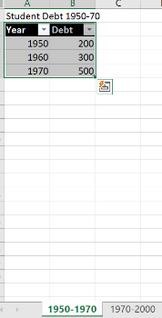

### Meaningful tab names (Excel)

A screenshot of the tabs on an Excel document labeled: Fall Term Scores 2022, Spring Term Scores 2023.

### Unicode symbols

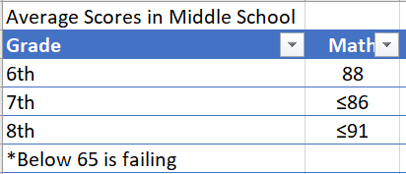

### Accessibility Checker, simple tables

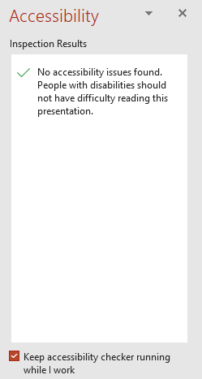

## Convert Word Doc to PDF

Do not use Print to PDF.

## Work on Remediation

1. Review Tags panel for table.
2. Use Reading Order to set the scope.
3. Autogenerate cell IDs.
4. Associate header IDS for data.
5. Run Accessibility Checker.

## Remediation Tools

## Questions

Marra Piazza Brass

AMA Consulting

[mpiazzabrass@ama-consult.com](mailto:mpiazzabrass@ama-consult.com)

## Resources

[Section 508 Creating Accessible Documents](https://www.section508.gov/create/documents/)

[Section 508 Training Videos](https://www.section508.gov/create/documents/training-videos/)

[WebAIM](https://webaim.org/)

[Section 508 Color Contrast](https://www.section508.gov/training/web-software/andi-training-videos/color-contrast-analyzer/)