**U.S. General Services Administration**



**Accessibility Requirements Tool (ART)**

**USER MANUAL**

**August 2018**

**Prepared by Kingfisher Systems, Inc.**

Table of Contents

**Introduction** **2**

**Overview** **2**

**How to Access ART** **3**

**Start a New Procurement** **4**

**Continue With An Existing Procurement** **6**

**Sample Procurement Language** **7**

**Questions and Exceptions** **9**

**Tooltips** **11**

**Component-Level Questions** **12**

**Final Report** **13**

**Glossary** **15**

ART User Manual

# Introduction

The Accessibility Requirements Tool (ART) is a web-based application that will help you determine the Section 508 requirements that apply to acquisitions that include information and communication technology (ICT) products and services. ART provides a comprehensive report detailing the technical criteria that apply to the specific procurement, including functional performance criteria (if applicable) and any exceptions, both at the component and overall procurement level.

# Overview

ART is a multifaceted tool that offers interactive, step-by-step guidance on how to determine applicable accessibility requirements. ART delivers an exportable, easy-to-follow list of Section 508 requirements to include as part of your procurement package, so vendors understand the specific technical requirements they need to meet. Features include:

* Tooltips for each question, detailing the relevant technical criteria and exceptions for the procurement. *(See the Tooltips section to learn more.)*
* The ability to save progress mid-review, and continue the review later by uploading the saved, *unsubmitted* .XML form file.
* The ability to save a *completed* form/review in multiple formats.

ART will first ask about any potential exceptions, and if none apply, it will walk you through the criteria for each item in your procurement, and produce a report of the applicable standards and exceptions that apply to your procurement.

# How to Access ART

Access ART at [buyaccessible.gov](https://app.buyaccessible.gov).

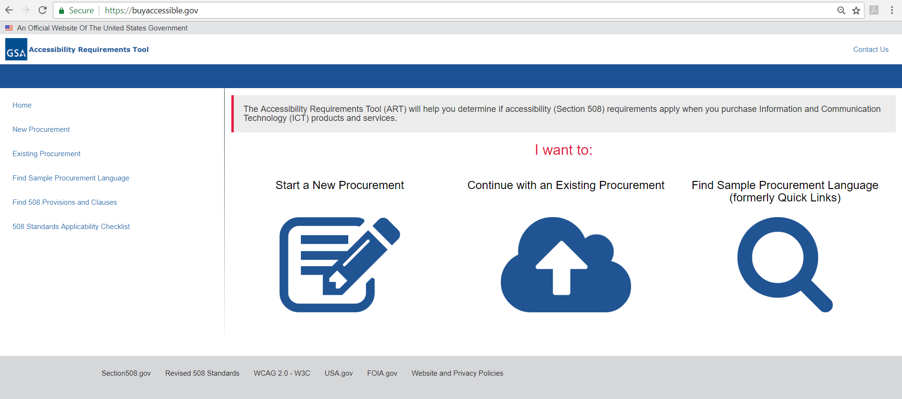

To start, choose from three options:

* Start a New Procurement;
* Continue with an Existing Procurement; and
* Find Sample Procurement Language

# Start a New Procurement

Begin a new review by choosing *Start a New Procurement*. You’ll be taken to a new screen asking for some basic information.

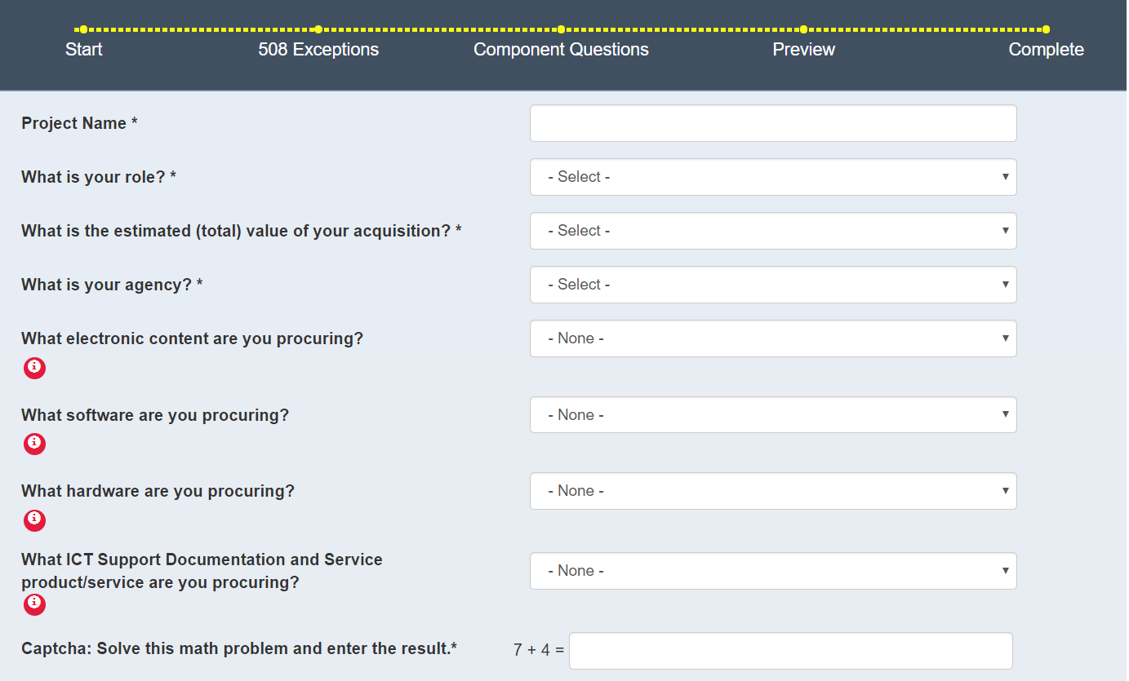

Questions include:

* **Project Name**
  + The project name will be displayed at the top of your final report.
* **What is your role?**
  + From a predefined drop-down list, choose the option that most closely matches your role in your organization.
* **What is the estimated (total) value of your acquisition?**
  + Choose the dollar range that is closest to the estimated value of your procurement.
* **What is your agency**?
  + Select your agency name. The list is in alphabetical order, organized by agency and sub-agency. *If your agency is not listed, please contact us at* [*art@gsa.gov*](mailto:art@gsa.gov) *so we can add your agency name.*
* **What <component type> are you procuring**?
  + What electronic content are you procuring?
  + What software are you procuring?
  + What hardware are you procuring?
  + What ICT Support Documentation and Service/product/service are you procuring?

Select the relevant type of ICT you want to procure. You can select one component of each type (e.g., one hardware and one software component). Note, you can only select one component per type, so if your procurement involves multiple components of a certain type (e.g., multiple software components), you will need to complete the form once per component.

* **Math question**: This is a required field, known as **captcha**, that must be correctly entered to proceed. It is a simple, randomized math question used to prevent automated bots from submitting the form.

Questions with asterisks are required; you cannot proceed until these questions have been answered.

You may save your information by clicking the **Save and Continue Later** button. Your information will be saved to your local drive as an .XML file.

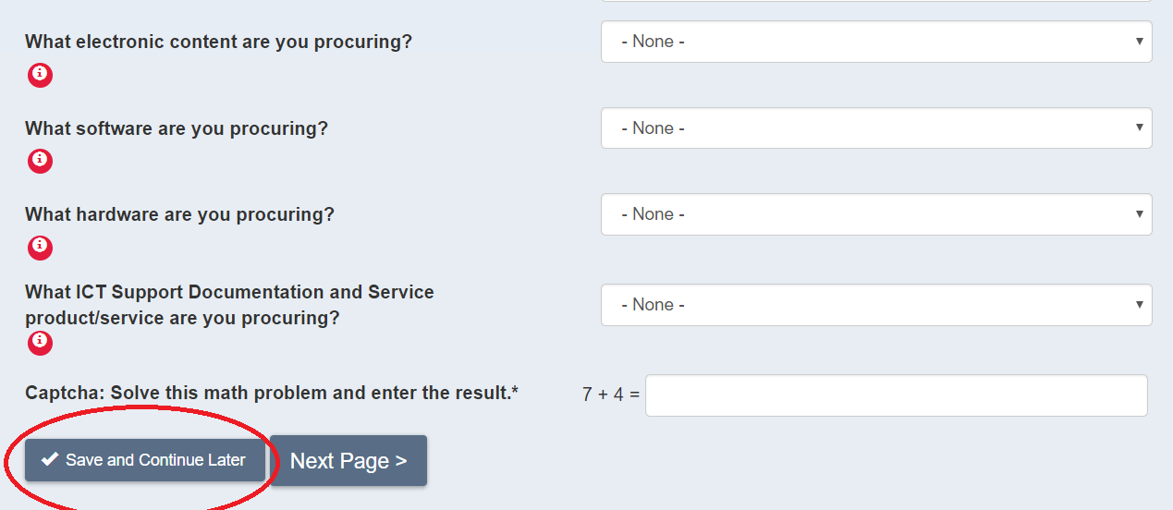

# 

# Continue With An Existing Procurement

If you started filling out the form, then saved it to finish later, you can upload the .XML file containing your partially completed form, and pick up where you left off.

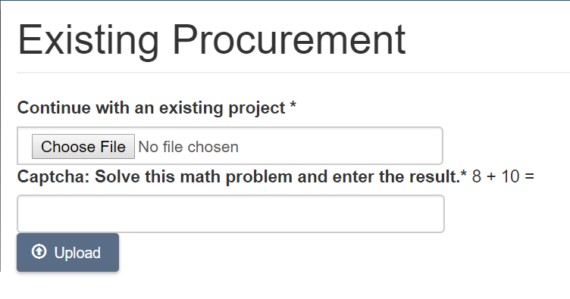

Select *Continue With An Existing Procurement*, and you will be prompted to locate the saved form and upload it to the tool. The filename will start with “**AccessibilityRequirementsDraft**”, have an “.**xml**” file extension, and contain a date/time stamp.

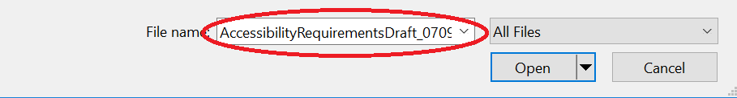

Correctly answer the **captcha math question** underneath the “Choose File” field. This is a security feature on each webform in ART.

Once you upload your saved ART form file, you can pick up where you left off, or revise any saved responses. You can also save the form at any point, up until you submit the final form. **Once submitted, you can no longer reuploaded or modify your information**.

# 

# Sample Procurement Language

There are two ways to access Sample Procurement Language - from the magnifying glass icon on the homepage, as well as the left navigation menu, which appears on each page the site.

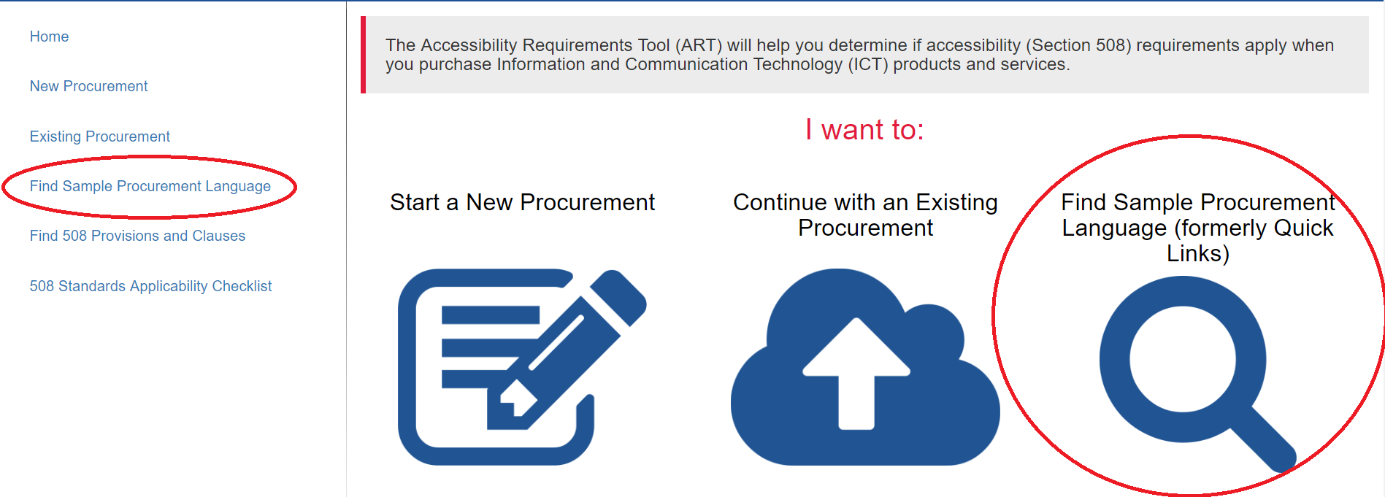

This section contains ready-to-use language to include in your procurement documentation. For example, if you need to procure printers or cell phones, but are not sure of the correct language to use, the sample procurement language in ART can help you complete the form.

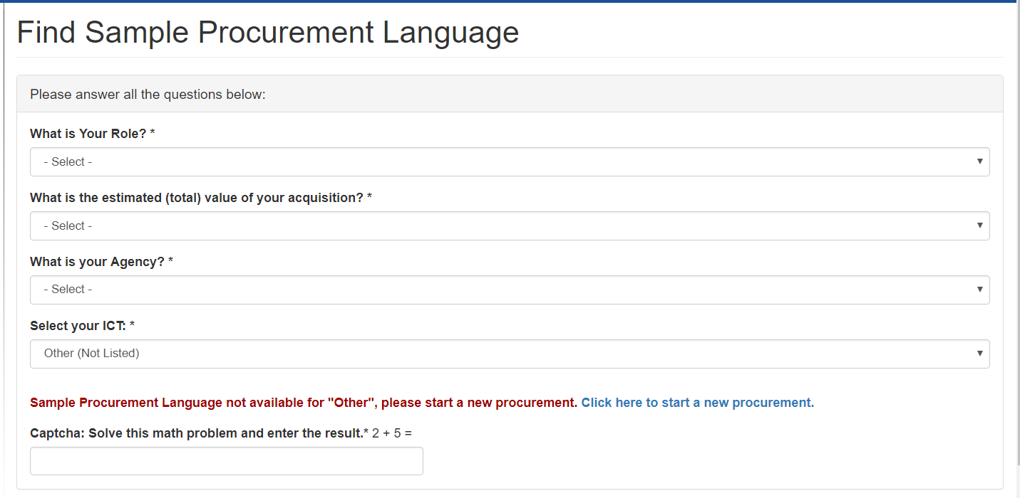

Questions for *Find Sample Procurement Language* include:

* **What is your role?**
  + From a predefined drop-down list, choose the option that most closely matches your role in your organization.
* **What is the estimated (total) value of your acquisition?**
  + Choose the dollar range that is closest to the estimated value of your procurement.
* **What is your agency**?
  + Select your agency name. The list is in alphabetical order, organized by agency and sub-agency. *If your agency is not listed, please contact us at* [*art@gsa.gov*](mailto:art@gsa.gov) *so we can add your agency name.*
* **Select your ICT**
  + Use the dropdown to select the product you want to procure (e.g., software such as time and attendance software or workflow applications, or hardware such as computers or document scanners).
  + *Note that if you choose “Other,” you will be prompted to start a new form.*
* **Math question**: This is a required field, known as **captcha**, that must be correctly entered to proceed. It is a simple, randomized math question used to prevent automated bots from submitting the form.

Once you make your selection, you will be taken to a screen containing the sample language for that item. For example, if you select “Cloud Computing,” you will see the following screen:

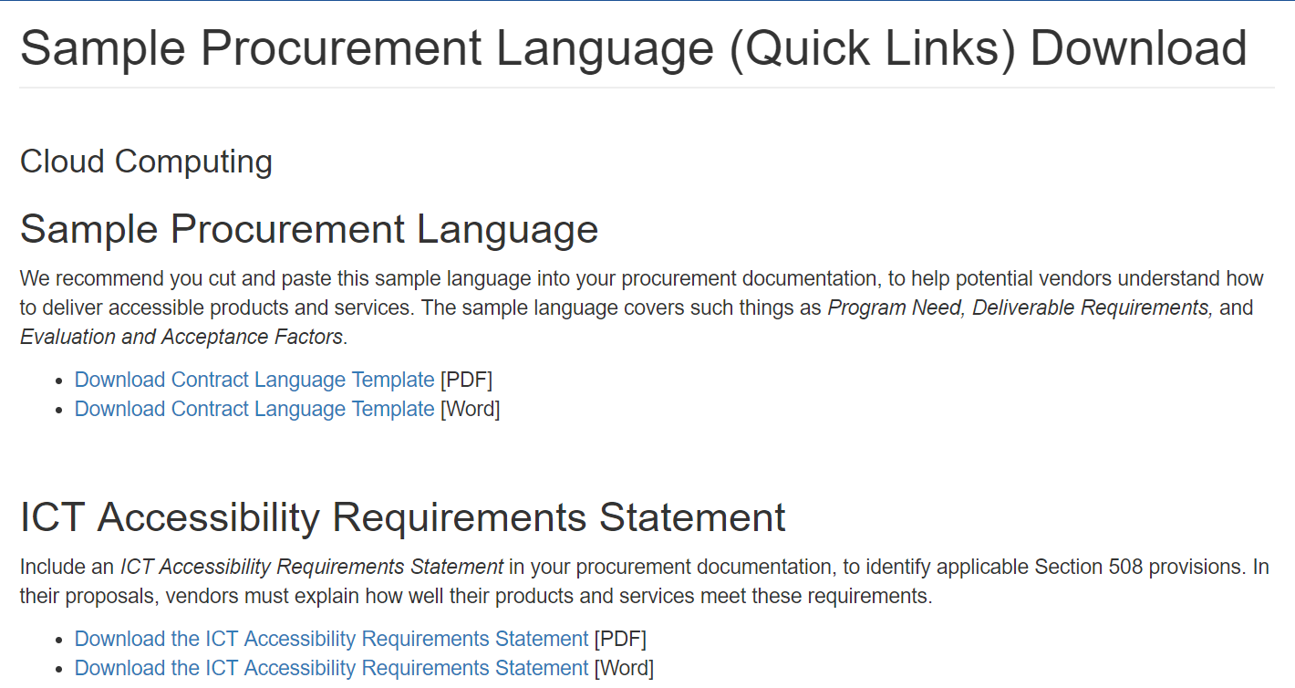

On this page you can download the Contract Language Template, as well as the ICT Accessibility Requirements Statement for the ICT you have chosen, in both Word and PDF formats.

When you want to start a new procurement, you may select either “Home” or “Start a New Procurement” from the left menu, as shown below.

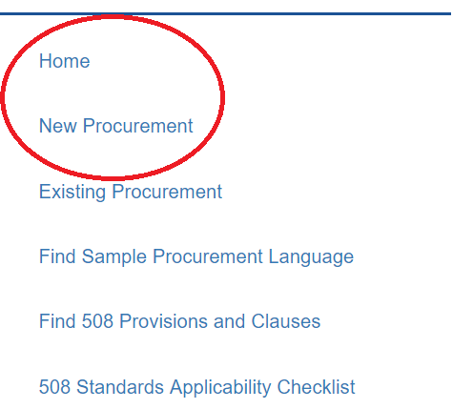

# 

# 

# 

# 

# 

# 

# Questions and Exceptions

Once you have completed the first page of the form, you will be prompted to answer questions about the item(s) you want to procure. Each product-related question (with the exception of the custom component name fields, and the justification text boxes) is a Yes/No question.

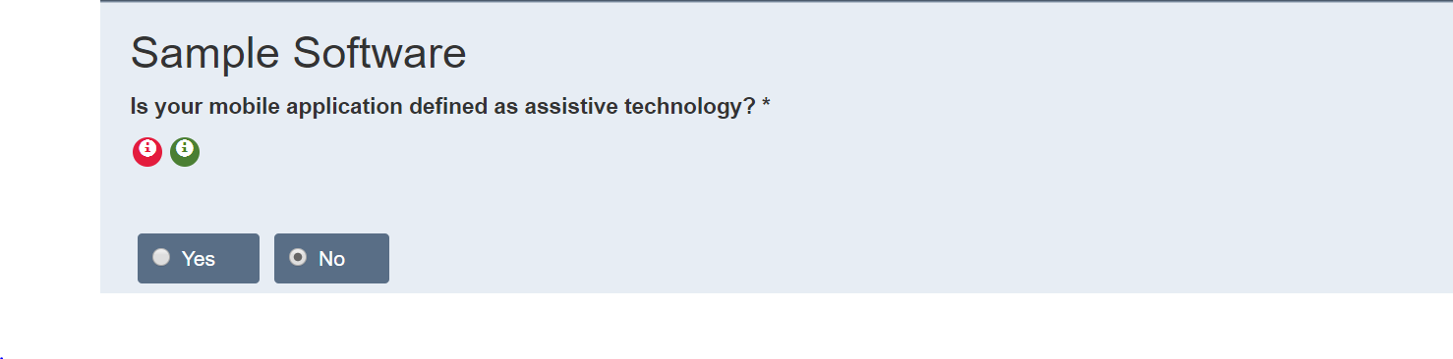

Required questions are marked with an asterisk (*). The answers you provide for each question will determine which exceptions or technical criteria apply to your procurement, and which follow-up questions you receive on the form.

If you answer “Yes” or “I don’t know” to the first question, you will be prompted to answer questions related to **General Exceptions** (as seen below). These procurement-level exceptions may or may not apply to you. Each potential exception has a specific number of related exceptions and/or technical criteria; the exception(s) is/are shown in both the text above each question, and in the Tooltip. Tooltips are discussed in the next section.

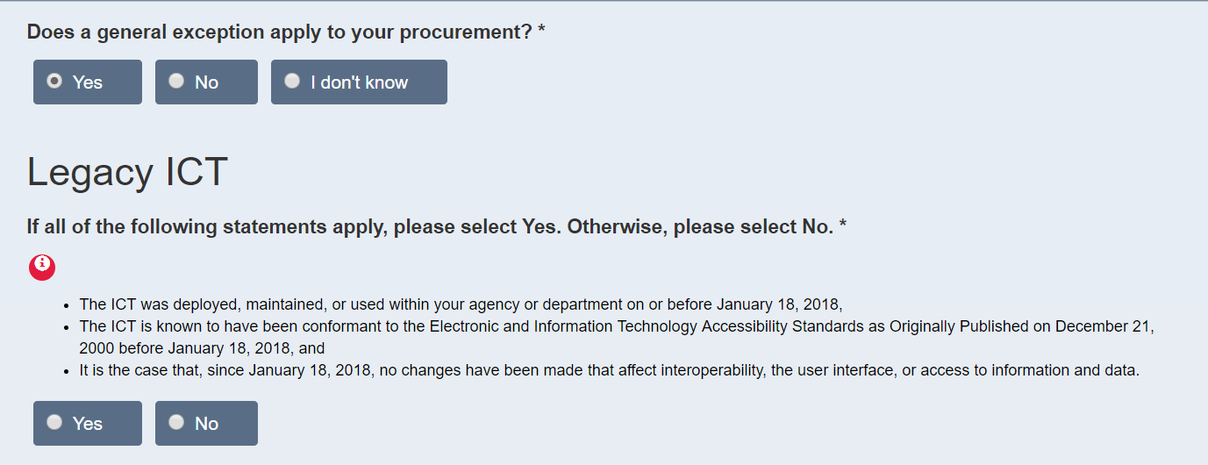

If you select “Yes” for any of the questions on this page, the justification text box will display at the bottom of the page, and all component-level questions will be skipped.

For the Legacy ICT (E202.2) general exception there are three associated criteria:

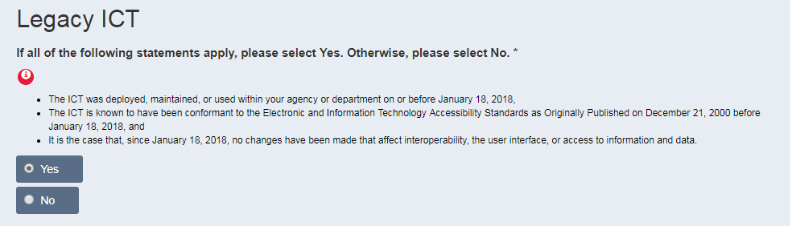

Answering ‘Yes’ to this question will prompt *E202 – Legacy ICT* to appear in the final report, and a justification text box will appear at the bottom of the page, as seen below:

**You only need to provide a justification for applicable general (procurement-level) exceptions.** For each applicable exception, you will need to provide a justification for the exception. Use the text box, as shown below:

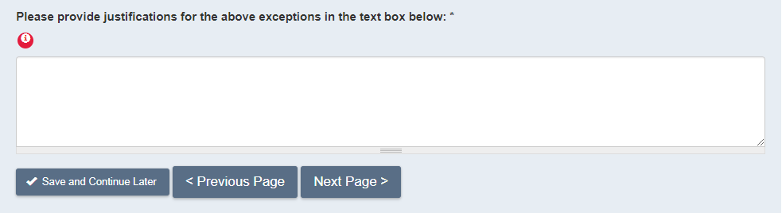

You cannot continue until you have provided a justification for the exception(s). The justifications will appear in the final report. There is a 1000-character limit for the justification.

# Tooltips

As you move through the tool, you will see **red icons with an “i”** (please see image below). These are **Tooltips**, and can be found with every question in ART. Tooltips provide chapter titles, chapter numbers, and text from the technical criteria and/or Section 508 exceptions that relate to the current question. Tooltips can help you understand the significance of a question as it relates to the Section 508 requirements for your procurement. You will also see **green circle icons with an “i”** on them. These are second level tool tips that provide you with additional details and examples. Hover over the icons with your mouse, or tab to them using your keyboard, to access the tooltips.

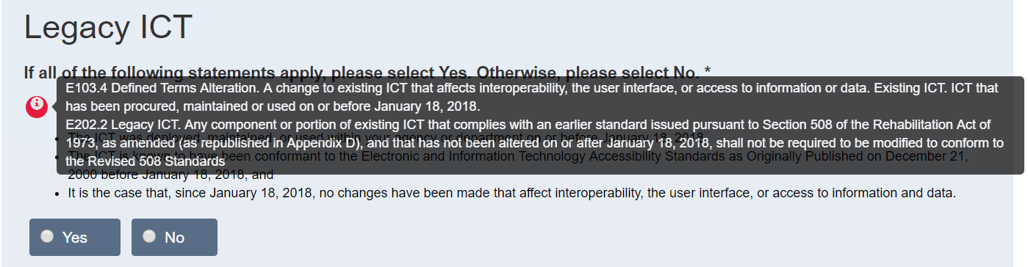

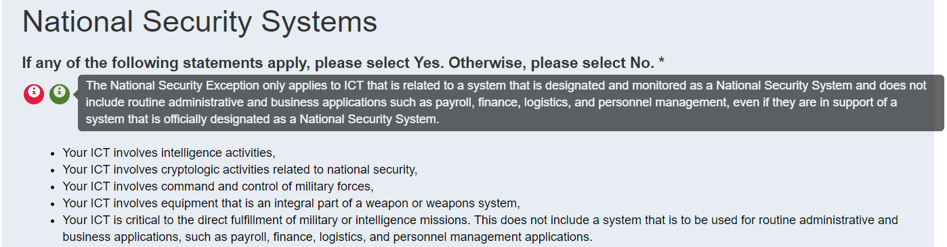

If you answer “No” to all of the “exceptions” questions, you will then see the component-level questions after you select “Next Page.”

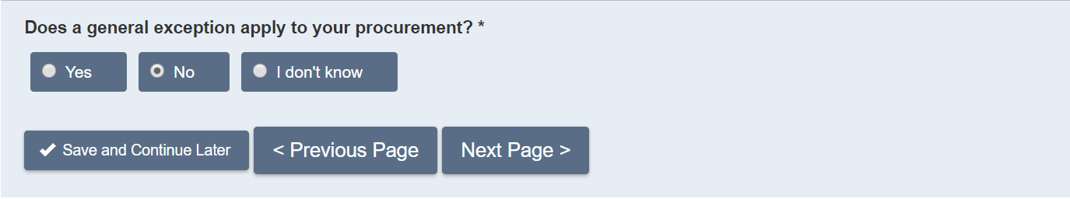

# Component-Level Questions

If none of the general exception questions apply, you will see the component-level questions pertaining to the component types you initially selected. For example, if you only selected a software component, then only software questions will appear.

First, enter a title for your component as shown below, then follow the prompts to answer the remaining questions.

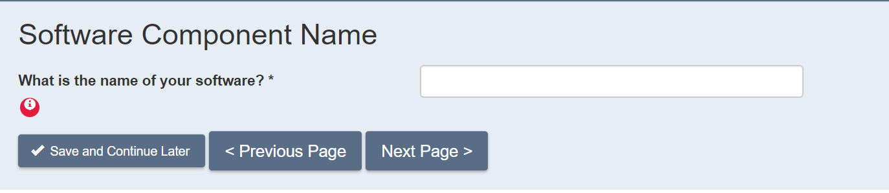

When you reach the component questions you will see questions like the software component question shown below.

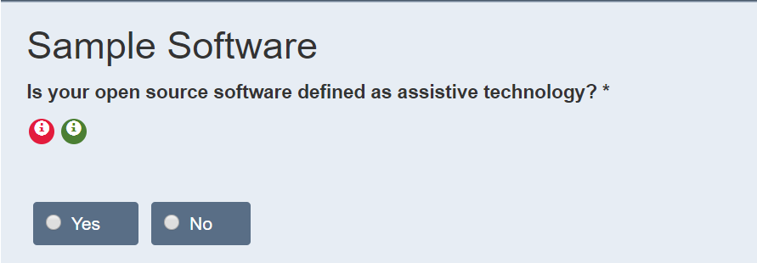

# Final Report

As a final step, you will be asked to review your submission before clicking the “Submit” button.

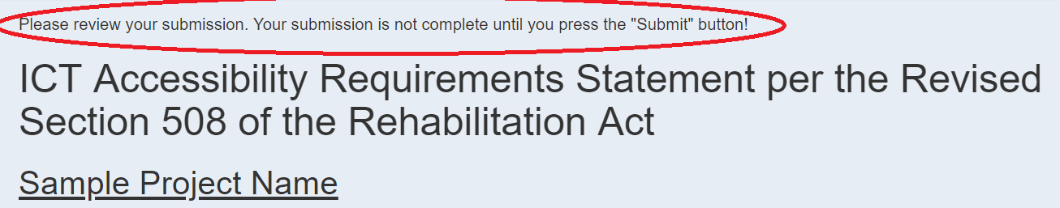

Note, you cannot change your form once it has been submitted.

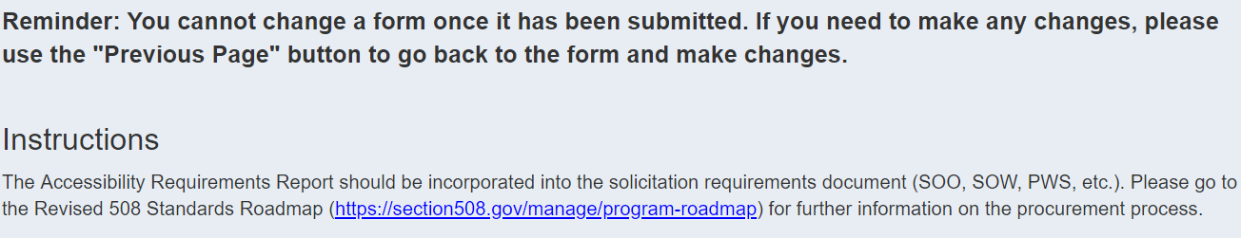

Once you click the “Submit” button, you will see the final report. See the example below:

# 

The report includes the following features and information:

* The standard title, which reads “ICT Accessibility Requirements Statement per the Revised Section 508 of the Rehabilitation Act.”
* Project Name (underlined).
* Agency Name.
* General Exceptions (if any apply). This section is divided into two sections:
  + Exceptions – The general exceptions that apply to your procurement. This will contain the chapter title, number, and text, as well as a link to the related chapter entry in the ART Glossary (discussed at the end of this section).
  + Justifications – Any justifications you have entered. As a general rule, each general exception must have an accompanying justification.
* Component-level information:
  + Component type (e.g., Hardware, or ICT Support and Services).
  + Custom component name.
  + Technical Criteria – As with the general exceptions, you will see the chapter title, number, and text for each criterion that applies.
  + Exceptions.
* Functional Performance Criteria (if applicable)
* Next steps to achieve a Section 508-compliant procurement, as shown below.

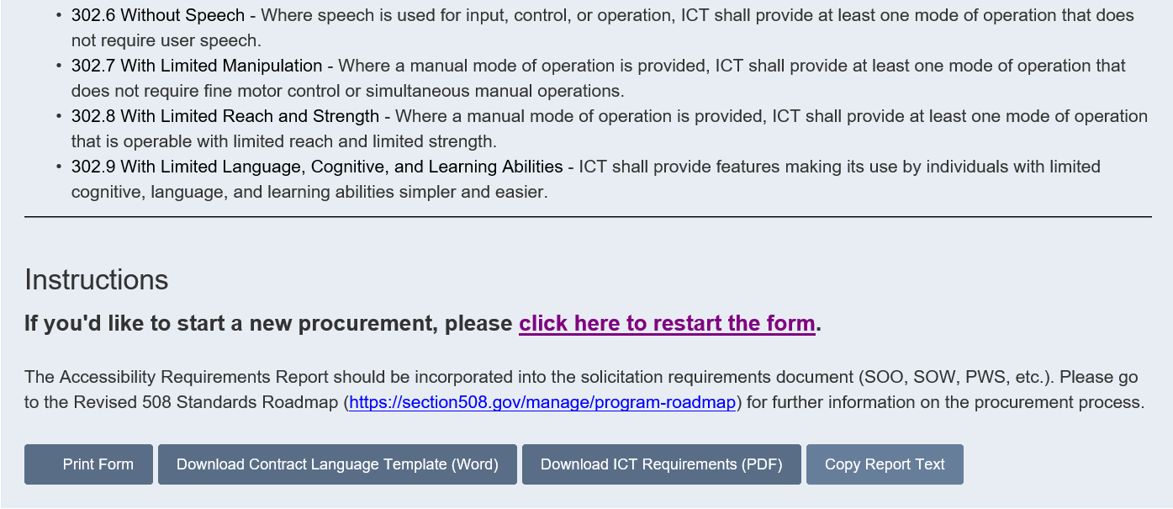

Note that each chapter title and number in the final report is linked to the Glossary, which contains the complete text of the relevant section of the Revised 508 Standards.

After you submit the form and the final report is generated, you will be able to:

* Save the report as either an HTML or CSV file, or save the URL as a bookmark.
* Print out the form (this will take you to a printer-friendly page containing your report).

Note that **once submitted, your form cannot be changed**. All changes should be made before submission.

# Glossary

# 

|  |
| --- |
| Section 508 Acceptance Criteria |

Section 508 Acceptance Criteria are specific accessibility criteria that may be applied to determine acceptance of deliverables submitted under an agency contract awarded for acquisition of Information Communication Technology (ICT). These criteria apply to those deliverables that have specific documented Section 508 requirements. Acceptance criteria are based on inspection and/or testing contract deliverables to confirm they meet the applicable documented accessibility standards.

|  |
| --- |
| Assistive Technology (AT) |

Any item, piece of equipment, or product system, whether acquired commercially, modified, or customized, that is used to increase, maintain, or improve functional capabilities of individuals with disabilities. Examples of Assistive Technology include, but are not limited to: computer software and hardware, such as voice recognition programs, screen readers, and screen enlargement applications.

|  |
| --- |
| Biometrics |

The measurement and analysis of unique physical or behavioral characteristics (such as fingerprint or voice patterns) especially as a means of verifying personal identity.

|  |
| --- |
| Closed Functionality |

Characteristics that limit functionality or prevent a user from attaching or installing assistive technology. Examples of ICT with closed functionality are self-service machines, information kiosks, set-top boxes, fax machines, calculators, and computers that are locked down so that users may not adjust settings due to a policy such as Desktop Core Configuration.

|  |
| --- |
| Component |

Components are the parts or pieces you are procuring, such as Hardware. For example, a *Hewlett-Packard laptop*, is an example of a hardware component name.

|  |
| --- |
| Electronic Content |

Content such as: text, images, tables, documents and multi-media that is commonly found in places such as websites, typically requiring conformance to applicable Revised 508 Standards using a defined testing process (see also: ICT).

|  |
| --- |
| Exceptions |

**Exception - Alternative Means (E202.6.3).** Where ICT that fully conforms to the Revised 508 Standards is not commercially available, and where conformance to one or more requirements in the Revised 508 Standards imposes an undue burden or a fundamental alteration in the nature of the ICT, the agency shall provide individuals with disabilities access to and use of information and data by an alternative means that meets identified needs.

**Exception - Basis for a Determination of Undue Burden (E202.6.1).** In determining whether conformance to requirements in the Revised 508 Standards would impose an undue burden on the agency, the agency shall consider the extent to which conformance would impose significant difficulty or expense considering the agency resources available to the program or component for which the ICT is to be procured, developed, maintained, or used.

**Exception - Best Meets (E202.7).**  Where ICT conforming to one or more requirements in the Revised 508 Standards is not commercially available, the agency shall procure the ICT that best meets the Revised 508 Standards consistent with the agency’s business needs

**Exception - Federal Contracts (E202.4).** ICT acquired by a contractor incidental to a contract shall not be required to conform to the Revised 508 Standards.

**Exception - ICT Functions Located in Maintenance or Monitoring Spaces (E202.5).** Where status indicators and operable parts for ICT functions are located in spaces that are frequented only by service personnel for maintenance, repair, or occasional monitoring of equipment, such status indicators and operable parts shall not be required to conform to the Revised 508 Standards.

**Exception - Legacy ICT (E202.2).**  Any component or portion of existing ICT that complies with an earlier standard issued pursuant to Section 508 of the Rehabilitation Act of 1973, as amended (as republished in Appendix D), and that has not been altered on or after January 18, 2018, shall not be required to be modified to conform to the Revised 508 Standards.

**Exception - NARA (National Archives and Records Administration) Exception.** Agency historically valuable records that are not public facing only need to be made accessible if they become public facing AFTER the agency transfers legal custody of the records to NARA for permanent preservation in the National Archives of the United States. In that case, NARA is responsible for making the records accessible.

**Exception - National Security (E202.3).**  The Revised 508 Standards do not apply to ICT operated by agencies as part of a national security system, as defined by 40 U.S.C. 1103(a).

**Exception - Required Documentation (E202.6.2).** The responsible agency official shall document in writing the basis for determining that conformance to requirements in the Revised 508 Standards constitute an undue burden on the agency, or would result in a fundamental alteration in the nature of the ICT. The documentation shall include an explanation of why and to what extent compliance with applicable requirements would create an undue burden or result in a fundamental alteration in the nature of the ICT.

**Exception - Required Documentation (E202.7.1).** The responsible agency official shall document in writing: (a) the non-availability of conforming ICT, including a description of market research performed and which provisions cannot be met, and (b) the basis for determining that the ICT to be procured best meets the requirements in the Revised 508 Standards consistent with the agency’s business needs.

**Exception - Undue Burden or Fundamental Alteration (E202.6).**  Where an agency determines in accordance with E202.5 that conformance to requirements in the Revised 508 Standards would impose an undue burden or would result in a fundamental alteration in the nature of the ICT, conformance shall be required only to the extent that it does not impose an undue burden, or result in a fundamental alteration in the nature of the ICT.

|  |
| --- |
| General Exceptions |

General exceptions are exceptions to the explicit requirements on ICT placed by the Access Board standard.

|  |
| --- |
| Functional Performance Criteria |

§1194.31 Functional performance criteria *(published in the Federal Register 12/21/2000)*

(a) At least one mode of operation and information retrieval that does not require user vision shall be provided, or support for assistive technology used by people who are blind or visually impaired shall be provided.

(b) At least one mode of operation and information retrieval that does not require visual acuity greater than 20/70 shall be provided in audio and enlarged print output working together or independently, or support for assistive technology used by people who are visually impaired shall be provided.

(c) At least one mode of operation and information retrieval that does not require user hearing shall be provided, or support for assistive technology used by people who are deaf or hard of hearing shall be provided.

(d) Where audio information is important for the use of a product, at least one mode of operation and information retrieval shall be provided in an enhanced auditory fashion, or support for assistive hearing devices shall be provided.

(e) At least one mode of operation and information retrieval that does not require user speech shall be provided, or support for assistive technology used by people with disabilities shall be provided.

(f) At least one mode of operation and information retrieval that does not require fine motor control or simultaneous actions and that is operable with limited reach and strength shall be provided.

|  |
| --- |
| Information and Communication Technology (ICT) |

ICT is any information technology and other equipment, systems, technologies, or processes for which the principal function is the creation, manipulation, storage, display, receipt, or transmission of electronic data and information, as well as any associated content.

**Information and Communications Technology Examples**

* Internet and Intranet websites and web based content (sites, pages, applications, etc.)
* Enterprise, web, and client applications (for example: time and attendance software, office productivity applications, web forms/applications, call center or customer rep workflow applications, electronic fillable forms, etc.)
* ICT software infrastructure (for example: document repositories, content management systems, systems/network administration software, operating systems, etc.)
* Training Materials (for example: online training materials, test, quizzes, surveys required to be provided in an electronic format before, during, and after the training is conducted)
* Reports
* Multimedia (video/audio)
* Electronic documents
* Electronic forms
* Interactive maps
* Electronic document templates
* Electronic emergency notifications
* Electronic surveys
* Subscription service (i.e. news feed, alert service, professional journals)

**ICT Software Examples**

Examples of software that must conform to the Revised Section 508 Standards

Web, desktop, server, mobile client applications

* Time and attendance software
* Productivity applications
* Web forms/applications
* Call Center Support applications
* Workflow applications
* Content management systems
* Learning management systems

Electronic content and software authoring tools and platforms

* Microsoft Office
* Adobe Acrobat Professional
* Adobe InDesign
* PDF Generators and Converters
* Graphing and Charting Programs

Software infrastructure

* Operating Systems
* Browsers
* Systems/network administration software
* Collaboration environments
* Remote access software
* User Authentication Software
* Virtual meeting tools (e.g., VOIP, screen shares, remote meetings)

Service Offerings

* Software as a Service (SaaS)
* Platform as a Service (PaaS),
* Infrastructure as a Service (IaaS)

**ICT Hardware Examples**

Examples of hardware that must conform to the Revised Section 508 Standards

* Computers & laptops
* Servers
* Tablets
* Printers and Copiers
* Document Scanners
* Multi-function office machines
* Peripheral Equipment (ex. keyboards)
* Information kiosks and transaction machines
* Mobile phones

See also: **Exceptions - Legacy ICT (E202.2) and ICT Functions Located in Maintenance or Monitoring Spaces (E202.5)**

|  |
| --- |
| ISO 32000-1:2008 |

ISO 32000-1:2008 is the first ISO specification for PDF. The document is an ISO formalization of Adobe’s own PDF Reference 1.7, and is technically identical to the Adobe document.

|  |
| --- |
| Multimedia |

If your agency intends to include all or part of the delivered information content as part of a video or multimedia production, then agencies may consider a requirement on the delivered content to assure that it considers the specific Section 508 accessibility requirements detailed in 1194.24.

|  |
| --- |
| Public facing content |

Public facing content is electronic information and data that a Federal agency makes available to the general public. Public facing content can be published on the web (for example: an agency website, blog post, or social media page). And it could also be made available via non-web methods (for example information screens in waiting areas via kiosks).

|  |
| --- |
| Sample Procurement Language (formerly Quick LInks) |

Sample Procurement Language provides pre packaged Section 508 solicitation documentation for standard ICT products and services.

|  |
| --- |
| Service Deliverables |

An ICT Related Service Deliverable is a work product produced as a result of an ICT Related Service. ART recognizes three types of ICT related work product deliverables typically produced by ICT Related Services:

* **Information Content**- Knowledge or intelligence delivered in any format including reports, case studies, analyses, recommendations.Information content may be delivered in many different formats, including reports, electronic documents, videos, and multimedia productions.
* **Custom ICT Product**- ICT products and systems developed specifically for or customized to specific agency/program requirements. Delivery of ICT product functionality developed to specification, including design and development of integrated ICT systems or solutions.
* **ICT Related Labor Hours**-Delivery of work activities on tasks specified to meet program requirements including operations and maintenance, on-site support, testing and validation and training. Delivering tasks performance on specified ICT-related activities, including operation, maintenance and / or support of ongoing ICT activities.

|  |
| --- |
| Service Types |

Types of services related to ICT include:

* **General Information Services**- expertise, consultation, research or other knowledge-based services that deliver information content in many different forms
* **ICT Development Services**- generally the design and development of custom ICT product deliverables. This includes the development of custom software, web-enabled applications and customized websites, as well as development of custom ICT hardware components, telecommunications equipment, including associated information, documentation and support. Also includes specific enhancements to existing ICT hardware / software.
* **ICT Integration Services** - composing various ICT components into a custom ICT system deliverable
* **ICT Operations and Maintenance**- providing management, operations and support of ongoing ICT functions, including the delivery of ICT functionality for end users, system performance, maintenance, monitoring and management of ICT-related activities. Developing new ICT is beyond the scope of typical Operations and Maintenance Services
* **ICT Testing / Validation Services**- delivering quality assurance and remediation for existing ICT
* **Training Services**- develop or provide training.
* **On-Site Support Services**- providing on-site management, operations and support of ongoing and new ICT functions including design, development, and delivery of ICT functionality for end users, ICT system performance assurance, maintenance, monitoring and management of ICT-related activities.

|  |
| --- |
| Technical Criteria |

A set of measuring tools to measure an activity objectively and from a technical standpoint.

|  |
| --- |
| Web Content Accessibility Guidelines (WCAG) |

The Web Content Accessibility Guidelines are part of a series of [web accessibility](https://en.wikipedia.org/wiki/Web_accessibility) guidelines published by the Web Accessibility Initiative of the World Wide Web Consortium, the main international standards organization for the Internet. They are a set of guidelines that specify how to make content accessible, primarily for people with disabilities--but also for all user agents, including highly limited devices, such as mobile phones. The current version, WCAG 2.0, was published in December 2008 and became an ISO standard, ISO/IEC 40500:2012 in October 2012. WCAG 2.1 is a "Proposed Recommendation" as of April 2018.