**Disclaimer:** This is a sample document. Agencies are encouraged to tailor the contents to fit their individual needs.

Cloud Migration Services RFI Synopsis

In November 2022, GSA’s Centers of Excellence (CoE) released a Request for Information (RFI) to GSA Schedule holders to gain a better understanding of industry’s capabilities regarding Cloud Migration Services. The government prepared an RFI and shared a draft [PWS](https://coe.gsa.gov/docs/CloudMigration/AttachmentA_PWS.docx) to receive industry’s feedback on the requirements and learn more about vendors’ capabilities.

The PWS outlined the government’s overall objectives and tasks to ensure there is a smooth migration to the cloud. The results and feedback are attached within this report.

# 

# 

# RFI Results

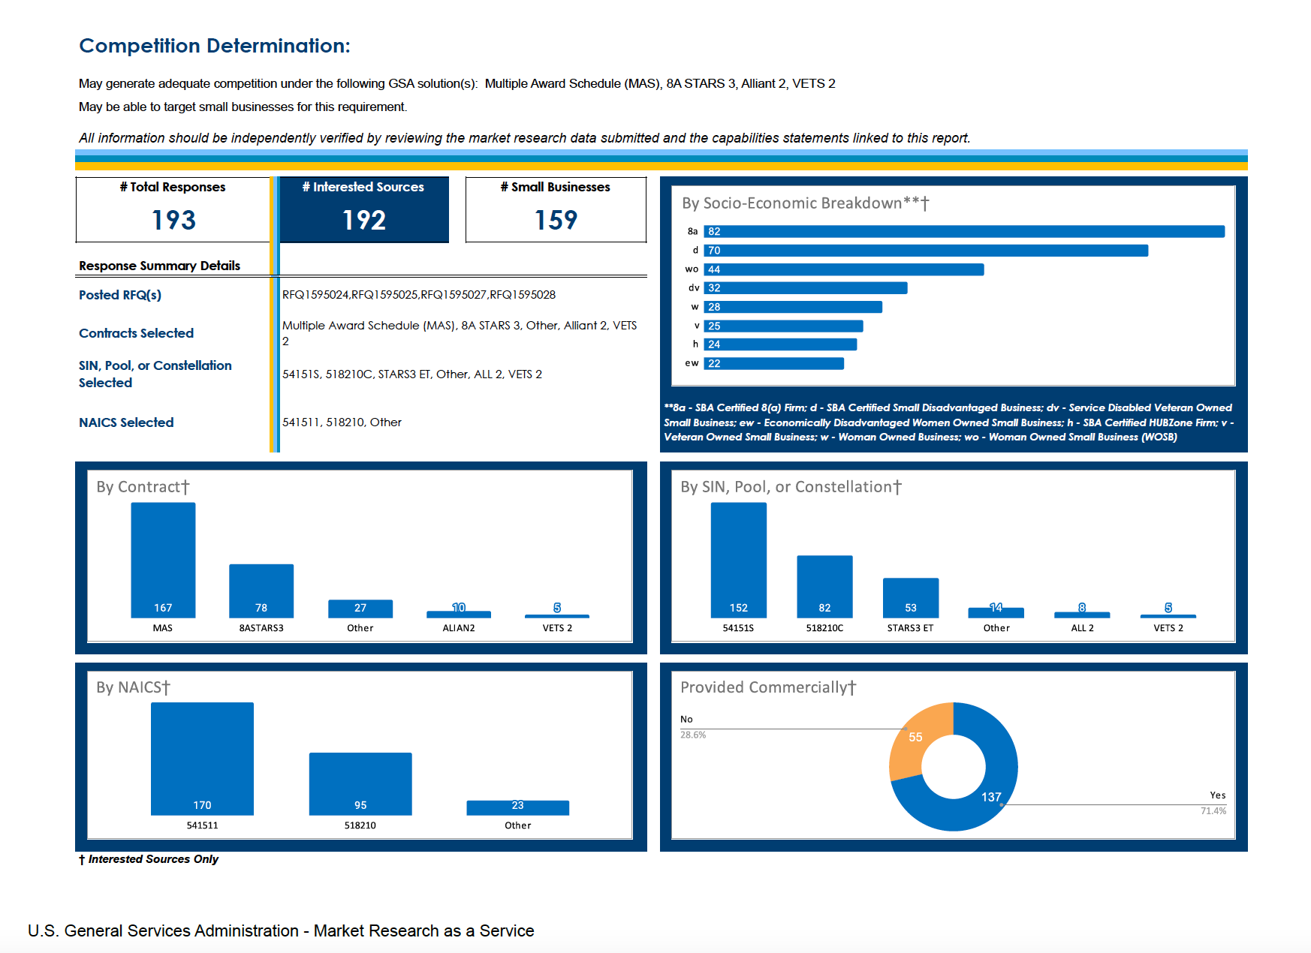

Summary of RFI Results

* Multiple Contract Vehicles potentially available (MAS, 8a STARS III, Alliant 2, VETS 2, GSA COMET, SBIR III, OASIS Pools 1&3)
* Many small businesses along with certain socio-economic categories available
* Most vendors fall under the 54151S (IT Professional Services SIN) & 518210C (GSA Cloud SIN) categories
* Most of these services are provided commercially

# RFI Feedback

## Cloud Migration RFI Feedback from Industry

Requests for more information

1. **Include more details on the current legacy system(s), databases, and enterprise architecture.**
   * Include clear estimates of:
     + Operating parameters such as number and size of applications to migrate
     + Number of users and size of current on-premise environment
     + Capabilities supported per system
   * Is it internal or external access?
   * What is the data storage requirement for any of these solutions?
     + If so, for what time and average file size per end user on each designated system.
   * What is the present composition of the IT ecosystem?
   * Does the agency have multiple locations or a single location?
   * Additional SOW details to identify infrastructure scope/sizing would be necessary to provide accurate pricing proposals.
   * Additional information is recommended such as:
     + More details on the applications to be migrated (e. g., COTS or GOTS, name of systems, level of customization, current state/environment, cloud assessment results, integration points)
     + More information on the current and to-be environments (e.g., any third-party tools in place and/or any pre-determined software/tools/solutions for the to-be environment),
     + The current maturity of the DevSecOps environment, the number of Agile teams in the SAFe Agile Release Train, the current ATO status, etc.

***Clarification: Any standards that should be adopted should also be listed. For example, one agency is working to adopt the open standard FHIR rather than proprietary standards.***

* + Additional detail could include:
    - A current architecture diagram,
    - Current software stack matrix
    - Related visual representations.

1. **Include background information such as why your agency is migrating to the cloud and any important timelines.**
   * Why are you migrating to the cloud?
   * What timeframe does the government expect the comprehensive cloud migration to be completed within?
2. **Include any policies that need to be followed or constraints.**
   * Address Agency-specific needs, such as:
     + The Agency's policies, security requirements, data classification, and clearance levels of personnel in order to staff, price, and design a technical solution that accounts for all tasks and associated objectives in the draft PWS.
   * Please elaborate on any ongoing Zero trust initiatives.
   * Include any Fedramp requirements the government anticipates, if applicable.
   * Any specific policy that will need to be compliant? For example, 508 compliance policy.
   * Would new cloud infrastructure be green field or be instantiated in an existing CSP’s environment with established policies, procedures, and rules.
3. **Include more details on any cloud migration work that is/was in place.** 
   * Are any cloud solutions currently in use?
     + If so, which solution (s) and the purpose (s)/features of use?
   * Which company(s) are presently maintaining the network?
   * What is the date of the most recent ATO?

***Clarification: Multi-cloud environments would theoretically have more than one applicable “recent” ATO (eg, O365 and Workspace working alongside one another for collaboration tools).***

* + What CSPs does the agency currently use?
    - Does the agency have a preference in terms of which cloud vendor it uses?

Recommendations to PWS’ Tasks

* Suggest removing **Task 2.1 - H: Analytics Foundry Environment**. NGS suggests replacing this with multiple Application Development options to provide flexibility to GSA from a technical and partnership perspective.

***TTS Clarification: By using the term “Analytics Foundry Environment”, the government intended a multiple application open development environment. “Analytics Foundry” does not imply any single vendor or application. We suggest use of an open, cloud agnostic platform that the analytics foundry concept promotes. To avoid any confusion, TTS updated this task to, “Flexible Application Platform.”***

* Provide **current state analysis** as a task: include a current state analysis as a task within the PWS to help define a successful future state recommendation.
* Ensure that the PWS reflects agency needs **post-migration** by including information on the agency plan to continue to optimize and modernize the environment.
* Recommend adding Disaster Recovery requirement in the PWS since there was no reference to DR.
* PWS should also specify non-functional requirements or service level agreement (SLAs) or Quality Assurance Surveillance Plan (QASP), if possible.
* Key personnel requirements should be a bit tightened with specific relevant certification requirements (e.g. Cloud/DevOps Engineer - Should possess AWS Certified DevOps Engineer or equivalent.)

Other RFI Feedback

* + The Government should consider requiring past performance within the last year as a prime or subcontractor migrating large IT systems and components to the cloud and building PaaS.
  + Please do not limit the competition to allow only authorized *resellers* of CSPs. The Government will limit the viable bidder pool and open themselves up to migration and cloud services recommendations that are conflicted with influence from CSPs sales/revenue streams, as CSP offer discounts and rebates to certain resellers in order to push their cloud offerings.
  + Additionally, we suggest a Time and Material project to enable Agile delivery of services per GSA’s “De-Risking Government Technology, Agency Field Guide.”
  + Consider separate awards for each desired cloud environment (Cloud Service Providers). Many Cloud Solution Providers are specialized in only one Cloud environment; separating the requirements based on Cloud environment would increase the quality of Cloud Solutions available to the government and increase competitiveness.
  + Introduce demos/orals as a key evaluation factor. Accelerate evaluations to help small businesses deploy planned resources that are contingent hires. Allow small businesses to transition in with phased timelines. Award based on technical capability; allow negotiations if pricing is an issue.
  + Ensure customers are engaging with industry early: This includes in their plans to procure migration services both formally (RFIs/ Draft RFPs) and informally (reach out to industry for discussions).
  + Make sure to explicitly mention the need for interoperability in a future-state resulting from a migration.
  + Recommend a multi-cloud environment. And if there is a preference for a single CSP, explain why an interoperable multi-cloud environment would not be preferable and be prepared to document that rationale in a J&A.