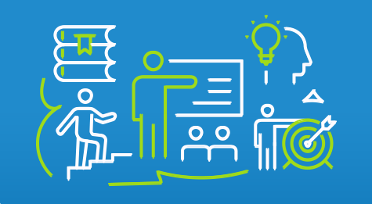

# Enabling Customer-Centric Innovation in Government Agencies Workbook



Section 1: About the CoE 4

Customer Experience (CX) Center of Excellence (CoE) 4

Advisory Support & Resources 4

Partnering with our Centers and Practice Areas 5

Section 2: Customer Experience (CX) 6

What is a Customer? 6

Why is CX important? 6

The Benefits of Prioritizing Customer Experience 7

What is Customer Experience? 7

CX Government Mandates 8

What Do We Need to Improve Our CX? 9

Inclusive CX 9

Section 3: Leveraging Human-Centered Design (HCD) 11

What is HCD? 11

How Can We Use the HCD Process to Improve CX? 11

What Are Key Parts of the HCD Process? 12

Section 4: Journey Mapping for Customer Experience 15

Understanding Journey Maps 15

The Customer Journey Map 15

Elements of Customer Journey Maps 15

Types of Customer Journey Maps 16

Linear Journey Map 16

Cyclical Journey Map 16

Multichannel Journey Map 17

Service Blueprint 18

Day in the Life Journey Map 18

Benefits of Customer Journey Maps 19

Steps to Create Customer Journey Maps 19

Section 5: Activities, Templates and Tools 21

A. Tool: Resource Links 22

Government CX Mandates 22

Customer Experience Links 22

Journey Map Examples 22

B. Workshop 1 Activities, Templates and Tools 24

Activity 1: Define Your Customers 24

Activity 2: What Are Your Customers’ Touchpoints? 25

Activity 3: Where Does My Team Stand? 26

Activity 4: Team Mindset Challenge 27

Activity 5: Diversity, Equality, Inclusivity and Accessibility (DEIA) CX Checklist 28

C. Workshop 2 Activities, Templates and Tools 29

Activity 6: Practicing the HCD Mindset 29

Activity 7: Practice the HCD Mindset 30

Activity 8: Frame your Challenge 31

Activity 9: Discover your Challenge 32

D. Workshop 3 Activities, Templates and Tools 33

Template 1: Steps for Customer Journey Maps 33

Template 2: Best Practices for Customer Journey Maps 34

Template 3: Measuring Success 35

Activity 10: Create a Journey Map 36

E. Journal Prompts 37

F. Notepad 39

#### About this workbook

This workbook has been prepared to complement the *Enabling Customer-Centric Innovation in Government Agencies* workshop series. The workbook distills the key content from the workshop to make it easier to access and use. In addition, it includes related templates, tools, and reflection questions. You may also want to take advantage of the notes section to jot down any ideas or questions you have.

## Section 1: About the CoE

As part of GSA’s Technology Transformation Services (TTS), the Centers of Excellence (CoE) accelerates IT modernization at federal agencies by leveraging private sector innovation and government services while centralizing best practices and expertise for holistic agency-wide transformation.

### Customer Experience (CX) Center of Excellence (CoE)

The Customer Experience (CX) CoE collaborates with agency stakeholders and staff to address complex challenges that impact the experiences of their customers. We transform data-driven insights discovered through research into innovative solutions that ultimately solve customer needs.

### Advisory Support & Resources

The CoE has launched a collection of starter guides, templates and models from each center and practice area available to federal agencies and the public. Through American Rescue Plan funding, this work furthers our mission of centralizing best practices and expertise for holistic technology transformation and is provided at no cost to users.

Using these resources, Federal agencies can take the first steps in their modernization journey by considering concepts themselves while also receiving live instruction at virtual workshops and office hours hosted by CoE leads. [Stay tuned for new releases from all of our centers and practices](https://coe.gsa.gov/press/events.html)!

#### 

#### Partnering with our Centers and Practice Areas

Government departments and agencies partner with the CoE to co-create and accelerate their modernization initiatives. Our model focuses on bringing in the right people, at the right time, to drive sustainable outcomes. [Learn more about partnering.](https://coe.gsa.gov/about/approach-team-structure.html#our-approach)

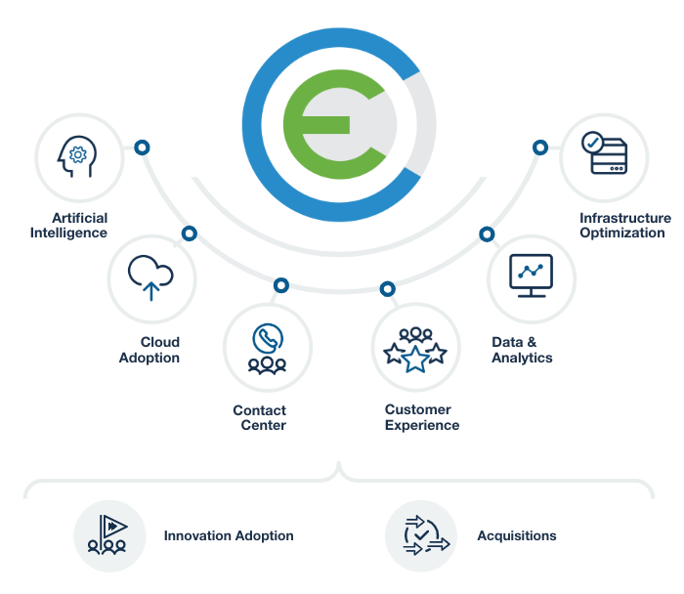

## Section 2: Customer Experience (CX)

### What is a Customer?

A customer is anyone your organization serves or meant to serve, directly or indirectly. This includes your employees as well as the public, among others. The customers of your organization are those whose needs you’re trying to satisfy through building or updating the product or service. In government, you may also have internal and external customers.

OMB defines it as “any individual, business, or organization (such as a grantee or State, local, or Tribal entity) that interacts with an agency or program, either directly or through a federally-funded program administered by a contractor, nonprofit, or other Federal entity. Federal government customers could also include public servants and employees themselves…”

### Why is CX important?

Unfortunately, the benefits of CX are not yet fully realized. Agencies lag behind other sectors in their ability to meet the public’s rising needs and expectations.

**Average CX score for federal agencies was 61, which is considered "poor" in Forrester's grading system.”**

– 2020 Forrester Federal Customer Experience Index (CX Index)

**Just 34% of federal employees believe that their agency provides a high-quality customer experience.”**

– 2019 Federal Employee Viewpoint Survey (FEVS)

**80% of businesses think they deliver superior customer experience. Only 8% of customers agree.”** 

– Harvard Business Review

#### The Benefits of Prioritizing Customer Experience

Good CX results in benefits for both the customer and an agency including:

* Increased trust and confidence in government
* Reduced burden on customers with frictionless service delivery
* More efficient use of agency resources and less rework

Prioritizing CX is the right thing to do. CX enables us to solve the right problems and solve them the right way.

There is immense value in prioritizing the customer’s experience in the requirements phase of any improvement process. As the phases progress, the cost increases by a factor of ten for each phase, as noted in the 1:10:100 Rule graphic.

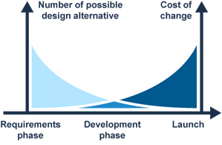**1:10:100 Rule**

For every $1 to fix a problem in design, it would cost $10 to fix the same problem in development, and $100 to fix after the product's release.

Source: Forrester

### What is Customer Experience?

CX is the entirety of a customer’s journey, including all touchpoints, in relation to an organization.

People are complex and to understand them we need to look at both their functional needs and emotional values, in context.

* **Functional needs:** Customer experience is the sum of all interactions customers have with an organization when trying to achieve an objective. Interactions are often called *touchpoints*.
* **Emotional values:** Customer experience is everything that gives the customer the feeling(s) they have about your organization. Often, we believe we understand what our customers go through, what they’re thinking and feeling. But to really understand objectively requires some rigor and science.

### CX Government Mandates

The Biden-Harris Management Agenda Vision defines government-wide management priorities for all federal agencies to improve how the government operates and performs. Below are active links to the President’s three outlined mandated management priorities.

The mandates help us reach three major goals:

1. Improving services and making service delivery a priority
2. Use customer trust and satisfaction as our measuring stick
3. Embed CX into agency culture and operations

| **Mandate** | **Resource** |
| --- | --- |
| **PMA** | [Priority 2: Delivering excellent, equitable, and secure Federal services and customer experience](https://www.performance.gov/pma) |
| **CX EO 14058** | [Executive Order on Transforming Federal Customer Experience and Service Delivery to Rebuild Trust in Government](https://www.federalregister.gov/documents/2021/12/16/2021-27380/transforming-federal-customer-experience-and-service-delivery-to-rebuild-trust-in-government) |
| **OMB A-11 Part 6  Section 280** | [Managing Customer Experience and Improving Service Delivery](https://www.performance.gov/cx/assets/files/a11_2020_sec280.pdf) |

### What Do We Need to Improve Our CX?

To fully realize the benefits of CX, we first must understand the elements of an effective approach to customer experience.

* **Human First:** Drawing from **human-centered design** practices and methodology, CX is an approach that solves problems by elevating customer perspectives and meeting the customer where they are, even in times of trauma or hardship.
* **Designed Holistically:** CX designs **user experiences** across all touchpoints and ensures that all “back-of-the-house” **process improvements** to services align to support the “front-of-house” experience.
* **Driven By Data:** CX practice is rooted in quantitative and qualitative **evidence** to assess efforts and optimize strategies and tactics to deliver measurable value.
* **Unrepentantly Agile:** Committed to **continuous improvement** and delivering impactful results early and often, CX applies principles from **agile and lean** to pivot quickly, seize opportunities, and deliver value to end-customers.

### Inclusive CX

Diversity, Equity, Inclusion and Accessibility (DEIA) are essential to improving Customer Experience for all. Since federal agencies rarely have one “target customer,” DEIA and customer experience are inextricably linked.

DEIA principles should not just be about accommodating or retrofitting. They should guide our efforts from the outset. Regardless of the level of CX maturity, all organizations should optimize the following essential elements of customer experience.

* **Diversity:** Customer experiences should be free of institutional bias.
* **Inclusion:** The organization should help everyone feel welcome to become their customers.
* **Equity:** The organization should treat all customers fairly, justly and impartially.
* **Accessibility:** The widest possible audience should be able to experience the organization’s services to the fullest. It is important to be 508-compliant, use plain language, ensure language access, and strive for excellence.

## 

## Section 3: Leveraging Human-Centered Design (HCD)

### What is HCD?

**HCD is a problem-solving approach that puts customers first.**

It incorporates the human perspective through customer participation in:

* Research
* Solution development
* Testing

HCD puts customers at the center of our work to solve the right problem in a way that works for them. HCD is a framework and a mindset. It is messy and chaotic, but it’s supposed to be that way.

HCD assumes you don’t know the answers and focuses on finding out the right problem to solve first--not diving right into solutions.

To assume you don’t know, you need to employ empathy, which means embracing ambiguity. Embracing ambiguity means you’re learning from failure. Learning from failure means you’re optimistic. And being optimistic means collaborating with others draws on the collective experiences of all involved.

### How Can We Use the HCD Process to Improve CX?

Human-centered design is an approach to defining and solving problems from the perspective of the people who will depend on the solution you come up with.

Human-Centered Design:

* Starts with an honest appraisal of how an agency defines and cares for its customers.
* Involves interviewing and observing customers and the staff charged with supporting them.
* Can also involve the analysis of an agency’s policies, culture, history and future planning.

### What Are Key Parts of the HCD Process?

There are four stages in the HCD process. Each stage contains one or more iterative steps. This means each step can be repeated until it is the best version possible with the current information.

There are four stages to HCD: Frame, discover, design, pilot. Within those stages, there are seven steps: Frame, immerse, synthesize, ideate, prototype, deliver and measure.


* + - 1. **Frame**

Framing the right design challenge is key to arriving at a good solution.

Analyze the challenge at hand. Define intended outcomes, scope, and organizational context. Coordinate across program offices.

Identify how success of the HCD effort and the final outcome will be measured. At the end of this phase, the team makes a decision to pursue this effort or reevaluate the problem statement.

* + - 1. **Discover**

Human-centered design is rooted in empathy, which requires understanding customers and the many factors shaping their experiences. Curiosity, objectivity, and empathy in data gathering prepare designers to create meaningful solutions.

1. **Immerse**

Borrowing techniques and best practices from anthropology, design researchers build empathy and understanding of stakeholders by engaging them in a variety of observations, interviews, and interactive activities. Design researchers capture needs, desires, motivations, beliefs, and behaviors of stakeholders to inform future solutions.

We use contextual observation to study behavior and discover workarounds or breakdowns that reveal emotional or functional needs that are not being met.

1. **Synthesize**

By synthesizing findings into insights and opportunities, the team clearly communicates the goals, constraints, and other considerations of the human aspects of the problem statement. Insights and understanding created through synthesis enables the research collected during the discovery phase to be actionable in future phases.

* + - 1. **Design**

Directed creativity where insights gained during synthesis inform lateral thinking and hyper-creativity to create new ideas, testing those ideas at increasing levels of fidelity, and iterating to increase confidence in meaningful recommendations.

1. **Ideate**

During ideation, the team strategically generates design ideas to meet the human needs outlined in the discovery phase. Insights from synthesis inform lateral thinking and hyper creativity through directed and structured brainstorming. Aiming for quantity of ideas over quality, the team opens the aperture to all possible solutions, and narrows at the close of ideation to those that best fit the problem.

1. **Prototype**

The team gives form to ideas generated during ideation, testing at increasing levels of fidelity, and iterating to increase confidence in meaningful recommendations. Feedback from each iteration of validation provides more information about what works and what doesn’t.

1. **Pilot**

Build and test artifacts in real-world spaces. Create engaging experiences, refining the details of an idea, and building necessary artifacts to support a pilot offering. Use ongoing evaluative testing to refine solutions as they are delivered to customers.

1. **Deliver**

The team creates engaging experiences, defining an idea’s details, and building necessary artifacts to support a pilot offering. Informed by ongoing evaluative testing, artifacts continue to be refined in rapid iterations as they are delivered to customers.

1. **Measure**

Capture metrics on the new product or service delivery to understand what is working well, what is not, and where improvements could be implemented. Feed measurement data into the next round of the discovery phase.

## Section 4: Journey Mapping for Customer Experience

### Understanding Journey Maps

Customer journey maps are a powerful tool to ensure that the customer's experience is at the center of the design process, and that products and services are designed with the customer's needs and preferences in mind.

A customer journey map is a visual representation of the steps a customer takes to achieve a particular goal when interacting with a product, service, or organization.

This holistic view of the customer’s experience allows us to understand the customer’s journey from initial awareness to the last moment a customer needs something.

#### The Customer Journey Map

* Provides a detailed understanding of their experience
* Identifies pain points or opportunities for improvement
* Informs the design and development of customer-centric products, experiences, and services

#### Elements of Customer Journey Maps

The elements of a customer journey map can vary depending on the specific context and goals of the map, but some common elements that are often included are:

* Customer Personas
* Timeline Stages
* Touchpoints
* Channels
* Emotional States
* Pain Points
* Opportunities

#### Types of Customer Journey Maps

There are several types of customer journey maps, and the type of map that's most appropriate will depend on the specific context and goals of the project.

By selecting the appropriate type of customer journey map for the project, CX designers can create a clear, detailed, and actionable view of the customer experience that can inform the design of customer-centric products and services.

##### Linear Journey Map

A linear journey map is a simple, chronological representation of the customer's journey, with each stage or touchpoint shown in a linear sequence. This type of map is often used to show the customer journey from start to finish, without going into too much detail.

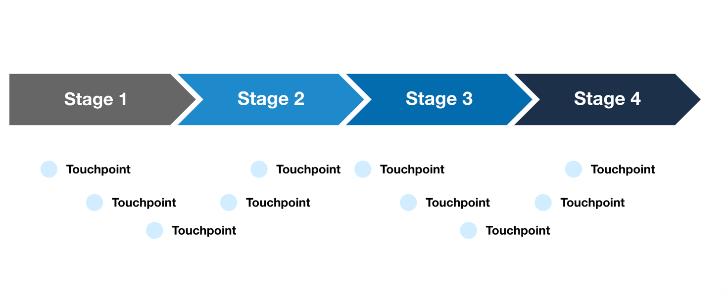

##### Cyclical Journey Map

A cyclical journey map shows the customer journey in a circular or repeating pattern, with the customer going through multiple cycles of engagement or interaction. This type of map is useful for showing ongoing relationships or repeated interactions between the customer and the product or service.

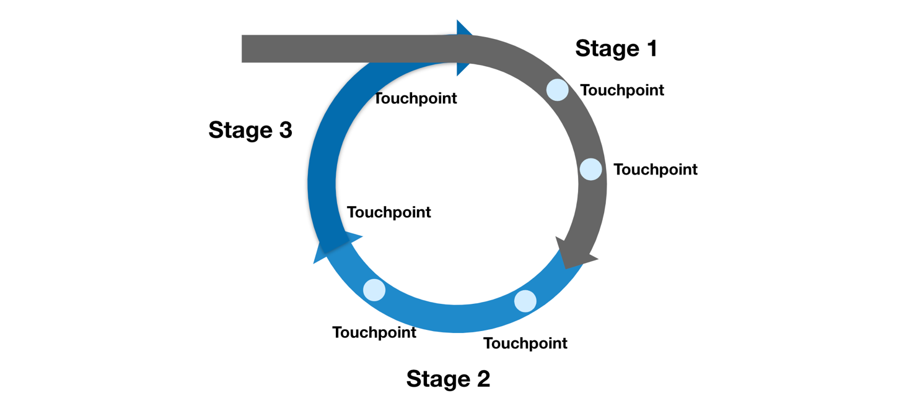

##### Multichannel Journey Map

A multichannel journey map shows the customer's journey across multiple channels or touchpoints, such as online and offline interactions. This type of map is useful for understanding how the customer interacts with the product or service in different contexts.

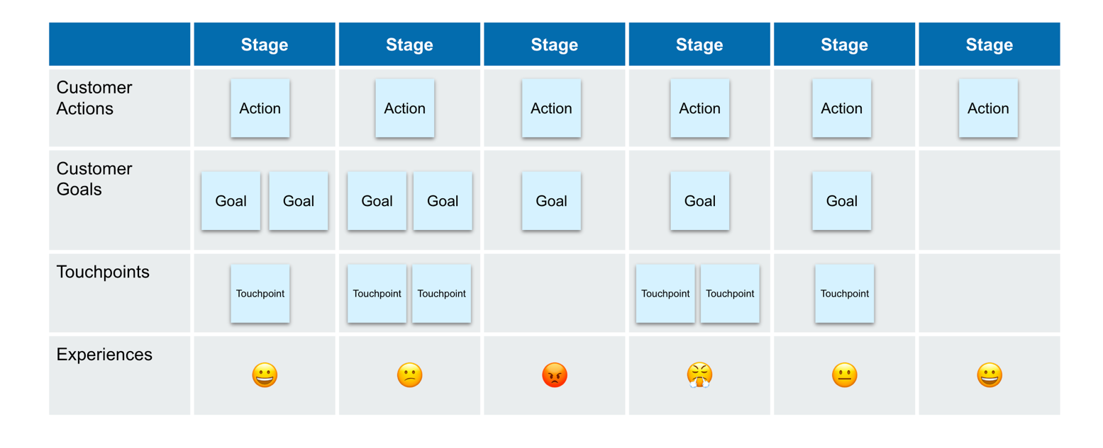

##### Service Blueprint

A service blueprint is a detailed map of the customer journey that includes not only the customer-facing touchpoints, but also the internal processes and resources that are necessary to deliver the service. This type of map is useful for identifying the people, processes, and technology that are necessary to deliver a high-quality customer experience.

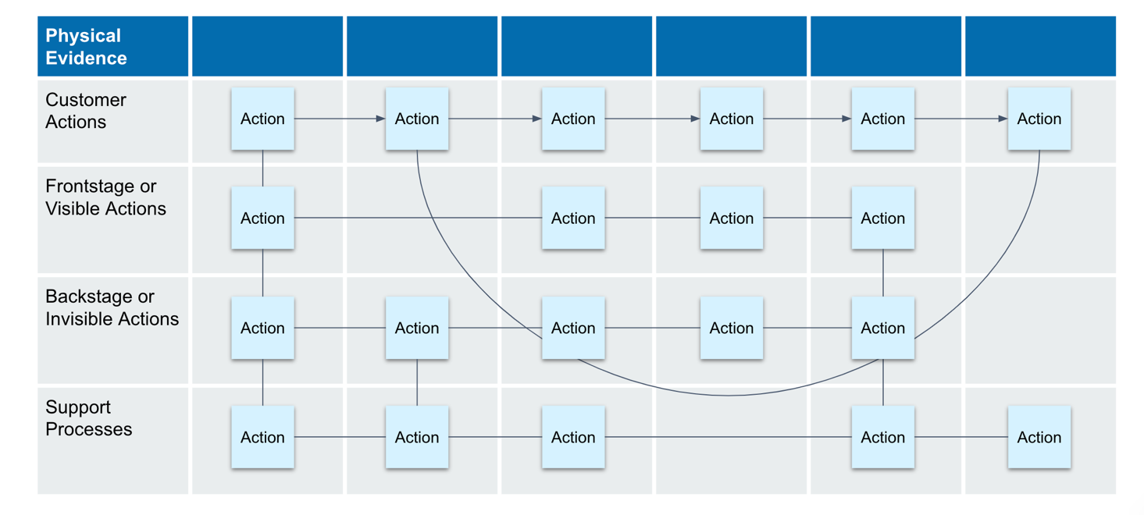

##### Day in the Life Journey Map

A day in the life journey map is a type of customer journey map that focuses on a typical day in the life of the customer, including all of the different interactions and touchpoints that they have throughout the day. This type of map is useful for understanding how the customer's experience with the product or service fits into their overall daily routine.

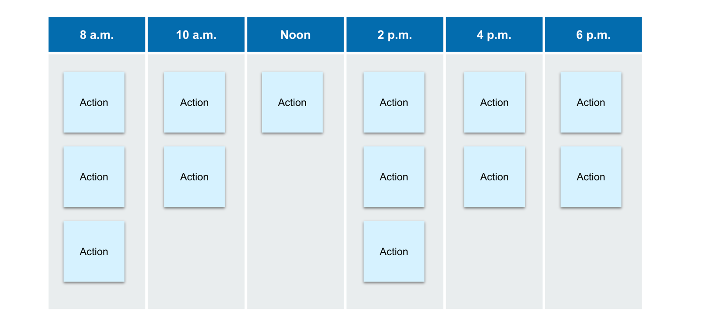

#### Benefits of Customer Journey Maps

1. Improved understanding of the customer experience
2. Increased customer satisfaction
3. More effective communication and collaboration
4. Better alignment with customer needs and goals
5. Increased efficiency

### Steps to Create Customer Journey Maps

1. Define your customer

* Conduct research
* Identify needs and goals
* Segment your audience

1. Identify your customer’s goals

* Understand their needs, wants and pain points
* Conduct surveys, interviews, and user testing

1. List the touchpoints

* Define the stages of the user journey
* Identify the touchpoints or interactions your user has with each stage
* List the touchpoints in chronological order
* Be as detailed as possible when listing touchpoints
* Make it visual

1. Analyze the customer’s emotions and pain points

* Use open-ended questions
* Look for patterns
* Use sentiment analysis

1. Create the customer journey map

* What specific customer journey are you mapping?
* What insights do you hope to gain from the map?
* Do you have a clear understanding of your goals?
* What channels do you need to include?

Overall, customer journey maps provide a powerful tool for the government to better understand and improve the customer experience, leading to increased customer satisfaction, loyalty, and profitability.

In Section 5 of this document, you can link to some published government Journey map examples.

## Section 5: Activities, Templates and Tools

Section 5: Activities, Templates and Tools 20

A. Tool: Resource Links 23

Government CX Mandates 23

Customer Experience Links 23

Journey Map Examples 23

B. Workshop 1 Activities, Templates and Tools 25

Activity 1: Define Your Customers 25

Activity 2: What Are Your Customers’ Touchpoints? 26

Activity 3: Where Does My Team Stand? 27

Activity 4: Team Mindset Challenge 28

Activity 5: Diversity, Equality, Inclusivity and Accessibility (DEIA) CX Checklist 30

C. Workshop 2 Activities, Templates and Tools 31

Activity 6: Practicing the HCD Mindset 31

Activity 7: Practice the HCD Mindset 32

Activity 8: Frame your Challenge 33

Activity 9: Discover your Challenge 34

D. Workshop 3 Activities, Templates and Tools 35

Template 1: Steps for Customer Journey Maps 35

Template 2: Best Practices for Customer Journey Maps 36

Template 3: Measuring Success 37

Activity 10: Create a Journey Map 38

E. Journal Prompts 39

F. Notepad 41

### A. Tool: Resource Links

To support teams in their customer experience efforts, it’s helpful to have access to a range of high-quality resources. In this section, we’ve compiled a list of a variety of resources that teams can use throughout the process. Whether you’re seeking technical guidance, best practices, or support from experts, these resources will provide valuable insights and support for your customer experience journey.

#### Government CX Mandates

[Priority 2: Delivering excellent, equitable, and secure Federal services and customer experience](https://www.performance.gov/pma)

[Executive Order on Transforming Federal Customer Experience and Service Delivery to Rebuild Trust in Government](https://www.federalregister.gov/documents/2021/12/16/2021-27380/transforming-federal-customer-experience-and-service-delivery-to-rebuild-trust-in-government)

[Managing Customer Experience and Improving Service Delivery](https://www.performance.gov/cx/assets/files/a11_2020_sec280.pdf)

#### Customer Experience Links

[Performance.gov’s Federal Customer Experience Resource](https://www.performance.gov/cx/)

[Centers of Excellence Customer Experience homepage](https://coe.gsa.gov/coe/customer-experience.html)

[Government-wide CX Community of Practice](https://coe.gsa.gov/communities/cx.html)

[HCD Discovery State Field Guide](https://www.gsa.gov/cdnstatic/HCD-Discovery-Guide-Interagency-v12-1.pdf)

[Centers of Excellence Customer Experience (CX) Maturity Model](https://coe.gsa.gov/docs/CXMaturityModel.pdf) (PDF)

[Centers of Excellence Customer Experience Playbook](https://coe.gsa.gov/docs/2020/Customer%20Experience%20Playbook-Nov%202020.pdf) (PDF)

#### Journey Map Examples

[Mapping the Cross-Agency Customer Experience Journey](https://www.performance.gov/cx/blog/mapping-cx-journey/)

[CX Journey Map Example](https://www.performance.gov/cx/assets/files/Service_Member_Transition_to_Civilian_Employment_Journey_Map.pdf)

### B. Workshop 1 Activities, Templates and Tools

#### Activity 1: Define Your Customers

Who are your customers? A customer is anyone you serve, directly or indirectly.

The customers of your organization are those whose needs you’re trying to satisfy through building or updating the product or service.

**Add your customers here:**

#### Activity 2: What Are Your Customers’ Touchpoints?

Some examples of touchpoints could include: websites, social media, Community resources, customer service/call centers, digital product experiences, in-person interactions, statutes and regulations.*

* Invisible to customers but highly impactful

Your customer’s touchpoints may include some of those listed. Reference **Activity 1: Define Your Customers** as a jumping-off point to list as many of your customer’s touchpoints as possible.

**List Your Customer’s Touchpoints:**

#### Activity 3: Where Does My Team Stand?

Let’s take a closer look at your current CX mindset. Where are you falling short? How can you make improvements in your organization’s mindset?

Review this checklist below to learn if your organization has the following key attitudes and behaviors.

* Willingness and ability to respond
* Enthusiastic leadership that prioritizes and champions customer needs and infuses customer-centricity throughout the organization’s culture in a systematic way
* A compelling belief that even if the customer’s request is denied, the experience can be vastly improved
* Champions who listen to the ideas of employees
* Iteratively tested products – responsive, seamless, and intuitive to use
* Treated users with dignity and respect, and shown an understanding of the situation or crisis they may be facing when seeking a service or resolution
* Employees who show trust and confidence in the institution and its ability to help the customer address their challenges

#### Activity 4: Team Mindset Challenge

Where does your organization’s CX team need improvement?

Use the **Activity 3: Where Does My Team Stand?** checklist of attitudes and behaviors to add your organization’s CX challenges in order of highest (1) to lowest (10), and add any others.

#### Activity 5: Diversity, Equality, Inclusivity and Accessibility (DEIA) CX Checklist

Diversity, Equity, Inclusion and Accessibility (DEIA) are essential to improving Customer Experience for all. Since federal agencies rarely have one “target customer,” DEIA and Customer Experience are inextricably linked.

DEIA principles should not just be about accommodating or retrofitting. We need them to guide our efforts from the outset. Regardless of the level of CX maturity, all organizations should optimize the following essential elements of customer experience.

Consider this your DEIA CX checklist. You can mark the items as True or False as they apply to your organization.

True or False: **Diversity**: Customer experiences are free of institutional bias.

True or False: **Inclusion**: The organization helps everyone feel welcome to become their customers.

True or False: **Equity**: The organization treats all customers fairly, justly and impartially.

True or False: **Accessibility**: The widest possible audience can experience the organization’s services to the fullest. It is important to be 508-compliant, use plain language, ensure language access, and strive for excellence.

### C. Workshop 2 Activities, Templates and Tools

#### Activity 6: Practicing the HCD Mindset

Let’s practice the Human-Centered Design (HCD) mindset. Think of a problem you or your team is facing.

**Detail the challenge here:**

#### Activity 7: Practice the HCD Mindset

Answer the following questions considering **Activity 1: Practicing the HCD Mindset.** This is a great activity for a group discussion.

1. How might we address this problem?
2. What use cases would they have?
3. What challenges do they face?
4. What empathy can you bring to the problem area?
5. What optimistic solutions could you produce to address this problem statement?
6. What would you do to test your idea?

#### Activity 8: Frame your Challenge

Thinking about **Activity 1: Practicing the HCD Mindset**, answer the following two questions to practice framing your challenge. Remember, measuring success is a key element to framing the challenge.

What are the intended outcomes?

How will you measure success?

#### 

#### Activity 9: Discover your Challenge

Thinking about the challenge defined in **Activity 1: Practicing the HCD Mindset**, answer the following two questions to practice discovering your challenge.

What are the hypotheses about the problems people face?

How might you go about better understanding people’s experiences?

### D. Workshop 3 Activities, Templates and Tools

#### Template 1: Steps for Customer Journey Maps

As part of laying the foundation for your journey map, use this table to get started with these five high-level steps to create a journey map. Each step listed here is a jumping off point for the detailed journey mapping process. You can mark when you’ve started each step, and enter your initial responses in the table. Use this table to get started as you begin your journey map.

| **Started?** | **Step** | **Response** |
| --- | --- | --- |
|  | 1. Define your customers |  |
|  | 1. Identify your customers’ goals |  |
|  | 1. List the touchpoints |  |
|  | 1. Analyze the customers’ emotions and pain points |  |
|  | 1. Create the customer journey map |  |

#### 

#### Template 2: Best Practices for Customer Journey Maps

Follow these best practices to ensure your journey map starts strong and stays on track. These best practices as well as the steps in **Activity 2: Steps for Customer Journey Maps** are intended to be used as both starting *and* ongoing tools in the creation of your journey map, so you can come back to them again and again as you iterate and refine your journey map practice.

| **Started?** | **Best Practice** |
| --- | --- |
|  | Start with a clear goal |
|  | Map the entire journey |
|  | Keep it simple |
|  | Focus on the customer's perspective and emotions |
|  | Use visual format |
|  | Make it collaborative |
|  | Iterate and refine |

### 

#### Template 3: Measuring Success

Planning for success starts at the beginning of your project, and one of the many benefits of this human-centered process is the ability to measure your success. In the framing phase, teams establish what the objectives are of the project and how success will be determined. The table below details a sample list of objectives that commonly guide CX efforts. Use the table below to support your efforts to measure your success.

| **Objective** | **Metric** | **Target** |
| --- | --- | --- |
| Improved understanding of the customer experience | What will you use to determine the outcome of your project? | What will your target for success be? |
| Increased customer satisfaction |  |  |
| More effective communication and collaboration |  |  |
| Better alignment with customer needs and goals |  |  |
| Increased efficiency |  |  |

#### Activity 10: Create a Journey Map

Refer to the collected information in the above Templates 1, 2, and 3. Use the tools available to your team, such as online whiteboards, sticky notes, markers, and other collaborative tools, to begin the first steps of journey mapping.

1. Identify an organizational problem or opportunity. Clearly define the project’s objectives and goals.
2. Identify project team members (by role).
3. Create a draft, high-level overview of the:
   1. Phases
   2. Steps
4. 2-3 pain points per phase.
5. Identify what sources of information you will need to validate and/or complete the journey map.

### E. Journal Prompts

The purpose of the *Enabling Customer-Centric Innovation in Government Agencies* workshop series is to support both individuals and teams executing internal change initiatives. Reflect on what you learned in this session and how you might leverage that moving forward in the following seven journal prompts.

1. To which project might you be able to apply the knowledge and skills from this session?
2. How can the customer experience approach detailed throughout these sessions benefit that project?
3. How does Human-Centered Design play a role in our customer focus?
4. What are some of the key considerations that you need to keep in mind when developing a journey map for your project?
5. How will you measure the success of your project, and how will the journey map help you to track and evaluate your progress?
6. Are there any challenges that you foresee in implementing these CX and HCD approaches, and how do you plan to overcome them?
7. What questions do you still have around CX within your organization?

### F. Notepad

Use the space below to jot notes and/or brainstorm ideas.

**Thank you**_______________________________________

To learn more, email us at   
[**connectcoe@gsa.gov**](mailto:connectcoe@gsa.gov)