**Unity Health Care, Inc.**

**Phase 2 Hypertension Challenge Submission**

**SCREEN SHOTS and IMAGES**

**EMR Hypertension Progress Note**

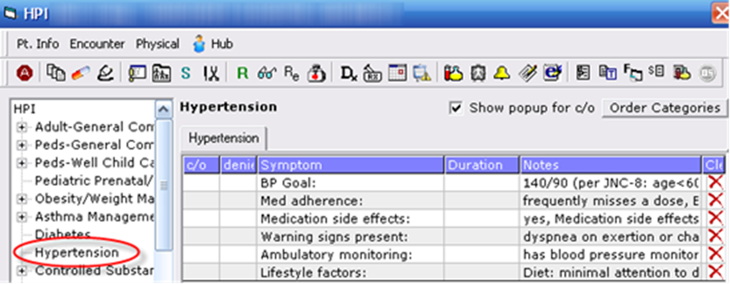

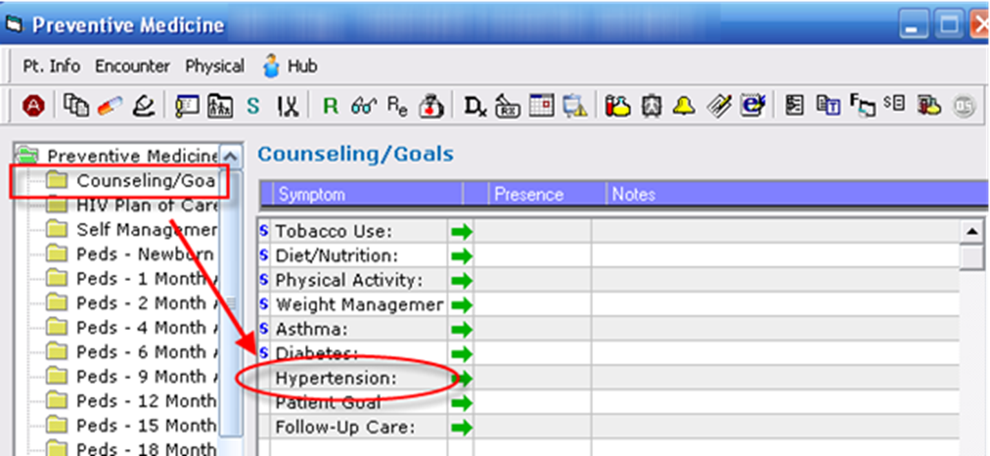

**Nurse BP Visit Template**

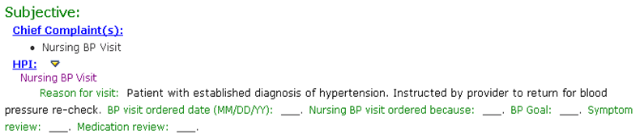



**“Red, Rest, Repeat” Campaign Report based on EMR Query**

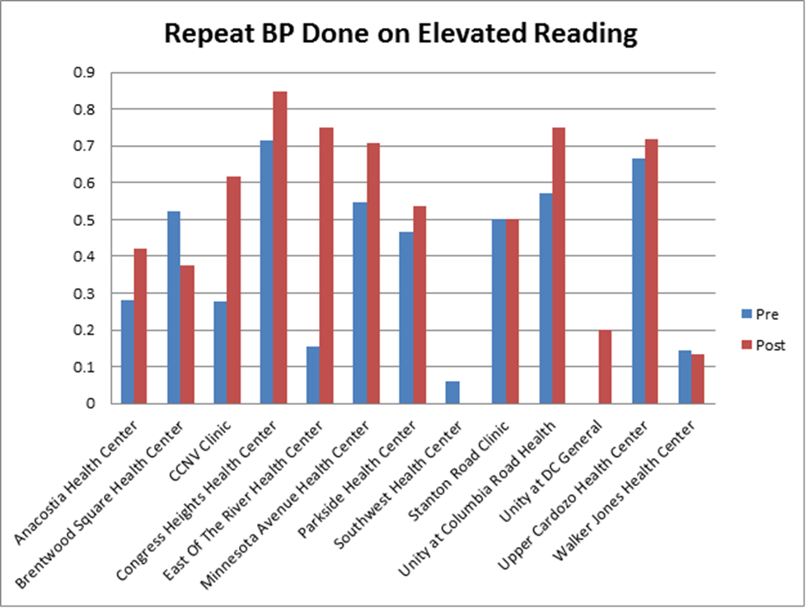

**The Heart of Gold Trophy**

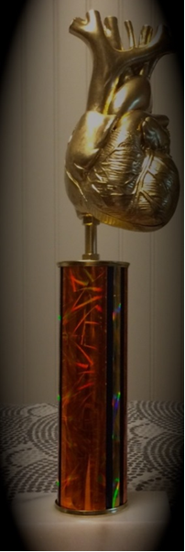

**Columbia Road Health Services, first winner of the Heart of Gold Award**

