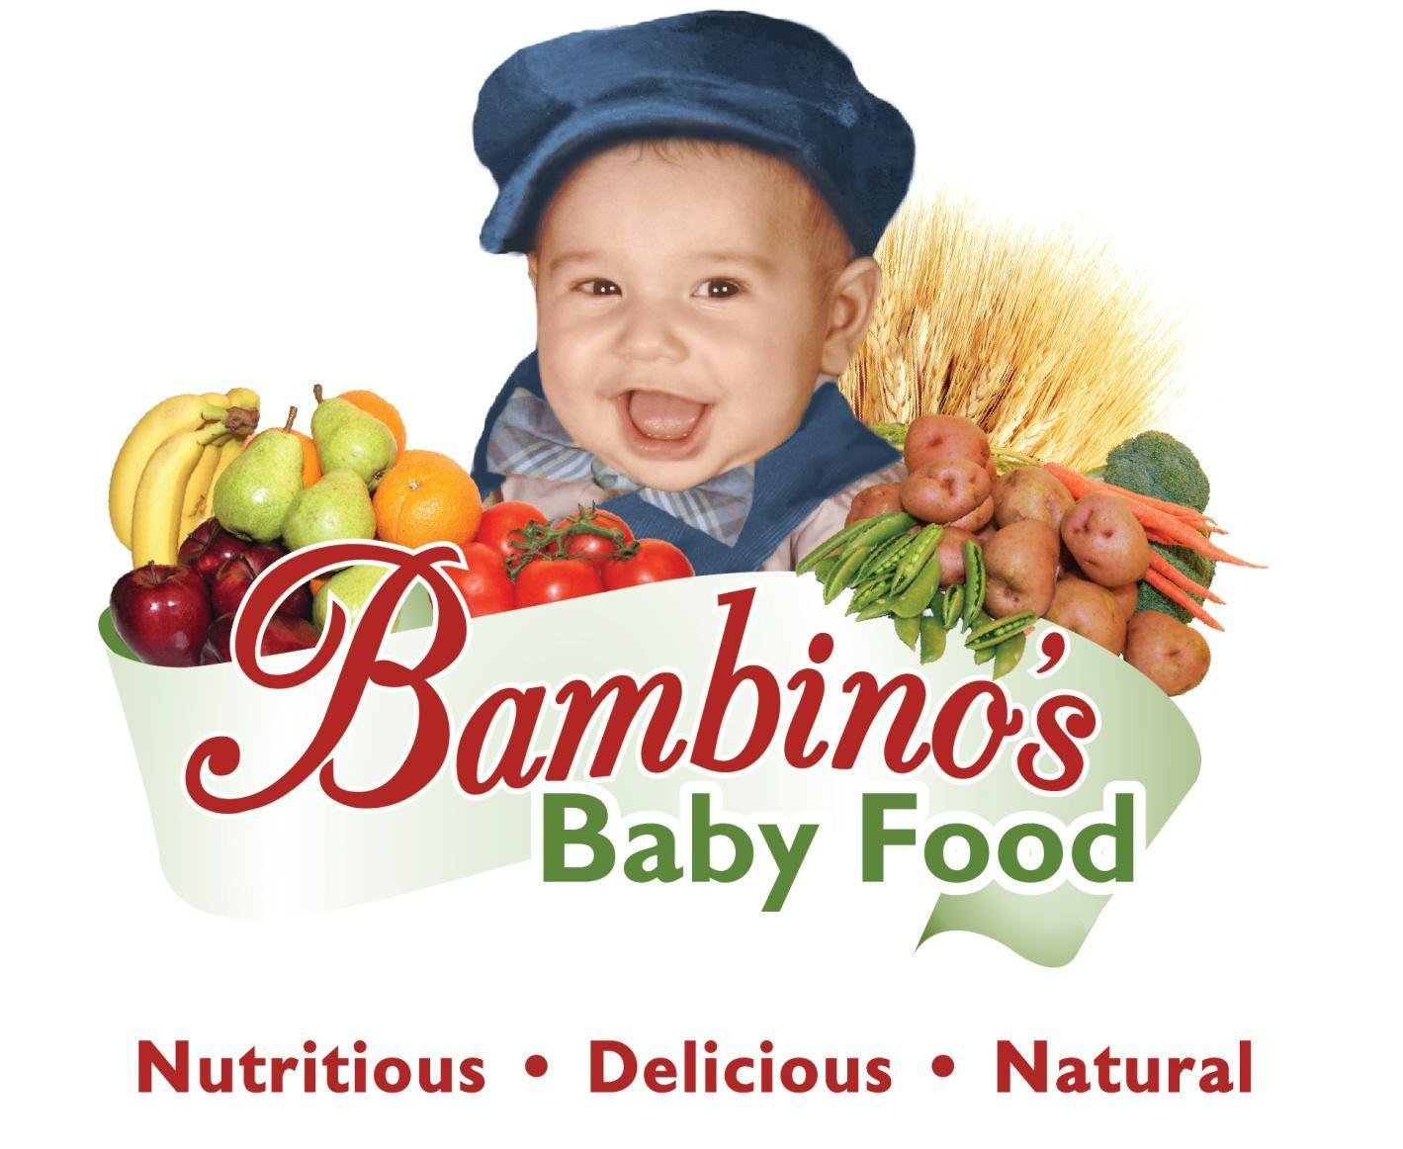

**Company Information**

Name: Bambinos Baby Food, LLC

Contact: Zoi Maroudas-Tziolas, President, [zoi@bambinosbabyfood.com](mailto:zoi@bambinosbabyfood.com), (907) 301-5932

Purpose: Healthy nutrition for infants, children and adults

Organization: For Profit Privately-held Limited Liability Corporation

State of Incorporation: Alaska

Founded: August 14th, 2012

Address: 2809 Spenard Rd, Anchorage, Alaska, 99503

Website: bambinosbabyfood.com

**Table of Contents**

1. Introduction Page 3

2. The Baby Food Industry Page 4

3. Our Company Page 8

4. Marketing Page 12

5. Operations Page 14

6. Management Page 16

7. Financial Information Page 17

8. Risks Page 19

Appendix I – Product Line Descriptions Page 21

Appendix II – Equipment Description Page 22

Appendix III – Financial Projections Page 23

**1 Introduction**

In today’s world, parents are busier than ever. Yet they take the time and cost prohibitive measures to create their own baby food. This shows the market has not evolved with the times. Bambinos Baby Food (“Bambinos” or BBF) is the next generation baby food brand. Bambinos’ exclusive purpose is to provide fresh frozen, top quality nutrition and convenience to babies and parents. Founder Zoi Maroudas has combined her unique knowledge of both medicine and Mediterranean cuisine to blend nutrition and flavor like never before. One may ask, “Why flash freeze baby food?” The answer is much simpler than one might assume: boiling points and cooking duration. Shelf stable foods must be heated and maintained at high temperatures for a longer period of time which breaks down the natural nutrients. Flash freezing baby food to preserve quality nutrition and reduce ice crystal formation enhances those nutrients.

The baby food industry has remained the same for the past 8 decades. However, lifestyles, pesticide use and newer transportation methods that preserve freshness have evolved. Mrs. Maroudas, who founded Bambinos in 2012, is a successful businesswoman and restaurateur with life-long experience in preparing healthy, nutritious meals. She has also received formal education in medicine and business development.

The combination of these parts of her background produced Bambinos. Mrs. Maroudas leveraged her expertise in nutrition to formulate a set of dietary requirements for babies. Bambinos recipes combine traditional Mediterranean cooking with locally grown, organic and nutritional produce. It is her desire to address our nation’s escalating obesity and childhood allergies through the variety of her baby food products.

***Bambinos Mission is to provide “Frozen Fresh” healthy, tasty, nutritious and delicious foods to infants and children throughout America.***

The products that Bambinos creates are free of additives and preservatives and emphasize locally grown and certified organic foodstuffs. They require quick and simple preparation because they are intended for, but not limited to, working parents and caregivers. Bambinos products are fresh-frozen to preserve the highest quality of nutrition. Each package comes with a complete balance of protein, carbohydrates, fruits and vegetables.

Parent /guardian values and needs in the $55 billion baby food market have changed and are continuing to do so. Parents increasingly value their time, but they increasingly value nutrition and convenience as well. The large commercial providers of baby food are not meeting these new concerns. Bambinos is positioned to meet these changing needs and contribute to the development of a unique market segment that is innovative and someday will redefine the baby food industry.

**2 The Baby Food Industry**

**2.1 Overview**

Consider some well-recognized characteristics of parents today. Moms and Dads are far busier than ever before. More parents take an active approach to their child’s nutrition and education. Family roles are shared and there are more single parents than ever in our nation. Families are and must be more sensitive to prices and the management of their time.

What baby food products are available to these parents? The perception is that the baby food currently available in the mass market is of poor quality. Around one-third of the baby food consumed is made at home because of this quality concern in the industry. Many parents spend evenings or a large part of their weekends boiling and puréeing, then freezing or filling jars because they don’t like what’s on the grocery shelf. These efforts cost parents time away from loved ones, money for ingredients and is a significant inconvenience to the family.

The values of nutrition-aware consumers are understandably influencing the baby food industry where consumers are making informed decisions on the type of baby food they purchase. Gerber, the US baby food industry leader (acquired by Nestle in 2007), serves as a useful example of how the industry is failing to meet today’s values. Historically, their offerings show little effort to change and respond to the powerful new trends among economic and nutrition conscious parents. The baby food market is open to innovators.

Innovation has succeeded before. In 1975 Beech-Nut was struggling with a marginal market share and launched a campaign to eliminate salt from baby foods. Investing over 1 million dollars in their marketing campaign, they raised public awareness and forced Gerber and other large baby food manufacturers to follow their lead by redesigning their recipes to eliminate “added salt”. In turn Beech-Nut’s market share rose from 6% to 25%, establishing this company as a maverick in the field.

**2.2 Competitors**

Current baby food manufacturing competitors produce up to two-thirds of the market of consumed baby food. The commercially produced baby food market is roughly divided between Gerber at 70%, Beech- Nut at 15%, Earth’s Best at 10% and a new and upcoming company, Plum Organics at 5%. The other third of the market of consumed baby food is homemade and nutrition-aware parents make these homemade purées. These findings are taken from market research funded by Beech-Nut. The percentage of homemade baby food has been steadily rising over the last several years. Some new entrants in the commercial segment are brands with exotic flavors and attractive packaging in pouches which facilitate rushed meals “on the go” for busy parents. Convenience is continually gaining market share.

**2.3 Opportunity for Competition**

There are 4 million babies born each year in the US, with a growth rate of 3%. There are 22 million infants and toddlers. The baby food market was $36.7 billion in 2010 estimated to grow to $55 billion in 2015. The percentages of parents who are taking more risks and spending more money for products that fit their new nutritional, economic and emotional values are high. The numbers of consumers and the expenditures on baby food represent a tremendous business opportunity for an appropriately positioned innovator. Plum Organics, a company founded in 2006 is currently leading in the commercially provisioned organic market. In 2010, it was sold for $249 million to Campbell Soup Corporation and in 2012 generated $93 million dollars in sales. They have conditioned the market for a new competitive entrant like Bambinos.

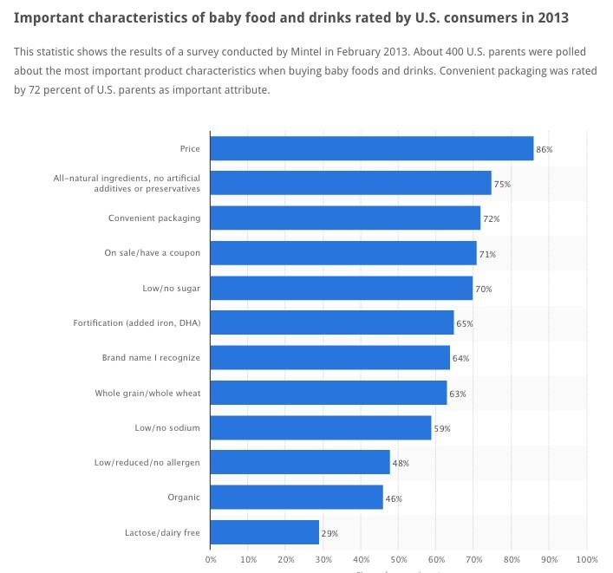

*Source: www.statista.com*

Kosher, organic, gluten free and other specially prepared baby foods in a multiplicity of convenient packages with a light carbon footprint and other niche offerings are emerging. This demonstrates that the baby food market is amenable to change and innovation.

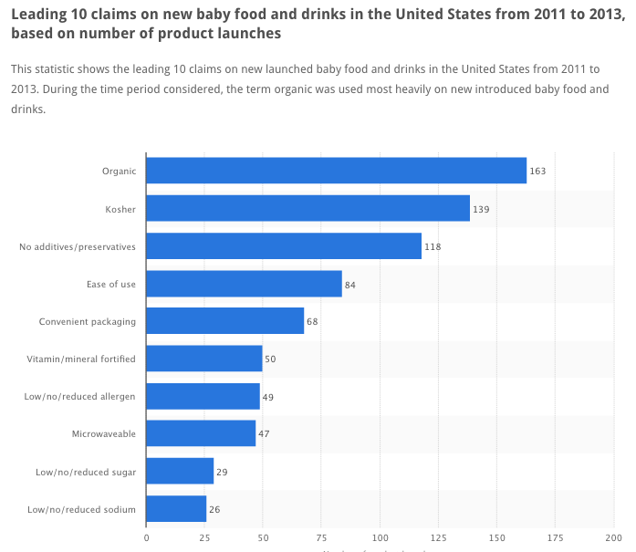

*Source: www.statista.com*

**2.4 United States**

In households with two parents, the majority have both parents working. The number of single parent households is steadily increasing. According to the US Department of Labor, 70% of mothers are employed full-time. Parents who make their own baby food often feel like Erika Radtke, who stated, “It was a pain. I used to take a whole weekend to cook the foods, portion it out into ice cube trays, freeze them and store them”.

Allergies, obesity and proper nutrition are national concerns in practically every household with children. The introduction of healthy eating habits in the early stage of a child’s eating development will form habits for life. Current baby food markets are creating more flavored shelf-stable products for parents who are creating food at home, but that is not enough. Bambinos has the advantage of targeting both parents creating their own baby food, and those using already existing baby food brands.

Some parents who have tried and given up on homemade baby food point out these disadvantages:

**a) Time.** It takes time to make and prepare lots of little servings of homemade baby food. It’s much faster to pick up prepackaged servings.

**b) Convenience.** Prepackaged baby foods come in measured amounts and are ready to serve.

**c) Storage.** Homemade baby foods may spoil more quickly and take up room in the freezer if many servings are prepared ahead of time.

Bambinos approach to baby food consumers as a whole is to throw a net rather than a single line into the school of consumers. Both homemakers and store buyers experience the advantages of our products.

Our broad target markets are families with infants and toddlers. Within the target market, the areas of special concern are:

a) Children who are purported to have dietary concerns such as obesity and food allergies (estimated at 43%[1]); and

b) Parents who are health conscious, heath aware and are working or have busy lifestyles, seeking convenience without sacrificing nutrition and flavor.

According to NACCRRA.org[2], 70% of households that have two parents working also have children. In single parent families, 82% have children. Therefore 72% of all working parents may prefer Bambinos products for quality and convenience. This is a plausible market for Bambinos products.

**3 Company**

**3.1 Overview**

Bambinos Baby Food is a woman founded local Alaska manufacturing company. The business focuses on creating and manufacturing nutritional and savory baby/toddler and adult pureed meals that will be sold in the United States. Bambinos provides quality nutrition in a uniquely frozen form.

Bambinos products address the primary concerns in the US baby food market: (a) nutritional content and (b) accessibility.

Nutritional content is maintained by excluding all preservatives and food colorings and by incorporating only fresh foods in preparation using locally grown products whenever possible. All products are carefully balanced so that children will receive a balanced diet with emphasis on preserving flavor. Every portion has a complete balance of protein, carbohydrates, fruits and vegetables. Products requiring preparation are flash-frozen to preserve their exceptional nutritional values. Meals can be prepared directly from a frozen state using a microwave or by heating in a small saucepan.

Bambinos currently uses locally sourced produce where possible, thus adding value and synergy to the local community. Parents will relate to the origin and nutritional value of the produce used in Bambinos baby food. Infant meals can be prepared in under a minute, cutting down preparation time for the busy or working parent. Bambinos products are best served warm, but can also be eaten at room temperature.

An immediate business goal of Bambinos is to successfully manufacture large-scale quantities of baby food up to the capacity of the equipment the company intends to acquire. This will allow Bambinos a unique opportunity to demonstrate that enough products can be produced to supply supermarkets and online sales orders. Bambinos will be the only baby food company producing fresh frozen baby food on a large scale for infants and toddlers. The product line encompasses top nutrition, flavor and a complete balanced meal for all the major food groups in every bite.

In addition, Bambinos offers a competitive variety of products appealing to vendors and consumers. To ensure product growth and awareness other than through normal marketing approaches, the company will seek referrals and feedback from its customers.

**3.2 Products**

Our feature product line description, noting highlights from each meal can be seen below:

**Single Ingredient (4 months+):**

* **Googly Carrots:** Sweet and velvety smooth with 465% DV of vitamin A. Important for vision and bone development.
* **Happy Peas:** Fresh and crisp sweet peas with 43% DV of natural DHA important for brain development.
* **Yummy Yams:** Smooth and creamy yams with 32% DV Folate essential for heart development.

**Hearty Meals (5 months+):**

* **Hali Halibut:** Alaska Halibut accompanied with veggies and grains. Excellent source of natural Omega 3.
* **Hearty Stew:** A perfect balance of protein grains and vegetables in every spoonful.
* **Hungry Munchkin:** Pasta with vegetables, a great primer for young eaters.
* **Oodles of Noodles:** Baby version of pasta with peeled tomatoes, carrots, filet mignon.
* **Salmon Basket:** Fresh wild Alaskan Sockeye Salmon with veggies and grains that a deliver significant amount of Omega 3 and folate essential for brain and heart development.
* **Summer Harvest:** Creamy tomatoes with a hint of chicken, puréed to a velvety smooth finish. This dish offers 280% DV of Vitamin A.
* **Sweet Spring Veggies:** Delightful sweet spring vegetables with chicken and a twist of lemon, featuring a staggering 440% DV of Vitamin A and a significant source of Folate and Niacin.
* **Vegetable Stew with Filet Mignon:** Filet mignon with crisp cut vegetables in a warm and comforting stew for evening meals. A staggering 98% DV Folate, 58% DV Niacin and 14% DV Iron is provided by this meal.
* **Veggies with Chicken:** Tender chicken with vegetables, reduced and 280% DV vitamin A, important for vision and bone development from beta carotene.

**Cookies and Cereals (4 months+):**

* **Bebalu Cookie:** Delicious and very nutritious teething cookies which fit perfectly in little hands. Each cookie offers a bountiful amount of Vitamins from B, C, B12, Iron and Folate.
* **Breakfast Cereal with Fruit:** Delicate pudding-like cream, rich with natural sweetness from fresh squeezed oranges and mangoes. Perfect for breakfast or a light snack, providing a significant source of Calcium and protein.
* **Carrot Orange Biscotto:** Carrot Orange Biscotto are a perfect snack and fit just right in baby’s hands. It delivers a wonderful amount of nutrition from the carrots and oranges. All the sweetness comes from fresh squeezed oranges and orange zest.
* **Peanut Mani Cookie:** Specially formulated to help reduce the frequency of peanut allergies in children at risk for developing this allergy by 72 percent.

These same products can become additional products by adjusting the emulsification time and changing labels for ages 2 to 4.

Additional information including label samples can be found in the Appendix.

**3.3 Target Market**

Bambinos target market is families seeking top quality nutrition, fresh frozen products, flavor and a healthy start in their child’s life. The simple convenience and storage of the Bambinos products will attract working parents with middle to high incomes and caretakers who make their own baby food in addition to those looking for Organic/Kosher products. Busy parents who purchase their baby-food from Bambinos can rest assured that the menu addresses every dietary requirement identifiable in current literature. Bambinos will appeal to parents who prefer making their own baby meals. Its product are fresh, organic and have a complete balance of protein, carbohydrates, fruits and vegetables in every pureed bite offering all around quality nutrition, flavor and convenience.

**Subscription Model:** Bambinos offers online subscriptions for those who want to buy monthly and have products delivered to their door-step as well as large and small retailers. Bambinos can to deliver direct to regional distribution centers such as Whole Foods and Central Markets.

**3.4 Value Added**

In a representative comparison of products currently offered by Bambinos and a leading competitor, Bambinos’ Sweet Spring Veggies and a similar Gerber product[3] stack up as follows:

|  |  |  |  |
| --- | --- | --- | --- |
| **Item** | **Bambinos (per oz)** | **Gerber (per oz)** | **Difference BBF to Gerber** |
| Vitamin A | 122% | 17% | × 7 more |
| Vitamin C | 20% | 0% | *\* No contest* |
| Calcium | 7% | 1% | × 7 more |
| Protein | 30% | 6% | × 5 more |
| Iron | 7% | 0% | *\* No contest* |
| Price | $0.75 | $0.62 | 13 cents (per oz) |

Bambinos delivers approximately tenfold the nutritional value of leading market competitors. This is the result of the company nutritional research and product development - the cornerstone of the company values.

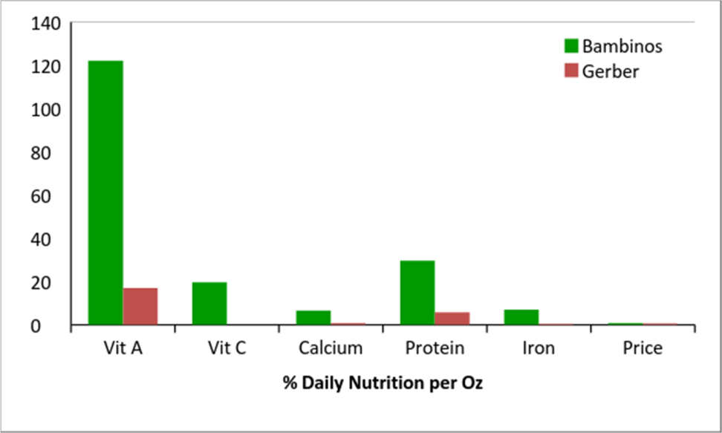

Preserving the nutritional content of the ingredients also enhances the flavor which makes children prefer better quality food and helps form better eating habits for life.

## Baby Food Product Comparison Matrix

|  |  |  |  |  |
| --- | --- | --- | --- | --- |
|  | **Gerber** | **Beech-Nut** | **Plum** | **Bambinos** |
| Frozen |  |  |  | ● |
| Organic | ● | ● | ● | ● |
| Kosher |  |  |  | ● |
| No Additives | ● | ● | ● | ● |
| Veg/Carb/Pro in 1 |  |  |  | ● |
| Gluten Free |  |  |  | ● |
| Savory Delicious | **?** | **?** | **?** | ● |
| Highest Nutrition |  |  |  | ● |
| Portion Control |  |  |  | ● |
| Alaska Water |  |  |  | ● |

**3.5 Structure**

Bambinos is currently organized as an Alaska Limited Liability Company with one member – Zoi Maroudas. An unofficial group of professionals are advising Zoi during the start-up process. For tax purposes, Bambinos initial losses are being absorbed by Zoi and her husband with the resulting tax advantages accruing to them. Zoi anticipates converting Bambinos Baby Food LLC to a Subchapter C corporation once outside investors are identified.

**4 Marketing**

**Website**

The Bambinos website has a fresh, modern and clean design. Bambinos is working with a web developer to optimize user experience and to simplify subscription sign-up and user subscription management. The website will always reflect Bambinos values: clean and fresh, premium quality, convenient and easy to use.

**Social Media Strategy**

Bambinos will have a robust social media presence. It is developing and deploying an aggressive social media strategy designed to build brand awareness and loyalty (customer retention) and attract new customers. Most of the marketing will be focused on Facebook and Instagram, though additional platforms will be explored. The social media plan will be directed at independent consumers and corporate entities.

**Online Advertising**

Bambinos will use paid media to increase social media followers to ultimately drive traffic to the Bambinos subscription website. The paid media strategy will include paid Facebook advertising to boost Facebook page posts and content as well as separate paid advertisements to connect prospective customers to Bambinos website. Retargeting, Pay Per Click and display ads will also be used as portals to the website. The company will use Google AdWords and Analytics to help increase traffic and/or conversions.

**Promotion through Influencers**

Bambinos will also pay influencers to tweet or share links about Bambinos products on Facebook, Twitter and Instagram. Influencers will include Mommy Bloggers and other parents with large followings.

In addition to Bambinos paid social media strategy, it will engage top Mommy Blogs whose readership includes the company’s target markets and will pay them to write about Bambinos. The ultimate goal will be for mommy bloggers to review and endorse Bambinos products and subscription service. Bambinos will also sponsor contests and provide product giveaways as a way to drive more traffic to the Bambinos website and increase subscriptions.

Bambinos has registered with mysubscriptionaddiction.com, a major subscription box directory and review website that has a “Baby Subscription Box” category and subsection.

**Traditional Media**

Bambinos will also engage writers for baby & toddler magazines and for parenting magazines with a focus on young children to secure earned media and articles that highlight the Bambinos story and products. In addition, Bambinos will pay for advertising in these publications to reach our target markets. Bambinos will also explore paid sponsorship of baby and toddler podcasts and podcasts about parenting.

**Public Outreach**

Finally, Bambinos will participate in or sponsor mom and baby fair shows to build brand awareness and to sign-up new subscribers. Sample packages will be available for inspection and a laptop computer will make sign-up immediately available.

**Local**

Samples and literature will be made available through local hospitals (labor/delivery/baby gift shops) and Birthing Centers. Flyers and information packets will be given for to OBGYN, Pediatrician and Allergy Specialist offices.

Everyone involved in Bambinos growth will be expected to pool connections with media, news, magazines, bloggers, etc. to promote Bambinos products and the company.

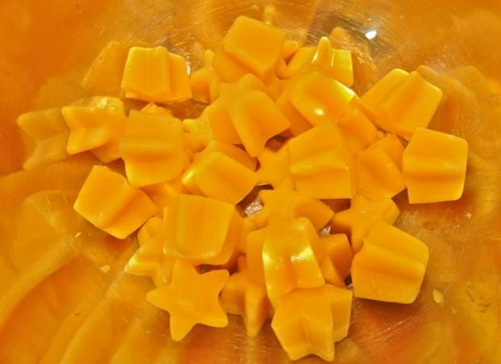

*Example of Bambinos recognizable serving delivery. Fun and delicious frozen cubes in a variation of shapes. The child’s meal is thawed before serving with just the right quantity for the majority of children.*

**5 Operations**

**5.1 Manufacturing and Distribution Operations**

Location:

*Location 1*

A 5,000 sq. ft. subleased space has been identified in the Midtown area of Anchorage. The site offers great visibility and accessibility for the company. The landlord is amenable to expanding the location space to an additional 8,000 sq. ft. in an adjoining warehouse. The location can be extended from the existing space, where access to ventilation and a bay door can be configured to suit company needs. Rent is estimated at $1.25 per sq. ft., negotiable for a long term lease.

*Location 2*

A 5,300 sq. ft. lease-to-own building is available in Central Texas on Interstate 35. The site offers a preexisting kitchen plus walk in coolers and freezers.

Major steps to be taken to prepare for operations include: 1) remodeling the building to support equipment with electricity and plumbing; 2) licensing from DEC for the new kitchen; and 3) setting up lines for custom order packing and inventory processing.

*Location 3*

A 23,452 sq. ft. building available for sale, offers perfect setup for manufacturing facility. Includes 3 bay doors, 3 phase electrical, tall ceiling, office space and a area great for setting up storefront.

**Production:**

Baby Food: Processing will begin and end using a KS Mixer / Homogenizer. Proteins, fruits, vegetables and carbohydrates will be added at certain times to assure optimum nutrition value. After each product is cooked and processed, it will be transferred to a holding tank which then be packaged and sealed with 9003 FFS. Completed product with then be flash frozen and ready distribution.

Teething biscuits: Ingredients will be combined in the mixer and then transferred to B22 where they will be shaped and cut. Workers will then place the biscuits on a sheet to be baked. Once cooled, they will be placed in automatic open fill and seal machine Zippy Bagger.

**Shipping:**

Products will be shipped to clients with a variety of carriers, such as Linden Transport, Frozen Fulfillment Centers, UPS, FedEx and Everts Air Cargo. This will ensure that the company can meet the needs of its customers as well as providing alternative delivery systems to satisfy company needs and costs.

**5.2 Product Development**

Bambinos has identified high efficiency / high yield food manufacturing equipment with the capacity to produce approximately 600,000 product items per month (minimum estimate) working 8 hours per day 24 days per month.

The company will produce baby-foods consisting of a variety of ingredients including vegetables and meats, and in various combinations. Single, double and multiple ingredient meals will be manufactured. Baked snacks such as teething cookies, snack bars, and the like will also be part of the product line. The meals will be fresh frozen and packaged, boxed, stored and shipped to consignment centers in the lower 48 states.

Product distribution will be made through consignment hubs and direct distribution centers. Sales will also be generated through online portals including, but not limited to, Bambinos website, Diapers.com, Amazon.com and other online businesses that distribute frozen products.

A company storefront will sell products directly to consumers that will also achieve company’s complete transparency to parents and caregivers. This will also provide parents direct contact/trust with our company products. Bambinos Baby Foods have been tested in a number of local retail outlets including New Sagaya, Pizza Olympia, Amber’s Olive Oils and Anchorage’s Farmers Markets since March 2014. Vendors who have expressed interest in carrying Bambinos Products are Costco, WholeFoods, Kroger/Fred Meyer and Albertsons/Carrs, The Fresh Market. As previously stated, mass production will be crucial to supplying these vendors.

**5.3 Labor Requirements**

Two employees are needed to operate the high efficiency food manufacturing equipment at low capacity: a manufacturing operation manager and a cook’s helper. An assembly line will be needed to package products directly into bags and heat-seal them. All employees of Bambinos will be needed for that process.

As demand grows Bambinos will add additional personnel and shifts to maintain efficient product capacity without needing any additional equipment.

**6 Management and Ownership**

**6.1 Management**

The founder and owner of Bambinos Baby Food, Zoi Maroudas, has been the sole person responsible for creating and developing the company. She has handled everything from the creation of recipes, testing and analyzing the products, marketing, sales and distribution. She is looking for a funding source to invest and assist in employing a successful and well-proven marketing team.

Once investors have been identified, Zoi will assume the positions of CEO, President, Chairman of the Board of Directors, and Director of Development of Bambinos Baby Food. She will be representing the public face of the company. Only Zoi Maroudas will have the authority to terminate her various positions.

Her salary will be commensurate with her responsibilities and approved by the Board of Directors. Increases in her compensation will be tied to the success and performance of the company.

When it is appropriate, a COO/CMO will be recruited to overlook both marketing and day to day employee operations. A successful candidate will have a Masters degree in Marketing and extensive experience with marketing and social media. This person will be compensated with a salary and possible stock options.

**6.2 Ownership**

The company intends to convert to a “C” Corporation once it has become profitable. Zoi Maroudas intends to offer investors the following:

**Founders’ stock to be retained 67%**

**Stock for Investors 27%**

**Incentive stock pool 6%**

Bambinos Baby Food will be listed as a “Woman-Owned Business”

**6.3 Advisory Board**

Bambinos Baby Food has an unofficial Board of Advisors that includes:

* Jamilia Ann George, JD, Former Director of Administrative Services AGDC with over 22 years of administrative and leadership experience in Alaska.
* Arthur L. “Art” Clark, Broker/V.P, Real Estate Brokers of Alaska with 24 years of professional real estate experience. Life-long Alaskan.
* T. W. Patch, JD, Chair, Regulatory Commission of Alaska
* Theodore Sherwin, CPA, CGMA with over 50 years of public accounting experience.
* Patrick Contreras, BS in Marketing, Baylor University

**7 Financial Information Investment and Growth Strategy**

Bambinos is pursuing an investment of $2,500,000 from venture capital in return for an equity ownership. These funds will be used to acquire food manufacturing equipment, building build out, and business start-up costs; Such as building improvements, equipment staging, office, legal, inventory and other administrative costs.

**7.1 Funding Sources**

Bambinos is approaching both individual and corporate venture capital sources to obtain the funds to build out the infrastructure to support its website and subscription sales efforts, to acquire the manufacturing equipment and to establish a retail presence.

**7.2 Use of Capital**

The $2,500,000 investment will be used as outlined below:

|  |  |
| --- | --- |
| Equipment | $960,000 |
| Inventory | $60,000 |
| Marketing | $150,000 |
| Working capital | $160,000 |
| Contingency (Including cost of building purchase) | $1,170,000 |
| **Total** | **$2,500,000** |

**7.3 Pro Forma Financial Information**

The compressed financial information below (expressed as thousands of dollars) is extracted from the Financial Projections in Appendix III. Bambinos cash flow is positive from Year 2. Both Net Income and Cash flow continue to grow in future years.

Net Profit margins are substantial from Year Three. These figures are typical of the subscription business model:

|  |  |  |  |  |  |  |
| --- | --- | --- | --- | --- | --- | --- |
|  | **Year 1** | **Year 2** | **Year 3** | **Year 4** | **Year 5** | **Year 6** |
| **Revenue** | $1,140 | $3,420 | $8,910 | $16,605 | $34,627 | $81,101 |
| **COGS** | 780 | 2,230 | 6,084 | 11,232 | 23,166 | 53,703 |
| **Gross Profit** | 360 | 1,080 | 2,826 | 5,373 | 11,463 | 27,398 |
| **Gross Margin %** | 31.58% | 31.58% | 31.72% | 32.36% | 33.10% | 33.78% |
| **Operating Expenses** | 532 | 591 | 661 | 747 | 854 | 986 |
| **Net Operating Income (Loss)** | ($172) | $489 | $2,165 | $4,626 | $10,608 | $26,412 |
| **Net Profit Margin %** | -15.11% | 14.30% | 24.30% | 27.86% | 30.63% | 32.57% |
| **Cash at EOY** | $170 | $370 | $2,186 | $6,354 | $15,055 | $41,114 |
| **Avg. Subscribers** | 3,000 | 9,000 | 22,500 | 45,000 | 90,000 | 150,000 |

**Pricing**

Bambinos is pricing its products to be competitive with current market offerings. The average cost of Bambinos Products start at $9.95 which includes the cost of product (materials and labor), distribution costs @30% and a 40% retail markup. The equivalent market competition is priced at $8.45. Bambinos has a superior nutritional content, better tasting, significantly more fresh, offers multiple servings per pouch, resistant to waste, and super convenient for caregiver.

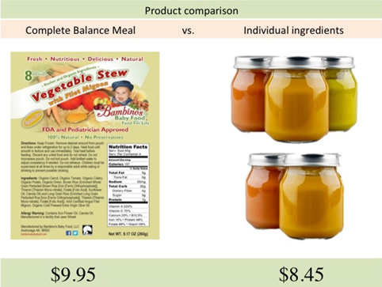

**Sales**

Operating at full capacity Bambinos could make a substantial gross profit of $2,170,000 per month (assuming 600,000 product unit sales @ $3.50 profit per unit).

The baby food market in United States is particularly amenable to newcomers who can offer Organic and Kosher healthy alternatives. With 4million baby born each year, Bambinos will be the only frozen baby food alternative in the market offering a novel option to parents seeking the best quality nutrition and convenience for their children.

Bambinos marketing studies are based on the vendors and subscribers who have tested its products to date in Alaska. The feedback received indicates that Bambinos can sell an average of 10 products per child every month.

Conservative calculations at a rate of .05% for a regional analysis in the Pacific Northwest reveals the potential for 200,00 units sold per-month. Estimated gross profit per unit is $2-$3, or $400,000 - $600,000 per month. Table 1 below demonstrates how small market share and isolated marketing can yield a significant return.

|  |  |  |  |  |
| --- | --- | --- | --- | --- |
| **Percentage** | **Number of Babies** | **Units** | **~ Profit Per-Item Month** | **Net profit** |
| 0.5 | 20,000 | 200,000 | $600,000 | $7,200,000 |
| 1.0 | 40,000 | 400,000 | $1,200,000 | $14,400,000 |
| 1.5 | 60,000 | 600,000 | $1,800,000 | $21,600,000 |
| 2.0 | 80,000 | 800,000 | $2,400,000 | $28,800,000 |

Single to two ingredient baby food products are tried and proven meal solutions for every household. Using Bambinos experience and techniques the company can use the food manufacturing equipment it intends to acquire to quickly branch into these basic markets. Bambinos products can be sold for all to enjoy no matter what the age. By eliminating the emulsifying step, hearty stews can be created which can also be frozen and sold. This gives the company additional markets for ensuring its success and growth.

**8.0 Risks**

There are several risks that BBF recognizes and has taken into consideration in their business planning. The first is developing and maintaining a reliable delivery system. Finished products will be delivered in bulk to Kansas City, Missouri for distribution to subscribers in the lower 48, as well as, directly to those subscribers located in Alaska or Canada. Bambinos must ensure that it has back-up delivery services in the event of disruptions that could arise with any one shipping entity.

Being able to secure the food products needed for our production of the various baby food products is another risk that Bambinos faces. The company must establish relationships with several providers with whom it can secure not only timely delivery but quality products as well. By necessity, not all of Bambinos providers will be located in Alaska.

As with many businesses the economy can either help or hurt its growth prospects. Bambinos is confident that the price and value the company offers will allow it to maintain its sales during any period of economic downturn. With the equipment that BBF will acquire, the company can provide diversification of products which will offers an attractive price that will help guarantee success in case of a shift in the marketplace. In addition, Bambinos expect that a large segment of online subscribers will be middle to upper income earners – those most likely to continue to purchase in any economic climate.

**Strength, Weakness, Opportunities and Threats (SWOT) Analysis**

|  |  |
| --- | --- |
| **Strengths** | **Weaknesses** |
| Experienced management (with 20 years in the food industry).  The Maroudas family has an excellent public image and the community is aware of their successful history and work ethics.  Locally unique market offering.  Addresses community concerns.  Clear target market.  Product trials completed with positive results.  Ready for local implementation.  Potential for maximizing current volume sales.  FDA/DEC approval procedures are completed.  Trademark acquired.  Established organic certified farmers within 60 miles radius to plant ingredients form BBF  Negotiated rates for low shipping costs for direct customer and retail freight shipping | Packaging costs a little higher.  High yield food manufacturing equipment is needed to our appeal to larger vendors.  High sales volume is needed to from distributors and vendors.  Advertising budgets for increasing public awareness of issues relating to obesity, allergies, as well as nutrition and convenience. |
| **Opportunities** | **Threats** |
| Kosher and Organic food stuffs have a strong following.  Locally-sourced goods helps improve economic growth.  Opportunity to educate parents while providing a public service in a financially sustainable and morally responsible manner.  Job opportunities offered.  Can attract parents who make their own baby food at home. | Large companies (e.g. Nestle, Gerber) already occupy and dominate the marketplace.  Frozen products contain no preservatives and must be transported frozen.  Frozen products have a 12 month “safe- for-consumption” shelf life in freezer.  Insurance costs are particularly high for the baby foods industry. |

**Addendums Certifications**

Bambinos Baby Food products are FDA and DEC approved.

The Trademark for Bambinos Baby Food was received in October 2014.

1. According to Health and Human Services Census 2012.
2. Child Care Aware of America website, retrieved August 2014.
3. Gerber Graduates Lil’ Entrees, Mashed Potatoes and Gravy with Roasted Chicken and Carrots