Dear InnovateHER Selection Committee,

Let me take this opportunity to introduce myself. I am Carol Penterman, Owner and CEO of Penterman Professional Care (PPC). It gives me great pleasure to introduce you to the PPC family of companies; Interim HealthCare of Middle Tennessee, Family Care Connection, and Penterman Concierge Care. PPC is the only comprehensive, professional personal service company in Middle Tennessee, making people’s lives easier by providing assistance for seniors, children and busy individuals. We are dedicated to making a positive difference in the communities we serve.

PPC operates under the firm belief that our core ideology of building trust through exceptional service, professionalism and accountability is a positive force to improving quality of life, as well as enhancing the productivity of a company’s employee workforce. The key to work life balance is having caring people whom you can call on when there is a need. PPC provides that key.

At PPC, we know how hard people work trying to balance family, friends and work schedules. But achieving that balance can be very illusive. Many workers feel overwhelmed by a growing number of job tasks and longer working hours. This compounding stress from the never-ending workday is damaging. It can hurt relationships, health and overall happiness. While doing the job of two or three people at work, we’re also expected to be exemplary parents AND have a fulfilling personal life in which we rear perfect children, enjoy our hobbies, volunteer in the community, and take superb care of our bodies, spirits, and minds.

With over 50 years combined experience, Penterman Professional Care provides childcare, senior care and concierge services. By helping to take care of loved ones and personal "to do" lists, we can help individuals find that balance between family, work and other life priorities. No matter how ordinary or unusual the request, our experienced staff can be relied upon to find the best solution. Our clients range from busy executives to new parents; seniors to celebrities; busy moms to small business owners – anyone wanting to regain control of their time and to focus on enjoying the more important things in life. With the professional, trusted assistance they need, everyone quickly realizes that they can be much better leaders, employees, managers, spouses and friends. We help individuals live happier, healthier, and more productive lives.

Thank you for taking the time to learn more about Penterman Professional Care. We are excited to present our company for InnovateHER recognition. A vibrant community consists of great people who come together and invest their time, talent and resources to jointly improve the lives of the individuals who are the heart of that community.

Sincerely,

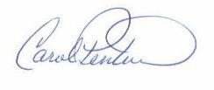

Carol Penterman

Owner & CEO

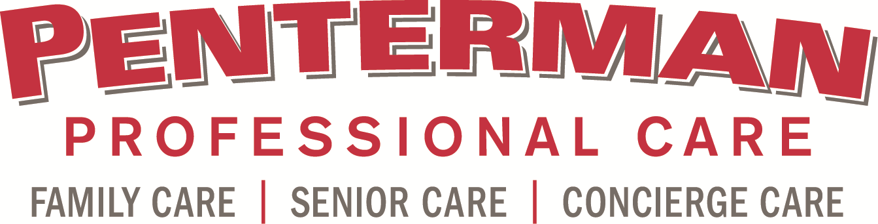

**Section 1: Executive Summary**

**Penterman Professional Care** (PPC) **is the** **only comprehensive, professional personal service company** in Middle Tennessee **improving people’s lives** by providing help for seniors, children and busy individuals. Our corner stones are trust, integrity, professionalism and accountability. Our core ideology is to build trusted relationships that enable us to make a positive difference in people’s lives.

We have developed three focus areas to address the needs of a wide spectrum of care. We provide in-home services for seniors, nanny placement and temporary child care for parents and children and professional concierge services for those with not enough hours in a day to get everything done. Each division has its own director and client support team with years of expertise and experience in their specific area of service. Business development, strategic planning, finances, marketing and public relations are handled by the Penterman Management Group, in consultation and coordination with, the teams of each division. The Penterman Professional Care family of companies is made up of:

**Interim HealthCare**®, founded in 1966, is the nation's leading home care, hospice and medical staffing company. Interim HealthCare of Middle Tennessee, a franchise of Interim HealthCare® opened in November 2012, serving Davidson, Rutherford and Williamson Counties. We offer Personal Care & Support Services, non-medical with skilled nursing and Certified Senior Advisor supervision, consultation and education, as well as hospice and staffing services for senior service organizations and facilities.

**Penterman Concierge Care** offers customized personal services to busy professionals. We will work with you to find out exactly what your needs are and take care of them with the ultimate professionalism and efficiency. Our professionals will keep you organized, manage your home services, serve as a personal assistant, and see to it that your business and personal obligations are met. We can help you squeeze 36 hours into your 24-hour day. As a distinctive personal service, we understand that each client is unique. Our services are customized to accommodate each individual’s needs. Our goal is to establish trusted, long-term relationships with our clients through integrity, reliability, competence, responsibility and innovation.

**Family Care Connection’s** goal is to provide carefully, selected individuals with a broad range of services to care for infants and children in your home. They are called "Care Professionals" because they are actively seeking to provide the finest possible care for your family on a temporary, permanent, part time, full time, live-in or live-out basis. We provide peace of mind to families who trust these respected "Care Professionals" with their precious family. Quality nannies and caregivers are in CONSTANT demand and LOW supply in the Nashville, Brentwood, Franklin and Murfreesboro area.

Trained professionals, who are dependable, trustworthy, fully insured and bonded, provide all of Penterman Professional Care services. They also undergo an extensive screening, interview and orientation process that includes background checks and drug testing. Because we are an extension of an individual’s household, we focus on finding the right fit for each job with skill and personality matching. We have developed age appropriate activities for children, as well as unique, life enrichment programs for seniors.

Penterman Professional Care and its family of companies are **problem solvers**, providing tailored and customized services for each need. We are responding to the need for “full service” personal care in the Middle Tennessee area. We not only care for our clients, we also care for our Care Professionals. Our brand promise is to provide professionals with the skills needed for your specific care needs. We have an on-going learning program for our Care Professionals, enabling them to develop the knowledge and skills needed to provide the highest caliber of care. Our supervisory teams include a Certified Senior Advisory, Alzheimer’s Certified Trainer, Newborn Specialist and Certified Concierge, to guide our Care Professionals in improving their personal service and ensure our clients have the care they need.

Our company is licensed in the State of Tennessee and private pay and private insurance carriers reimburse most of our services. The process for licensure and insurance certification has been completed. The primary office is currently located in Nashville, TN. The grand opening of our second office location in Murfreesboro, TN is scheduled for early December.

The demographics support our business model and are a key factor in our anticipated success. The older population is on the threshold of a boom. According to U.S. Census Bureau projections, a substantial increase in the number of older people will occur during the 2010 to 2030 period, after the first Baby Boomers turn 65 in 2011. The older population in 2030 is projected to be twice as large as in 2000, growing from 35 million to 72 million and representing nearly 20 percent of the total U.S. population at the latter date.

Census statics note that from 22% to 28% of Davidson, Williamson and Rutherford County’s combined population of nearly 2 million is under the age of 17. Over the past several decades, women have entered the workforce in record numbers. In the 1940s, less than one in five women with children worked outside the home. By 1998, 65% of women with children under the age of six were in the labor force. The percentage was even higher among women with children between the ages of six and 17 at 78%. Today, over half (55%) of these women provide most, if not all, of their family’s income.

As more and more women have moved, by necessity or choice, from the home to the workforce, the need for affordable, high-quality childcare has become critical. Sadly, this need often goes unmet. Each week nearly 5 million children are left unsupervised after school. This lack of supervision is associated with increased drug use, juvenile delinquency, and crime.

Employee absenteeism costs U.S. businesses an estimated $84 billion a year in lost productivity, according to a new study. The annual cost ranges from $24.2 billion in professional fields to $160 million among agricultural workers, according to a Gallup poll. Concierge services can help alleviate employee absenteeism by relieving the employee of personal tasks for which they would normally take time off from work to accomplish. Corporate Human Resource departments are one strategic partner for Concierge Care. Nearly half of all U.S. workers feel overwhelmed by a growing number of job tasks and longer working hours. Experts agree: the compounding stress from the never-ending workday is damaging. It can hurt relationships, health and overall happiness.

Penterman Professional Care’s leadership team brings over 80 years’ combined experience in personal care and support services, as well as successful business management.

**Carol Penterman, Owner and Chief Executive Officer**- After serving the Nashville Opera and Arts community for 19 years and with over 30 years as a professional business woman Carol made the decision to take her business experience and commitment to the broader community.

**Patricia Delgado-Bostic, Chief Client Services Officer** - Patricia began her career in the home care industry 21 years ago by being the client, a mother of a medically fragile son. This has created a huge passion in her life, to help people.

**Mike Roberts, Chief Business Development Officer** – Mike is a native resident of Williamson County, involved in client care for over 25 years.  He is well respected in the medical and business community and is considered to be a valuable resource for developing creative solutions for clients.

**Rhonda Bingham, Director of Family Care Connection -** For the past 10 years Rhonda has been the President of Family Services Group, LLC d/b/a Family Care Connection. In 2004 she and her partner made strategic changes in the business model that enabled the company to increase revenues by 300%.

**Section 2: Organizational Chart**

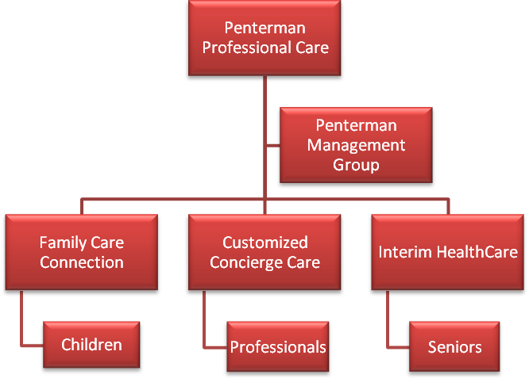

**Section 3: Subsidiary Detailed Summary**

**Mission: We improve people’s lives!**

Values:

* **Integrity** – we adhere to a firm code of ethics with honesty and the highest moral character. You can trust us.
* **Reliable** - we mean what we say, and say what we mean. You can depend on us.
* **Competent** – we have the skills and resources to handle all situations. Our professionals are skilled, experienced and capable.
* **Responsible** – we hold ourselves accountable and live up to our obligations and commitments.
* **Innovative** – we are problem solvers and will find the creative, imaginative solution when needed.

**INTERIM HEALTHCARE**®, [founded in 1966](http://interimhealthcare.com/Our-History), is one of the nation's leading [**home care**](http://interimhealthcare.com/getdoc/464cd3c3-4694-423e-a445-5e9ca325013d/Home-Care), hospice and [medical staffing](http://interimhealthcare.com/getdoc/3f30819b-557d-44f8-b8bf-06a0e382de26/Staffing) company. Interim HealthCare of Middle Tennessee is a franchise of Interim HealthCare which opened in November 2012.

At Interim HealthCare of Middle Tennessee we know that it is vital to have someone you can depend on when you or your senior loved one wants to stay at home and maintain the highest level of health, dignity and independence. We provide personal care and support services for seniors in Nashville, Franklin, Brentwood, Murfreesboro and all of Williamson, Davidson and Rutherford Counties. With a broad range of senior home care expertise, our trained professionals offer [**comprehensive elder care and supportive services**](http://www.interimhealthcare.com/FranklinTN/Our-Services) that are cost-effective and designed to meet the specific needs of each patient.

At [Interim HealthCare of Middle Tennessee](http://www.interimhealthcare.com/FranklinTN/About-Us) goal of home care or senior care is to help you or your loved one remain at home as long as possible, rather than moving into a long–term care facility. Personal care and support services may be right for your loved one needing assistance with daily activities such as bathing, light housekeeping and meal preparation but don’t have a close network of nearby family and friends around to help, or if the family caregiver just needs some time off. Our personal care and support services are also the extra support you need as you are recuperating from a stay at a hospital or rehabilitative facility.

In each instance, our trained Interim HealthCare professionals are dedicated to providing quality care with compassion and a commitment to the highest level of customer service. We provide a wide range of home care services, in Middle Tennessee that can help you maintain your independence.

From extended blocked contract positions to per diem shifts, Interim employs nurses and other health care professionals with a variety of different skill sets. So whether you need a nurse to fill the gap in a high specialty unit within a hospital, physician office, school nursing, long term care facility, or clinic, Interim provides the staff you need. All staff are properly credentialed, screened, and covered by our professional liability and workers compensation insurance. Interim assumes all responsibility for employer taxes and benefits.

We assist facilities to:

* Meet the need during peaks in census
* Reduce costly overtime and staff burn-out
* Provide clinical staff that they do not currently employ for projects and services
* Fill the gap for last minute call-offs
* Meet a short term need or cover for an extended leave of absence
* Cover for vacations and holidays

In addition, our customers rely on Interim HealthCare to provide temporary to direct hire and direct hire sourcing services in order to:

* Reduce costs and staff time associated with full time hiring
* Improve employee selection results through a 13 week “try before you hire” program

**PENTERMAN CONCIERGE CARE** offers customized personal services to busy professionals, parents and the elderly. We will consult with you on your specific needs and take care of them with the ultimate professionalism and efficiency. Our professionals will keep you organized, run your errands, and see to it that your business and personal obligations are met. We can help you squeeze 36 hours into your 24-hour day.

As a distinctive personal service, we understand that each client is unique. Our services are customized to accommodate each individual’s needs. Our goal is to establish trusted long-term relationships with our clients through integrity, reliability, competence, responsibility and innovation.

**Your Own Assistant - Invaluable and Affordable!**

**Home Manager**: This highly specialized service takes the worry out of managing you home services, repairs and personnel. In short, home management is the overall management of a home.  A Home Manager can arrange all sub-contractor services, oversee their execution and ensure they are done thoroughly and in a timely manner, often saving homeowners money. They can take the worry and stress out of the personal to-do list. They will work with the homeowners selected service providers, or utilized Penterman Professional Care’s carefully screened and selected preferred provider list to ensure each job is done right. Our exclusive services can also help ease your transition after your move, making your start in a new community as smooth, seamless and stress free as possible.

**Personal Assistant:** Juggling daily responsibilities can be stressful and time consuming. Our problem solvers can help. We will give you back your most valued commodity — time. We are reliable, responsible, educated adults who take pride in our work and enjoy helping others. We work with clients individually to customize a solution addressing their specific needs.

**Home Waiting Service**: Your time is one of you most valuable commodities. Most people would prefer not to spend time away from work, social activities or with their family waiting for a deliver or service person. Our home assistants can do the waiting for you.

We provide our customers with a strong customer protection package. Each of our professionals is insured including:

* Comprehensive Professional Liability
* Professional and General Liability with all employees as additional insured
* Adherence to non-discriminatory Policies and Procedures
* Employee Dishonesty Bond - Coverage extended to include loss to our clients
* Worker’s Compensation
* Our professionals undergo extensive screen, testing and training with:
* License verification
* Reference checks
* Criminal background checks
* Drug testing
* Fully insured and bonded

**FAMILY CARE CONNECTION** is the Greater Nashville / Middle Tennessee area's largest, oldest, and most experienced in-home care referral and full-service nanny placement agency.

Our goal is to provide carefully, selected individuals with a broad range of services to care for infants and children in your home. They are called "Care Professionals" because they are actively seeking to provide the finest possible care for your family on a temporary, permanent, part time, full time, live-in or live-out basis. You will feel comfortable and confident as you trust these respected "Care Professionals" with your precious family. Quality nannies and caregivers are in CONSTANT demand and LOW supply in the Nashville, Brentwood, Franklin and Murfreesboro area, including full-time, part-time, and on-call!

Many families have grown weary of their children being in daycare, catching every childhood disease that is currently making the rounds, being just one of the mob of kids who doesn't receive the individual care they need, etc., etc. Many child psychologists are beginning to express grave concerns about the current phenomena of young children basically learning from other young children and not having the close adult supervision that so often is preferred for a child's development.

Our temporary division makes over 20,000 referrals a year to families throughout the area.

Family Care Connection is a member of the International Nanny Association, Alliance of Professional Nanny Agencies, Chamber of Commerce (Brentwood and Nashville), and Better Business Bureau.

Every Permanent and Temporary Nanny meet all of the following qualifications:

* Twenty-one years old
* Previous childcare experience
* Background checks for criminal felony, sex offenders and driving history
* Must have their own transportation with valid driver’s license and proper insurance
* Complete our sixteen page application and Interview with staff
* Have six verifiable work references, three personal and three business
* Complete our orientation class and test, which covers such as, first aid, child safety and HIPPA privacy laws

SERVICES

**Childcare – Permanent and Temporary Nanny Services**

Selecting a nanny for your child is one of the most important decisions you will ever make. A nanny provides more than the daily necessities for your child. She has a significant role in your child's social, emotional and physical development as well as your child's safety.

The properly matched nanny is the best investment you can make in your child's future. The individual care a nanny provides, especially; in pre-school years, in the familiar environments of your home is the next best alternative to the presence of loving parents.

Beyond making the basic provisions for your child's daily care, a nanny plays a significant, lasting role in all realms of your child's development; socialization, emotional learning as well as physical safety and well-being are just some examples of the areas of influence of this most important person in your child's life. The individual care a nanny provides in the safe, comfortable and familiar environment of your home is truly "the next best thing" to a loving parent.

Our temporary nannies can be used a little or a lot. They can work a set schedule for you a couple of days a week or just for special events. We have nannies that can spend the night or the week; they also go on vacation with you. If you need daycare backup or emergency service we have an after hour staff that can find someone for you in a couple of hours. When you sign up for our temporary service you have access to childcare 24/7/365.

**Newborn Specialist Services**

Commonly known as a "Baby Nurse", Newborn Specialists are extensively trained and experienced in all aspects of newborn baby care and parental education and support. Whether you need a lactation consultant, a sleep schedule specialist, an expert in care of multiples, or just an extra set of hands, Family Care Connection can provide a Newborn Specialists that meets your needs.

The primary role of the Newborn Specialist is to provide assistance during post-delivery recovery period and assist you with all aspects of newborn care including feeding, changing, bathing, infant laundry, sterilizing bottles and helping parents catch up on much needed rest.

Most Newborn Specialist work eight to twelve hour shifts day or night. We have Specialists that work two to four hour shifts. All Newborn specialists are required to meet our full background check and caregiver requirements.

**Temporary Hotel, Convention, and Back-up Day Care Services**

**Sitter Solutions**

Family Care Connection believes that in our complex, modern and mobile society, the need for care and compassion is more important than ever. When you are out of town your hotel becomes home to you and your loved ones. Our caregivers are experienced in providing in-room activities for children, which can help make their stay more enjoyable and will even, take them to local attractions and eateries at your direction. Just tell us what your needs are and let us do the rest.

**Group Care Services**

If your event, church, organization or facility is in need of group childcare Family Care Connection is the service for you. We can provide one or multiple caregivers to watch any size group of children to make certain they are safe, active, fed and happy. Our ratio for Group Care is 5 children to 1 caregiver to ensure all the children have the attention they need. We also provide age appropriate activities, toys and games to occupy their time and keep them active. This allows parents to enjoy their meeting, conference or activity with the confidence their children are well cared for.

**Day Care Staffing**

Family Care Connection provides temporary staffing to Day Care Centers who are in need of help. We can help ensure you are compliant with State Day Care Regulations by maintaining the correct child to caregiver ratio. If someone is out sick or on vacation or the Day Care just needs some additional help, Family Care Connection can provide the right person to assist.

**Section 4: Market Analysis Summary**

The U.S, Bureau of Labor Statistics (BLS) predicted personal care services to be the fastest growing industry sector over the ten-year timeframe 2002 through 2012. The expected growth rate of 28% will include the establishment of single service, multi-service and full service concierge type businesses.

Time constraints, busy work schedule, extended working hours, and lack of work-life balance in everyday life, are all contributing to the growing demand for corporate concierge services. The concierge market is expected to grow greatly in the next five years, particularly among households that earn more than $100,000, which is one of the industry’s primary target markets. Those with a household income between $100-$250k/year probably don’t have their own staff, but do need someone to support or help them. They have the means to purchase things, and have a lot of direct interaction with brands.

**SENIOR SERVICES**

Significant growth is expected for the personal care and support service industry due to the more than 34 million people in the U.S. who are 65 years or older and the anticipated increase of this age group’s population to include more than 70 million by 2030.

In comparison to the nation as a whole, Williamson County of Tennessee has 6.5% (projected to grow to 9% by 2015) of its total population between the age of 65 to 74 and 4.3% (projected to grow to 4.3% by 2015) age 75+. Rutherford County of Tennessee has 5.3% (projected to grow to 6.6% by 2015) of its total population between the age of 65 to 74 and 3.6% (projected to grow to 3.9% by 2015) age 75+. Davidson County of Tennessee has 6.6% (projected to grow to 7.7% by 2017) of its total population between the age of 65 to 74 and 5.0% (projected to grow to 5.4% by 2017) age 75+. Clearly there is a current and growing need for home care services to assist older adults with either self - c are limitations or mobility issues to help maintain their safety and independence.

We have conservatively estimated that this market includes between 25,000 and 50,000 individuals. These estimates are based on 40,000 seniors not living in nursing homes that needed services in 2009 (most recent data available) and have an income level of $110,000.

**CONCIERGE SERVICES**

Concierge services have been available for decades but were historically only found in hotel lobbies. Today, the concierge industry is growing rapidly and concierges are literally popping up all over the world. In fact, companies and individuals are not only starting to use concierges, but many are making them a part of their corporate benefits packages. Concierge are now everywhere from shopping malls to universities, hospitals, churches, associations, small and large companies, country clubs, condominiums, office buildings, small plane airports and yacht clubs to name just a few.

According to statistics provided by the BLS, the demographics of the US will shift to an age-wise, top-heavy population of "older" adults. The predicted age distribution indicates that the youth population (aged 16 to 24) will increase, the middle-aged population (35 to 44) will decrease and the baby boomer population (aged 55 to 64) will increase by 44%.

Add in the factor that the past few years of economic instability means more and more homeowners (even the wealthiest homeowners) are opting to remain in the workforce and take on an additional or third career rather than settle for retirement income alone and you may well find your community full of an older, time-deprived demographic who will likely insist on soft services that free up their time or otherwise simplify their lives.

According to a recent blog on the ICLMA website:

* The average U.S. worker admits to frittering away more than 2.09 hours a day, not counting lunch, on personal business. This costs companies an estimated $759 billion a year. - Salary.com and AOL Survey.
* The average worker skips 24 minutes of his or her lunch break every day, the equivalent of approximately two weeks more holidays per year - figures from Data Monitor.
* Since 1969, family time for a working couple has shrunk an average of 22 hours a week. -U.S. Government
* Workplace stress is costing the economy $14.81 billion a year.
* Stress related presenteeism and absenteeism are directly costing employers $10.11 billion a year.
* According to the Health and Safety Executive, 6.5 million sick days are taken every year as a result of stress.
* Approximately 13.7 million working days are lost each year as a result of work-related illness at a cost of over $45 billion per year – National Institute for Health and Clinical Excellence.

When looking at these statistics, it is easy to see why time has become the commodity of the century and will be even more so in the decades to come. The popularity of concierge services stems from the fact that people are stressed out, overworked, and need help dealing with life so they can spend their free time nurturing themselves and their families. As good workers become harder to find, businesses are looking for concierge services to offer as perks to keep valuable employees happy and help them maintain their work-life balance.

**CHILD CARE SERVICES**

The first five years of a child’s life lays the groundwork for how his brain will develop.   
These short and critical years are essential to his cognitive, social and emotional well-being. According to the Centers for Disease Control and Prevention, if a child is reared in an environment where his developmental needs are not being met, the risk of him experiencing learning delays is increased.

Increases in the number of working women, changes in family structure, and the desire to provide young children with educational opportunities have all driven up the demand for child care provided both inside and outside of the home. Like most service sectors, child care primarily serves local demand. Overall, the ratio of child care establishments per 1,000 children under five years more than doubled from 15 per 1,000 in 1987 to 37 per 1,000 in 2007. Most of this increase occurred among non-employer businesses, which rose from 12 per 1,000 in 1987 to 33 per 1,000 in 2007.

Selecting a childcare arrangement can be a balancing act for many parents as they work to fulfill their responsibilities to both their children and their employers. Parents often make decisions based on the accessibility, affordability, and quality of a childcare provider. The inherent complexity of the childcare market has led to an uneven distribution of services, leaving some communities well-supplied while others have unmet needs.

**Section 5: Competitive Analysis**

Potential clients can be found in all age groups, ethnic backgrounds, and religious faith. They include:

• The elderly, frail or housebound

• The physically and mentally challenged or accident victims

• Family caregivers and parents with newborns

• Those recently discharged from the hospital

• Those juggling children, work and personal needs

• School age children requiring supervision and transportation

• Corporations looking to decrease employee absenteeism and enhance employee benefits

Clients’ needs vary in terms of duration (short-term versus long-term). Although our personal care and support business will provide service to all segments of the population (young, middle-aged and seniors), the majority of our clients are expected to come from the parents, busy professionals and senior categories.

**SENIOR CARE**

The competition is comprised of the home care businesses offering similar services to the same clients selected as our target market (seniors). We have studied the competition and the following are the top competitors in the market based on reputation, image, customer service and market share:

1. Home Instead  
2. Comfort Keepers

3. Visiting Angels

4. Senior Helpers

Home Instead Senior Care was established in 1994 and has over 900 franchises. They have a two-hour minimum at $24.50 per hour. After 4 hours the price drops to $16.50 per hour. The Caregiver salary is $7.50 per hour, which can increase to $10 per hour. They list special services such as Alzheimer, Veterans, AARP and the TNCare Choices Program.

Comfort Keepers notes they have 650 franchises in five countries. The local franchise has over 100 employees. They note that they have a registered nurse on staff that is able to do some medical treatment in a partnership situation with them. They have a two-hour minimum at $24.50 per hour. The hourly rates can decrease to $16.50 depending on how many hours.

Visiting Angels was established in 1998. The local franchise has been open for five years. They charge $17 per hour on weekdays and $40 per hour on weekends. They pay their caregivers $10 per hour.

At present, there are approximately 29 licensed senior home care companies offering personal care services within Davidson, Rutherford and Williamson Counties in Tennessee. These companies advertise their services to consumers in a variety of ways including paid print advertising, television, radio, internet and social media. They advertise for employees through internet, social, print and referrals.

The three county area also includes:

* 12 Hospitals
* 38 Licensed Assisted Living Facilities
* 42 Licensed Home Health Agencies
* 36 Licensed Nursing Homes
* 7 Independent Living / Retirement Communities
* Numerous large churches with senior programs

**CONCIERGE CARE**

Research indicates only 11 listings providing “concierge services” in the Metro Nashville area. Of those, only four direct competitors have web sites.

* My Concierge
* Elite Concierge on the Run
* It’s About Time

Individuals who advertise services operate each of these. According to our research there are no professional concierge agencies providing personal care and support within the greater Nashville area. The business model for Customized Concierge Care is based on three established agencies;

* At Your Service (atyourservicestlcounty.com), St. Louis, Missouri
* Best Friend Errand Service (bestfrienderrand.com), Cincinnati, Ohio
* Quicksilver Concierge (quicksilverconcierge.com), San Jose, California

**CHILD CARE**

Family Care Connection one of only four professional childcare services agency in Middle Tennessee.

* Nannies of Brentwood
* The Lillian Nanny Agency
* Nannies of Green Hills

There are numerous web sites listing individuals offering services, the most popular of which is Care.com. Over the past 18 years Family Care Connection has developed a reputation for excellent service and quality caregivers. This has enabled the company to grow significantly and established a solid platform on which to build.

**Section 6: Marketing Strategy**

We are differentiating ourselves by basing the company on integrity, accountability, consistency, professionalism and quality. It’s not just one thing, but a group of ideas based on a strategic promise. We have three spectrums of business each with a unique, yet integrated target market. Our pay rates are well above minimum wage, creating a more stable, dedicated employee base. This enables us to provide a greater consistency and quality of care for our clients, with reduced turnover. As we identify specific needs for our clients we provide additional training for our Care Professionals to meet those needs. Our senior care Client Services Specialist is a Certified Senior Advisor and one supervisor is a Certified Alzheimer’s Trainer. The President of our Family Care division has almost 20 years’ experience running a child care company and the manager of our Concierge division has done project management, event planning and been the manager of a hotel concierge department.

All three businesses have similar primary target markets.

* Women, 35+ who are caregivers, with children or parents
* Upper income and higher wealth individuals
* More affluent neighborhoods; Green Hills, Belle Meade, Forest Hills, Brentwood, Franklin, Murfreesboro
* Appropriate agencies and partners

Concierge services in particular will also be marketed to Corporate Executives, HR departments, CPA firms, Attorney firms, independent business owners and entrepreneurs.

Penterman Professional Care is “the only professional personal services company in Middle Tennessee providing a full spectrum of care options.” In addition to individuals and facilities, Penterman Professional Care is in the unique position to be able to offer bundled child, senior and concierge services to present to Human Resource departments, professional service agencies, property management firms and other corporations as part of their incentive and employee assistance programs.

Studies show that more than 70% of CEOs thought that they could not remain competitive if they didn't help employees balance their work and home life. To stay competitive and retain your most talented employees, they must provide more than a good salary and medical plan. They needed to provide resources to keep workloads realistic and remove interruptions.

Providing personal care and support services as an employee benefit is an effective tool for recruiting and retaining top talent. It’s also an ideal way to send the message to your staff that you value them more than ever. Penterman Professional Care provides business childcare, senior and concierge services, with expert advisors in each division, for corporations to offer as a compelling employee benefit.

What makes bundled services so valuable?

Everyone’s day-to-day is different but for most 24 hours in a day is never enough. Our errand services keep things manageable. Need childcare on an unexpected snow day? Need someone to go to the house to wait for a plumber? Concerned that your parents are getting older and need some assistance? How about picking up an important gift, dropping off the car at the shop, or helping out an employee while on maternity leave or even after the baby is born with a Newborn Specialist? Whatever your employees don’t have the time or inclination to do—we do, and extremely well. This allows them to focus on the really important aspects of their life, which might be in the boardroom or on the bleachers at a Little League game.

Business professional care services and the integrated lifestyle

Concierge service is an employee benefit entitling you to peace of mind on the job. There’s a growing movement in corporate America to bring reality to the workplace, respecting the demands of family, home, and personal life. Penterman Professional Care is uniquely positioned as an integrative benefit to energize your workforce. Our business personal care service enables better performance on the job, through increased productivity and satisfaction and decreased absenteeism, while increasing work/life balance.

Work-life balance increases employee productivity

One feature of modern life that employers and employees find hard to quantify is work/life balance. If you can’t measure it, you can’t manage it. Using our professional personal care and support service improves business performance, employee productivity. These are results our clients can quantify. Why does it work? Support from our quality, guaranteed service gives your employees’ peace of mind as well as back precious time while allowing them to stay focused at work. In fact, surveys have shown that eighty-six percent of workers say work/life balance and fulfillment are top career priorities. Offering our services is also an innovative way to recruit and retain top talent. Penterman Professional Care is a “next-generation” work/life benefit.

Professional care and support service & employee assistance programs

A recent Roper poll reported that 87 percent of respondents would work harder for an employer who helped them handle their personal issues. Feeling supported reduces stress. It’s common knowledge and something we know from experience. The Penterman Professional Care employee assistance program (EAP) encourages increased productivity, higher morale, decreased employee turn-over and absenteeism. We’ve seen it happen again and again for corporations who offer concierge and errand services. The advantage through Penterman Professional Care is we also off expert child and senior care services. The most valuable gift a corporation can give employees is TIME.

Word of mouth is an extremely important part of generating awareness and lead generation for the personal care business. This is particularly true in senior living communities where a positive experience can easily lead to additional clients. We intend to deliver premium quality service and benefit from high satisfaction scores, which result in positive word of mouth.

**Section 7: Description of Key Personnel**

**Carol Penterman, Owner & CEO** - After serving the Nashville Opera and Arts community for 19 years and with over 30 years as a professional business woman Carol made the decision to apply her business experience and commitment to the broader community. She created Penterman Professional Care with three distinctive service lines focusing on the needs of seniors, parents and busy business professionals. Prior to owning her own business Carol was Executive Director/Chief Executive Officer of the Nashville Opera Association since 1995. She is the proud recipient of a variety of awards, Ms Penterman is the proud recipient of a variety of awards, most recently the Tennessee Association of Home Care Outstanding Home Care Leader award in 2014 and the Interim HealthCare Leadership Award in 2013. She receive the Opera America Bravo Award for Excellence in 2012 as well as a many other community awards she’s earned over the years. She has a deep affection for the area and is also a huge community participant.

**Patricia Delgado-Bostic, Client Services Specialist, Certified Senior Advisor** - Patricia began her career in the home care industry 21 years ago by being the client, a mother of a medically fragile son. When she began providing care to others, she always took care to do things the way she would want them done for her loved one. This has created a huge passion in her life, to help people. This is the dedication that exists in the career path she has chosen for herself. Her professional experience includes working as a Business Manager, CEO, Parent Advocate as well as Patient Advocate and Guardian. She brings with her over 20 years of professional home care experience.

**Mike Roberts, Business Development Representative** – Mike is a native resident of Williamson County, involved in client care for over twenty five years.  He is well respected in the medical and business community and is considered to be a valuable resource for developing creative solutions for clients. Mike's career began as a Radiological Technologist providing quality care at some of Nashville's premier healthcare facilities.  He soon progressed into management positions, which eventually led him into key business development opportunities.  In 2009, he transitioned into the home health business segment further diversifying his client care background.  Mike's passion for quality client care will assist Penterman Professional Care in developing itself as a preferred provider of services for seniors, parents and busy professionals in the Middle Tennessee region.

**Rhonda Bingham, Director of Family Care Connection & CPA** - For the past 8 years Rhonda has been the President of Family Services Group, LLC d/b/a Family Care Connection. In 2005 she and her partner made strategic changes in the business model that enabled the company to increase revenues by 300%. In 2013 Carol Penterman acquired the company. Rhonda continues to manage the company operations, personally overseeing client relations. Rhonda was a CPA and Consultant with RMBII and Associates for 7 years. She held the position of Senior Vice President of Governmental Affairs, Chief Financial Officer and Executive Vice President of Finance with The Potomac Group from 1989 to 1998. Rhonda is dedicated to the Nashville community. She has been on the Nashville Junior Chamber of Commerce for 8 years, is a board member of Buddies of Nashville and has 20 years of service with the Junior Chamber of Commerce. An avid basketball player and general sports fan, she was girls’ head basketball coach with St Edward School for 21 years, as well as First Presbyterian Recreation boys’ soccer coach.

**Section 8: Financial Plan**

Interim HealthCare of Middle’s Annual sales for its first year of operation were just over $213,000. Year two increased sales by 282%, with annual sales just over $815,000. Year three sales have increased an average of 47% to date over year two, with average monthly growth of 5%. The third year has projected revenue of $1.2 million.

Family Care Connection income from 2010 to 2012 was $635,000, $655,000 and $670,000 respectively. Upon acquisition in June 2014, the growth rate slowed somewhat. We are projecting to approximately 3% annual growth rate going forward. However to be conservative, the 5-year pro forma indicates a slower growth rate.

Projections for the Concierge branch are extremely conservative as it is a start-up company and has no proven track record or branding awareness.

The following five- year pro-forma is a good faith projection with actuals from 2014 and estimates of income and expenses over the next five years. These estimates are based on past performance, and actual trends year to date.

Annual Income and Expense 2014 – 2018

|  |  |  |  |  |  |
| --- | --- | --- | --- | --- | --- |
| Penterman Professional Care | **Yr 1; 2014** | **Yr 2; 2015** | **Yr 3; 2016** | **Yr 4; 2017** | **Yr 5; 2018** |
| Five Year Pro Forma . | Actual | Act. to Oct |  |  |  |
| INCOME | **Total** | Total | **Total** | Total | Total |
| IH MID TN | $815,627 | $1,205,463 | $1,429,950 | $1,728,002 | $1,960,388 |
| Concierge Care | $0 | $37,450 | $245,944 | $505,034 | $755,493 |
| Family Care Connection | $284,804 | $691,530 | $703,769 | $914,626 | $1,329,876 |
| Total Sales & Services Income | $1,100,431 | $1,934,443 | $2,379,662 | $3,147,662 | $4,045,757 |
| TOTAL INCOME | $1,105,431 | $1,934,443 | $2,379,662 | $3,147,662 | $4,045,757 |
| EXPENSES |  |  |  |  |  |
| IH MID TN |  |  |  |  |  |
| Cost of Sales | $420,065 | $658,096 | $731,575 | $753,250 | $907,945 |
| Administrative | $305,841 | $456,809 | $486,081 | $587,646 | $1,052,443 |
| SUB-TOTAL IH MID TN | $725,906 | $1,114,905 | $1,217,656 | $1,340,896 | $1,960,388 |
| CUSTOMIZED CONCIERGE CARE |  |  |  |  |  |
| Cost of Sales | $0 | $14,265 | $62,408 | $106,501 | $181,911 |
| Administrative | $0 | $2,380 | $7,571 | $8,583 | $10,314 |
| SUB-TOTAL CCC | $0 | $16,645 | $69,980 | $115,084 | $192,225 |
| FAMILY CARE CONNECITON |  |  |  |  |  |
| Cost of Sales | $269,208 | $298,564 | $358,177 | $553,431 | $834,903 |
| Administrative | $49,185 | $133,632 | $172,809 | $232,914 | $215,910 |
| SUB-TOTAL FCC | $318,393 | $432,196 | $530,986 | $786,345 | $1,050,813 |
| TOTAL EXPENSES |  |  |  |  |  |
| Cost of Sales | $689,273 | $970,925 | $1,152,160 | $1,413,181 | $1,924,759 |
| Administrative | $355,026 | $592,821 | $666,461 | $829,144 | $1,278,667 |
| **GRAND TOTAL ALL EXPENSES** | $1,044,299 | $1,563,746 | $1,818,622 | $2,242,325 | $3,203,426 |
| NET Inc. vs. Exp. w/o Financing | $56,132 | $370,697 | $561,041 | $905,337 | $842,330 |
|  |  |  |  |  |  |
| Startup Financing Expenses |  |  |  |  |  |
| Loan Interest Payment (FCC) | $8,089 | $6,120 | $6,120 | $6,120 | $2,550 |
| Loan Repayment (FCC) | $78,000 | $78,000 | $78,000 | $78,000 | $28,000 |
| Cash Flow LOC Interest (IH) | $8,829 | $8,668 | $7,720 | $6,207 | $712 |
| Cash Flow LOC Payment (IH) | $5,000 | $20,000 | $25,000 | $35,079 | $65,079 |
| Total Financing Expense | $99,918 | $112,788 | $116,840 | $125,406 | $96,341 |
|  |  |  |  |  |  |
|  | **Yr 1; 2014** | **Yr 2; 2015** | **Yr 3; 2016** | **Yr 4; 2017** | **Yr 5; 2018** |
| Total Expenses w/ Financing | $1,144,217 | $1,676,534 | $1,935,462 | $2,367,731 | $3,299,767 |
| Total Income from Above w/Financing | $1,105,431 | $1,934,443 | $2,379,662 | $3,147,662 | $4,045,757 |
| NET Income & Expense - w/ Financing | ($38,786) | $257,909 | $444,200 | $779,931 | $745,990 |
| **Accumulative Cash Flow** | ($15,362) | $244,000 | $686,748 | $1,466,678 | $2,127,905 |

**Individual Subsidiary Income Chart**

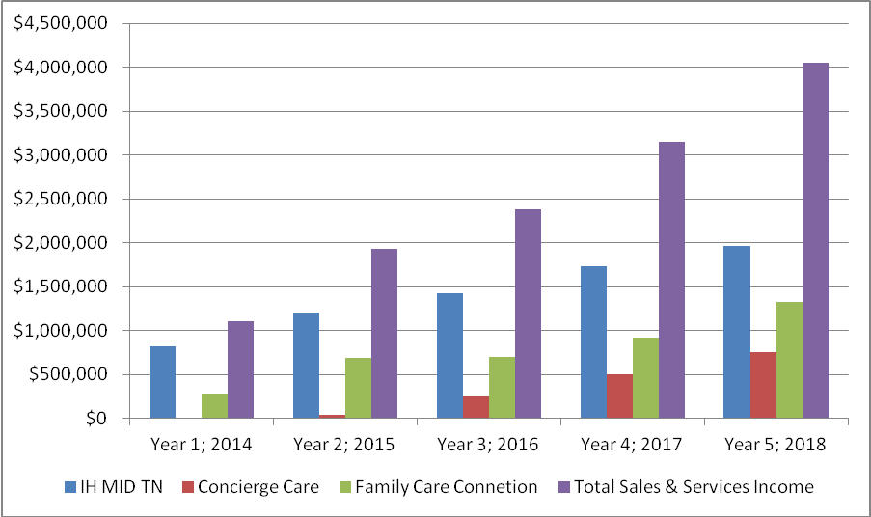

**Combined Income vs. Expense Chart**

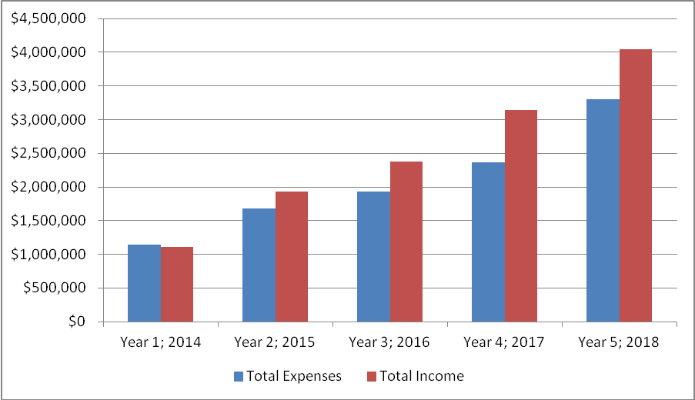

**Section 9: Client Testimonials**

**Current Client Since 2014**

“In April 2014, Interim Healthcare (A Penterman Professional Care Company) accepted our unique challenge. Our husband, dad, son, musician, teacher and coach, was officially diagnosed with Alzheimer ’s disease at the age of 52, and we were contemplating hiring the first paid caregivers since our November 2012 trek to Mayo Clinic. Given my husband’s relatively young age, three generations had been providing the ever-progressing caregiving activities for several years. Now we needed professional assistance.

After months of working remotely, my job required more office time, our daughter was college bound, and my 82 year old mother-in-law developed limiting medical issues. The caregiving, which we prefer to call “helping,” reached a new level…24-hour supervision with more hands-on assistance. Although extended family and friends were just phone calls away, as the primary source of care, my increasing exhaustion was becoming obvious.

Interim was prepared. They sent a client services representative to meet with the family. Following a home assessment, qualified caregivers were screened and very soon the family was interviewing potential helpers. The only hesitation was on our part. The anxiety about opening our home to strangers and trusting others to care for my husband was daunting. However, the day we said “yes” to Interim became a “God thing.” HE and Interim knew what was best for our family, sending those with knowledge, confidence, and flexibility. After all, it is difficult to satisfy a wife of 27 years, a mom of 54 years, and a couple of teenagers, each of whom have seen their techniques work at various times. Our family discovered that what works one day may not work another; the Interim staff knew that, but gave us time to adjust.

Our goal is to build a team of helpers who are accepted by my husband and available for eventual full-time care. We prefer individuals who enjoy music, sports, and nature, plus require persons capable of adjusting to his pace. Helpers’ motivational skills are critical to my husband’s daily functioning. Fortunately, our first helper was a great fit and now serves as chief recruiter and screener for new team members. As our “house manager,” she identifies his and our needs, often before we recognize them ourselves.

Our family feels blessed to have been led to Interim Healthcare. They have become a trustworthy partner in my husband’s care and our family’s ever-changing needs. We anticipate working with a larger Interim team with God’s guidance.”

**Story of Current Client Beginning 2013**

We began services with client in April 2013. When Interim (A Penterman Professional Care Company) began working with him he was roughly 30lbs. under-weight, unhappy with his current diet and taking several medications daily. He was eating the same meal every day, and had been for the past 5+ years. Interim matched him up with a care professional that had prior experience working with clients on the same diet limitations; the care professional was able to prepare him a cookbook full of recipes’ that were within his diet limitations. The care professional took him to the grocery store to show him the different foods, explain their benefits and get him more involved in his meal planning. The client began eating more healthy meals, and enjoying finding new recipes to prepare. It’s now going on two years of receiving services from Interim; the client is at the healthy weight for his body, he is no longer taking any prescription medications (only a daily multi-vitamin), and he is doing very well health-wise.”

**Story of Current Client Since 2014**

Lynn became a first time mother this fall to her son, McKendrie.  Lynn’s family that lives out of town, shared in the joy of her new arrival and was there for the birth, but had to return home shortly thereafter.  Lynn had contacted Family Care Connection (A Penterman Professional Care Company) regarding Newborn Specialist care as she planned for McKendrie’s arrival.  She called while in the hospital to let us know when she would be released and booked care for days as well as overnights.  Family Care provided several Newborn Specialists to assist Lynn and care for McKendrie.  Lynn stated that “All the nannies that have helped me are so great.  I have felt like I could rest and not worry knowing my baby was in such good hands.  Also, as a first time mother, the nannies were tremendous in helping me to get to know my baby and sharing their knowledge and tips on motherhood.  The experience has been wonderful, having nannies that went above and beyond what I expected.  I don’t know how I would have gotten through this first month without them.”  We appreciate the opportunity to serve Lynn and look forward to assisting with McKendrie as he continues to grow and flourish. Current Client since 2014

**Doctor Referral Client in 2012**

"I wanted to thank you for the excellent service you provided for our patient.  He was so happy with the professional manner he was treated and how the caregiver was right on time and very attentive.   The facility also has informed me they were very impressed with your service and the care given to the patient. I know they will be passing your information on to others in need of your services. I especially want to thank both Carol and Patti who were wonderful to work with and made it very easy to arrange services needed for our patient.  They were very kind and professional and I look forward to working with them in the future.  Thank you for all you do as this is a much needed service.”

**Current Client Since 2012**

"My Mother is very pleased with her caregivers and your personal attention - thank you so very much!   Everything is going so well and her caregivers are truly wonderful!    You have the quality company for which we have been searching.  I have been recommending you to all my friends who may need some assistance.  Thank you again for your exceptional care!"

**A New Mother in 2013**

“I have had a very professional but caring experience from the very beginning. I could NOT have walked these past months without you! Thank you!”