November 19, 2015

**To:** Small Business Association

InnovateHER Competition

*Statement of Support*

**From:** Ashley Sturchio, Community Development Specialist

Microsoft-Westfield Garden State Plaza

1 Garden State Plaza Way

Suite 2303

Paramus, NJ 07652

Microsoft Westfield Garden State Plaza served as a host location for the 2015 InnovateHER Competition on Thursday November 19, 2005. This location’s 2015 winner is MySuperFoods Company LLC. MySuperFoods Company, LLC is a New Jersey based healthy food and lifestyle brand built to empower parents and grow healthy SuperKids. MySuperFoods was founded in 2011 by two mothers, Silvia & Katie. The company’s mission is to create delicious, nutritious, organic and Non-GMO foods for kids. Their focus is to nourish growing bodies and minds with superfoods and healthy fats, while keeping sodium and sugar low in mind. The heart of their company is a commitment to help end child hunger by donating funds, product and time to community food banks and schools. Other remarkable aspects to their business plan is their launch of “Pack a Lunch, Give Back a Lunch.” Their overall mission is to grow awareness of social causes and increase contribution to local food banks.

Katie Jesionowski presented the company’s business proposal at the InnovateHER challenge. She presented in front of a panel of three judges. During her highly detailed and impressive presentation, Katie provided the panelists with samples of the MySuperSnack Granola Bites and MySuperCookies Heroes. They are well deserving of a chance to compete in the semi-finals. As a small company, they reinvest every dollar that they make back into the company, to support existing products. If awarded the prize money, they would support the projects that require outside funding. Specifically, this would mean an additional product line that is created to deliver organic, nutrient dense and allergy-friendly options for kids. They are looking to be able to increase their commitment to the local food banks in New York, New Jersey and Seattle, with whom they partner.

Thank you,

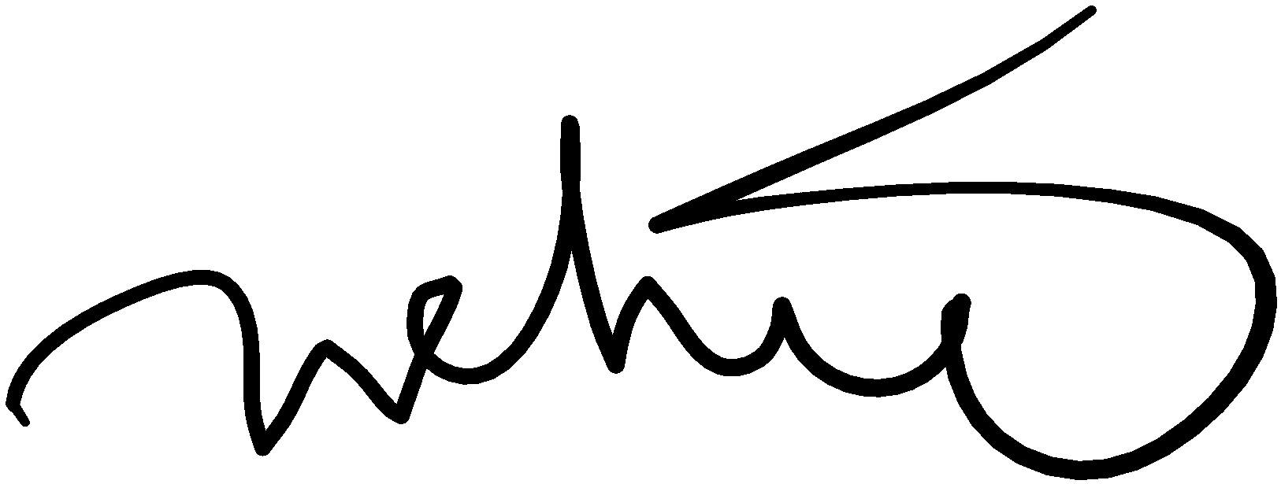

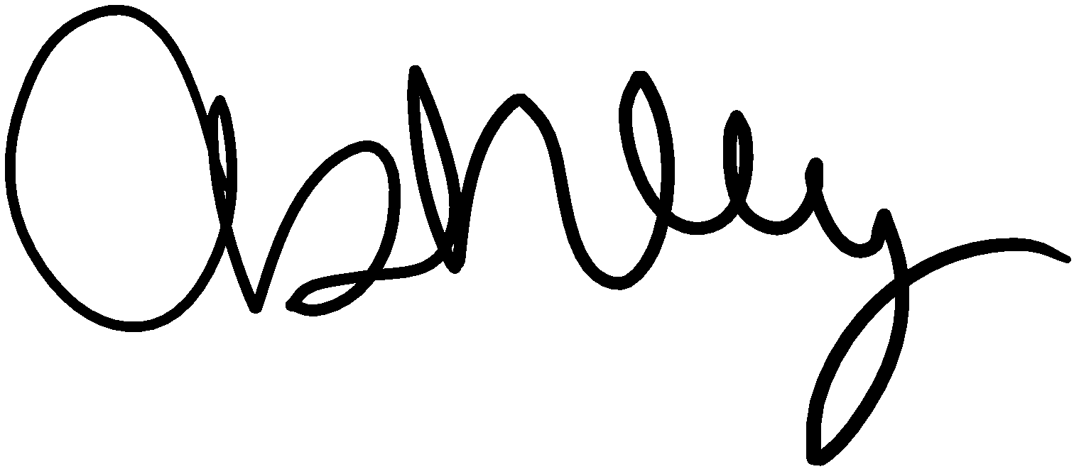

Ashley Sturchio