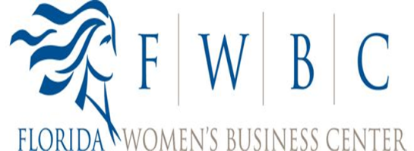

2016 InnovateHER Challenge

[www.challenge.gov](http://www.challenge.gov)

**Broward County Local Challenge Winner**

Name of winning individual: Gelena Hinkley

Name of Business: Natural BirthWorks – The Birthing Cottage

Product/Service Name: Birth Center - performing natural, holistic, and organic birthing method

Address: 513 Melaleuca Drive, Margate FL 33063

Contact Telephone: 954-960-3213

Website Address: [www.naturalbirthworks.com](http://www.naturalbirthworks.com)

Email Address: [galena@naturalbirthworks.com](mailto:galena@naturalbirthworks.com)

Florida Women’s Business Center

Name of Host: The Center for Technology, Enterprise & Development, Inc.

Address: 401 W Atlantic Ave., Ste. 09, Delray Beach, FL 33444

POC: Victoria A. Hughes

Contact Telephone: 561-265-3790 x103

Email Address: Victoria@FLWBC.org

A Birthing Cottage providing an environment for natural, holistic, and organic birthing methods. The facility provides prenatal, antepartum and postpartum care and education for mothers, babies and families.





December 4, 2015

Regarding: InnovateHER Broward County Local Challenge Winner

To Whom It May Concern;

Natural BirthWorks is focused on supporting women in obtaining a memorable experience in delivering their child. The services offered are an alternative to birthing in a hospital with medications and unknown individuals on the team. The owners of Natural Birth Works are experienced individuals who are truly engaged in supporting and guiding women through child birth. They are genuinely committed to making the experience a pleasant one.

As they have “tested” the market to prove the concept and now realize the need for their services they are moving forward to expand the services to more customers.

For the woman who wants an experience similar to home birth, she will have the option of going to a birthing center/cottage. A birthing center encourages natural birth and allows the woman to have more control in the decision making. If an emergency should arise during the birth, it can be handled more quickly than at home. Also unlike the hospital, the woman and baby go home a few hours after the baby has been born.

Natural BirthWorks presented a business plan to the judges which addressed the need to help and support women . Their service is in a niche marketplace and the service is scalable and repeatable therefore it meets all of the criteria of the challenge and we concur with the judge’s decision.

Victoria Hughes

Director

Florida Women’s Business Center