AD RescueWear Business Plan

**“Absolutely, without a doubt, in my opinion, AD RescueWear garments are the BEST for wet wrap therapy.” Kelly Hamilton-McMahon, parent of an eczema child**

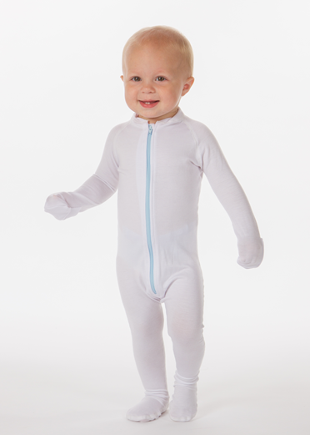

Anne McVey

Co-Owner and Marketing Director

563-508-4170

[anne@adrescuewear.com](mailto:anne@adrescuewear.com)

**Contents**

Executive Summary 3

Eczema Ruins Childhoods 3

The market is significant and growing. 4

Traditional Wet Wrap Therapy is Complex and Expensive 5

AD RescueWear Wet Wrap Therapy is Fast, Easy, Effective and Economical 5

Tencel® Fabric – 6

Company 7

Achievements to Date 7

Products 7

Competition 8

Marketing Strategy 8

Target Consumers and Key Influencers 8

Product Strategy 9

Expansion of product line into larger children’s and adult sizes 9

Expansion of related products 9

Distribution Strategy 9

E-Commerce Retail Distribution 9

Secondary distribution through Medical Supply Channel 10

Medical Professionals: Education and Sales 10

Promotional Strategy 10

Inbound Marketing 10

Promotion to Physician Influencers 11

Pricing Strategy 11

Proprietary Strategy 12

Operations Plan 12

Manufacturing: Tencel® 12

Manufacturing: Clothier 12

Manufacturing: China 13

Fulfillment: E-Fulfillment 13

Management Team 13

Our Consultants 13

Our Advisors 14

Financial Plan 15

Key assumptions 15

Financial Forecast 16

Investment 17

# Executive Summary

AD RescueWear, LLC is a medical garment business focused on the treatment of atopic dermatitis, commonly called eczema. It is the most common chronic skin disorder in infants and children. Founded by two mothers of eczema children, the company manufactures innovative garments that radically improve eczema treatment.

Founded in 2012, AD RescueWear is the first and only U.S. Company to manufacture and sell wet wrap therapy products for the treatment of eczema. This type of treatment is highly effective in alleviating eczema, which affects 6.4 million children in the U.S. and 150 million globally[1].

The company’s *Wrap-E-Soothe™* products are currently sold in the U.S., Canada, Europe and Asia. Annual revenue has grown from $50,000 in 2013 to $165,000 in 2015[2]. 2015 gross margin is 65%. The company distributes through online specialist retailers and direct to consumer via its website[3].

AD RescueWear is poised for the next stage of growth which will involve four main components:

* An allergist with 9 years’ experience as a doctor treating eczema is joining the team. He will greatly increase awareness of the product in the medical community.
* A proportion of manufacturing will be moved to Shanghai, China. This will cut cost of goods by as much as 50%.
* The product line will be expanded to include larger child and adult sizes that are being demanded by customers.
* Increased e-commerce marketing, with specialized talent contracted

# Eczema Ruins Childhoods

The condition has both emotional and physical consequences and in moderate to severe cases the entire family suffers. Sleep is a major issue for eczema children and their parents with 84% of sufferers having difficulty falling asleep and 79% being awakened by itching and scratching.

Sleep deprivation affects performance at school, family relationships, parents’ work performance and decreases coping skills at work and at home for families. Caring for a child with eczema is a significant burden, requiring as much as 2-3 hours per day of additional care[4].

# The market is significant and growing.

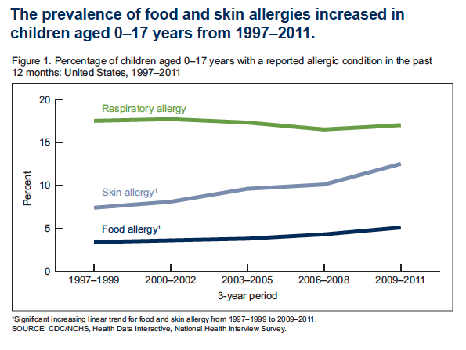

Eczema/Atopic Dermatitis is the most common chronic skin disorder in infants and children worldwide. In the US 20% of children and 10% of the adult population are afflicted with eczema. Globally the rate of affliction in children ranges between 10% (UK) and 38% (Sweden)[5].

Eczema cases can be classified as mild (25%), moderate (50%) or severe (25%). Moderate and severe sufferers stand to benefit the most from wet wrap therapy treatment.

# Traditional Wet Wrap Therapy is Complex and ExpensiveScreen Shot 2014-05-19 at 10.57.00 AM.png

Wet wrap therapy traps much needed moisture near the eczema skin, reduces itching, and enhances the effects of medication used on the skin.

Traditional wet wrap therapy (Figure 2) requires wrapping the child head to toe in wet and dry gauze. In a hospital setting costs are typically $10,000-$20,000. It is time-consuming, requiring a great deal of patience and supervision.

Some parents do take on the challenge of wet wrapping at home but it is a miserable experience. Moreover, wet wrapping with traditional gauze leads to an enhanced risk of folliculitis, irritation of the hair follicles that requires antibiotics to treat.

Exhibit 1 contains a more detailed description of wet wrap therapy and associated problems.

# AD RescueWear Wet Wrap Therapy is Fast, Easy, Effective and Economical

AD RescueWear garments make wet wrap therapy quick, easy, effective and comfortable for the child and can be applied in under 2 minutes. These garments also alleviate the parental burden of caring for a sick child by decreasing the application time from hours to minutes. When done properly, wet wrap therapy decreases eczema symptoms by 75% allowing the family to sleep and decreasing the stress of caring for a sick child.

The company’s garments are sold under the *Wrap-E-Soothe* brand and use Tencel® fabric (see below). The garments retail in the $22-$105 range and are reusable.

## **Tencel® Fabric** –

Tencel® is an advanced fiber which is proven to be superior for treating eczema. It virtually eliminates the risk of folliculitis and significantly retards bacterial growth compared with other fabrics (see figure 3). Tencel® is smoother than other materials, making it the most effective fabric for itch reduction.

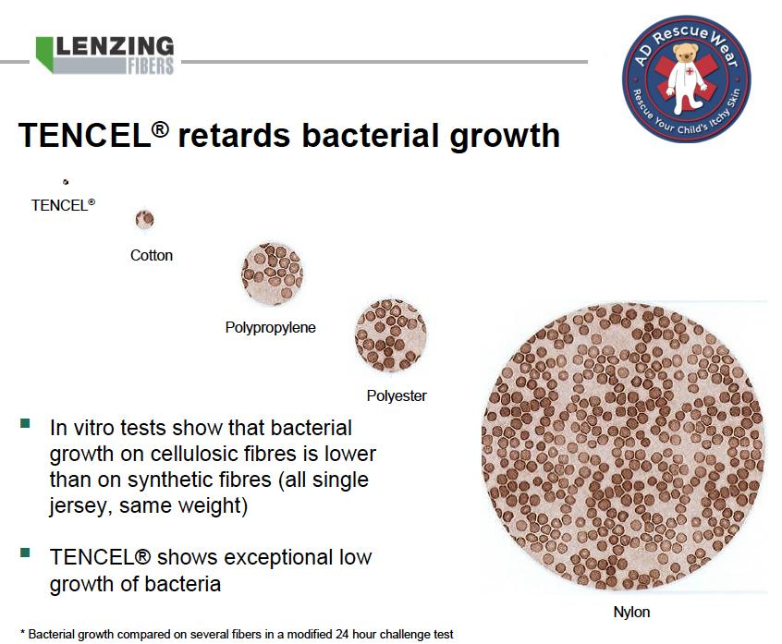

Figure 3: Tencel® significantly retards bacterial growth

# Company

AD RescueWear was founded in 2012 by Beth Scott and Anne McVey to bring wet wrap therapy garments to market. The goal of AD RescueWear is to become the go-to brand for eczema relief. AD RescueWear is the first U.S. Company to manufacture and sell garments for childhood eczema and wet wrap therapy.

AD RescueWear is a Colorado LLC.

## Achievements to Date

* Registered with the FDA as a Class 1 Medical Device that can be sold in the U.S.
* Registered with the European Union as a Class 1 Medical Device allowing it to be sold in over 30 European countries
* Provisional patent filed January 2013
* Seal of Acceptance from National Eczema Association
* Distribution agreement with McKesson Medical, the No. 1 ranked company for pharmaceutical distribution in the U.S. and Canada
* Distribution agreement with Mission Allergy in the United States
* Featured in Parents Magazine in October 2014 "Our pint-size testers and their moms saw their eczema almost vanish with regular use!"
* Over 12,000 Facebook followers
* Over 1000 satisfied customers, with 50% reordering as their children grow
* Monthly sales have grown to over $18,000
* Some insurance companies are covering AD RescueWear and Medicaid has also covered the AD RescueWear Suit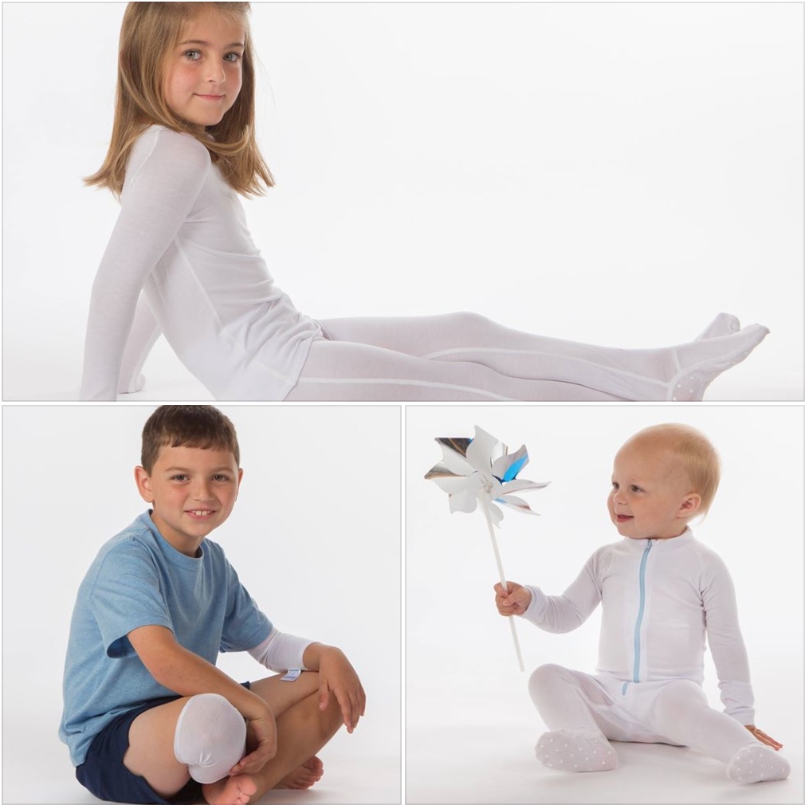

# Products

The *Wrap-E-Soothe* Suit is a full body garment with hand covers and enclosed feet used to treat eczema that covers the entire body. The *Wrap-E-Soothe* Top and Bottom are for older children that are toilet trained and are also used to treat an entire body covered with eczema. *Wrap-E-Soothe* Sleeves are used to treat problem areas such as inside elbows and behind the knees. They can also be used for ankles, hands and feet.

In addition to these products AD RescueWear distributes bamboo gloves (manufactured by Granberg) and Vaniply ointment (manufactured by Pharmaceutical Specialties, Inc.).

# Compe**t**ition

In the United States, AD RescueWear is the only company offering this type of medical garment for the treatment of eczema. No other company is registered with the FDA to sell wet wrap therapy garments in the U.S. There are no other U.S. companies making garments for wet wrap therapy for eczema and none made with the TENCEL® fiber.

Direct competition is from home-made systems of regular cotton clothing, gauze bandages and tube socks. There are three European companies: Tubifast, Comfifast and Skinnies that sell wet wrap therapy garments but none are made with TENCEL® and none are registered with the FDA to sell legally in the United States. Just last year, Clinisupplies, a European company introduced a line of bio-functional eczema clothing made with TENCEL®.

The following chart summarizes the material information about each of these competitors:

|  |  |  |  |  |  |
| --- | --- | --- | --- | --- | --- |
|  | **AD Rescuewear** | Skinnies/UK | Cotton Pajamas | Derm a-silk (dry wrap) | Tubifast (wet wrap) |
| Soothes/Provides Relief | **5** | 3 | 2 | 3 | 2 |
| Helps my child sleep better | **5** | 3 | 2 | 3 | 2 |
| Prevents child from scratching | **4** | 4 | 3 | 2 | 2 |
| Convenient to use/treat | **5** | 4 | 2 | 4 | 3 |
| 3rd party endorsements | **4** | 3 | 5 | 3 | 3 |



# Marketing Strategy

## Target Consumers and Key Influencers

AD RescueWear targets parents/grandparents of children with eczema. Of these parents and grandparents, 77% are mothers between the ages of 24-35 years old. 95% of our consumers live in the United States, and 5% live outside the United States.

Although doctors (pediatricians, allergists and dermatologists) typically do not purchase directly from AD RescueWear, they are key influencers that we target in our marketing efforts. It is estimated that 40% of orders come from referring physicians. Once physicians learn of AD RescueWear, they send a continuous stream of customers to the AD RescueWear website and our reseller, Mission Allergy.

## Product Strategy

AD RescueWear currently provides the *Wrap-E-Soothe* suit, Wrap-E-Soothe sleeves, Wrap-E-Soothe tops and bottoms for children up to 8 years old. The company will expand its product range as follows:

### Expansion of product line into larger children’s and adult sizes

The company will increase its range of products based on customer demand. This will enable us to increase the lifetime value of each customer as they develop through adolescence and into adulthood. The most immediate requirement is to expand the product line to include larger children’s and adult sizes. The children’s line will include: larger size tops and bottoms, socks, full arm and leg sleeves. Adult sizes will include tops, bottoms, full arm and leg sleeves and, socks. We plan to introduce additional children’s sizes in the 3rd quarter of 2016 and adult arm sleeves in the 4th quarter of 2016. Expanding to larger sizes in children and adults would increase our customer value from $395.47 to $947.47.

### Expansion of related products

AD RescueWear currently retails Vaniply ointment, which can be applied in conjunction with Tencel® garments. AD RescueWear also retails Eczema Treatment Gloves. These gloves are used in conjunction with Vaniply ointment. The company will expand its range of ancillary products based on customer needs. AD RescueWear plans to add Free and Clear Liquid Cleanser for face, hands and body in early 2016. We are also evaluating expansion of related products and plan to introduce those that meet our brand promise for quality and effectiveness.

## Distribution Strategy

### E-Commerce Retail Distribution

Our primary current channel of distribution is direct to consumers through our company website [www.adrescuewear.com](http://www.adrescuewear.com). We are investing in web development and contracting e-commerce expertise to grow traffic to our site and improve conversion rates.

We also make our products available through other allergy-focused e-retailers as follows:

* [www.missionallergy.com](http://www.missionallergy.com), which serves the U.S. market.
* [www.eczemacompany.com](http://www.eczemacompany.com), which serves the Canadian market.
* <http://www.everythingforeczema.com>, which serves the European market
* [www.Hardamshop.dk](http://www.hardamshop.dk) and <http://eksembutikken.dk/index.php>, which serve the Netherlands market.
* <http://m.happyebabies.com.hk/>, which serves the Asian market.

### Secondary distribution through Medical Supply Channel

Our secondary distribution channel is selling through Medical Supply stores. We currently have a non-exclusive distribution agreement with McKesson Corporation to distribute *Wrap-E-Soothe* products in the United States to medical supply stores. McKesson is the world’s largest medical supplier.

### Medical Professionals: Education and Sales

Because we recognize medical professionals as significant influencers to our target consumers, in the upcoming year, AD RescueWear will test the efficiency and effectiveness of hiring a sales representative to educate pediatricians, allergists and dermatologists in the use of the *Wrap-E-Soothe* garments. The sales representatives will provide medical professionals (physicians, physician assistants, nurse practitioners and nurses) with training with respect to the efficacy of wet wrap therapy, the use of our products, insurance and Medicaid reimbursement. Sales will occur through referral to our website or one of our distribution partners.

## Promotional Strategy

### Inbound Marketing

AD RescueWear currently generates inbound leads, at a current $10 cost of customer acquisition, to our website through:

* Original content published once or twice per week
* Curated content published between one and three times per week
* Content promoted on social media, primarily Facebook but also Pinterest, Twitter and Linkedin.
* Pay per click advertising, primarily through Facebook, Google Adwords but with some directed to Yahoo and Bing

We are currently bringing on an e-commerce specialist to help further optimize our inbound PPC, and coordinate PPC efforts with video and email. With this specialist’s help, we expect to acquire new customers at a higher rate, and at lower cost.

The above online promotional tactics will be supplemented with:

* Public relations and press releases. The company will build on the success of the PR campaign that lead to a feature in Parents Magazine (circulation 2.2 million)
* Event sponsorships such as National Eczema Association’s Itching for a Cure 5K and Food Allergy Bloggers Conference
* Membership of the National Eczema Association
* Participation in trade missions to France, Germany and the UK – building on past trade mission successes in Scandinavia

### Promotion to Physician Influencers

Dr. Frank Lichtenberger will be a key part of our drive to raise awareness of the product in the medical community. As an experienced allergist, he will add to the company’s credibility with this segment of the market.

Dr. Lichtenberger will generate original content that will be used to reach physicians online – through social media (primarily LinkedIn) and search.

He will also represent AD RescueWear at medical conferences. In 2016 we are planning on attending: The American Academy of Allergy, Asthma and Immunology Conference; The American Academy of Pediatrics Conference, The National Eczema Association Patient Conference, The American College of Allergy, Asthma and Immunology Conference, and the American Academy of Dermatology Conference.

AD RescueWear will also develop a targeted direct mail campaign for pediatricians, allergists and dermatologists.

## Pricing Strategy

AD RescueWear garments are premium products. This reflects superior performance and the high quality of fabric and design.

The gross margin of around 75% allows for distribution through large medical distributors and on-line retailers. This margin will be increased to as much as 90% at current prices with manufacturing of both Tencel® material and garments in China.

|  |  |  |  |  |  |  |
| --- | --- | --- | --- | --- | --- | --- |
| **Product** |  | **US Cost\***  **($)** |  | **China Cost ($)** | **Retail Price** | **Wholesale Price** |
| *Wrap-E-Soothe* Suit |  | 21.92 |  | 11.05 | 105.00 | 52.50 |
| *Wrap-E-Soothe* Sleeves |  | 4.69 |  | 1.65 | 22.95 | 11.50 |
| *Wrap-E-Soothe* Top (4T) |  | 13.95 |  | 8.95 | 65.00 | 32.50 |
| *Wrap-E-Soothe* Top (5T) |  | 14.12 |  | 8.95 | 65.00 | 32.50 |
| *Wrap-E-Soothe* Bottoms (4T) |  | 10.48 |  | 9.75 | 45.00 | 22.50 |
| *Wrap-E-Soothe* Bottoms (5T) |  | 11.84 |  | 9.75 | 45.00 | 22.50 |

*Excluding S&H.

# Proprietary Strategy

Our *Wrap-E-Soothe* garments embody one or more proprietary technologies/inventions. As part of a comprehensive strategy to secure intellectual property protection, AD RescueWear filed a patent application in the United States for FULL-BODY GARMENT OR SYSTEM OF GARMENTS FOR TREATMENT OF SKIN DISORDERS (13/744,257) on January 17, 2013.

We will file additional applications as appropriate to protect existing and future proprietary technologies/inventions. We have determined at this time not to file for patent protection internationally, due to the high costs associated with such filings.

We have not yet filed for trademark protection for *Wrap-E-Soothe* or AD RescueWear. AD RescueWear is currently looking into this with Kathleen A. Kleiman (Simmons Perrine Moyer Bergman PLC ).

# Operations Plan

AD RescueWear currently outsources to chosen, appropriate suppliers. We currently outsource manufacturing, accounting, web development, legal counsel, graphic design, copywriting, manufacturing, printing, public relations, fulfillment and photography.

## Manufacturing: Tencel®

The Lenzing Group in Austria is a world leader in manufacturing man-made cellulose fibers. It created Tencel® fiber and certifies other manufacturers. We purchase the fabric from Eagle Fabrics, a California-based company. Production may take up to six weeks. Following the first large production orders, we sent samples of the finished fabric to Lenzing in Austria for certification. This certification allows us to use the Tencel® branding on our products. We are currently planning to have a second manufacturer in China produce Tencel® fabric and will go through a similar certification process.

## Manufacturing: Clothier

We currently manufacture our garments at Clothier Manufacturing in Minneapolis, MN. Clothier was recently featured as Top Innovator in the Industry in Apparel Magazine. They were also rated the #1 Top Rated Factory by Makers Row[6]. Our garments take 6-8 weeks for a reorder and 8-10 weeks for a new order to manufacture, pack and ship. They are shipped to our fulfillment company where they are placed into inventory.

## Manufacturing: China

We are currently working to manufacture our products in Shanghai, China and plan to have our first manufacturing run produced and shipped from there by March of 2016 with a reduction in cost of goods of over 50%. We are working with Ed Wells of Jade Apparel Ltd, an agent based in the United States who deals with manufacturing plants in China. Producing in China would allow AD RescueWear to produce larger quantity manufacturing runs at a reduced cost.

## Fulfillment: E-Fulfillment

Product is held in inventory and shipped to both retail customers and wholesale distributors from E-fulfillment in Traverse Bay, MI. Inventory is controlled at E-fulfillment. Once inventory is accepted and calculated it updates the system flowing from the fulfillment company to the AD RescueWear Website to the accounting software Quickbooks. Our payment processing systems (Stripe for credit cards and Paypal) dump payment into our bank accounts. It is then matched with Quickbooks. Inventory reports and inventory forecasting are provided by E-Fulfilment. Accounting through Quickbooks, and inventory ordering and shipping is automated.

# Management Team

***Beth Scott, Co-Owner Founder and President***: Beth invented the *Wrap-E-Soothe* product line. Prior to devoting her skills to inventing wet wrap therapy garments, Beth worked in advertising as a project manager at The Integer Group before a successful career as lead project designer for Associates III Interior Design for over 15 years before founding ESH Interior Design. In her role as President, Beth manages the daily operations of the Company. She also manages Customer Service and Customer Relations on behalf of the Company. Beth has a Bachelor of Arts in Sociology from Arizona State University.

***Anne McVey, Co-Owner and Marketing Director***: Anne joined Beth as a co-owner of AD RescueWear in 2012. Anne has an extensive background in Advertising, Marketing, Public Relations and Fundraising. She worked as the Creative Director at LICOR Biosciences, an international biotechnology firm, for almost a decade. In addition, she has extensive product launch experience. Anne holds a Bachelor’s Degree from Creighton University with a Major in Advertising and Public Relations. She also holds a Master’s Degree from the University of Nebraska at Omaha in Communications with a Specialty in Mass Media and Media Relations.

***Dr. Frank Lichtenberger, MD, PhD Co-Owner and Medical Director***: Dr. Lichtenberger has a medical degree and a PhD from Ohio State University. He is Board Certified in Internal Medicine and Allergy/Immunology and is in private practice in Statesville, North Carolina. Dr. Lichtenberger advises AD RescueWear on medical/scientific issues and also writes articles for AD RescueWear.

## Our Consultants

From time-to-time will rely on outside consultants to provide us with specialized services. We may compensate such consultants with rewards of equity in the Company or with cash payments. Currently we are working with an outside consultant on public relations as well as with our legal counsel, tax advisors, web development, graphic design, and copywriting - none of which will receive equity compensation. Kathleen A. Kleiman (Simmons Perrine Moyer Bergman PLC ) is our business attorney. Stephanie Parnell (Hanson and Co.) is our tax advisor. Greg Durbin is our patent attorney. Jennie Lyon (Owner + CEO Jennie Lyon Virtual Assistant Services) is our copywriter. Stefanie Williamson from 9th Street Communications is our public relations consultant.

## Our Advisors

AD RescueWear works with EDC, a business accelerator, based in Cedar Rapids, Iowa. They give advice in strategic planning, marketing, accounting, and sales/business development.

# Financial Plan

## Key assumptions

* Company will establish a $50,000-$100,000 line of credit with borrowing base
* Dr. Frank Lichtenberger will buy into the company by January 31 2016 for $30,000
* A funding round of $500,000 will be completed by March 31 2016
* Inventory ordered every 2 months to cover next 2 month sales
* Inventory will increase by $15,000 in month 6, $10,000 in month 14 and $20,000 in month 26 to account for increased manufacturing in China
* Temporary CEO will cost $3k per month in 2016 and Full Time CEO will be hired ($150,000 salary) from 2017 onwards
* Founders will draw salaries of $60,000 from 2016 onwards
* Office Manager $50k in 2016, $75k in 2017 & 2018
* Finance & Accounting $60k from 2017 onwards
* Customer Service $45k from 2016 onwards
* Social Media Specialist $50k from 2016 onwards
* Payroll burden will be 30%
* General marketing budget will grow steadily from $150,000 in 2016 to $200,000 in 2018
* Medical conference budget will be $27,000 per year
* Company will remain virtual with no head office premises
* Premium pricing will be maintained
* Direct to consumer Gross margins will be maintained at 75% until the end of 2018, when they will begin to decline (to 70%) due to competitive pressure
* Reseller Gross margins will be 50%
* Ancillary Gross margins will be 30%
* Monthly sales growth will be linear each year with the following start and end points in each category of sales:

|  |  |  |  |  |  |  |
| --- | --- | --- | --- | --- | --- | --- |
| Monthly sales | Year 1 beginning | Year 1 end | Year 2 beginning | Year 2 end | Year 3 Beginning | Year 3 End |
| Direct to Consumer | 12,000 | 45,000 | 55,000 | 120,000 | 130,000 | 300,000 |
| Resellers | 5,000 | 40,000 | 45,000 | 130,000 | 140,000 | 500,000 |
| Other Sales - ancilliaries | 1,000 | 1,500 | 2,000 | 20,000 | 22,000 | 50,000 |
| Monthly Revenue | 18,000 | 86,500 | 102,000 | 270,000 | 292,000 | 850,000 |
| Run Rate ($m) | .2 | 1.0 | 1.2 | 3.2 | 3.5 | 10.2 |

* Increased awareness in the medical community will drive both direct to consumer and wholesale revenue growth:
* Amazon will become the dominant reseller in the US

## Financial Forecast

Exhibit 2 contains detailed annual financial projections. Highlights are as follows:

|  |  |  |  |
| --- | --- | --- | --- |
| ($000) | 2016 | 2017 | 2018 |
|  |  |  |  |
| Revenue | 501 | 2,333 | 5,805 |
| Gross Profit | 318 | 1,360 | 3,300 |
| Sales & Marketing | 409 | 434 | 460 |
| General & Administrative | 223 | 512 | 598 |
| Net Income (loss) | (315) | 359 | 1,654 |
| Net Increase (Decrease) in Cash | (323) | 353 | 1,637 |

Revenue will grow both as a result of continued growth in awareness among people who care for eczema children and AD RescueWear’s marketing. This will include online marketing and direct marketing to medical professionals.

Margins will initially increase as a result of overseas manufacturing and an increase in order quantities. By 2018 we expect margin pressure from competition to bring our gross margin on retail sales down from 75% to around 70%.

The company’s marketing costs will increase in line with revenues. General and administrative costs will increase more slowly since accounting and inventory management systems will be automated.

In the next 3 years the company expects to grow its annual revenue to almost $6m. We estimate this to be only a fraction of the $1.5 billion potential market in the U.S. for therapeutic eczema clothing. We therefore anticipate further rapid sales growth beyond 2018 as AD RescueWear expands its presence in the U.S. and overseas.

# Investment

In order to execute this plan the company will need to invest in working capital (inventory), marketing and people as demand for its product increases.

The sources of funds will be as follows:

* $30,000 buy in by Dr. Frank Lichtenberger
* $50,000-$100,000 bank line of credit
* $500,000 funding round

Please contact us for further information.

1. Company estimate
2. Forecast based on actual revenue to 9/24 2015
3. [www.adrescuewear.com](http://www.adrescuewear.com)
4. Lawson V, Lewis-Jones MS, Finlay AY et al. The family impact of childhood atopic dermatitis: the Dermatitis Family Impact Questionnaire. Br. J. Dermatol.138,107-113 (1998).
5. Source X
6. Maker’s Row is an online marketplace launched in November 2012 that connects American manufacturers with small, medium-sized, and product-based businesses. The site lists more than 1,400 manufacturers.