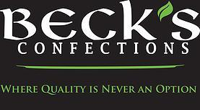

1. **Winner:**

Annie Beck

Beck Lewis LLC / DBA Beck's Confections

P O Box 8252

Biloxi, MS 39535

601-927-3137 - Cell

601-255-3874

Email: [info@becksconfections.com](mailto:info@becksconfections.com)

Web: www.becksconfections.com

1. **Host:**

Magnolia Business Alliance

88360 Diamondhead Drive East

Diamondhead, MS 39525

Phone: 228-222-5922

Email: [nguess@magnolia-ba.biz](mailto:nguess@magnolia-ba.biz)

1. **Product Description:**

Beck's Confections uses only the finest and freshest ingredients to create pastries, custards, and seasonings that will fill and warm your heart with no preservatives or fillers.

1. **We had 5 applicants that participated in this year’s challenge.**