# Executive Summary

### Problem

High school students are still using old, time-consuming methods (Google search & word-of-mouth) of finding extracurricular activities such as volunteering, internships, and summer programs.  These programs are critical to discovering one's passions and making informed decisions about college and careers.

### Solution

Blayz is an online, mobile-ready marketplace where high school students can find and manage extracurricular opportunities. Our marketplace offers over 75,000 opportunities across the country from over 200 universities and hundreds of volunteer organizations.  Our users have told us "Blayz is probably one of the best websites a high school student could ask for".

### Business Model

### We have two planned revenue streams. Our primary source is through a referral fee for students who register for programs through Blayz. Our second source will be through a premium subscription model, for value-added services. This allows us to keep our basic services free for all users.

### Market

Our marketplace has two sets of customers.  Our primary customers on the demand side are high school students.  On the supply side, we have universities and companies that offer high school extracurricular opportunities from which we can generate our revenue.  Taking a look at the market cap for these opportunities, we calculate the TAM for Blayz to be roughly $830 million.

### Competitive Advantage

We are bringing disruption to a niche market of activities for high school students.  Our advantages over competitors are:

* We are focused only on extracurricular activities.
* We are focused only on high school.
* We have a technology advantage because we’ve built an extensive backend system to automatically aggregate content from across the web and keep it updated

There are other companies doing one or two pieces of what we are doing, but no one is bringing a complete solution to our target market.

### Forecast

We will be focusing Q1 and Q2 of 2016 on aggressive user growth.  Once we achieve that, we can focus on signing up the supply side of the market to referral agreements to generate revenue.  We will have minimal revenue in 2016.  Revenue will be increasing in 2017, but we will still be operating with a net loss.  By the end of 2018, we will be profitable, and expect to see a profit of almost $1 million.

### Financial Highlights by Year

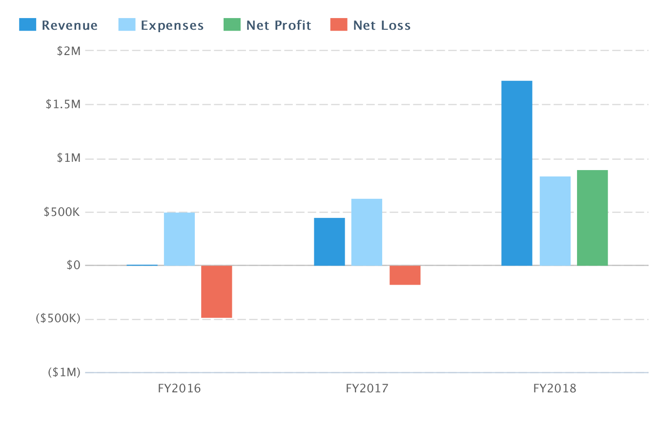

### Financing Needed

We are looking for $500,000 in funding for a 10% stake in the company post-money to get us to the end of 2016, at which time we will be in position to get much better valuation after having proved out the need and the business model.  This funding will go mainly towards marketing and salaries for further development of our product.

# Opportunity

## Problem & Solution

### Problem Worth Solving

Spending hours on Google search, going to the Career Counselor’s office to go through stacks of brochures about summer programs, or relying on word of mouth are currently the only ways that high school students can find extracurricular opportunities.  Parents, over 75% of them moms, spend hundreds of hours and create spreadsheets to keep track of the various opportunities they find for their child, because they know it is critical for students to find and participate in these opportunities in high school.  It enables students to figure out their interests and make informed decisions about majors, careers, & colleges.  Tiger parents aren’t the only ones who are concerned – most students and parents know that extracurricular activities are important. But students who aren’t in private schools and can’t afford private counseling (the vast majority) often don’t get any guidance on opportunities available outside of school, so this contributes to the Opportunity Gap in education.

### Our Solution

Blayz offers a better, faster, & cheaper way of finding the extracurricular opportunities that high school students and moms are looking for. Blayz is better and faster because it eliminates the existing painful paths and provides a web-based, searchable marketplace with smart filtering so users can find exactly what they need in minutes.  Busy moms don’t have to spend hours searching for activities because our large marketplace gives them the quality results they’re looking for. We already have 75,000 opportunities in our database, and are growing every week. Blayz is cheaper because with our recommendation engine, parents don’t need to shell out thousands of dollars for private guidance counseling.  Students can get a full plan of extracurricular activities spanning their high school years based on their interests and goals.

## Business Model

Our business model relies on two revenue streams.  The largest source of revenue will be through a referral model.  We will charge a referral fee for students who sign up for fee-based opportunities through Blayz.  We plan to base these referral fees on a percentage of the tuition for the opportunities, with the percentage on a tier-based scale.  Since the fees for opportunities can run the gamut between $100-$15,000, with the average falling around $3000, even a 5% referral fee would present significant revenue.  On the flip side, we will price it appropriately so that it still represents a cost savings over traditional advertising for the companies and universities who are trying to attract students.  Also, we know that not every opportunity in our database will generate referral revenue - volunteer opportunities, free programs, and internships where students get paid will not generate revenue.  Even fee-based programs may choose not to sign a referral agreement, although they would still appear in our searchable database as a basic listing.  We will entice programs to sign the referral agreement by giving them additional marketing benefits to users on our website, including, but not limited to: featured listings, blog opportunities, and webinar opportunities, through our social media channels, and through featured email blasts.

The second source of revenue will be through a Premium subscription model.  There are many opportunities for value-added features to our product that we can bundle into a premium subscription, including, but not limited to: online, on-demand college guidance counseling, automatic e-portfolio generation, and career path discovery and matching.  The assumption for our models is that we would charge $19.99/month for the premium subscription, which offers considerable savings over paying private counselors anywhere from a thousand to tens of thousands of dollars in fees.

## Target Market

Our target market is broadly defined as US high school students aiming for 4 year colleges. In numbers, there are about 16 million US high school students.  68% of those that graduate high school enroll in college, of which 43% enroll in community college.  So 39% go directly to a four year college. If we project that percentage not just to seniors but to grades 9-12, that's about 6.2 million high school students that will most likely be in 4 year colleges. Those are the customers we are targeting.

Let's look at the specific use cases for our product.  Our prime focus is on students in the low and middle-income demographic. These students may be the first in their family to go to college and don't have the network of support guiding them on the steps they need to take to get there. Or these students may be attending schools where they are not able to get the support and resources they need from school guidance counselors who are overburdened and trying to support 500-800 students. These are the students who know where they want to go, but not how to get there - and they certainly can't afford to hire a private counselor to help them. They need access to tools and resources that can help them reach their goals.

Our second focus is on tiger moms and tiger students - those who always want to find the best opportunities available to them and their children, regardless of income demographics.

Our existing users love our product and are able to find opportunities through our marketplace. When we talk to users, we hear “Oh, yeah, I’ve already signed up for a couple of opportunities I found on Blayz”, or “Blayz is the best website for high school students, I wish I had known about it earlier”. When we talk to parents, what we hear most often is “I wish I had that when I was in high school!” and “This is what I’ve been looking for!”

We have the students and parents on one side of our marketplace, but the other side of the marketplace is where we will be monetizing, so we need to take a look at the market targets there.  Extracurricular activities for high school students are dominated by academic pre-college programs at universities, mostly at private ones.  These programs are growing in number and size as universities realize that these provide a great opportunity to get prospective students onto their campus and also as function as a new and lucrative revenue stream.

We can get a rough idea of the TAM for Blayz by looking at the numbers for these programs.  There are about 2000 private 4-year universities in the US.  If 60% of them have pre-college programs whose average cost is $3000 and attendance is 1000 students, that creates a $3.6 billion market opportunity for just this segment.  Taking a 5% referral fee would create a $180 million TAM for this segment.  In addition to extracurricular activities, we will also be bringing in Test Prep opportunities and College Counseling services. The US test prep/tutoring/counseling market is a $13 billion market.  A 5% referral fee in this market would create a $650 million TAM, giving a combined $830 million TAM by these two segments alone.

## Competition

### Current Alternatives

Our current competitors are Google search & word-of-mouth.  Those really are the tools that students and parents are currently using to find extracurricular opportunities.  There are other companies doing bits and pieces of what we are doing, although no one is bringing a complete solution to our target market.

Naviance, TeenInk and CollegeXPress have listings of summer programs, but this is not an area of focus for them – it is just a small portion of their overall solution. Naviance is a much larger LMS system, and it’s main focus for high school is college search and personality testing/career matching.  TeenInk is an online and print teen magazine, and CollegeXPress is one of the many sites focused on college and scholarship search that also lists summer programs as an aside.  Their revenue models are ad based and are completely different from what we propose and what we think can really drive a business in this space.

VolunteerMatch and InternMatch have volunteer listings and intern listings respectively but are not focused exclusively on high school students.  ActivityHero & Camperoo offer marketplaces for summer camps but are working only on the K-8 market, which has the parent as the driver in decision-making.  In high school, the student is the key influencer, if not the decision maker altogether, and this user group requires a highly differentiated product.

### Our Advantages

Our advantage over Google search and the counselor's office is clear - we save time.  Our advantage over word-of-mouth is also clear - we give access to thousands more opportunities than could be found through word of mouth.  What about the other related marketplaces?  What's to stop them from coming into "our" space?

High school students have unique needs, and we have spent time with students, parents, and counselors to make sure that we are meeting those needs.  We are not solving education for all students, but rather focusing on creating an extremely well thought out solution to a defined problem in a niche market.  Other companies have a much broader core business, so growing another marketplace and developing the revenue stream represents significant effort which will take focus away from their core business, so is unlikely to happen by the time we attain traction.

On the technology side, we have an advantage as well.  We have created an extensive automated web-scraping system that allows us to keep our marketplace up-to-date with the latest opportunities.  In fact, while the few other listing sites may list “Stanford High School Summer College” as a summer program, we are able to obtain the entire course listing for the program, find that there is a course for “Foundations of Water Science & Engineering”, pull out the key information like deadline dates and prerequisites, and present them to the user with all the details they need to make a decision.  That will take considerable time and effort to replicate.

# Execution

## Marketing & Sales

### Marketing Strategy

Blayz has used multiple marketing strategies with minimal resources to attract and keep customers in 2015. We have organically grown to over 6800 Twitter and Facebook users and 2800 Blayz users with an average CAC of $10, and plan to start aggressive marketing in 2016.  The most rewarding fact is that our users love our product.  In fact, College Track Palo Alto, which is using Blayz, found that 80% of their 10th graders found opportunities through Blayz and they were thrilled with the whole experience.

We have two main customer targets, high school students and high school parents, so we have separate marketing strategies for each.

### Marketing to High School Students

Our students target market is comprised of lower and middle-income high school students in the United States, and tiger students.  We have found that high school career and guidance counselors are the key influencers in guiding students to resources, so much of our marketing to students is focused on marketing to these counselors who will then guide the students directly. We will also be working with NCAN – National College Access Network organizations and AVID counselors that provide college guidance services to low-income students.

* **Direct Marketing:** We will be emailing, calling, and physically mailing marketing materials to counselors to create awareness of our free resources for students.  This also includes engaging with college access organizations and local and state-funded counseling programs.
* **Digital Advertising**:  We will reach high school students via targeted advertising on Facebook, Twitter and other teen focused websites.
* **Content Creation:** We will post content on our own social media channels (Facebook, Twitter, G+, YouTube, Pinterest, blog) that interests high school students, for example:  “Tips on how to be successful in high school” “How to find extracurricular activities during high school”.
* **Trade shows**:  We will set up a Blayz booth at national counseling conferences like NACAC and HECA to demo Blayz to counselors, hand out information to pass on to students, and hand out promotional items. This is one of our most important channels since it allows us to directly connect with those that directly influence students.
* **Rewards Programs**: In 2016, we plan to introduce rewards for student by  “incentivizing” signups with giveaways ranging from cash to products like tablets, smartphones, concert tickets, etc.  We will also reach out with incentives to student clubs as a way for them to earn money.

### Marketing to Parents

* **Direct Marketing**: We will advertise in local newspapers and use direct mail campaigns to target our key demographics.
* **Digital Marketing**: We will reach high school parents via targeted advertising on Facebook, Twitter, and online click-based advertising.
* **Content Creation**: We will post content on our own social media channels (Facebook, Twitter, G+, YouTube, Pinterest, blog) that interest high school parents.
* **Networking**:  We will connect with parents in school settings including PTA meetings, and high school parent nights.  We will also connect with parents in work settings through HR programs that help busy employees find resources they need.

### Other Marketing Strategies

* **SEO (Search Engine Optimization)**: We have made sure our site is well structured for SEO, with appropriate indexing of content, use of keywords, and appropriate metadata.  In 2016, we will focus on strengthening our inbound SEO by generating relevant content.
* **Press and Medi**a: We will be hiring a PR person to connect with news outlets and arrange interviews and press releases.

### Marketing Goals

* 25,000 users by end of Q2 2016
* 100 High Schools on boarded by the end of Q2 2016
* 100 Program Vendors signed up under a referral agreement by end of Q4 2016
* 10,000 Twitter followers by end of Q2 2016
* 2000 Facebook users by end of Q2 2016

## Operations

### Locations & Facilities

We are based in Silicon Valley, and have been working out of a home office since the company started. This works well because we have an offshore development team and other contractors helping remotely.  As we start growing, we will shift to a co-working space before we get to our own office.

### Technology

Our solution is built as a responsive web-based application to ensure that students can access our functionality across all types of devices, from older school computers, to new tablets and smartphones.  The main functional pieces of our current solution for students are

* Opportunity search
* Saving of opportunities into list of favorites
* Weekly notifications of upcoming deadlines and new opportunities that match their interests
* Timely deadline reminders sent by email or SMS
* Calendar
* Creation of personalized plan of extracurricular activities
* Linking with parent and/or counselor Blayz account for communication and feedback

Parents can access all of the above for each of their children, and also get a combined view of the activity calendars.  Counselors have the following functional pieces:

* Opportunity search
* Creating groups of students to share/forward specific opportunities to
* Counselor dashboard to see aggregate view of student interests

For vendors (companies and universities), we have multiple ways of being added into our marketplace of opportunities:

* Vendors can add their listings through a link on our website.
* We can add them to our backend system to crawl and add to our database
* Partnership with VolunteerMatch to get their volunteering opportunities applicable to high school

Our entire platform is deployed on Amazon Web Services (AWS) EC2 cloud hosting to reduce hardware and maintenance costs, and provide a high degree of uptime and scalability.  We use a standard LAMP (Linux, Apache, MySQL, PHP) stack as our platform.  Apache Web Server is serving all the web pages, and MySQL serves as the database for both user and marketplace data.  We use the open source Yii Application Framework to generate the CRUD (Create, Read, Update, Delete) code for the data in the database.  The data-aggregating system is built using a platform called Scrapy.

We use Bootstrap, CSS & HTML5 to create the responsive interface.  We are using Amazon Simple Email Service (SES) for email delivery, and a 3rd party service - Nexmo for SMS delivery.

We are using a wide variety of SaaS solutions to handle different aspects of our project management, prototyping, and marketing, including Mailchimp, Basecamp, Redmine, Buffer, Tweetfull, Canva, and Balsamiq.

## Milestones & Metrics

### Milestones Table

|  |  |  |
| --- | --- | --- |
| **Milestone** | **Due Date** | **Achieved?** |
| Company Launched | April 1, 2014 | Yes |
| Company incorporated | June 13, 2014 | Yes |
| Blayz Alpha released | Sept. 12, 2014 | Yes |
| Blayz Friends & Family Beta Released | Nov. 5, 2014 | Yes |
| Blayz Beta released | Jan. 1, 2015 | Yes |
| Blayz Soft Launch | Sept. 21, 2015 | Yes |
| 5,000 Users | December 31, 2015 | Planned |
| 25,000 Users | June 01, 2016 | Planned |

### Key Metrics

In 2014, we were focused on building our Minimum Viable Product.  In 2015, we were beta testing and improving the product, determining our target market, and experimenting with marketing techniques.  Now we are focusing on user growth throughout Q1 and Q2 2016, and then focusing on revenue generation in Q4 of 2016.  Our key metrics are:

* Total Users
* New Users/month
* Active Users/month
* Customer Acquisition Cost (CAC)
* Number of Opportunities listed
* Avg. M/M growth

The metrics for 2015 have fluctuated as we have tested out different services and target markets, but we plan to start aggressive marketing in January, when we believe the timing is right in our cyclical market which is driven by searching for opportunities over summer.

Here are our key metrics for 2015

|  |  |  |  |  |  |  |  |  |  |  |
| --- | --- | --- | --- | --- | --- | --- | --- | --- | --- | --- |
|  | Jan | Feb | Mar | Apr | May | June | Jul | Aug | Sept | Oct |
| Total Users | 108 | 264 | 747 | 884 | 1066 | 2180 | 2245 | 2306 | 2368 | 2501 |
| New Users/month | 34 | 156 | 483 | 137 | 182 | 1114 | 65 | 61 | 62 | 133 |
| Avg CAC | $14 | $10 | $6 | $7 | $6 | $4 | $4 | $4 | $6 | $6 |
| Avg M/M growth |  | 144% | 183% | 18% | 21% | 104% | 3% | 3% | 3% | 6% |

# Company

## Overview

### Ownership & Structure

Blayz, Inc. is registered as a Delaware C-corp.  It was incorporated in June 2014.  The two cofounders - Renee Rashid and Shazia Khan, own the company.  Renee owns a 60% stake and Shazia has a 40% stake.  No outside investors are involved at this point.

### Company History

We started Blayz out of frustration as parents.   We wanted our kids to take advantage of the multitude of experiences available to them, be able to find out what they love to do, and be ready for college applications.  We looked for an existing website that would help us find activities for high-school students in a timely manner and give us clear, accurate, and up-to-date information, but we didn’t find anything.  So we decided to create it ourselves.  And thus Blayz was born - to help other students and parents like us be able to find awesome camps, cool internships, meaningful volunteering positions, and relevant courses, and manage them in a simple, easy interface.

## Team

### Management Team

Renee Rashid – Cofounder, CEO, CTO

Renee received her B.S.  in Computer Science at the Univ. of Minnesota (attending as a National Merit Scholar), her M.S. in Computer Science at the Univ. of North Carolina.  She has 20 years of experience in software development almost exclusively at startups, in the fields of medicine, computer graphics and EdTech.  Her EdTech experience was developing an entirely new platform and product at Kno.  She is a patent holder of an innovative algorithm for medical visualization.  She has experience in the full stack of product development –conceptualization, user studies, application development, analytics, testing, and support.  Her high school extracurricular activities? Captain of the Math Team, Odyssey of the Mind, SpaceCamp, National Honor Society, and Tennis

Shazia Khan – Cofounder, Chief of Business Development

Shazia obtained her B.S. in Sociology at Punjab University, Pakistan.  She cofounded the first all-women print ad company in Pakistan.  In the US, she built award-winning customer support teams from the ground up at two EdTech startups – Chegg & Kno (now Intel).  She is a seasoned manager of employees spanning multiple continents.  She is an expert in CRM systems; call centers & creating happy customers.  Her high school extracurricular activities? VP of Student Council, Lead in Women's Guard, Drama Club, and Tennis

### Advisors

Osman Rashid - Advisor

Osman has been a successful serial entrepreneur in EdTech since 2009 and is known as a thought leader in education.  He is the founder of Chegg, Kno & Galxyz.  Chegg started out as Craigslist for college students, did a successful pivot into textbook rentals, and attracted investments from KPCB, Floodgate, Foundation, Gabriel, and GSV.  Chegg went public in 2013.   Kno is a digital learning platform that started out as a dual-screen tablet, then pivoted into software.  Intel acquired it in 2013.  He is currently Founder & CEO of Galxyz, an intergalactic science adventure. Osman has received many honors, including Ernst & Young's Entrepreneur of the Year award for Northern CA 2009, as well as Forbes Impact 15 for 2012.

# Financial Projections

### 2016 Revenue by Month

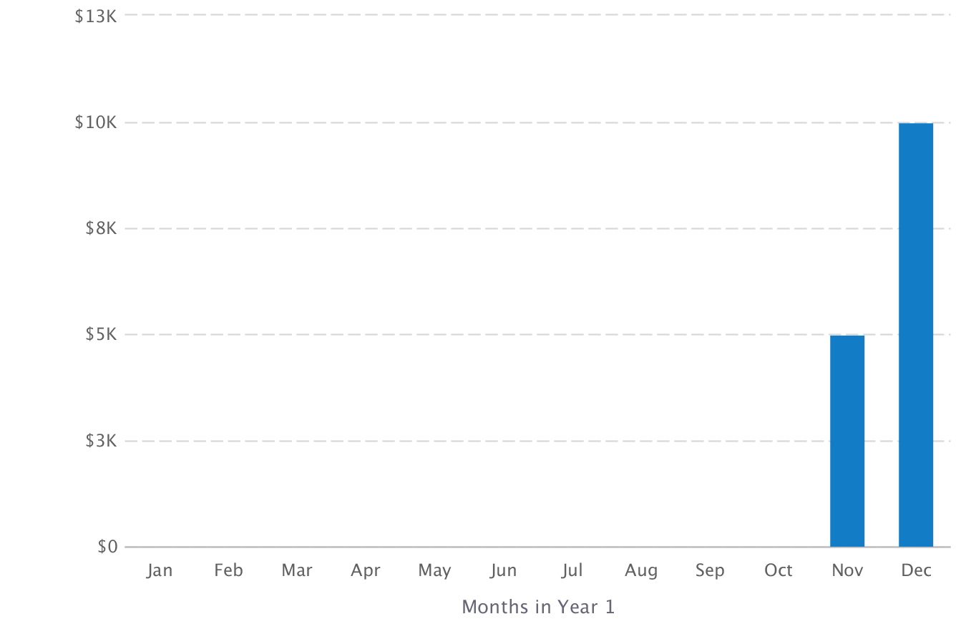

### 2016 Expenses by Month

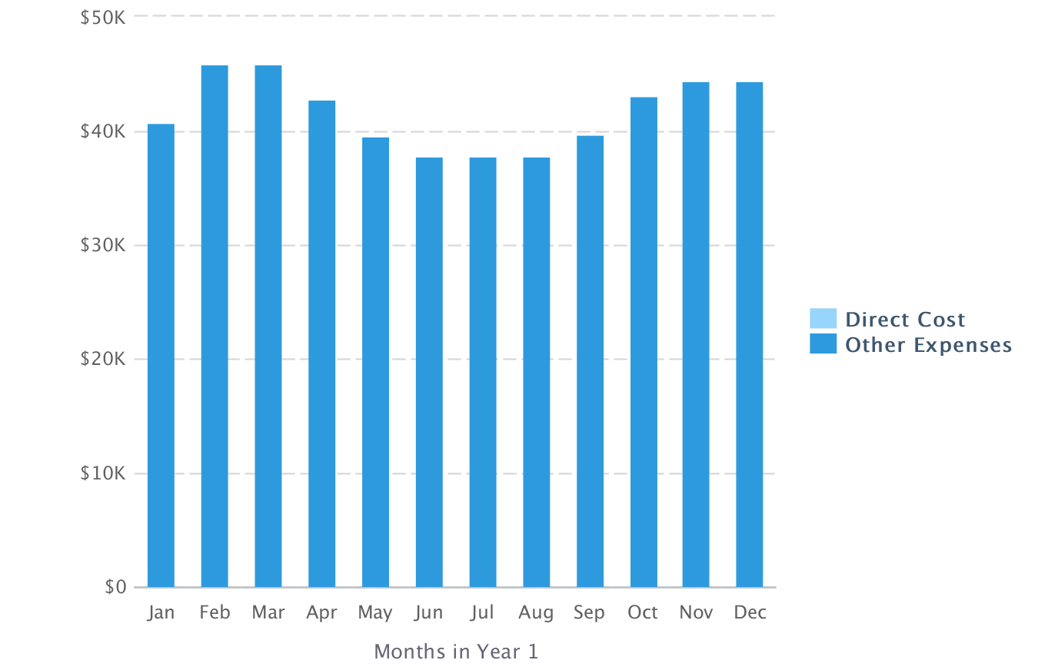

### Net Profit (or Loss) by Year

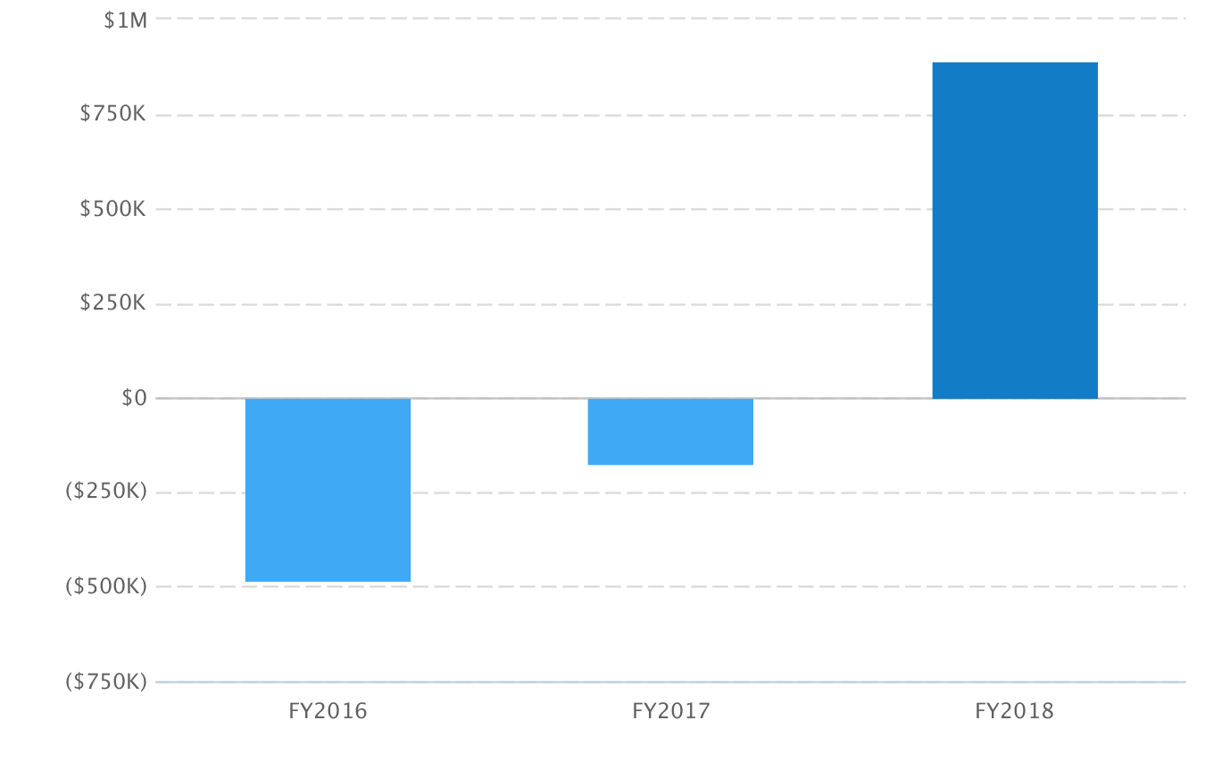

## Financing

### Ask

We are looking for seed funding of $500K to cover our operating costs for 2016.  In 2016, we will need to get to 25,000 users and show that we can generate revenue through our referral model.  Most of our funding will go towards marketing and salaries for ourselves, a marketing manager, and for developers (who will be needed to continue aggregating content on the backend and personalizing the product).

We can make the company significantly more valuable once we have proved our product and revenue model by the end of 2016 with an investment of $500,000.  We are willing to sell up 10% of the company, which would give a post-money valuation of $5 million.  We believe this valuation is justified by looking at the $2.5 million valuations of companies coming out of 500Startups or YCombinator, which are at a much earlier stage in development.

### Exit Strategy

Our exit strategy is acquisition.  We will make a great acquisition target for a larger student hub site like The College Board, Naviance, ACT, or Chegg who want to expand their offerings and provide end-to-end solutions for students, but do not have the time and focus to pursue each product on their own.

## Statements

### Projected Profit & Loss

|  |  |  |  |
| --- | --- | --- | --- |
|  | **FY2016** | **FY2017** | **FY2018** |
| **Revenue** | **$15,000** | **$451,861** | **$1,728,232** |
|  |  |  |  |
| **Direct Costs** |  |  |  |
|  |  |  |  |
| Gross Margin | $15,000 | $451,861 | $1,728,232 |
| **Gross Margin %** | **100%** | **100%** | **100%** |
| **Operating Expenses** |  |  |  |
| Salary | $391,680 | $472,904 | $578,248 |
| Employee Related Expenses | $64,000 | $80,000 | $100,000 |
| Rent | $8,600 | $32,000 | $48,000 |
| Data hosting | $5,400 | $10,800 | $20,400 |
| Marketing | $30,000 | $30,000 | $30,000 |
| **Total Operating Expenses** | **$499,680** | **$625,704** | **$776,648** |
|  |  |  |  |
| **Operating Income** | **($484,680)** | **($173,843)** | **$951,584** |
|  |  |  |  |
| Interest Incurred |  |  |  |
| Depreciation and Amortization |  |  |  |
| Income Taxes | $0 | $0 | $58,611 |
| **Total Expenses** | **$499,680** | **$625,704** | **$835,259** |
| **Net Profit** | **($484,680)** | **($173,843)** | **$892,973** |
| **Net Profit / Sales** | **(3,231%)** | **(38%)** | **52%** |

### Projected Balance Sheet

|  |  |  |  |
| --- | --- | --- | --- |
|  | **FY2016** | **FY2017** | **FY2018** |
| Cash | ($484,684) | ($658,523) | $280,155 |
| Accounts Receivable | $0 | $0 | $0 |
| Inventory |  |  |  |
| Other Current Assets |  |  |  |
| **Total Current Assets** | **($484,684)** | **($658,523)** | **$280,155** |
|  |  |  |  |
| Long-Term Assets |  |  |  |
| Accumulated Depreciation |  |  |  |
| **Total Long-Term Assets** |  |  |  |
|  |  |  |  |
| **Total Assets** | **($484,684)** | **($658,523)** | **$280,155** |
|  |  |  |  |
| Accounts Payable | $0 | $0 | $0 |
| Income Taxes Payable | $0 | $0 | $45,709 |
| Sales Taxes Payable |  |  |  |
| Short-Term Debt |  |  |  |
| Prepaid Revenue |  | $0 | $0 |
| **Total Current Liabilities** | **$0** | **$0** | **$45,709** |
| Long-Term Debt |  |  |  |
|  |  |  |  |
| **Total Liabilities** | **$0** | **$0** | **$45,709** |
|  |  |  |  |
| Paid-in Capital |  |  |  |
| Retained Earnings |  | ($484,684) | ($658,523) |
| Earnings | ($484,684) | ($173,839) | $892,969 |
| **Total Owner's Equity** | **($484,684)** | **($658,523)** | **$234,446** |
|  |  |  |  |
| **Total Liabilities & Equity** | **($484,684)** | **($658,523)** | **$280,155** |

### Projected Cash Flow Statement

|  |  |  |  |
| --- | --- | --- | --- |
|  | **FY2016** | **FY2017** | **FY2018** |
| **Net Cash Flow from Operations** |  |  |  |
| Net Profit | ($484,680) | ($173,843) | $892,973 |
| Depreciation and Amortization |  |  |  |
| Change in Accounts Receivable | $0 | $0 | $0 |
| Change in Inventory |  |  |  |
| Change in Accounts Payable | $0 | $0 | $0 |
| Change in Income Tax Payable | $0 | $0 | $45,709 |
| Change in Sales Tax Payable |  |  |  |
| Change in Prepaid Revenue |  | $0 | $0 |
| **Net Cash Flow from Operations** | **($484,680)** | **($173,843)** | **$938,682** |
| **Investing & Financing** |  |  |  |
| Assets Purchased or Sold |  |  |  |
| Investments Received |  |  |  |
| Change in Long-Term Debt |  |  |  |
| Change in Short-Term Debt |  |  |  |
| Dividends & Distributions |  |  |  |
| **Net Cash Flow from Investing & Financing** |  |  |  |
| Cash at Beginning of Period | ($4) | ($484,680) | ($658,527) |
| Net Change in Cash | ($484,680) | ($173,843) | $938,682 |
| **Cash at End of Period** | **($484,684)** | **($658,523)** | **$280,155** |