**Click & Carry Business Plan**

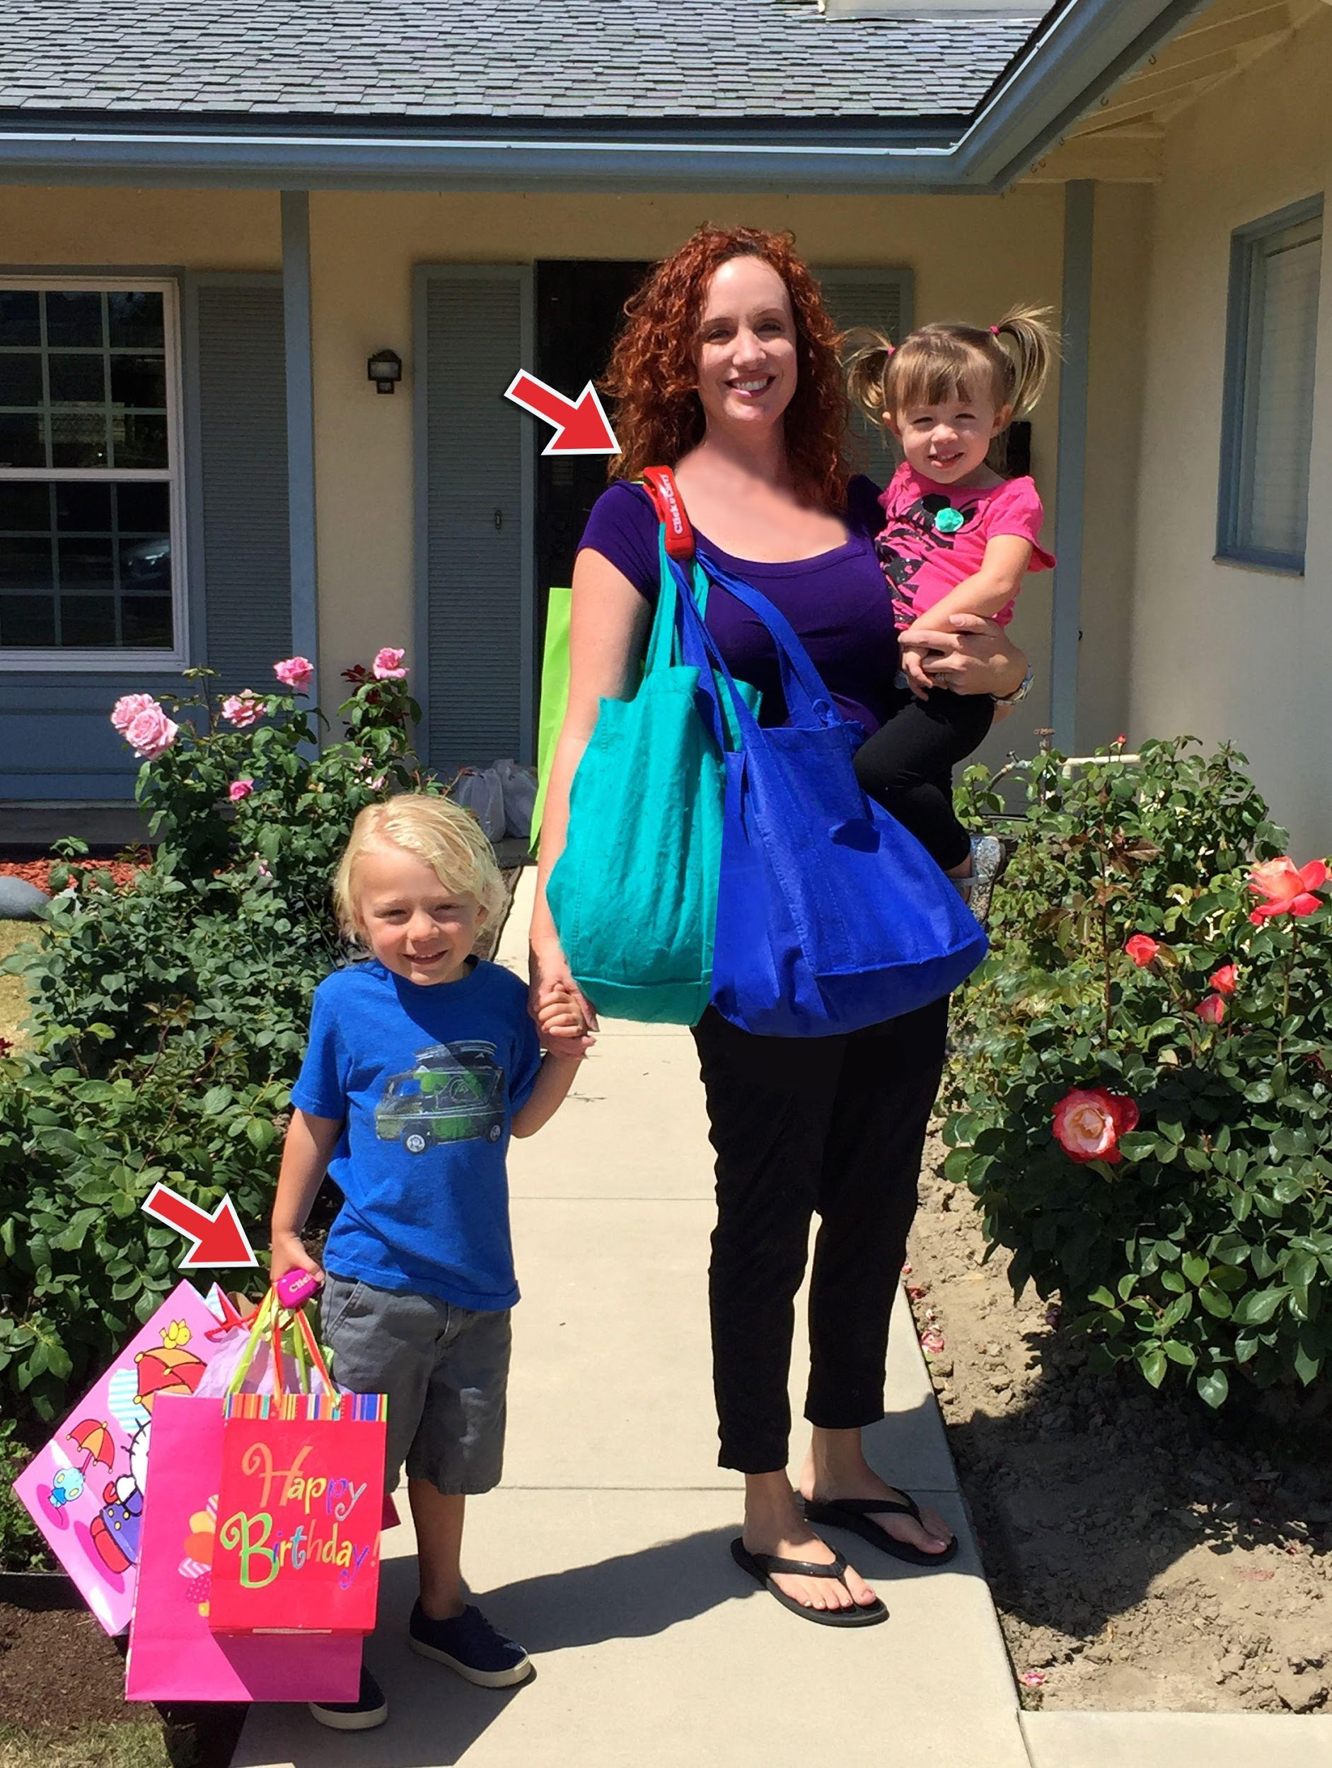

### Table of Contents

**II. Executive Summary 4**

**III. General Company Description 5**

**IV. Products & Services 7**

**V. Marketing Plan 8**

**VI. Distribution & Strategy 10**

**VII. Economics 12**

**VIII. Operational Plan 14**

**IX. Financial Plan 16**

**X. Refining the Plan 17**



### Executive Summary

Click & Carry is an inventive device designed for the consumer products industry. Click & Carry is a bag handle that allows the user to tote multiple handle bags, paint cans and construction pails without incurring the “grooves” in your hands and arms from carrying too much weight. Click & Carry allows the user to “wear” purchases over the shoulder so the weight burden is placed on the back versus the extremities. Although the weight burden is not lighter, it feels lighter because the back is such a good support system. Click & Carry was awarded two utility patents and one trademark from the United States Patent and Trademark Office.

The ideal target market for Click & Carry includes moms, urban dwellers, seniors with dexterity issues and construction workers. Distribution channels include grocery stores, convenient stores, drug stores, big box retailers, sporting goods stores and home improvement stores. Click & Carry is also sold direct to consumer on-line at www.clickandcarry.com. Click & Carry may be bundled with reusable bags and a stationary version is a perfect gadget for the promotional products industry and as a fund-raiser for charities. Future versions will include a bicycle version, a stroller version, an attachment for shopping carts and a military version.

Click & Carry is 100% owned and operated by Kimberly Meckwood, who is a WBENC member. Kim has a background of medical device and pharmaceutical sales.  She worked for Medtronic in neuromodulation, at Schwarz Pharma in neurology and Wyeth-Ayerst Pharmaceuticals in psychiatry and gastroenterology.

Click & Carry is applying for a $250,000 SBA loan to attain the resources necessary to create a successful business. The funds will be used for inventory and warehousing of the inventory, to expand the team to include a Head of Business Development to handle operations and financials, a Social Media Expert to expand product awareness, to purchase additional molds to expand the monthly output and to expand the product line, to attend industry trade shows and for miscellaneous expenses.

### General Company Description

Click & Carry is a simple, handle device that allows shoppers to manage and carry multiple bags at once ~ comfortably. Click & Carry may be CARRIED in the HANDS or WORN over the SHOULDERS.  When worn over the shoulder for easier carrying, the device uses the weight of the bags to counterbalance for a “hands-free” carry.

Click & Carry benefits Shoppers with a Conforming Gel Grip, a Rotating Top to easily load/unload bags, it provides Even Distribution of Weight, Carries up to 80 lbs. and is CARRIED in the HANDS or WORN over One's SHOULDER.

Click & Carry is also used to carry paint cans/construction pails, for dry cleaning, as a ski boot tote, to carry sports equipment and to walk multiple dogs at once.

**Mission Statement:** To make lugging purchases home easier on the hands.

**Company Goals and Objectives:** The goal for Click & Carry is to allow a shopper to tote his or her purchases home in ONE QUICK trip! The objective of Click & Carry, Inc. is to be made available in all grocery stores, convenient stores, big box retailers, sporting goods stores, pharmacies and convenient stores to aid shoppers everywhere in lugging home their purchases.

**Target Market:** Click & Carry is ideal for moms, urban dwellers, seniors with dexterity issues and construction workers. Everyone carries bags – young, old, rich, poor, male & female. This item is universal.

**Moms** stock up for the entire family when grocery shopping. She's busy and seeks solutions to be the best mom possible. With Click & Carry, she can "wear" her groceries, hold her baby and still have a free hand to extend to her toddler.

**Urban dwellers** shop for fill-ins on daily trips to the store and are generally on foot or using public transportation. An urban shopper seeks to maximize convenience. With Click & Carry, the urban dweller no longer has to choose between the milk or the detergent, which are both heavy items. He can buy both since the Click & Carry makes toting multiple bags much easier - all in one quick trip!

**Seniors with Dexterity Issues** and **Baby Boomers** experience physical limitations when household/grocery shopping. Bags can be painful to hold or carry ~ especially if the Senior has arthritis. Click & Carry is ergonomically designed for comfort and even distribution of weight. The conforming gel grip on the Click & Carry eases the pain for seniors toting multiple bags.

Click & Carry **may also be used for** carrying dry cleaning, as a ski-boot tote, to transport paint cans or construction pails, for toting sports equipment, to walk multiple dogs at once and as a give-away for the promotional products industry.

**What Sets Click & Carry apart:** Click & Carry is the ONLY bag carrier that may be carried in the hands as well as worn over the shoulders for a “hands-free” carry. Click & Carry was awarded two utility patents (USPTO #7874602 & #8182008) and a trademark in both the United States (serial #77667140) and Europe. The owner/inventor is WBENC accredited. (Women’s Business Enterprise National Council)

**Legal Form of Ownership:** S-Corporation

### Products and Services

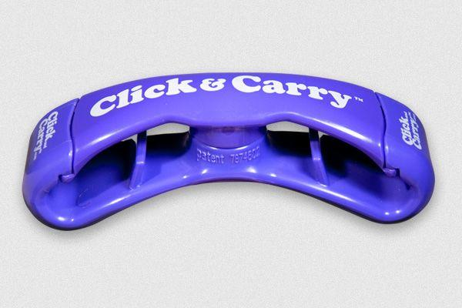

Click & Carry is a simple, handle device that allows shoppers to manage and carry multiple bags at once ~ comfortably. Click & Carry may be CARRIED in the HANDS or WORN over the SHOULDERS.  When worn over the shoulder for easier carrying, the device uses the weight of the bags to counterbalance for a “hands-free” carry.

How Click & Carry benefits Shoppers: Best value proposition for durability, utility and price, and it’s compliant with CPSIA limits for lead & phthalates.

* Conforming Gel Grip
* Rotating Top to easily load/unload bags
* Provides Even Distribution of Weight
* Carries up to 80 lbs.
* CARRIED in the HANDS or WORN over One's SHOULDER
* Used for paint cans/construction pails, for dry cleaning, as a ski boot tote, to carry sports equipment and to walk multiple dogs at once.
* Click & Carry is sold B to B for approximately $4.00/unit and retails for $7.99 to $9.99 a unit in stores.

### Marketing Plan

Facts about the Bag Handle industry:

* The market size: Grocery Stores – 638,338; Convenient Stores – 152,794; Big Box Retailers – 8,042; Home Improvement Stores – 9,088; Drug Stores – 19,128 and Sporting Equipment Stores – 1,829 = Total of 829,219 doors.
* Click & Carry’s goal is to service 20,000 doors, which comprises 2.4% of the market size. When Click & Carry sells 2 units/store per week at 20,000 stores, the total yearly revenue is $8,320,000 USD (20,000 stores x 2 units per store x 52 weeks x $4.00 (wholesale price))
* Estimated demand for the Click & Carry is 1/5th of all reusable bag purchases nationwide.
* Trends in market – consumers are moving away from single use plastic bags. The Trend is to use recycled or reusable bags. New programs are being implemented across the nation where consumers order their groceries on-line and then pick up their purchases at a valet station at the grocery store. (For example, Kroger is implementing a like program called “Click & Connect”)
* Growth potential and opportunity for bag carriers is enormous as more states across America seek to outlaw plastic ban use and more & more grocers are moving toward the “Click & Connect” concept.
* **Barriers to entry that Click & Carry faces:**
* High capital costs, production costs & importation costs
* High marketing costs
* Consumer acceptance and brand recognition
* **Overcoming the barriers to entry:**
* Invest in a multi-cavity mold to lower COGS; decrease the weight of ABS material used in the production of Click & Carry to lower importation costs.
* Hire MBA interns to manage social media campaigns.
* Capitalize on PR to create brand awareness and photograph an “influencer” to gain consumer acceptance.

##### Competition

There have been 16 US patents issued to bag carriers since 1962. Click & Carry is the ONLY bag carrier that may be “worn over the shoulders” as well as carried in one’s hands.

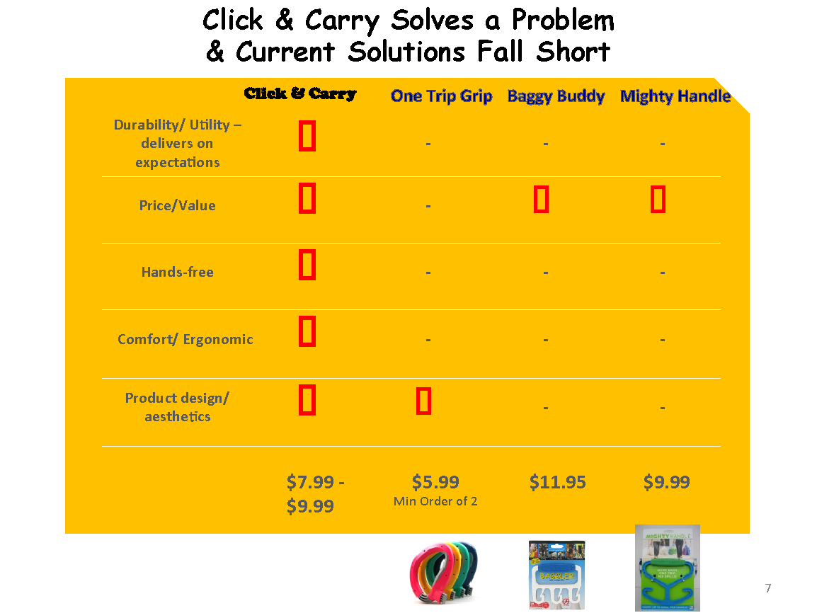

**Competition Facts:**

The “One Trip Grip” is carried at Bed, Bath & Beyond

The “Mighty Handle” is carried at Walmart and ShopRite

Indirect competitors include grocery delivery services such as Amazon.com and consumers will also carry their bags without the aid of a carrying apparatus.

##### Niche

Click & Carry allows the shopper to tote his or her groceries in just ONE QUICK trip! Click & Carry is ideal for moms, urban dwellers, seniors with dexterity issues and construction workers.

### Distribution & Strategy

Click & Carry is currently sold on QVC, in The Container Store, in Corningware Stores, at Ralphs (a division of Kroger) and in ShopRite on the east coast. The product is currently being reviewed by Bed, Bath & Beyond, Lowe's, Publix, Wegmans and the One Step Ahead Catalog. Click & Carry is also sold to vendors in Japan, England, France, Korea, Canada and Australia. Finally, the product is sold direct to consumers on at www.clickandcarry.com.

Click & Carry’s strategy is to expand into grocery stores, convenient stores, drug stores, big box retailers, home improvement stores and sporting goods stores within the “impulse” category. Click & Carry is also sold internationally to augment cash flow issues with the strongest markets being Europe, where consumers shop on a daily basis for groceries, and in Southeast Asia, where bicycles are the primary mode of transportation.

**Direct** – web – www.clickandcarry.com

**Wholesale** - Kroger, The Container Store, Corningware Stores, ShopRite and QVC

**Distributors** – Snacks R Us (Kroger) and Chamoiserie De France (France)

To hire an MBA intern to head a social media campaign on Facebook, Instragram and Twitter; Align with “mom bloggers” to spread the word about Click & Carry.

Attend trade shows including the Home + Housewares Show and the Fancy Food Show.

Click & Carry recently revamped the consumer packaging to better describe the use of the product to make the purchasing decision more intuitive to the consumer. Ideally, the product will be merchandised on a header card or adjacent to a looped video detailing the product usage.

**Promotion**

PR through television (QVC, Food Network & Fox), magazines and social media

Appeared on QVC six times, the nationally syndicated talk show “The Bethenny Show” and on the Food Network’s show called “Food Fortunes”. Applying to appear on “Shark Tank” for Season #8.

**Recent PR clips for Click & Carry**

1.  The first video is a B-Roll showing the many uses of Click & Carry

<https://www.dropbox.com/s/pil4konp2a92va7/CLICK%20N%20CARRY%20WITH%20VO.mov?dl=0>

2.  This video is for the FFANY foundation for breast cancer awareness - presented on QVC on October 16, 2014

<http://www.qvc.com/FFANYVideos.content.html?cm_re=PROMOTIONS-_-eSpotFFANY-2-_-PROMOTION&metaeSpot=FFANY%7CFFANY&cm_sp=PROMOTIONS-_-VIDEOS-_-2>

(Scroll down to "Kimberly Meckwood" entry)

3.  Please view the video clips on my website

[www.clickandcarry.com](http://www.clickandcarry.com/)

4.  Appeared on a nationally syndicated talk show "Bethenny" where QVC hosts Lisa Robertson & David Venable presented me with a national partnership with QVC to sell my product on a national stage.

<http://www.yourepeat.com/watch/?v=-4YG8XPIQfA>

5. Go to [QVC.com](http://qvc.com/) & search "Click & Carry" to view my last airing (3/30/15) and see customer reviews. <http://www.qvc.com/Set-of-4-Click-and-Carry-Shoulder-or-Hand-Multiple-Bag-Carrier.product.V33027.html?sc=V33027-SRCH&cm_sp=VIEWPOSITION-_-1-_-V33027&catentryImage=http://images.qvc.com/is/image/v/27/v33027.001?$uslarge$&vid=y#vidPlayerHolder560x315>

6.   Featured in the United States Patent and Trademark Office newsletter, the Inventor's Eye, where I was featured in the June 2014 issue in the "Spark of Genius" section.

<http://www.uspto.gov/inventors/independent/index.jsp> (scroll down to the June 2014 issue)

### Economics

**Budget:**

Inventory - $100,000

Miscellaneous Expenses - $1,500/month

Capital Equipment - new mold - $17,500 (2nd mold) + $17,500 (new stationary version) = $35,000

Payroll - $10,000/month

Trade shows - $15,000 for the 3 main shows

**Pricing:**

Click & Carry is sold wholesale for approximately $4.00 a unit (58% margin) to retailers and on-line direct to consumer for $9.99/ unit (87% margin) and as a bundled set of 4 Click & Carries to QVC at $13.75 (56% margin)

Click & Carry is priced higher than competitors. The advantage in durability and integrity warrant the higher price point and retailers make a larger margin on Click & Carry due to the greater price point.

**Proposed Location:**

Click & Carry is currently run from a home office. As the company expands, it will be necessary to rent office space and warehouse space to host employees and store the inventory.

##### Sales Forecast:

See Complete Projections from Theorem

|  |  |  |  |  |
| --- | --- | --- | --- | --- |
| **Profit & Loss** | |  |  |  |
| **Revenue** | | **Year 1** | **Year 2** | **Year 3** |
|  | Direct Sales | 17,143 | 32,273 | 57,958 |
|  | Wholesale Sales | 2,100,306 | 3,057,578 | 3,518,512 |
|  | Int'l & FOB Sales | 1,188,346 | 1,675,266 | 2,022,233 |
| **Total Revenue** | | **2,889,393** | **4,765,117** | **5,598,703** |
|  |  |  |  |  |
| Expenses | |  |  |  |
|  | Cost of Goods | 1,087,728 | 1,862,370 | 2,171,218 |
|  | Fulfillment & Merchant Fees | 50,285 | 88,336 | 104,510 |
| **Total Expense** | | **1,138,012** | **1,950,707** | **2,275,728** |
|  |  |  |  |  |
| **Gross Margin** | | **1,751,381** | **2,814,411** | **3,322,975** |
|  |  |  |  |  |
| Operating Expenses | | 874,954 | 1,290,633 | 1,409,296 |
|  |  |  |  |  |
| Operating Profit (EBITDA) | | **876,427** | **1,523,777** | **1,913,680** |
|  | 1.9% | 1,523,777 | 10,666,442 |  |
|  | Depreciation & Amortization | 8,133 | 25,767 | 42,933 |
|  | Taxes | 356,000 | 614,184 | 767,006 |
|  |  |  |  |  |
| Net Income | | **512,293** | **883,826** | **1,103,740** |
|  |  |  |  |  |

### Operational Plan

##### Production:

Click & Carry is manufactured in China.

* Production techniques and costs – Plastics Infusion - $1.36/unit at Uyoung and $2.17/unit at Li & Y Manufactory
* Quality control – Inventory is independently tested at Intertek and static & dynamically tested by Eurofins
* Product development – engineers Steven Hauser & Drew Palumbo

##### Legal Environment:

* S-Corporation #C3038279
* Sellers Permit #SR AS 101-699661; City of Los Angeles #0002580085-0001-8
* WBENC Accreditation (Women’s Business Enterprise National Council)
* Insurance coverage – The Hartford – Sentinel – Policy #72 SBM IT9108 DX
* Trademark # =77667140, Utility Patent #8182008 and #7874602

##### Inventory:

* On-hand inventory = $15,000
* Lead-time is 1-2 months for manufacturing (depending on size of the order) and an additional 6-8 weeks to ship to the United States and go through US customs

##### Suppliers:

* **Uyoung Appliance Manufacturing Company** - No.88, North Tongsheng Road, Tong'an Chengnan Industrial District, Xiamen, China 361100
* $1.36/unit including packaging Type and amount of inventory furnished
* 20% cash down/ 80% FOB China release
* History and reliability – recommended by the co-founder of “The Perfect Push-Up” who had manufactured over 10,000,000 units of The Perfect Push-Up at Uyoung with very few errors
* **Li & Y Manufactory LTD**- Flat C 10/F Effort Industrial Building, 2-8 Kung Yip Street, Kwai Chung, Hong Kong
* $2.17/unit including packaging
* 20% cash down/ 80% FOB China release
* History and reliability – worked with factory for 5+ years

##### Credit Policies:

* Terms are established by my clients: Kroger – Net10 – 2% discount; QVC – Net45; The Container Store – Net60; Corningware Store – Net60 and ShopRite (Wakefern) – Net30

##### Professional and Advisory Support

List the following:

* Management advisory board – Paul Chau, Don Loewel, Albert Napoli and Don Kasle
* Attorney – Jason Fardadian Esq.
* Accountant – Paul Chau
* Insurance agent – The Hartford - Sentinel
* Banker – Wells Fargo
* Consultant – Vanessa Ting Anderson – Retail Consultant
* Mentors and key advisors – Don Loewel and Albert Napoli – SBA; Randy Klinenberg and Gary Polk - SBEC

### Financial Plan

##### Three-Year Profit Projection (Optional)

Presented by Theorem

##### Projected Cash Flow

Presented by Theorem

### Refining the Plan

##### For Raising Capital

* Amount of loan - $250,000
* Repayment terms – 3-5 years repayment schedule
* Collateral offered – Deed on home – valued between $850,000 & $900,000