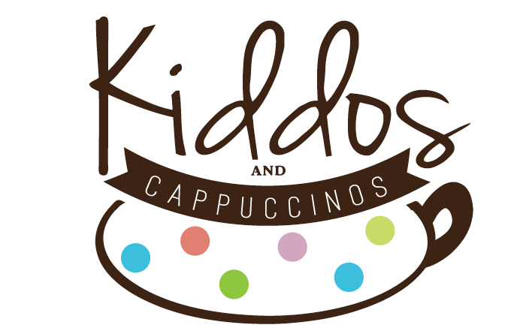

# Business Plan

Jasmine Farnsworth, Owner

400 Madison Street Apt 302

Alexandria, VA 22314

### Table of Contents

**I. Table of Contents 2**

**II. Executive Summary 3**

**III. General Company Description 4**

**IV. Products and Services 5**

**V. Market Analysis 7**

**VI. Marketing Strategy 12**

**VII. Operational Plan 14**

**VIII. Management and Organization 16**

**IX. Startup Expenses and Capitalization 18**

**X. Financial Plan 19**

### Executive Summary

##### Introduction

“Kiddos and Cappuccinos” is a start-up coffee shop with an indoor recreation area that is attempting to bring some sanity and community to the lives of parents with young children. It as an idea inspired by the “Kid’s Cafes” of South Korea, which provide a stimulating, but age appropriate play experience for young children who aren’t quite old enough to attend school. It is because of these cafes that I was able to connect with other young families when our family was stationed in South Korea. It allowed me to establish a network of support, and even finish my MBA.

##### The Company

Kiddos and Cappuccinos is incorporated in Virginia, and I am currently the sole owner. I have an MBA from East Carolina University and am a former Afghanistan war veteran. I am also mother to two toddlers and wife to an active duty military officer, so I understand the target market very well, since I am a part of it. I have extensive experience managing family programs with a very small budget; experienced I gained while managing a USO center in South Korea. In addition to my understanding of financial administration and event planning, I also have real-world experience with market research and promotion. To bridge the gap in knowledge of running a food and beverage service, I plan to hire a general manager with at least 5 years experience to run the café. The company will also hire four part-time workers to monitor the play areas, work behind the food counter, and assist with cleaning and other duties as needed. All employees will be trained in CPR and First Aid.

##### Products and Services

Kiddos and Cappuccinos will offer 2 hours of play time for children 9 months -6 years. The play area will be sectioned off by age group to keep the youngest of our guests safe. The main features will be a large play structure, big enough for the adults to accompany their children if they desire, and a separate infant area with soft-play structures and sensory items. There will also be a reading nook, dress-up closet, train set, pretend grocery store, and ride-on cars for the children.

We will offer a full coffee bar for the adults, and juice and milk for the children. We will also offer a limited menu of food items, striving to provide alternate options for children with food allergies as well. Guests will have access to our free Wi-Fi, and a private nursing room will be available for mothers to breastfeed their infants. Guests also have the option of renting two party rooms which will be available with the purchase of a party package.

##### The Market

There is a growing trend of family growth and “opt-out” moms in the country, which is reflected in the demographics of Fairfax County. Children under 5 years old make up 6.7% of the population, and millennials, the current parent generation, continue to migrate to the area to raise their families. There are also a large number of military families in the area who tend to have very young children and no ties to the community. Additionally, there are few options in the area for young children and their parents to get out of the house other than local parks and limited membership-only classes.

Kiddos and Cappuccinos will easily establish a loyal customer base as we have the advantage of being the first business of this kind in the area. We are anticipating a 40% market penetration rate with families within 1 mile of the store, and 30% for families 1-5 miles of the store. These families will make up our target customer base and who we expect to have the most repeat visits. After an initial proof of concept, the next step will be to create a chain targeted at major military bases and communities.

##### Financial Projections

The owner is planning on raising $86,052 in funding, which leaves $164,208 to be obtained as a commercial loan. Investors will receive 20% returns over 5 years, and the commercial loan will be repaid over 10 years at estimated 10%. Start-up costs are high for this business because of the cost to build-out the space and purchase the playground equipment.

Once operational, Kiddos and Cappuccinos has low overhead costs since parents are responsible for watching their children play. Admission sales will provide 44% of revenue and 40% will come from concession sales. The other 16% will come from party package sales. We estimate sales in Year 1 to be $845,631, with total sales reaching just shy of $1M in year 3, projected at 5% growth. Net profits over the next 3 years are projected to be $220,942, $265,080, and $286,820 respectively. We do not anticipate any cash flow problems, however occupancy during the spring and fall are projected to be at 70% of our average.

##### Conclusion

While the startup costs of the business are significant, our financial estimates show the business to be profitable at even the worst of times. Furthermore, we are operating in an environment with very few competitors. Party and admission sales estimates are modest, and we have the option of expanding our business to provide “drop-off” care should we need to increase revenue. This is a service that any new parent can appreciate, especially stay-at-home parents or playgroups looking for a new location. This company has the potential to even improve the economic development of communities, including the value of homes, due to its ability to galvanize the family market.

### General Company Description

Kiddos and Cappuccinos is a coffee shop with indoor recreation area targeted towards children 6 and below and their parents. Parents supervise children in the play area and our employees will constantly monitor the area to attend to messes and address dangerous or overly rowdy behavior. The play area is sectioned into two primary areas-a large area for children 3-6 and a smaller area for babies 0-2. Since very young babies aren’t yet walking, or even crawling, we will have a number of bouncers and jumparoos available as well.

The café is a full-service coffee shop with a small selection of food and drink items. Outside food and drinks will not be permitted, with the exception of baby food/formula/milk/water. The menu will offer something for children with allergies and there will be no nut or nut products allowed in the center.

This play café will offer something for parents of young children and the children themselves that is not currently available in the local area-a clean, safe place to play while parents can relax and interact. While there are many activities for school-age children and above, there aren’t many options for new parents to meet other new parents outside of playgroups, which don’t in and of themselves present a local meeting place with play facilities created especially for children.

The only similar businesses within a 10-mile radius are JW Tumbles, The Little Gym, and Chuck E Cheeses. While these businesses are similar in that they are classified as Family Entertainment Centers (FECs), our café offers some unique characteristics that put us in a category all our own. The competitors are further discussed in the Market Analysis section of this business plan.

My goal for this company is to provide a place for children to go when they need some unstructured play time and their parents need a break. Every parent knows that there are times when they just need to get out of the house because the stress level there has become too high. Kiddos and Cappuccinos give parents that escape while providing children with an entertaining, stimulating environment to explore. Goal #1 is that the family leaves happier, more relaxed, and positive.

Another goal is to provide a location for parents who telework or are in school to complete tasks while their children are engaged in safe, and more importantly, distracted, play. I was able to complete my MBA thanks to the play cafes in South Korea, and I read another review from a woman who said she was able to complete a majority of her research for her PhD thanks to the same. Goal #2 is to create an environment which enables parents to pursue other ambitions that provide them with a sense of self-fulfillment and self-satisfaction, which in turn makes them even better parents and strengthens the family overall.

Lastly, Kiddos and Cappuccinos isn’t just about escaping the stressors of parenthood or finding ways to keep children distracted. It’s also a place where you can go to spend quality time with your children, and bond while exploring a new world through their eyes. When you’re at home with your children, you are constantly faced with distractors such as the dishes, bills, laundry, or any other number of household chores that can take your attention away from the moment. At Kiddos and Cappuccinos, it is about you and your child, or you and a fellow parent. Goal #3 is a reminder to our guests- life is about putting the cell phone and your worries away and bonding with the people around you.

### Products and Services

##### Product

The primary product we are selling is sanity, the second is social interaction. A common joke in mommy blogs, parent magazines, and playgroups is that you usually have to reheat your coffee at least 4 times in the microwave before finishing it with a newborn. The only thing that changes as the child grows older is that the number of times you need to reheat it usually goes down-if you’re lucky. Playgroups are not popular because parents need to socialize their babies, they’re popular because parents need to socialize themselves, which is where our business really offers something unique.

My café will be tailored towards the 6 and under crowd, offer amenities for new mothers such as nursing rooms, extra diapers, wipes, bottles, and a menu with options for allergy-sensitive guests. The café will also have a robust Wi-Fi network to allow parents to connect and complete work assignments, school assignments, or other small tasks. It will give parents the option to interact and run around with their children or let their children run wild while they enjoy a cup of coffee and conversation with another parent.

The cafe will have a smaller infant/toddler area with soft play structures and sensory items such as mirrors, colorful blocks, and music-makers. It will be an enclosed area with seating around the perimeter for parents. There will also be a larger playground structure for the 2-6 crowd, which will be large enough for parents to crawl into and play with their children if they so desire. An example of the structure is shown in Appendix B.

In addition to these main two areas we will have a dress-up area, a reading nook, ride-on cars, and two party rooms which can hold up to 40 people. There will be two bathrooms with changing tables in them and a nursing room for breastfeeding mothers.

##### Uniqueness of Our Product

Indoor playgrounds are not new to the United States, but they have not been implemented in the way that I envision for Kiddos and Cappuccinos. Traditionally indoor playgrounds have been targeted towards a larger market, and not specifically towards the stay-at-home parent. Our venue will not be seen as an overwhelming, trite area attraction but will have the appeal of a local coffee shop that also happens to provide a robust play area for children.

Our nursing room is an amenity that many competitors have overlooked, and we have decided to opt out of structured play or classes as they are offered at various venues throughout the local area. To build our “community feeling” we will also dedicate a portion of our wall to birth announcements, “new mother advice” and “stay-at-home dad heroes”. The last section was inspired by the growing trend of stay-at-home dads announced in a report published by the Pew Research Foundation in 2014. (<http://www.pewsocialtrends.org/2014/06/05/growing-number-of-dads-home-with-the-kids/>) While still a minority, stay-at-home dads are on the rise. In fact, there is a local network of stay-at-home dads called “DC Metro Dads” which currently has over 1000 members.

Our snack options will also differ from the typical pizza, cheeseburger, and corn dog menu that is typical of many FECs. While we will still most definitely offer pizza, we will also offer healthy-options such as organic milk and yogurt, apple slices, and sandwiches. In a recent survey conducted by Millennial Marketing, 52% of millennial parents stated that they “closely monitor what their children eat”. A complete list of our menu is available in Appendix B. <http://www.millennialmarketing.com/2013/07/new-research-the-millennial-generation-becomes-parents/>

By differentiating our product in these ways, and staying on top of trends in our target market, we are confident that we can head off emerging competition as other business try to imitate our model.

### Market Analysis

##### Market research

Fairfax County has shown tremendous growth in families and income over the past couple of years. The percentage of household with families increased from 17% in 2012 to 23.1% in 2013. The number of children ages 5 and under makes up 6.7% of the Fairfax County population.

Fairfax County has a strong family demographic, with Alexandria and Franconia/Kingstowne showing some of the highest number of family households in the county. These areas are also showing steady growth in family population/birth rate as well as a strong base of millennial workers. This is important as the millennial generation is now starting to have children of their own and will be joining our target market.

The average family size in Fairfax County is 3.18, showing that most families in the area are of smaller size, with two parents and one or two children. Income is also high in the area, growing steadily at about 6% YOY. The average household income as of 2013 was $86,775.

Kingstowne, which is the closest town in a 1-mile radius, has similar statistics with the average family size at 2.59 and average income at $118,275. Age breakdown demographic for the city was unavailable so we used the data from Fairfax County, which saw the 5 and under age group at 6.7%, which gave us 3,838 children in that age group. Using the Alexandria % of children under 5, the number rises to 4,297.

The number of children in daycare for the area was unavailable, most likely due to the large number of unregulated daycare providers in the area. However we were able to find that approximately 63% of married couple families with children under 6 years old in the US were dual-income families, giving us the approximate number of children in daycare or the number of children who would most likely not visit the café during the week. This gave us a pool of 7,388 potential visitors.

It is also worth noting that dual-income families include people working part-time, telecommuting, and working from home. Also, only 1.6% of families with children <5 in Fairfax County are below the poverty line, indicating that our potential pool of visitors also have the means to visit.

Consumer spending on entertainment in the area is 146, compared to the US average of 100, meaning that families in the area are more willing to spend money on entertainment.

##### Market Penetration

Comparable businesses estimate their first year market penetration between 35%-50%, depending on distance to the café. Because of the café’s proximity to Fort Belvoir, which has a large percentage of stay-at-home parents, we estimated our first year market penetration at 40% for areas within 1 mile. We included some zip codes in Alexandria City in our counts as well, attributing a modest 10% penetration rate for that area.

We also estimate the percentage of visitors returning at 65%-75%. It has been my experience that once families experience this business they tend to return frequently, sometimes as often as twice a week. We also anticipate the number of repeat customers to increase once the café is established in the area.

##### Target Market Segmentation

This business will appeal most to the parents who stay at home, work part-time, or work from home. One major portion of our target market is military families, as they are constantly moving in and out of the area, have young children, and are always seeking to make connections in the local community. The importance of this demographic cannot be overlooked as they will be key to the growth and expansion of our business. Once we start to expand into other locations near major military bases, brand recognition will play an important role in separating us from our competitors.

Caregivers and daycare providers may also find the café appealing as it gives the children and adults an experience outside of the “daily grind”. Our weekend and after-work hours allow us to capture working parents and children who attend daycare or Pre-K and Kindergarten.

##### Service Business Analysis

Kiddos and Cappuccinos is unique in that it is targeted towards a very specific demographic-parents with children under 6. Other similar businesses have failed due to out of control scope creep or trying to be everything to everyone. Yelp reviews of other family entertainment centers in the DMV area have shown that parents are unwilling to take their younger children to centers where they can get run over by bigger kids. Our business will focus on serving our customers and our customer’s needs only. It is understood that this is a business that our customers will eventually grow out of and move on from, however with the current birth rate trend we do not anticipate running out of business in the years to come.

Our success is dependent on three main factors: safety, cleanliness, and customer service. These three factors will become the pillars on which the business is built and be reinforced regularly through training and the company culture. All monitors and management will be CPR and first aid trained, which is not a requirement for our business but will create much value for our customers. Training will also be provided by an outside contractor for our baristas, unless they already possess the skills needed at the time of hire.

##### SWOT Analysis

|  |  |
| --- | --- |
| **Strengths**  Simple value proposition  Large market  Unique concept  Rotating customers  Low overhead | **Opportunities**  Expansion into other military-heavy areas  Untapped market (Alexandria)  Drop-off Childcare |
| **Weaknesses**  Heavy start-up costs  Location  Initial learning curve  Susceptible to bad word-of-mouth marketing | **Threats**  Similar businesses <25 miles away  Possible upcoming recession  Imitation businesses |

Kiddos and Cappuccinos has a lot of strengths and opportunities in this area. The most significant strength is that there is very low overhead since parents are responsible for watching their children. The drinks and food options offered are not very labor-intensive, and cleaning will be a shared task with the employees and daily deep cleaning will be contracted out. The business is also new, which gives us the advantage of being novel, and due to our proximity to a large number of military bases, our clients will constantly be rotating in and out, keeping our business from becoming stale.

The fact that we are the only business of this kind within a 20 mile radius makes this market virtually untapped; every business owner’s dream. We reap significant advantages of being a first-mover in this area including the opportunity to learn best practices right away and create a loyal customer base.

Start-up costs are a huge disadvantage to us, as we will need to build-out the building and pay for the playground equipment. Also, finding the perfect location may be difficult as all of the prime locations are already leased or too expensive. We are also incredibly susceptible to bad word-of-mouth, however establishing a loyal client base and hiring customer-service centric employees will help to mitigate that risk.

Our biggest threat is imitation competitors. Because of the low overhead and lack of competitors in the area we are certain to see at least one new competitor pop up, most likely in the second year of us being open. Conducting regular market analysis, establishing a loyal customer base and being in tune to our market’s needs will keep us ahead of the competition. The other threat is the possibility of another recession, as world markets that affect our own continue to be unstable. While this is outside of our control, we do have the option of lowering admission fees if we need to, renegotiating our lease, or expanding our service to include drop-off childcare for date nights. This last option has the potential to be very lucrative as we establish relationships with our customers and they grow to trust us and our employees.

##### Competition

Major Competitors:

JW Tumbles

3223 Duke Street, Alexandria, VA 22314

7.8 miles away

* Offers structured/unstructured play
* Membership style fee system
* No food offered onsite
* No adult seating
* Offers birthday parties
* Offers “childcare” (adult drop-off)

Chuck E Cheese

6301 Richmond Highway, Alexandria, VA 22306

6 miles away

* Primarily birthday party venue
* Arcade games
* Pizza, soft drinks
* Crowded
* Very stale model, bad reviews on Yelp

The Little Gym

Huntley Meadows, 6911 Telegraph Road, Alexandria, VA 22310

3.4 miles away

* Highly rated on Yelp (but only 3 reviews)
* Primarily structured play
* Offers birthday parties
* “Offers childcare”
* No onsite food/drinks

PB & Jack

9540 Main Street, Fairfax, VA 22031

12.9 miles

* Closest to our business model
* Offers classes
* Offers “childcare”
* Offers birthday packages
* Very small venue
* $15 per child, with unlimited play time
* monthly membership options

### Marketing Strategy

##### Promotion

We plan to use Facebook, Twitter, community list serves, free ad placement in local baby boutiques, and daycares are our primary, on-going form of promotion. To break into the market we will offer a 40% discount to 1000 guests through Groupon. While the cost of using Groupon is significant, it has an immediate effect on sales and can attract customers from all over the D.C., Maryland, and Virginia area.

We are also planning on getting our website up and running two months prior to opening day to build anticipation and awareness. We will post blog updates of the café’s progress to start a dialogue with our customers. Through pre-opening feedback from our customers we will also be able to get an idea of their wants and expectations, allowing us to make small modifications in things like menu offerings prior to our first sales.

After we have broken into the market we will continue to pursue free or low-cost advertising strategies. We will also occasionally make donations in the form of free passes to the local USO centers and military family support programs, such as Morale, Welfare, and Recreation (Army). We will occasionally host competitions on our Facebook and Twitter pages to encourage user interaction and establish a loyal customer base.

##### Pricing

Our café will operate on a pay-per-play basis, with admission being $10.50 per child over 9 months old. We will offer a 15% military discount and a 20% sibling discount. We arrived at this price point through analyzing our competitors and calculating our costs. As it stands, we are the most affordable.

Online reviews of other FEC’s in the area reveal a common complaint was that there are no discounts for siblings. This puts a large burden on bigger families, where 3 children can cost $30 for an hour and half of playtime, and discourages their repeat use. The average family size in Fairfax County is 2.74, meaning there are not many households in the County with more than one child. We therefore decided to offer a sibling discount, anticipating that it will not be used very frequently but will be seen as a tremendous value. However the sibling discount will not apply on weekends and holidays, when we anticipate a heavy volume of customers and birthday parties.

##### Sales Forecast

My sales forecast reflects the drastic seasonal fluctuation that is typical of indoor entertainment centers. Inclement weather such as rain and snow will drive the most customers to our doors, as well as the cold winter months and hot summer months. While I am estimating to be at 110% of my average during those months, I expect to be between 65% and 75% of my monthly average during the spring and fall season since this is a time where families in the area prefer to spend time outdoors. Staffing and other variable costs can be adjusted during those times, however they were not adjusted in my sales forecast to keep my profit estimates conservative. Other revenue options can also be explored to draw business in during the slow months such as hosting “home business fairs” or adding a “drop-off” option. This would be most appealing to parents who need to run quick errands, but would also increase our costs and government regulation, so a more thorough analysis of this possibility will be evaluated before moving forward.

My sales forecast assumes a 40% market penetration rate for localities within 1 mile of the location, 30% for localities <3 miles, 20% <5 miles, and 10% >5 miles. Reading Yelp reviews from a business in Chantilly, VA that is very similar to mine, customers are willing and do travel in excess of 10 miles for this unique experience. My forecast also assumes a 75% repeat customer rate, with each customer returning an average of 1.67 times a month. In my experience, businesses like this tend to become a meeting place for play dates, bringing customers back as often as every week.

Since no exact numbers were available for daycare attendance, I subtracted the number of dual income family households in Fairfax County that have children <6 from the total number of families that have a child <6 to arrive at an estimated number of children who stay at home with one parent. This is the cohort that would most likely represent my repeat customers, but is also a “worst case” scenario.

##### Growth Strategy

My long-term vision for this company is to open a café near every major military base. Military families are unique in that they are more likely than the general population to have one stay-at-home parent (Lim, Golinelli and Cho, 2007, p.14), younger children, and little or no ties to the communities that they are stationed in. According to a 2010 Department of Defense census, 43% of military families have a child under 5 years old. Our business will be able to make a profit serving a demographic that needs us the most.

After 2 years of operations I expect our proof of concept to be validated, and will open our second café near Fort Bragg, NC, the largest military base in the world. We will expand as quickly as our resources will allow, ensuring that we are able to maintain our high standards of safety, cleanliness, and customer service. We will expand into areas that have a large population of military families, and also a demonstrated need for indoor play facilities. Hawaii, for example, will most likely not be a target destination since there are a number of free activities for children and temperate weather year-round.

### Operational Plan

##### Location

There are a number of locations that we have found to be ideal for our business, but the basic requirements are a retail location with minimum of 4500 square feet and a maximum of 6500 square feet, 9 feet or higher ceilings, located near an area with a heavy population of young children who come from households with a median income of at least $75,000 a year. It would ideally be located in a retail center, but not a mall. Ample parking must also be available to accommodate our high number of guests during our peak seasons.

##### Legal

Will operate as an LLC, licenses and permits needed to be determined by legal assistance.

##### Inventory

We will maintain inventory on a first in, first out (FIFO) basis. Food supplies will be delivered on a weekly basis with paper/cleaning supplies delivered bi-monthly or as needed.

##### Suppliers

|  |  |  |
| --- | --- | --- |
| Product | Contact | Financing Available? |
| Playground Equipment | Atomic Playgrounds  Surrey, BC  (604) 507-1260 | No |
| Playground Equipment | World of Wow | No |
| Food Products/Supplies | Costco | No |
| Coffee Beans/Barista Training | Cervantes Coffee  Springfield, VA 22153  (703) 738-6443 | No |

##### Personnel Plan

Kiddos and Cappuccinos will be managed by a General Manager, with four part-time staff members. There will be 2 staff members working at the café at all times. Workers will all be cross-trained on running the café, monitoring the play area, and assisting with birthday parties. Morning shifts will start 30 minutes prior to open to prepare for the day, and closing shift will stay 30 minutes past. Cleaning crews, which will be outsourced, will clean the facility after the café has closed for business.

### Management and Organization

##### Job Description/Responsibilities

Manager: We will be hiring a general manager who has at least 5 years of management experience in the food and beverage industry. They will have had experience will full-cycle HR responsibilities including hiring, training, motivating, scheduling, reviewing, and payroll. S/he will be responsible for maintaining the highest standards of cleanliness, customer service, and safety in the café. The manager will work with the owner to identify gaps in service, and opportunities in the marketplace.

Team Member: Team members are responsible for the cleanliness and safety of all guests in the café. They will have a number of responsibilities to include checking in guests and taking payments, preparing all food and drinks in the café, and assist in the cleaning of the center. They will also assist in planning/executing birthday parties.

##### Professional and Advisory Support

Graphic Artist: Candace Taylor

Web Hosting/design: Squarespace

Legal: Fluet, Huber, & Huang PLLC (Marlena Ewald)

CPA: Rita Schooley

Early Childhood Education Advisor: Yuki Hwang

Commercial Broker: Todd Allen

Professional Mentors: Len Johnson (SCORE), Richard Rose (SCORE)

### Startup Expenses and Capitalization

|  |  |  |  |
| --- | --- | --- | --- |
| **Fixed Assets** | **Amount** | **Depreciation** | **Notes** |
|  |  |  |  |
| Leasehold Improvements | $50,000 | 7 |  |
| Play Structure | $60,000 | 7 |  |
| Furniture and fixtures | $20,000 | 5 |  |
| Restaurant Equipment | $10,000 | 7 |  |
| Signs | $10,000 | 5 |  |
| Computer System | $1,200 | 5 |  |
| Telephone System | $500 | 5 |  |
| Misc Office Equipment | $1,000 | 5 |  |
| Total Fixed Assets | $152,700 |  |  |

|  |  |  |
| --- | --- | --- |
| **Operating Capital** | **Amount** | **Notes** |
| Pre-Opening Salaries and Wages | $14,560 |  |
| Prepaid Insurance Premiums | $3,000 |  |
| Inventory | $8,000 |  |
| Legal and Accounting Fees | $8,000 |  |
| Rent Deposits | $24,000 |  |
| Utility Deposits | $2,000 |  |
| Supplies | $500 |  |
| Advertising and Promotions | $8,000 |  |
| Architect | $15,000 |  |
| Opening Event | $4,000 |  |
| Licenses | $5,000 |  |
| Uniforms | $500 |  |
| Working Capital (Cash on hand) | $5,000 |  |
| Total Operating Capital | $97,560 |  |
| Total Required Funds | $250,260 |  |

|  |  |  |  |  |  |
| --- | --- | --- | --- | --- | --- |
| **Sources of Funding** | **Percentage** | **Totals** | **Loan Rate** | **Term (months)** | **Monthly Payments** |
| Owner's Equity | 17.98% | $45,000 |  |  |  |
| Outside Investors | 16.40% | $41,052 | 20% | 60 | $(1,087.63) |
| Additional Loans or Debt |  |  |  |  |  |
| Commercial Loan | 65.61% | $164,208 | 9% | 60 | $(3,408.69) |
| Credit Card Debt |  |  | 15% |  |  |
| Other Bank Debt |  |  |  |  |  |
| Total Sources of Funding |  | $250,260 |  |  |  |
| Total Funding Needed |  | $250,260 |  |  |  |
| Surplus (Deficit) |  | $0 |  |  |  |
| Total Monthly Payment |  |  |  |  | $(4,496.31) |

### Financial Plan

##### 12-Month Profit and Loss Projection

|  |  |  |  |  |  |  |  |  |  |  |  |  |  |
| --- | --- | --- | --- | --- | --- | --- | --- | --- | --- | --- | --- | --- | --- |
| **Pro Forma Income Statement** | | | | | | | | | | | | | |
|
|  | January | February | March | April | May | June | July | August | September | October | November | December | Totals |
| **Sales** | $88,590 | $88,590 | $88,590 | $56,375 | $56,375 | $64,429 | $72,483 | $68,456 | $56,375 | $56,375 | $64,429 | $84,563 | $845,631 |
| **COGS** | $18,230 | $18,230 | $18,230 | $11,601 | $11,601 | $13,258 | $14,916 | $14,087 | $11,601 | $11,601 | $13,258 | $17,402 | $174,017 |
| **Gross Profit** | $70,360 | $70,360 | $70,360 | $44,774 | $44,774 | $51,171 | $57,567 | $54,369 | $44,774 | $44,774 | $51,171 | $67,161 | $671,614 |
| **Expenses** |  |  |  |  |  |  |  |  |  |  |  |  |  |
| Rent | $12,000 | $12,000 | $12,000 | $12,000 | $12,000 | $12,000 | $12,000 | $12,000 | $12,000 | $12,000 | $12,000 | $12,000 | $144,000 |
| Utilities | $1,000 | $1,000 | $1,000 | $1,000 | $1,000 | $1,000 | $1,000 | $1,000 | $1,000 | $1,000 | $1,000 | $1,000 | $12,000 |
| Insurance | $1,500 | $1,500 | $1,500 | $1,500 | $1,500 | $1,500 | $1,500 | $1,500 | $1,500 | $1,500 | $1,500 | $1,500 | $18,000 |
| Telephone & Internet | $160 | $160 | $160 | $160 | $160 | $160 | $160 | $160 | $160 | $160 | $160 | $160 | $1,920 |
| Cleaning Contract | $1,500 | $1,500 | $1,500 | $1,500 | $1,500 | $1,500 | $1,500 | $1,500 | $1,500 | $1,500 | $1,500 | $1,500 | $18,000 |
| Advertising | $1,000 | $1,000 | $1,000 | $1,500 | $1,500 | $1,500 | $1,000 | $1,000 | $1,500 | $1,500 | $1,500 | $1,000 | $15,000 |
| Salaries | $7,986 | $7,986 | $7,986 | $7,053 | $7,053 | $7,986 | $7,986 | $7,986 | $7,053 | $7,053 | $7,986 | $7,986 | $92,096 |
| Credit Card Charges | $2,303 | $2,303 | $2,303 | $1,466 | $1,466 | $1,675 | $1,885 | $1,780 | $1,466 | $1,466 | $1,675 | $2,199 | $21,986 |
| Misc | $50 | $50 | $50 | $50 | $50 | $50 | $50 | $50 | $50 | $50 | $50 | $50 | $600 |
| **EBITDA** | $42,861 | $42,861 | $42,861 | $18,546 | $18,546 | $23,800 | $30,487 | $27,393 | $18,546 | $18,546 | $23,800 | $39,767 | $348,012 |
| **Interest** | $1,132 | $1,132 | $1,132 | $1,132 | $1,132 | $1,132 | $1,132 | $1,132 | $1,132 | $1,132 | $1,132 | $1,132 |  |
| **Taxes** |  |  |  |  |  |  |  |  |  |  |  |  |  |
| Federal (25%) | 10,715 | 10,715 | 10,715 | 4,636 | 4,636 | 5,950 | 7,622 | 6,848 | 4,636 | 4,636 | 5,950 | 9,942 | 87,003 |
| State | 3,215 | 3,215 | 3,215 | 1,391 | 1,391 | 1,785 | 2,287 | 2,054 | 1,391 | 1,391 | 1,785 | 2,983 | 26,101 |
| **Depreciation** | $1,164 | $1,164 | $1,164 | $1,164 | $1,164 | $1,164 | $1,164 | $1,164 | $1,164 | $1,164 | $1,164 | $1,164 | $13,966 |
| **Net Profit** | $27,767 | $27,767 | $27,767 | $11,355 | $11,355 | $14,901 | $19,415 | $17,327 | $11,355 | $11,355 | $14,901 | $25,679 | $220,942 |

##### Three-Year Profit Projection

|  |  |  |  |  |
| --- | --- | --- | --- | --- |
| **Pro Forma P&L Years 1-3** | | | |  |
|  |
|  | Year 1 | Year 2 | Year 3 | Totals |
| **Sales** | $845,631 | $887,913 | $932,308 | $2,665,852 |
| **COGS** | $174,017 | $174,887 | $175,761 | $524,664 |
| **Gross Profit** | $671,614 | $713,026 | $756,547 | $2,141,188 |
| **Expenses** |  |  |  | $0 |
| Rent | $144,000 | $144,000 | $144,000 | $432,000 |
| Utilities | $12,000 | $12,060 | $12,120 | $36,180 |
| Insurance | $18,000 | $18,000 | $18,000 | $54,000 |
| Telephone & Internet | $1,920 | $1,920 | $1,930 | $5,770 |
| Cleaning Contract | $18,000 | $18,090 | $18,180 | $54,270 |
| Advertising | $15,000 | $10,000 | $10,000 | $35,000 |
| Salaries | $92,096 | $92,557 | $102,553 | $287,206 |
| Credit Card Charges | $21,986 | $23,086 | $24,240 | $69,312 |
| Office Supplies | $600 | $603 | $606 | $1,809 |
| **EBIT** | $348,012 | $392,711 | $424,918 | $1,165,640 |
| **Interest** |  |  |  | $0 |
| **Taxes** |  |  |  | $0 |
| Federal (25%) | $87,003 | $98,178 | $106,229.49 | $291,410 |
| State | $26,101 | $29,453.29 | $31,868.85 | $87,423 |
| **Depreciation** | $13,966 | $13,966 | $13,966 | $41,898 |
| **Net Profit** | $220,942 | $265,080 | $286,820 | $772,841 |
| **Owner Draw** | $50,000 | $60,000 | $80,000 | $190,000 |
| **Adj Retained Earnings** | $170,942 | $205,080 | $206,820 | $582,841 |

##### Opening Day Balance Sheet

|  |  |  |  |
| --- | --- | --- | --- |
| **Assets** |  | **Liabilities and Owners' Equity** |  |
|  |  |  |  |
| **Current Assets** |  | Current Liabilities |  |
| Cash | $92,560 | Accounts Payable | $0 |
| Prepaid insurance | $3,000 | Current Portion of Long-term debt | $16,420.80 |
| Supplies | $2,000 | Total Current Liabilities | $16,421 |
| **Total Current Assets** | $97,560 |  |  |
|  |  | Long-term Liabilities |  |
| **Fixed Assets** |  | Bank Loans Payable | $164,208 |
| Leasehold Improvements | $50,000 | Less short-term portion | -$16,421 |
| Play Structure | $60,000 | Investor Loans Payable | $41,052 |
| Furniture and fixtures | $20,000 | Less short-term portion | -$8,210 |
| Restaurant Equipment | $10,000 | Total long-term liabilities | $180,629 |
| Signs | $10,000 | Total Liabilities | $197,050 |
| Computer System | $1,200 |  |  |
| Misc Office Equipment | $1,000 | Owners' Equity | $79,210 |
| Telephone System | $500 | **Total Liabilities + Owners' Equity** | **$276,260** |
| **Total Fixed Assets** | $152,700 |  |  |
|  |  |  |  |
| **Other Assets** |  |  |  |
| Rent Deposit | $24,000 |  |  |
| Utilities Deposit | $2,000 |  |  |
| **Total Other Assets** | $26,000 |  |  |
| **Total Assets** | **$276,260** |  |  |
|  |  |  |  |

##### Revenue Build-up

|  |  |  |  |  |
| --- | --- | --- | --- | --- |
| **Admission Sales** | | | | |
|  | Total Population <5 | Adjusted for Daycare | Monthly (Total) | Monthly (Adjusted) |
| Annual Visitors | 83208 | 42446 | 6934 | 3537 |
| Average Admission | $10.12 | $10.12 |  |  |
| Per Unit Cost | $4.48 | $4.48 | $31,072.36 | $15,850.64 |
| Contribution margin | $5.64 | $5.64 |  |  |
| Total Admission Revenue | $ 841,799 | $429,419 | $70,149.88 | $35,784.89 |
| % of revenues | 48% | 44% |  |  |
| **Concession Sales** | | | | |
|  | Total Population <5 | Adjusted for Daycare | Monthly (Total) | Monthly (Adjusted) |
| Annual Visitors (Children) | 83208 | 42446 | 6934 | 3537 |
| Annual Guests (Children & Parent) | 149775 | 76403 | 12481 | 6367 |
| Average Food Sales per visitor | $ 5.00 | $ 5.00 |  |  |
| Per unit cost | $ 1.60 | $ 1.60 | $19,970.02 | $10,187.11 |
| Contribution margin | $ 3.40 | $ 3.40 |  |  |
| Total Food Sales | $ 748,876 | $382,017 | $62,406.30 | $31,834.73 |
| % of Sales | 43% | 40% |  |  |
| **Party Sales** |  |  |  |  |
| Party Packages | Per Person | Avg # of guests | # of parties annually | Revenue by package |
| Bronze | 20 | 20 | 150 | $60,000 |
| Silver | 25 | 20 | 120 | $60,000 |
| Gold | 35 | 20 | 50 | $35,000 |
| Total Party Sales | $155,000 |  | 320 |  |
| % of sales | 9% | 16% |  |  |
| **Sales Totals** | | | | |
|  | Total Population <5 | Adjusted for Daycare |  |  |
| Total Annual Sales | 1,745,674 | 966,435 |  |  |
| Monthly Sales | 145,473 | 80,536 |  |  |

##### Break-Even Analysis

|  |  |  |  |  |
| --- | --- | --- | --- | --- |
| **Break-Even Data** | | | | |
|  | Concessions | Admission | Party | Total (Weighted) |
| CM Ratio: | 68% | 95% | 50% | 79% |
| Break-even sales | $43,455.80 |  |  |  |
| Admissions Sales | $14,340 |  |  |  |
| Break-even customers |  |  |  |  |
| Monthly | 1,417 |  |  |  |
| Daily | 47 |  |  |  |
| Hourly | 5 |  |  |  |

##### Key Financial Ratios

|  |  |
| --- | --- |
| Gross Margin | 79.4% |
| Operating Profit Margin | 41.2% |

### Appendix A

Concept Design

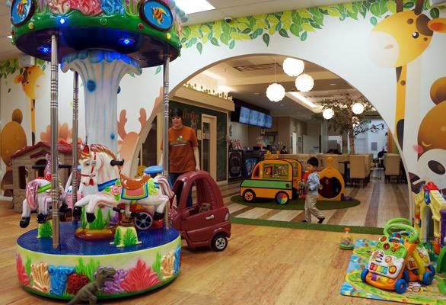 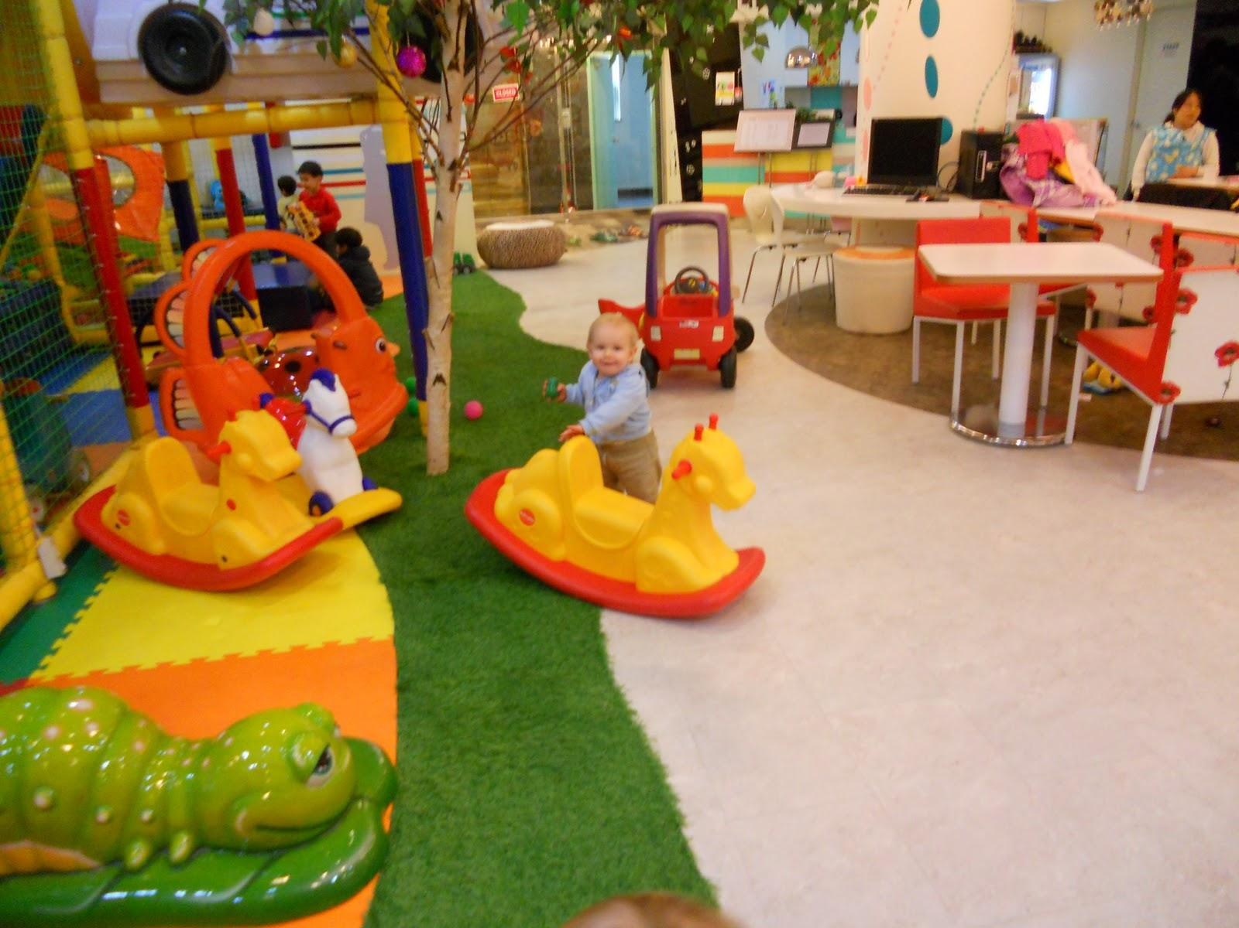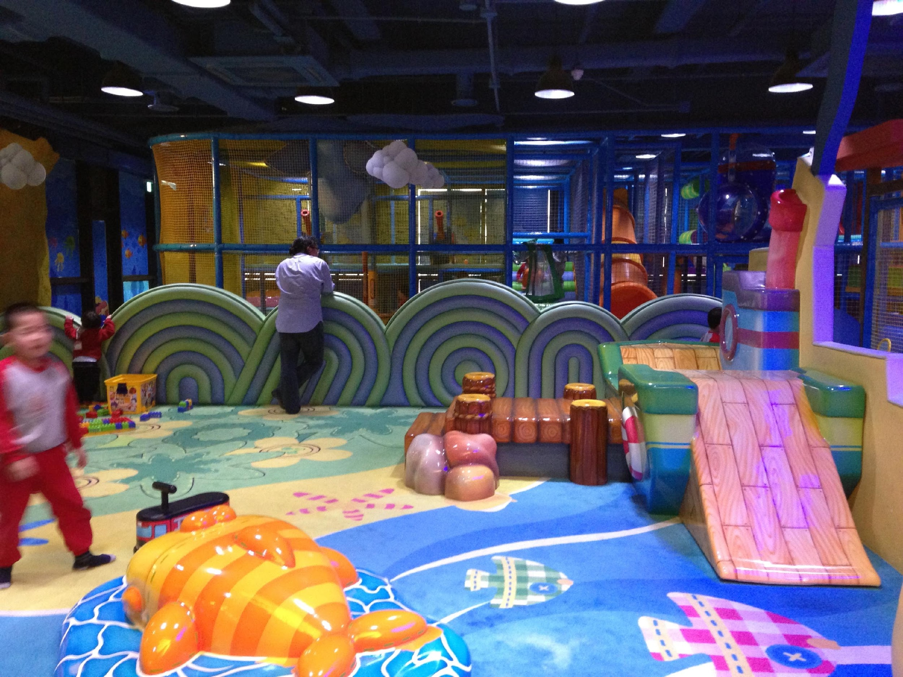

### 

### Appendix B

Menu

|  |  |
| --- | --- |
| Café Menu |  |
| **Beverages** | **Price** |
| Coffee/Decaf | $ 1.99 |
| Americano | $ 2.75 |
| Latte | $ 3.25 |
| Cappuccino | $ 3.25 |
| Mocha | $ 3.25 |
| Iced Coffee | $ 2.50 |
| Iced Americano | $ 3.75 |
| Iced Latte | $ 3.75 |
| Iced Cappuccino | $ 3.75 |
| Iced Mocha | $ 3.75 |
| Tea | $ 1.75 |
| Bottled Water | $ 1.00 |
| Organic Milk | $ 1.75 |
| Organic Juice | $ 1.75 |
|  |  |
| **Food** |  |
| Pepperoni Pizza 7" | $ 6.99 |
| Cheese Pizza 7" | $ 6.99 |
| Paninis | $ 5.99 |
| Grilled Cheese | $ 3.99 |
| Yogurt | $ 2.00 |
| Apple Sauce | $ 2.00 |
| Muffins | $ 1.75 |
| Fruit Cup | $ 2.50 |
| Bagel and Cream  Cheese | $ 2.00 |