|  |  |
| --- | --- |
|  | **2015** |
|  | Compassion Society , L3C  Dr. Kyshun Webster , Founder  New Orleans, LA |

|  |
| --- |
| **INNOVATE HER BUSINESS COMPETITION** |
| A business plan submitted describing a product that would improve the lives of women and families. |



**Company Core Purpose**

Compassion Society is an employee insurance benefits company focused on creating innovative products and services focused on the wellness and work, life balance of its customers.

Compassion Society has developed a voluntary, employee-welfare fring benefit plan that is completely employee funded. CS fring benefit plans are designed whereby employers and employees establish sustainable options to make extended leaves from work accessible and available to its employees. CS was conceived as a hybrid social enterprise where we dovetail the economic advantages of a for-profit enterprise with the social impact causing ability of a non-profit enterprise. We are incorporated as a L3C Corporation domiciled in Louisiana. L3C Corporations are required to have a social purpose to create a material positive impact on society. Our measurable social impact provides for: (1) **Financial inclusion of working class families; (2) Reduction of economic impact due to wage loss of caregivers (primarily women); (3) The financial security for families to ensure the health and well-being of all.**

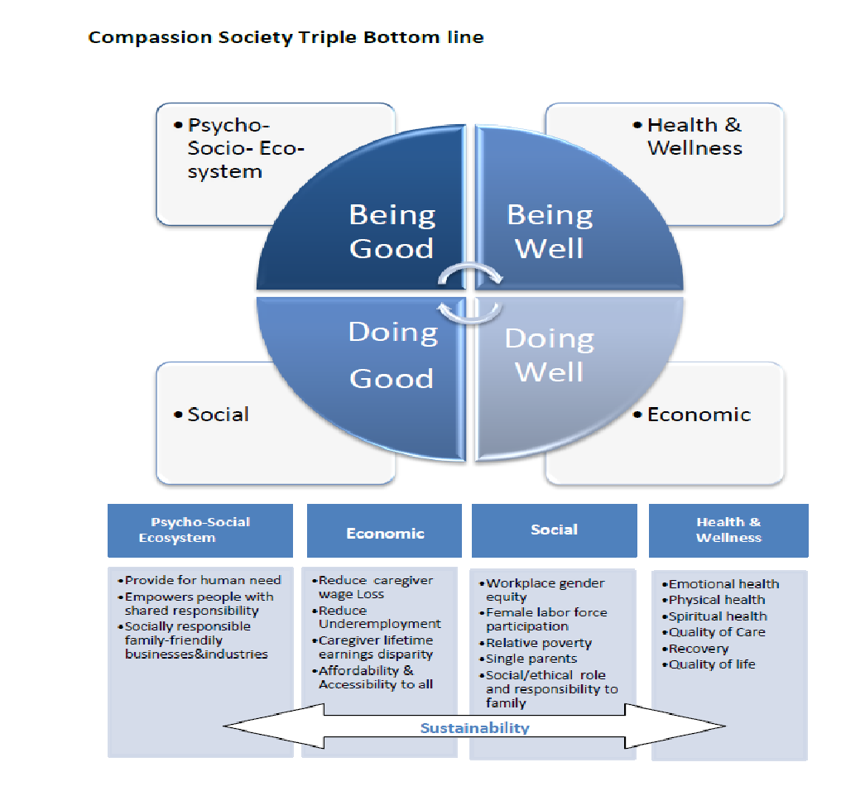

Our plans establish the type of flexibility needed in the 21st Century workplace aimed at helping **“The** **Sandwich Generation,”** (Gen X and Y working class families with dual caregiving roles) and to weather unexpected financial storms. Our products are designed to balance the demands of work with the costs of caring for family. We accomplish this through our main product:

* **“The Sandwich Plan”** -Family Care Leave Insurance (Group plan)

## CS helps to position employers to be forward thinking organizations with a progrssive outlook on the changing attitudes towards achieving healthy work life balance in the American Workforce. CS can offer organizations a benefit package that will promote self-care and respite. With current economic conditions and the rapidly rising costs, employee-funded benefit memberships are even more valuable today and provide a cost savings to both employees and employers. Most small businesses are not required to comply FMLA, but this product allows small business to become more family-friendly with leave policies.

**The Problem of Equality with FMLA Leaves**

W

hen the landmark federal Family and Medical Leave Act (FMLA) was signed into law by President Clinton in 1993, the United States took a great leap forward in recognizing and supporting workers in being both productive employees and caregivers for themselves and for their families. Unfortunately, the FMLA falls short of providing access to extended leave from work for many American workers. ***Just 11% of the workforce has access to paid family leave through their employers, and fewer than 40 % of workers have access to personal medical leave through an employer’s temporary disability insurance program.*** For families dealing with chronic disease, the lack of child care and social services, along with job inflexibility, create a toxic brew. Working-class families face inflexible schedules that clash with family needs.

In the absence of significant federal reforms since 1993, the guarantee of leave for all workers remains an unrealized goal. Low-income workers are less likely to have access to any type of leave—yet they are the ones most in need of financial support when illness strikes or when a new child joins the family. Only half of first-time mothers take paid leave around their child’s birth, indicating that paid leave is not available to many women who need it.

Women made up half of the workforce in 2009, and their workforce participation continues to grow. In nearly two-thirds of households with children, all adults in the household are working. More women in the workforce mean fewer women acting as full-time caregivers for their families. In this environment, not having access to paid leave when new children arrive or family members need care threatens the financial stability of entire families. The total cost of FMLA leave is approximately 0.4% of the total U.S. payroll. By reducing this cost by just one quarter to 0.3% of payroll, a company with 5,000 employees could save $2.3 million per year. The CS plans help employers to reduce costs associated with absenteeism.

**More workers are caring for elderly parents and family members.**

The number of older Americans is growing rapidly; they are projected to make up 20% of the population, or 72 million people, by 2030. As the number of older Americans increases, so does the need for caregivers. Today, there are at least 43.5 million caregivers of adults over 50 in the United States. Most of them have paying jobs in addition to their caregiving responsibilities. Informal (unpaid) family caregiving accounts for the vast majority of care provided to older adults, at an estimated annual value of $450 billion. Without access to paid leave, these caregivers may have to sacrifice their pay, pension, social security benefits, and or their jobs to care for their loved ones.

**Paid leave promotes caregivers’ financial and retirement security.**

Family caregivers have asignificant positive impact on the overall health of their care recipients, such as elderly parents.Unfortunately, nearly 7 in 10 caregivers report having to make work accommodationsduring their caregiving experience. Of family caregivers who were forced to take time off tofulfill their care responsibilities, 48% lost income. Between the loss of pay and retirementbenefits, the consequences of not having paid leave on caregivers’ financial and retirementstability are immense. For example, the average caregiver over 50 who leaves the workforce tocare for a parent will lose $303,880 in wages, Social Security and private pension. On average,a woman will lose $324,044 and a man will lose $283,716.41. According to Corporation for Enterprise Development (CFED), data shows that nearly half of Americans (43%) have almost no savings. These “liquid asset poor” families would fall into poverty in just three months if a job loss or other emergency left them without an income. This underscores the point that income alone does not translate into financial security.

**Product Description**

## T

## he CS benefit plan is based on two enacted state sponsored plans, California Paid Family Leave (PFL) and New Jersey Family Leave Insurance (FLI). The family leave program is financed 100% by worker payroll deductions.  This plan, like the aforementioned allows employers to voluntarily comply with FMLA without incurring any losses. Most small businesses are not required to comply, but this product allows small business to become more family-friendly with leave policies.

## *Product Purpose*

## To provide affordable options that ensure the financial stability of families in the event that it should become necessary to take extended time off from work to attend to the urgent care needs of family members.



***Reasons for Paid Leave***

To care for a seriously ill child, spouse, parent or registered domestic/civil union partner with a domestic partner. *LEAVES TO CARE FOR OWN ILLNESS ARE EXCLUDED AND SHOULD BE COVERED BY MEDICAL OR SHORT-TERM DISABILITY INSURANCE. NOT COVERED IN CS POLICY.*

***Length of Leave***

For caregiving, leave must be taken up to six weeks in any 12-month period. Leave may be taken intermittently. Caregivers receive up to 80% of replacement income in exchange for affordable monthly premiums (Exhibit 1 Developed by Lewis & Ellis Actuarial Firm for rate filing in Louisiana).

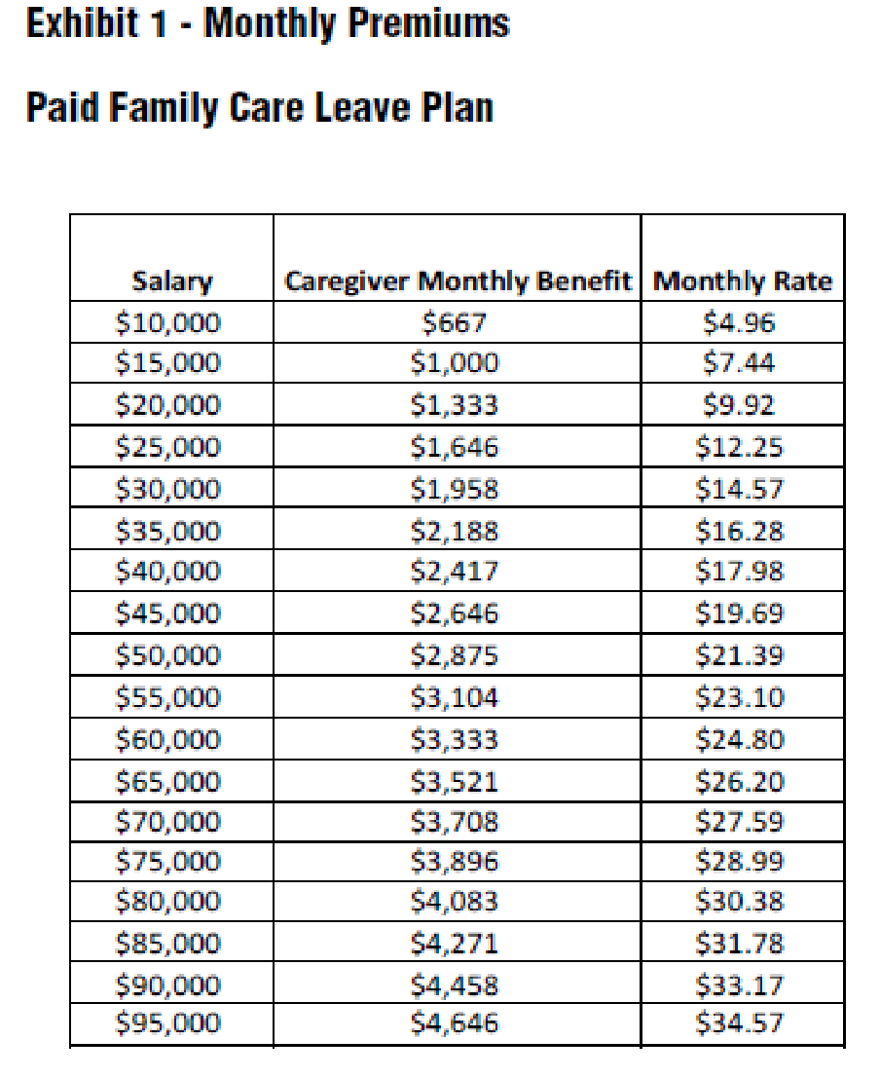

**The Market**

C

SC goal is to create a new market niche based on futuristic predictions informed by the Pew Research Center trending: (1) changing worker attitudes towards work life balance; and (2) the inherent needs psychographics needs of the workplace regarding family leaves and sabbaticals. In considering the product design and features, this benefit plan is essentially tailored to what we know about the evolving generational workplace characteristics of babyboomers, Generation X and Y. The Sandwich Plan will target the liquid-asset poor, working-class, middle income, generations X and Y employees, working in “compassion-related” fields who have specific expectations of the workplace and who ***work to live***. This plan anticipates high interests from this target population. Generation X andY are targets within the workforce for our products. CS goal is to gain 5% of the market within 3yrs (1 million members). This market penetration goal is deemed realistic given there are over 155million civilians in the U.S. workforce and only 62% work at companies where FMLA leaves are applicable, leaving 38% of the workforce vulnerable without the protection of FMLA.

**Generational Predictions: Background on Worker Diversity Issues**

For baby boomers, it's been the juggling act between job and family. For Gen X, it’s been moving in and out of the workforce to accommodate kids and outside interests.

Now along come the 76 million members of Generation Y. For these new 20-something workers, the line between work and home doesn't really exist. They just want to spend their time in meaningful and useful ways, no matter where they are.

Generation X & Y workers entered the workplace as independent, resourceful and self-sufficient people who value freedom and responsibility. About 60% of younger workers say it is not very likely or not likely at all that they will stay with their current employers for the remainder of their working life. (In contrast, 62% of Generation X workers say it’s likely they will never leave their current employer.)

Gen X-ers place a premium on family time, are ambitious and hardworking and still value work/life balance. Generation X work ethics include taking responsibility for themselves and a complete lack of desire to waste their lives for a company that will turn its back on them late in life. They seek fun and meaningful work. They value the freedom to set their own hours. Flexible work schedules and work-from-home options

78.2 million baby boomers, born from 1946 to 1964, will have greater longevity, exploding health care costs and global market volatility. Babyboomers risk outliving their assets. X-ers will have to step in and assist their parents.

**Management Plan**

C

ompassion Society plans to develop an efficient organizational infrastructure primarily co-sourced to third party insurance benefits &claims management companies and investment brokers to manage the company’s assets. The primary functions to be out-sourced are as follows:

* Claims and benefit management
* Marketing
* Prime Brokerage

**Governance**

The company will be governed by a board of directors comprised of individuals/entities partnering with this firm that have an equity stake in the company. Board composition will be a mix of internal staff and external shareholders. The board will meet quarterly in the formative years of the company and then go to a bi-annual schedule.

**Day-to-Day Operations**

A Chief Executive Officer will be recruited from within this industry to lead the day to day operations and oversee the management team. This person, once selected, will be responsible for building out the proposed Organization **Chart 3.1**, below.

In-house management functions that will be managed directly by the company:

* Sales
* Research & Development
* Investment portfolio management/monitoring
* Corporate Philanthropy
* Internal Accounting Controls

High-level industry experts will be recruited by CS to staff senior management positions within the company to manage day to day affairs. This management team will be supervised by the founder and board of directors comprised of industry experts and partnering investors.

The following industry professionals have been sought out and consulted on this project at the conceptual stages. These advisors will be engaged on retainer to help direct the launch of CS products.

**Entrepreneur & Start-up Manager , New Orleans, LA**

**Dr. Kyshun Webster** — a visionary, advocate, entrepreneur and scholar. He earned a Doctor of Philosophy degree in Work, Family and Community Education from the University of Minnesota, Master’s in Urban Studies and Non-Profit Leadership from the University of New Orleans and a Bachelor’s in Art Education from Xavier University of Louisiana. Dr. Webster also completed the inaugural Executive Program on Social Innovation at Stanford University.

As he pursued higher education he also delved into business ownership. In 2001, at age 22, he founded The Roux Gallery located in Jazzland Theme Park in eastern New Orleans. In 2010 he introduced mobile cupcakes to New Orleans with the city’s first cupcake truck. Under the name Cupcakes & Co., it became a popular specialty presence at events, festivals and private parties. A land-based retail store extended the brand to a wider range of customers. All of his experiences converge in his current capacity as the founder and principal of the Webster Group, Inc., a private consulting firm. He is an executive coach guiding and nurturing aspiring entrepreneurs with dreams regarding for-profit businesses and socially responsible organizations

**Ty R. Sagalow** is President of Innovation Insurance Group, LLC. Mr. Sagalow is a 30-year veteran of the insurance industry, having held senior executive positions in underwriting, legal, and product development for major insurance companies. Mr. Sagalow is an expert in new product development in a range of insurance product lines, particularly cyber-insurance, directors & officers liability insurance, professional liability insurance, employment practices liability insurance, and reputation insurance.   Additionally, with his unique background combining management and professional liability legal, underwriting, and policy drafting, Mr. Sagalow is one of the industry’s most sought-after experts in D&O/E&O coverage disputes.

Mr. Sagalow spent 25 years as a senior executive with AIG. His major positions included ten years as Chief Underwriting Officer and General Counsel for AIG Executive Liability (f/k/a National Union). National Union is the largest provider of management and professional liability insurance in the United States. From 2000 to 2005, he was Chief Operating Officer of AIG eBusiness Risk Solutions, a large provider of security and privacy insurance. From 2005 to 2009, he headed up new product development at AIG General Insurance as President of Product Development before moving to Zurich North America as Chief Innovation Officer. In April 2011, he departed Zurich to create Innovation Insurance Group.

**Adams & Reese Legal Counsel & Filing, Baton Rouge, LA**

**Robert Wooley** joined Adams and Reese in 2006 and serves on the governmental relations team of the Special Business Services Group. He is the former Commissioner of Insurance for the state of Louisiana where he managed more than 250 employees and a multi-million dollar budget. He regulated the licensing and compliance of all insurance companies and agents operating in the state.  
  
Robert has more than 20 years of extensive governmental relations experience. Prior to his service with the state insurance department, he was the Director of Governmental Relations for a major gaming corporation where he directed and consulted on national and statewide election efforts and worked with various governmental entities in several states. His other significant contributions include: Appointment as First Assistant Secretary of State and Executive Counsel to the Louisiana Secretary of State; Serving as Special Counsel for the Louisiana Trial Lawyers Association; Successful representation for clients before state insurance departments across the country; and, providing private political and governmental relations counsel. Wooley attended the Paul M. Hebert Law Center of Louisiana State University, and received his J.D., 1977 has bar admission in Louisiana.

[Lewis & Ellis, Inc. Actuaries & Consultants](http://lewisellis.com/) has provided actuarial support for 40 years to the insurance industry and experienced professionals.  With offices in Kansas City and Dallas, the company partners with agencies to provide actuarial support as needed.

**CHART 3.1 CS Organization Chart**



**Market Entry &Distribution**

I

n order to position the new product and service nationally with sector decision-makers, CS will partner and license a major insurance carrier to assist with the distribution of the product. In addition, CS will employ a communications strategy that will reach organizations that represent decision-making bodies and who have large constituent bases of targeted members in the private, governmental and non-profit sectors. This outreach will be two-fold:

1. Creating a presence at these organizations’ national conferences.
2. Secure endorsements from key national organizations as a means to gain deeper market access.
3. Direct solicitation to H.R. Departments within target entities.

**Multi-Channel Distribution**

To increase market penetration, insurance companies need to expand their distribution network. In the recent past, the industry has witnessed the emergence of alternate distribution channels. The typical distribution channels used by insurance companies now include direct selling agents, brokers, online distribution, corporate agents such as non-banking of para-banking companies with local corporate agencies (for example NGOs) in remote areas. Agencies have been the most important and effective channel of distribution to date. According to the industry, the role of agents has started evolving from merely a prospecting and selling role to an advisory and service related one. In order to be competitive and maintain affordability CS will have to consider the most cost effective ways to reach customers directly to minimize the costs of intermediaries.

* Broker
* Individual Agents
* Corporate Agents
* Micro-Insurance
* Cell Phone/PDA
* Kiosks
* Internet
* E-commerce
* Work Site Marketing
* Direct Marketing – INTERNET

**Sales and Marketing**

C

S will concentrate significant resources into a sales and marketing strategy for its multi-distribution channels. Given that this product is new to the market, considerable attention must be given to educating the public and potential institutional clients. Hence, the initial strategy will entail a “working below the radar” while marketing directly to key constituents, policymakers, and national institutional membership organizations etc.

CS will procure a relationship with a reputable national insurance marketing group that has distribution networks already established in order to build a sales force. This will increase CSs ability to get the product to market.

***Broker Recruitment***

Ideal brokers will have experience with disability, worker’s compensation, and medical insurance products, since the Family Care Leave policies are closely related in purpose. Additionally, Agents that have demonstrated success with large group accounts with school districts, universities and hospitals will be deemed the most competitive for licensing with CS

**Sales Goal:**

1. Recruit and train a 300 broker/agents sales force, with representation in all 50 states.
2. Each of the 300 broker/dealers will have a quota to enroll 1,000 members within 12 months of the launch of the product.

Within 12 months of the product launch, CS will have 300,000 members enrolled paying an average monthly premium

***Organizational Sales Approach***

CS uses a direct sales model team approach to penetrate markets. The salesforce will be comprised of an outside team (field workers, brokers/dealers) and the inside team (staff managers) will provide guidance support and lead generation.

Commissioned insurance agents will be licensed to sell the product to interested organizations. These commissioned sales persons/brokers will be trained to demonstrate the value-added proposition for subscribing to the membership plan.

Compassion Society Financial Plan is based on the following set of assumptions that takes into account industry and regulatory standards. This was completed by Lewis & Ellis Actuarial Firm.

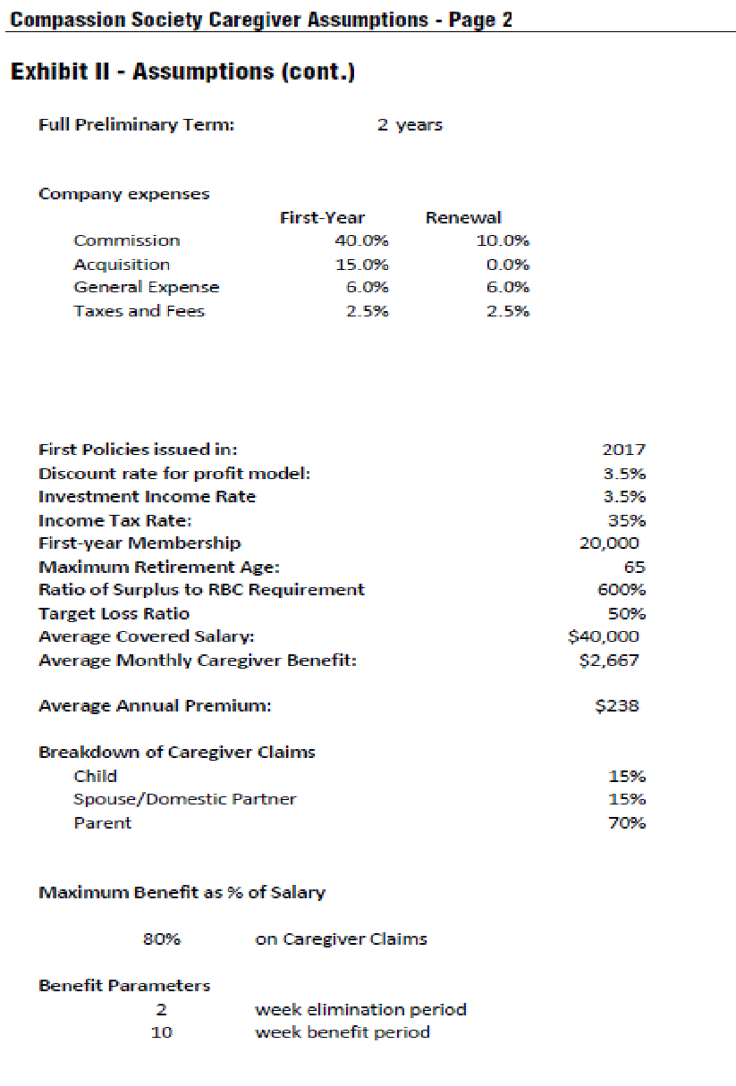

**Financial Assumptions prepared by Lewis &Ellis Actuarial Firm**

