December 2, 2015

**WINNING ORGANIZATION**

*Scent Solutions LLC,*

*DBA Find’em*

*1440 Beaumont Ave Ste A2-260*

*Beaumont, CA. 92223*

(**855) FINDEM(8)**  
(855) 346-3368

http://findemscentkit.com/

**HOST ORGANIZATION**

Desert Lighting

Heather Coladonato or Steven Slomkowski

14080 Palm Drive Suite A

Desert Hot Springs, CA

760.620.3100

[sjs@desertlightning.org](mailto:sjs@desertlightning.org)

[heather@desertlightning.org](mailto:heather@desertlightning.org)

**Total Number of applicants:** 17

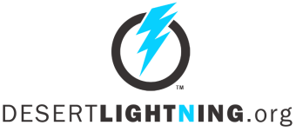

14080 Palm Drive, Suite A

Desert Hot Springs, CA 92240

760.422.3452 x2

STATEMENT OF SUPPORT

To Whom It May Concern,

Find’em met every criteria set forth by the SBA as we understood those requirements. In addition the judges from the selection committee and the Fast Pitch event unanimously agreed that the Find’em team should make it’s way to the coming event in March of 2016.

We concluded that Find’em is lacking only a clear marketing strategy and the resources to implement that once it has be produced.

Regards,

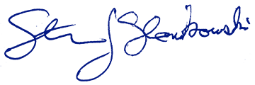

Steven J Slomkowski

Chief Business Development Officer

760.620.3100