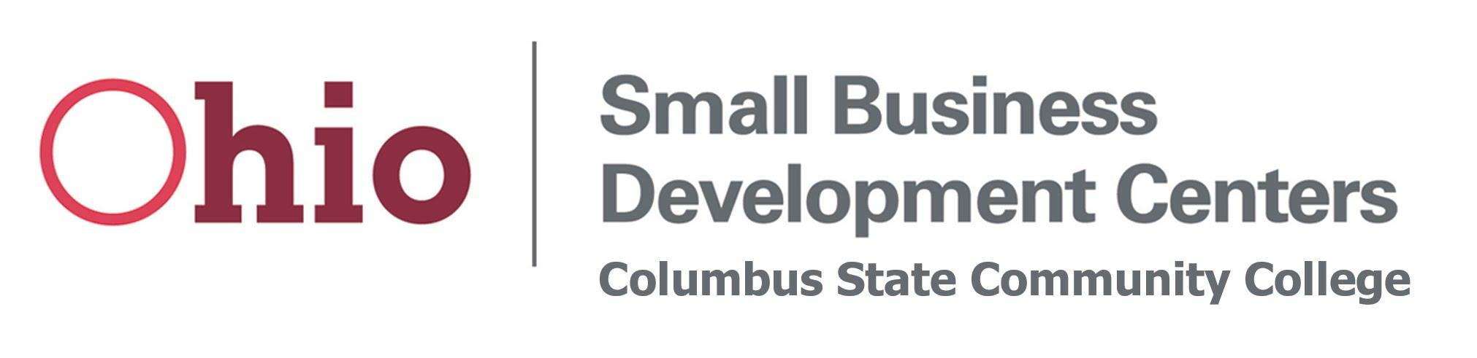

1. The winner of the Ohio SBDC at Columbus State’s InnovateHER regional competition is:

Anna Brown

Hoot Studio, LLC

5781 Laura Lane

Hilliard, OH 43026

614-446-2662

[www.thehootstudio.com](http://www.thehootstudio.com)

[abrown@thehootstudio.com](mailto:abrown@thehootstudio.com)

1. Host:

Ohio Small Business Development Center at Columbus State Community College

550 E Spring St

Columbus, OH 43215

Ariana Ulloa-Olavarrieta, District Director

614-287-2338

[aulloaol@cscc.edu](mailto:aulloaol@cscc.edu)

1. Hoot Studio is an inclusive indoor play center providing a variety of services including open gym play, art classes, music classes, yoga classes, and party rentals. The studio’s mission is to create a compassionate community through inclusive, interactive play for children with special needs.
2. 13