# 

Contents

Unmet Clinical Need 1

Elidah’s Solution 2

The market and addressable market for the innovation 3

The business economics and market drivers in this industry 3

Validation of the market opportunity 3

Customers and business model 4

Competition and the changing competitive landscape 4

Commercialization Strategy 5

Impact 6

The Company 7

Company vision and impact 7

Team and Relevant Experience 7

Team member commercialization history 8

Role and expertise of consultants/advisors 8

Technology Market Fit 9

Competition 11

Intellectual Property Landscape 11

Revenue Generation 12

Funding Required 12

# Unmet Clinical Need

Urinary incontinence (UI) is a widely prevalent condition of 40 million women in the US, affecting approximately 1 in 3 women over the age of 30, and 1 in 2 women over the age of 50. Although a very private concern, it has far-reaching physical, psychological, social, and economic implications. For example: UI has been found to reduce health-related quality of life measures, with a strong correlation with depression[1], UI is the number one reason for entry into nursing homes, and the annual cost to Medicare has been estimated at $10 billion, and at $25 billion for the entirety of the US healthcare system [1-3]. 75% of these women are specifically affected with Stress Urinary Incontinence (SUI), which is the loss of continence due to weakened pelvic floor muscles, resulting from a variety of factors including child-bearing, athletic pursuits, trauma, and aging. Their urine leakage occurs when physical exertion (e.g. sneezing, lifting, running) increases intra-abdominal pressure. There are no medications that address SUI, and while surgery can provide relief, it is painful, expensive, and requires hospitalization and multiple weeks of recovery. 

Non-surgical strengthening of the pelvic floor muscles has proven effective in treating most SUI, and this is typically achieved through Kegel exercises, pessaries or intravaginal electrical muscle stimulation (EMS). However, patients routinely struggle to perform Kegel exercises correctly or with sufficient frequency (3x/day for 3-6 months) which leads to low compliance. Introducing intravaginal devices or an intravaginal probe (Figure 1) necessitates a private location and dedicated treatment time (often at a treatment center), further challenging the likelihood of adoption [4-7].

To complicate matters, 4 out of 5 sufferers do not talk with their physician until conditions are severe, and the “incontinence experts” often advocate surgery which patients want to avoid. The patients are often too embarrassed about the situation or know that their options are to exercise on their own or to have surgery. This leads to two thirds of affected women to suffer quietly without treatment while conditions worsen. Thus, the need exists for a non-surgical means of strengthening the pelvic floor muscles that has a higher rate of patient adoption and compliance than current solutions.

# Elidah’s Solution

Elidah was founded to provide a conservative, discreet, easy-to-use treatment to strengthen the pelvic floor muscles to restore continence. Elidah will provide an EMS solution that eliminates the intravaginal probe, that facilitates convenient treatments, that allows the wearer to go about and do other activities during treatment, and that presents as a discreet, unobtrusive device. Women suffering from SUI will be more likely to pursue and complete medical treatment.

**Overview of Elidah’s Project:** Elidah’s device utilizes surface (i.e. transcutaneous) application of EMS to strengthen pelvic floor muscles and alleviate symptoms. In Phase I, Elidah has developed the patient contacting component of the device, an SUI specific electrode. The proposed Phase II SBIR project furthers optimization of the electrode and completes design and validation of the other components of the system. The proposed project also evaluates performance and safety via benchtop testing.

The product, called Etude™, is comprised of three components: a disposable electrode, a signal generator and a user interface. 

* **SUI Electrode** - The *disposable* electrode is configured as a single unit contoured to fit against the perineal tissues, with conductive regions located at the four corners. The skin-contacting surface proximate the conductive regions is fabricated from a mildly tacky hydrogel to enhance continuity and conductivity. Below the hydrogel is a printed flexible circuit that routes electrical current between the conductive regions and a connector that links the electrode to the signal generator. The midline of the electrode is defined by a region through which bodily fluids can pass.
* **Signal Generator** – This component comprises the rechargeable battery, transformer and microprocessor that supply the pulsed electrical current. The outer housing is water resistant and easily cleaned. It has a thin profile that allows concealment within the underwear waistline. Controls are limited to on/off and intensity adjustments.
* **User Interface** – This component(s) serves to recharge the batteries in the signal generator, provides the interface through which the device is programmed (treatment schedule, duration) and enables data collection/reporting features. Packaging the system controls and displays separate from the signal generator facilitates a wearable form factor. The user interface is likely (in part) to take the form of a mobile app for both the iOS and Android based cell phones.

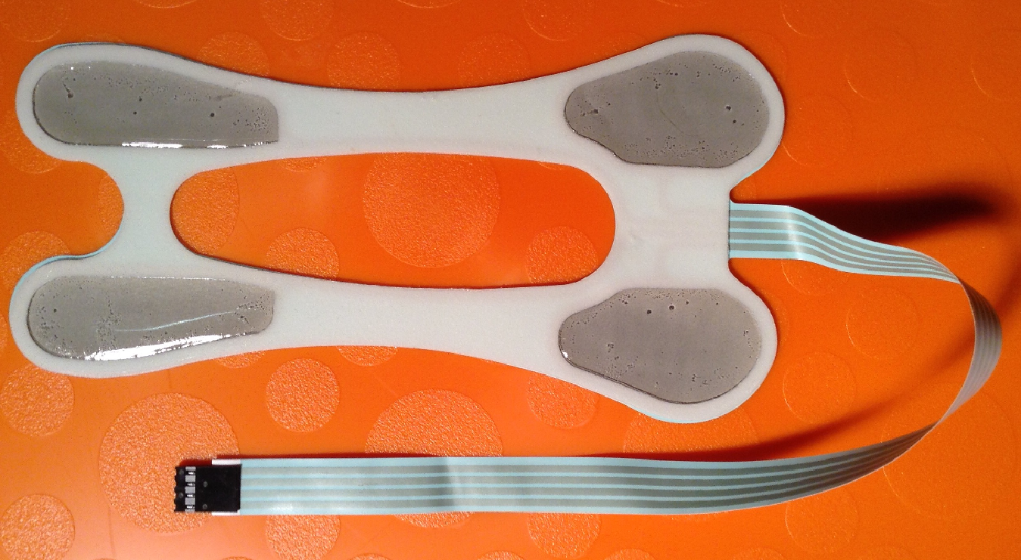 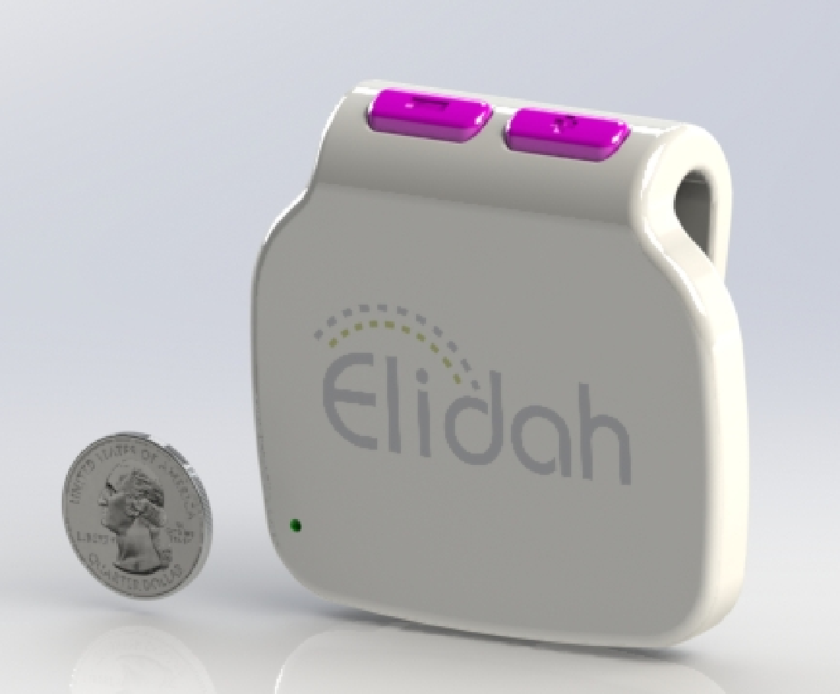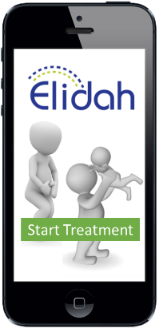

Figure 3: LEFT – Elidah’s SUI electrode developed as part of NSF Phase I SBIR. MIDDLE – Rendering of signal generator, sized to be worn discretely under clothing. RIGHT – Mockup of mobile app that enables device functionality through Bluetooth connectivity.

# The market and addressable market for the innovation

Elidah’s fully developed device will enter a market with substantial commercial opportunity. US sales for therapeutic incontinence products exceeds $300 million (2007) and the global market of $1.6 billion (2011) [10,11]. The market opportunity for the device is even greater considering that 2/3 of sufferers currently forego treatment. It is these tens of millions of women that this technology has the opportunity to benefit the most.

Although the proposed product and scope of work is specific to female SUI, the commercial product may additionally benefit women suffering from mixed urinary incontinence (i.e. stress + urge). Further, discovery and design effort is likely to advance future product development efforts for male urinary incontinence, especially after prostate surgery, and fecal incontinence products. Collectively these indications substantially increase the market potential and impact of this technology.

# The business economics and market drivers in this industry

Many factors play a role in the industry surrounding treatment of SUI, including:

* **Physician recommendations** – Although many woman don’t consult their physician about SUI, for those who do, primary care physicians and gynecologists are challenged to recommend an intermediate treatment solution for woman who don’t have success with Kegel exercises yet aren’t so severely symptomatic that surgery is warranted.
* **Awareness** – Internal surveys by Elidah found that the majority of symptomatic woman were unfamiliar with intravaginal treatment options. Many women also did not go see their doctors because they were afraid of being referred to a surgeon. However, it is critical for them to be aware that symptoms will only get worse and early treatment allows for strengthening options while their musculature is still intact.
* **Accessibility / Regulatory** – Products typically enter the market as prescription only devices. To pursue women who do not see their physician, Elidah will make the device available online with the consult of physicians. The disposable electrodes will be available for continual purchases online without a prescription.
* **Reimbursement** – Failure to obtain a reimbursement code is frequently the downfall of new medical device technologies. In this market however, at least three relevant CPT codes (64550, 97014 and 97032) and HCPCS code G0283 exist to provide a sizeable reimbursement for the proposed device. A competitive device (InTone) lists its product near $800 and realizes reimbursements in excess of $500.

# Validation of the market opportunity

Many technology companies do not succeed in product commercialization because they fail to understand their market. Both key contributors for this proposal have participated NSF I-Corp training and regularly utilize approaches from that program in validating assumptions regarding customers and market opportunity. These activities have included:

* **Interviews with symptomatic women** – Elidah has conducted over 60 in person and anonymous online surveys with symptomatic woman. Key findings include the willingness of women to try a new non-surgical, non-intravaginal treatment option, their hesitation to discuss incontinence concerns with their physician, and their interest in self-treating. In addition, key benefits they were interested in were: use while going about other activities, discreet, and taking minimal time. Cost was not as big of an issue, as patients were willing to spend up to $500-600 out of pocket. Additionally, although continuous contact with skin required for the device to function properly, in a survey of women 100% were willing to shave for an efficacious solution.
* **Interviews with clinicians** – Elidah confirmed with more than fifteen primary care physicians and gynecologists that they want to avoid surgery and are hesitant to send mild/moderate suffers down that path. Clinicians also confirm that intravaginal devices are not well liked/adopted by patients. The interviews also showed that urologists, who are specialists in incontinence, are not the primary market, as they continue to focus on surgery.
* **Meta-analysis** – In 2012 HHS reported results of a meta-analysis involving 148 random controlled clinical trials for non-surgical incontinence treatments. Salient observations included that the benefits from pelvic floor muscle training, bladder training, and electrical stimulation are large, but that current options for reminding patients to conduct muscle training are inadequate [12].
* **Third party assessment** – Foresight Science and Technology was contracted to conduct an independent review of the market opportunity for Elidah’s technology. The report was favorable and validated many of Elidah’s market assumptions (see Letters of Support).

# Customers and business model

Analysis of medical device customer segments typically considers the “3-P’s”: patients, providers and payers. Elidah has interviewed over 60 of these customers to define and validate value propositions. Clinical benefits are chiefly realized by the patient, but important value propositions exist in each customer segment.

* **Patients** – Females suffering from mild to moderate stress or mixed urinary incontinence will see symptom relief/elimination and improved quality of life. The target market make up approximately 75% of all urinary incontinence in women [14], roughly 25-30 million women in the US. Elidah does not intend to treat patients with severe symptoms, as their pelvic floor musculature is so compromised (e.g. prolapse) that strengthening is unlikely to realize a benefit. However, by effectively treating mild to moderate patients before symptom progression Elidah’s device may reduce the 100,000 SUI surgical procedures performed annually [15]. To further break down the market, the mild to moderate SUI sufferers who have an incidence a few times a week (enough times to seek out a treatment) are typically 45-65 years old. Of particular interest to Elidah are those who are uncomfortable approaching their physician for treatment and are privately seeking discrete, effective ways to resolve their symptoms, as our device adds value by giving them privacy
* **Providers** – This segment comprises women’s health providers, specifically gynecologists and primary care physicians. These clinicians currently offer the first line of treatment to women suffering from incontinence and as a group they are quick to acknowledge the poor patient compliance of current non-surgical treatments. This segment also includes the nurses and therapists who provide stimulation treatments and make device recommendations. Patient satisfaction is becoming an increasing driver in choice of product, as well as the financial drivers such as the ability to keep patients longer (i.e. not refer them to urologists), see these patients for more frequent follow-up, perhaps a shorter office stay, and sell/distribute the devices through their practice (which they already do for incontinence products such as pessaries).
* **Payers** – Successful treatment through non-surgical means presents a significant cost savings for insurance providers. For patients actively seeking treatment, Elidah’s device provides this non-surgical option. Also, for patients with mild symptoms who are not ready for surgery and not willing to use intravaginal devices, Elidah’s device provides a treatment option that may prevent symptom progression, eliminating future need for surgery. Elidah plans to prepare an economic benefit plan to help convince payers. Effective execution will depend on making sound financial arguments based on clinical data. That said, reimbursement codes already exist for Elidah’s proposed device, although currently only half of the insurance companies covers it. With the current Health Savings Account system on the rise, many patients are also the payers and are more willing to pay for devices with funds that have already been saved (as mentioned by a number of interviewees).

# Competition and the changing competitive landscape

As described above, existing technologies and devices substantially fail to satisfy patient needs. Exercises and manual devices are difficult to implement properly and regularly, and standard of care intravaginal EMS devices have poor adoption rates. Surgical procedures (including placement of meshes) are rife with complications as attested to the 75,000 pending lawsuits currently, with an example of a $1.6B settlement for American Medical Systems (formerly Endo)[2]. New companies like InControl Medical are pursuing enhancements to conventional intravaginal probes, but new features are limited to improved fit and audible instructions, which Elidah (and the above referenced HHS report) believes are unlikely to affect patient perception and ultimate product adoptions. A number of permanently implantable electrical stimulation devices are also on the horizon. These devices target specific nerves tied to urge incontinence. Although likely to be effective, they still present with the risks of invasive devices and are an order of magnitude more expensive than Elidah’s proposed solution.

The proposed device will achieve higher rates of patient adoption and compliance, while providing efficacy equivalent to proper implementation (i.e. full compliance) of existing solutions. These higher adoption and compliance rates will drive treatment benefits to an expanded pool of patients.

|  |  |
| --- | --- |
| Existing Solution | Relative Benefit of Elidah Solution |
| Kegel exercises | Patients struggle to perform these exercises properly or with sufficient frequency (3x/day). The proposed solution delivers the treatment correctly and at a prescribed frequency. Also, as demonstrated with other wearable therapy devices, since the device records and reports usage data, compliance is likely to increase. [23] |
| Intravaginal EMS | For many women, intravaginal devices present both physical and psychological deterrents to treatment adoption and ongoing compliance. [4-6, 21]. Use of surface stimulation, delivered in an easy to wear device that doesn’t require a dedicated treatment time or location, provides a clear benefit over current intravaginal treatments. Elidah has validated this concept through over 60 patient and clinician interviews. More than 2/3 of respondents indicated they would be more likely or much more likely to use a surface device over intravaginal. In addition, the number one benefit/feature that patients wanted was “Hands-free, can go about your normal tasks during treatment,” which is not possible with an intravaginal device. [21] Additionally, reusable intravaginal devices have a high infection rate that would be avoided with Elidah’s disposable surface electrode. Intone’s clinical study showed a 32% UTI or vaginitis contraction rate. [22] Since Elidah’s device is not intravaginal, there will be a reduction in adverse events. |
| Surgery | Although surgical solutions do provide more immediate treatment resolutions, these options are burdened with surgical risks, prolonged recovery times, pain and high costs. The non-surgical Elidah solution provides advantages on all these points, most likely for mild to moderate SUI patients receiving surgery. The adverse implications of these surgeries has become particularly real over recent years, with the FDA recalling surgical meshes and thousands of women undergoing reconstructive procedures to correct failed devices. |

# Commercialization Strategy

FDA clearance is only one component of commercialization readiness. Elidah’s team has extensive experience in moving products through these later phases of product development. Although a fully detailed product development/sales and marketing plan is beyond the scope of this submission, this section comments on several key considerations. Commercial launch of the device is expected within 6 months of FDA clearance. To achieve this timeline much of the commercialization activity will occur in parallel with FDA review and Phase II SBIR. Note that other common elements of a commercialization strategy (e.g. market size, customer definition, competitive analysis, intellectual property, financial plan, expansion of team) are presented elsewhere in this plan.

* **Regulatory Clearance** – Elidah’s device is an FDA Class 2 device under the product code KPI – “Stimulator, Electrical, Non-Implantable, For Incontinence”. 65 other products fall within this category, including the ApexM device (InControl Medical, K150183), which will be the predicate for determination of substantial equivalence. Elidah’s device will (initially) be a prescription device with Indications for Use language specific to the “treatment of stress urinary incontinence”. FDA guidance document “The 510(k) Program: Evaluating Substantial Equivalence in Premarket Notifications” (2014) provides clarity to manufacturers in assessing substantial equivalence. Following the FDA’s “Decision-Making Flowchart”, Elidah will demonstrate that differences in technological characteristics (e.g. transcutaneous electrodes vs. intravaginal electrode) do not raise new questions of risk and that methods exist to characterize performance. This argument can be made effectively by following the FDA’s own guidance documents regarding transcutaneous electrodes, powered muscle stimulators, and clinical investigations of devices for incontinence [11-13]. Elidah will also pursue regulatory clearances in other markets (e.g. Europe, Canada, and Asia) and as an OTC device, but that work is beyond the scope of the immediate project. Regulatory clearance is expected within 6-months of filing the 510(k), and 3-4 years earlier than if the device was classified as Pre-Market Approval (PMA).
* **Manufacturing** – Elidah will partner with ISO 13485 certified OEM manufacturers to produce the various elements of the system. For the electrode component, Elidah is currently utilizing Katecho (Des Moines, Iowa), Lightfab (Rochester, NY) and Si-Cal Technologies (Westborough, MA). Production of the signal generator will be similarly outsourced at the component level. Production volume vendor selection (potentially different from the prototype suppliers identified in Attachment 3, Part B) will initiate at the midpoint of the Phase II. Suppliers will be audited in accordance with Elidah’s Quality Management System. The scope of Elidah’s manufacturing operations is likely limited to develop specifications and review of quality documents. This proposed manufacturing model is the industry norm for small companies.
* **Distribution Channels / Business Models** – Elidah anticipates pushing the product to market through three channels.
* **Online Orders (Telemedicine)** – Surveys of patients and clinicians confirmed that women who are hesitant to discuss their incontinence with their doctor seek out treatment information through online sources. Elidah will provide a telemedicine portal through which patients may converse with a prescribing physician from the privacy of their home. They can then order the device for home delivery. Alternately, a patient can ask her own physician for a prescription and then send it directly to Elidah for fulfillment. Other prescriptions currently use this business model, such as SAM the wearable ultrasound for pain and Viagra. The recurring electrode purchase will not be prescription-based, just the system with generator.
* **Clinician as Prescriber** – Here the clinician recommends use of the device to the patient, submits a prescription to Elidah, receives the device and then trains the patient on its proper use. Different from the online orders, the clinician maintains involvement in the treatment process and is likely to monitor recovery using device features like onboard data tracking.
* **Clinic as Distributor** – Many clinics act as product distributors to increase practice revenue. These clinics will purchase Elidah’s devices at bulk discounts and resell or rent them to their patients at a profitable margin.
* **Pricing / Reimbursement** – For each of the above channels/models payment for the device may come from either the insurance provider or directly from the patient. At least three relevant CPT codes (64550, 97014 and 97032) and a HCPCS code G0283 exist that provide reimbursement for Elidah’s device. The comparable Intone device achieves an average reimbursement of $565. With Elidah’s projected COGS of less than $100, the same reimbursement provides a favorable margin for a medical device. Despite the existing reimbursement codes, Elidah anticipates some initial resistance from insurance providers until they are fully educated regarding the health economics benefits of Elidah’s technology. During this time Elidah will pursue private pay patients. Elidah has also confirmed that patients are willing to pay an out of pocket cost that still realizes a large margin. Note also that the device’s disposable electrode component serves as reoccurring revenue with patients who continue to use the product for continence maintenance after initial treatment.
* **Marketing / Sales** – Because the device is principally offered for sale by prescription only, Elidah will direct significant marketing effort toward educating its clinician customers. This effort will be driven by an experienced marketing/sales executive, most likely through a strategic partner. Elidah also anticipates using direct-to-patient, low-cost, social-media campaigns, highlighting the noninvasive benefits. In the near term, Elidah will likely utilize independent sales staff/distributors to reach customers and manage accounts in a cost effective manner.

# Impact

Urinary incontinence is a widely prevalent condition, affecting 40 million women in the US, approximately 1 in 3 women, and a cost to the US healthcare system of $25 billion. Elidah believes that with its technology, feature set and presentation (i.e. form factor), women will be significantly more likely to pursue and adopt successful treatment. In addition to providing obvious short-term patient benefits, early, non-invasive intervention may reduce the necessity for later stage surgical procedure and the associated costs and patient risks.

A secondary impact of this proposal, is that as a part of device development, it will increase understanding of how the nerve and muscles are activated through various waveforms and generator settings, which is not very well understood currently. In addition, a better understanding of how reducing psychological barriers may positively affect outcome.

# The Company

Elidah was founded in 2014 with the specific purpose of bringing medical device solutions to market to fill large unmet needs such as in the case of urinary incontinence. The company was formed as a limited liability company in the State of CT. As the company is young, there are no revenues and the company has been funded as detailed in the following chart.

|  |  |  |  |
| --- | --- | --- | --- |
| Date | Raised | Source | Use of |
| April 2014 | $10,000 | Kolb Consultants (founders) | Research & early development |
| Feb 2015 | $18,000 | CCAT | Rapid prototyping |
| June 2015 | $150,000 | NSF SBIR Phase I | Electrode development  Quality systems |
| June 2015 | $10,000 | CT Next- EIA | Start of generator design |
| Sep 2015 | $60,000 | CT Innovations-  SBIR Supplement | Clinical Pilot study |
| Oct 2015 | $25,000 | CT Innovations- Talent Bridge | Engineering and marketing interns |
| Oct 12015 | $30,000 | NSF SBIR Phase Ib | Electrode connector |
| **TOTAL** | **$203,000** |  |  |

# Company vision and impact

Like most medical device startups, Elidah is prepared for multiple years of pre-revenue product development activity. However, different from many products, commercialization of this technology does not require a multi-year prospective clinical study or FDA pre-market assessment (i.e. PMA), and thus the time course is only several years instead of a more typical 5-10 years. Elidah expects first commercial use of the final product in 2017 and to realize a positive cash flow by 2019. We expect that in 2017 development of the technology for other indications will commence, such as vulvar pain. Key corporate milestones over the next four years include:

* 2015 – Development of electrode component
* 2016 – Clinical testing and development of signal generator / user interface
* 2017 – Clinical/marketing studies / early product release (100s of units sold)
* 2018 – Broad commercial launch (1000s of units sold)

Core competencies of the company is found in the education and experience of the founders. They have the engineering expertise, management experience and specific medical device knowledge and competencies to successfully commercialize products in this space.

# Team and Relevant Experience

Gloria Kolb and Eric Kolb are medical device engineers, each with 20 years of product design experience and each having led development efforts from concept generation through clinical use and commercialization. They have demonstrated innovative thinking with a combined 35 medical device patents.

* Gloria Kolb is co-founder and CEO of Elidah. She holds degrees in mechanical and electro-mechanical engineering from MIT and Stanford University, and an MBA in entrepreneurship from Babson College. Gloria will serve as the PI for this project. Previously, she has worked for Johnson and Johnson Orthopedics (now Depuy), and founded Fossa Medical.
* Eric Kolb is co-founder and CTO of Elidah. He has extensive experience in medical device product design and entrepreneurship. Eric currently holds a position as Director of Engineering for ZetrOZ (www.zetroz.com) a medical device company actively commercializing a wearable therapeutic ultrasound technology (Elidah products are not in direct conflict with Zetroz, and Zetroz leadership is aware and supportive of Eric’s ongoing involvement in Elidah). Eric holds biomedical and mechanical engineering degrees from Rennselaer Polytechnic Institute and Case Western University. He has previously worked at Johnson and Johnson, Depuy Spine, and start-up Doctor’s Research Group.

The team has specific expertise with urological devices and relevant expertise with biomaterials, regulatory, quality systems, intellectual property, project management, fundraising, financial management and entrepreneurship. Specific experience to elements of the proposed scope of work include:

* **Prototype design and fabrication** – Eric and Gloria both have extensive experience with SolidWorks 3D CAD system, which will be used for concept development and detailed engineering design. Both are also trained to use machine shop equipment/tools useful for prototype fabrication and test equipment. Eric has specific experience (through clients of Kolb Consultants) with many of the materials and techniques used to fabricate electrodes. Gloria has spent much of her career developing products for the urology market (through Fossa Medical).
* **Benchtop testing** – Throughout his career Eric has designed and conducted a variety of mechanical and electromechanical tests many of these with similar objectives to those included in this proposal. These include tests that utilize animal tissue in characterization of device performance. For example, Eric (through Doctors Research Group) has used porcine tissue as a model to assess the flow of a novel biomaterial through bone.

# Team member commercialization history

Serving in the capacity of entrepreneur/founder or project leader, Gloria and Eric have track records of taking products from early product development through commercialization. Exemplary products are listed in the table below. Note that this list only represents those products for which Eric and Gloria led activity through the entire (typically multi-year) development cycle. They have led portions of or participated in many other product commercialization efforts. The total revenue impact of these products is approximately $500 million dollars.

|  |  |  |  |
| --- | --- | --- | --- |
| Name | Product Name | Application | Company |
| Gloria | Stone Sweeper | Kidney stone removal device | Fossa Medical |
| Gloria | Open-8 | Ureteral stent | Fossa Medical |
| Gloria | Uriprene Stent | Dissolvable ureteral stent | Indevus Pharmaceutical (through Kolb Consultants) |
| Gloria | SmartSet | Calcar hip instrumentation | Johnson & Johnson |
| Eric | Kryptonite X | Biomaterial for cranial repair | Doctors Research Group |
| Eric | Expedium 6.35 | Spinal fusion system | DePuy Spine |
| Eric | Swift | Anterior cervical plate system | DePuy Spine |
| Eric | Eagle | Anterior cervical plate system | DePuy Spine |

# Role and expertise of consultants/advisors

Elidah will utilize clinician consultants/advisors to assist in providing feedback and advice on design concepts and reviewing performance data, and other aspects of commercialization. Elidah has selected consultants/advisors from a variety of clinical specialties with contact to symptomatic woman. Each of the consultants/advisors sees a significant need for improved treatment options and is enthusiastic about Elidah’s proposed device solution. The consultants/advisors include:

* **Dr. Mary Ellen May (Gynecologist, Danbury Hospital)** – As a gynecologist she sees patients very early in their search for treatment, often first presenting with mild/moderate symptoms
* **Dr. Leslie Rickey (Urologist, Yale University)** – As a urologist she sees patients with more severe symptoms, often after previous failed treatments, and is able to offer them a wide range of treatment solutions.
* **Cheryl Richmond (APRN/Clinical Researcher, Yale University)** – She has hands-on interaction with patients as they receive treatment.
* **Dr. Kenneth Blau (Urogynocologist, Danbury Hospital)** – His practice is focused on female incontinence and he brings specific interest in the physiology of SUI
* **Barbara Hunt (Clinical Director, Women’s Health USA)** – Directs clinical studies for the 50+ gynecologist offices around the State of CT.
* **Chris Hufnagel (Marketing / Business Development, formerly at Incontrol Medical)** – former senior vice president of business development at a main competitor, manufacturer of intravaginal EMS probe
* **Tim Watson, PhD (Physiotherapist, University of Hertfordshire)** – Expert on electrical stimulation for use in the body.
* **Alexander Andrews, JD (Patent Counsel, Alix, Yale & Ristas, LLP)**

In addition to the list of advisors and consultants, we understand that our team is small. Currently, we have hired college student interns to fill the gap. One intern is devoted to marketing and public relations. She updates social platforms, websites and other public relations duties to build up a following which is important for direct to patient marketing and fundraising. Another intern is a graduate student in electrical engineering. He will help us plan for and do some preliminary tests. Some of the next hires include:

* Electrical Engineer- at initiation of Phase II to continue generator design, prototyping and testing.
* Supply Chain Manager - at initiation of manufacturing for human use to manage suppliers, quality, and order fulfilment.
* Quality Engineer- at initiation of manufacturing for human use to manage complaints from the field, issues during manufacturing, packaging and documentation.

# Technology Market Fit

Analysis of medical device customer segments typically considers the “3-P’s”: patients, providers and payers. Elidah interviewed over 40 of these customers to define and validate value propositions, and additionally had a comprehensive survey completed by 40 current incontinence patients. Clinical benefits are chiefly realized by the patient, but important value propositions exist in each customer segment.

* **Patients** – Females suffering from mild to moderate stress urinary incontinence will see symptom relief/elimination and improved quality of life. Use of surface stimulation, delivered in an easy to wear device that doesn’t require a dedicated treatment time or location, provides a clear benefit over current intravaginal treatments. More than 2/3 of respondents on a survey indicated they would be more likely or much more likely to use a surface device over intravaginal. In addition, the number one benefit/feature that patients wanted was “Hands-free, can go about your normal tasks during treatment,” which is not possible with an intravaginal device [21]. Additionally, intravaginal devices have a high infection rate that would be avoided with Elidah’s disposable surface electrode. Intone’s clinical study showed a 32% UTI or vaginitis contraction rate [22].

With the assumption that Elidah’s Etude device is efficacious in treatment to help avoid embarrassing situations, the following three *value propositions* emerged from interviews as the most important to the patient.

|  |  |
| --- | --- |
| **Value Proposition** | **Device Features** |
| **Comfort**   * Forget the device is in use * Non-vaginal | * One simple, combined electrode for easy application * Thin, flexible materials for surface electrode * Not too sticky for ease of removal * Printed ribbon connector for comfort (no bulky connectors or wires) |
| **Convenience**   * Minimal time * One time, at end of each day * At home | * Small wearable generator to be worn under clothes that can move with you. * Rechargeable battery * One time/day treatment for 20-30min |
| **Privacy**   * Avoid pharmacy or drugstore * Avoid doctor if possible, unless symptoms warrant it | * Mail Order for home delivery * Potential for form order for PA to prescribe |

Based on interviews with the customer, price sensitivity is related to severity of symptoms. The worse off the patient is, the less price-sensitive they are, as the treatment would replace current cost of pads/diapers/laundry and eventually surgery. Overall, the product is not very price sensitive as women just “want to make life normal again.” With education, women understand that this is not a problem that will go away on its own and will worsen. Although the women interviewed tended to be in the middle class income category, women were willing to pay out of pocket up to an average of $500. This corresponds well to the reimbursement already established, however it is at a low enough price point where reimbursement is not a determining factor for purchase. There was also an indication that women are willing to pay more for the privacy of not having to go to the doctor or the pharmacy.

* **Providers** – This segment comprises women’s health providers, specifically gynecologists and primary care physicians. These clinicians offer the first line of treatment to women suffering from incontinence and as a group they are quick to acknowledge the poor patient compliance of current non-surgical treatments. This segment also includes the nurses and therapists who provide stimulation treatments and make device recommendations. Beyond having healthier, happier patients, the value propositions for these providers include financial drivers like the ability to keep patients longer (i.e. not refer them to urologists), see these patients for more frequent follow-up, have an option to give the patients which may reduce time in office and potentially sell/distribute the devices through their practice (which some already do for incontinence products such as pessaries). Some providers were willing to stock product because they know their patients are less likely to follow through with a purchase on their own. However, others are not set up to do so.
* **Payers** – Successful treatment through non-surgical means presents a significant cost savings for insurance providers. For patients actively seeking treatment, Elidah’s device provides this non-surgical option. Also, for patients with mild symptoms who are not ready for surgery and not willing to use intravaginal devices, Elidah’s device provides a treatment option that may prevent symptom progression, eliminating future need for surgery. Convincing payers of these long-term health care economics benefits will not occur immediately. However, reports trend that there is a shift towards preventative health and wellness solutions.[3] Effective execution will depend on making sound financial arguments based on clinical data. That said, a reimbursement code already exists for Elidah’s proposed device, and patient pay models for similar product have proven effective, making the path to revenue generation substantially shorter than with many new medical device technologies.

The product system will include the generator, a set of electrodes to start (n=5), rechargeable/ programmable docking station, Instructions for Use and packaging. Eventually we will add a no-cost mobile application. We expect our costs to be around $50-70. This yields a 80-90% profit margin. Costs, of course, are expected to decrease significantly as volumes increase. Replacement electrodes will also be available for recurring revenue. The largest hurdle will be to lower the cost of the electrodes down to $1-2 each, to take advantage of the recurring revenue strategy (analogous to the replacement razor blades strategy).

# Competition

Competition includes all treatments from “doing nothing”, to exercising, to surgical devices. However, the most direct competitors are those with similar electrical stimulation active devices. The most prominent competitors in these categories are listed in the following table.

|  |  |  |  |  |
| --- | --- | --- | --- | --- |
| **Feature** | **Elidah**  **(Surface EMS)** | **InControl Medical**  **(Intone device)** | **Tenscare**  **(iTouch Sure device)** | **Neotonus Chair** |
| Notable Features | Surface electrodes for better product adoption and compliance | Inflatable probe fits a wide range of vaginal canals, voice instructions | Standard intravaginal EMS device.  (similar to 30+ other competitors) | Stimulation via magnetic waves (shown to be ineffective [8]) |
| Avoids intravaginal probe (comfort) | Yes | No | No | Yes |
| Wearable while doing other tasks (convenience) | Yes | No | No | No |
| Worn under garments (discreet) | Yes | No | No | No |

In addition to these active (i.e. powered) devices, passive devices including pessaries or weighted cones are also prevalent. Although, pessaries, cones and intravaginal probes have been in use for more than 20 years (source: FDA 510(k) submissions), Elidah’s customer surveys have shown that less than 10% of incontinence sufferers have used an intravaginal device, and that women *prefer* non-vaginal devices [21]. Intravaginal electrical stimulation ranges from $200-800 and pessaries/cones range from $18-200. The manufacturers of non-implantable electrical stimulation and other pelvic floor accessories are smaller and more unknown than the large surgical device manufacturers.

# Intellectual Property Landscape

Elidah believes it has the opportunity to develop a family of patents that protect structural elements of the device as well as methods of treatments specific to non-invasive, continuous use therapies for urinary stress incontinence. Elidah wrote and filed a US provisional patent application in April 2014 disclosing its unique electrode design and the broader system of treatment. In April 2015, with the help of Alexander Andrews, JD (Patent Counsel, Alix, Yale & Ristas, LLP), this was converted to a non-provisional application with claims written to protect structural elements of the most current device embodiments as well as user interface and treatment algorithms designed to promote patient adoption and compliance. Elidah has also filed a parallel PCT application to seek patent protection outside of the US. As the team continues to iterate and innovate, it maintains awareness of the value in protecting Elidah’s IP assets. Discussions with external entities are conducted under non-disclosure agreements and Elidah intends to file additional patent applications throughout the product development process as opportunities arise.

The Elidah team has conducted a “freedom to operate” search of the USPTO database, and tools such as Innography, using a variety of search strings comprising keywords including “incontinence”, “electrode”, and “stimulation”. The search returned 100+ potentially relevant patents. Secondly, Foresight Technology group conducted a third party assessment of the patent landscape and identified five patents for further review. Lastly, prior art search results from the PCT application identified four patents of interest with regard to patentability. These patents have been thoroughly reviewed and none limit the ability of Elidah to commercialize its proposed device. Elidah will continue to monitor the patent landscape as the project progresses. Lastly, with an eye toward product commercialization, Elidah has identified “Etude” as a potential brand name for the product, and in July 2015 filed for a trademark with the USPTO. The following table summarizes Elidah’s current IP assets.

|  |  |  |  |  |
| --- | --- | --- | --- | --- |
| **Filed** | **Date** | **Country** | **Application Number** | **Title** |
| Provisional | 14-Apr-14 | US | 61/979065 | Device to Treat Incontinence |
| Non-provisional | 3-Apr-15 | US | 14/678,058 | Device to Treat Incontinence |
| PCT | 13-Apr-15 | International | PCT/US2015.025500 | Device to Treat Incontinence |
| Trademark | 1-Jul-15 | US | 86679917 | "Etude" wordmark |

# Revenue Generation

* **Distribution Channels / Business Models** – Elidah anticipates pushing the product to market through three channels.
* **Online Orders (Telemedicine)** – Surveys of patients and clinicians confirmed that women who are hesitant to discuss their incontinence with their doctor seek out treatment information through online sources. Elidah will provide a telemedicine portal through which patients may converse with a prescribing physician from the privacy of their home. They can then order the device for home delivery. Alternately, a patient can ask her own physician for a prescription and then send it directly to Elidah for fulfillment.
* **Clinician as Prescriber** – Here the clinician recommends use of the device to the patient, submits a prescription to Elidah, receives the device and then trains the patient on its proper use. Different from the online orders, the clinician maintains involvement in the treatment process and is likely to monitor recovery using device features like onboard data tracking.
* **Clinic as Distributor** – Many clinics act as product distributors to increase practice revenue. These clinics will purchase Elidah’s devices at bulk discounts and resell or rent them to their patients at a profitable margin.
* **Pricing / Reimbursement** – For each of the above channels/models payment for the device may come from either the insurance provider or directly from the patient. At least three relevant CPT codes (64550, 97014 and 97032) and a HCPCS code G0283 exist that provide reimbursement for Elidah’s device. The comparable Intone device achieves an average reimbursement of $565. With Elidah’s projected COGS of less than $100, this reimbursement provides a favorable margin for a medical device. Despite the existence of reimbursement codes, Elidah anticipates some initial resistance from insurance providers until they are fully educated regarding the health economics benefits of Elidah’s technology. During this time Elidah will pursue private pay patients. To better enable patient to access, Elidah will provide no-interest third party financing through an established provider (e.g. CareCredit). The cost to Elidah for such a program is favorable to distributor pricing. Note also that the device’s disposable electrode serves as reoccurring revenue stream from patients who continue use for continence maintenance after the initial treatment period.
* **Marketing / Sales** – Because the device is principally offered for sale by prescription only, Elidah will direct significant marketing effort toward educating its clinician customers. This effort will be driven by an experienced marketing/sales executive, most likely through a strategic partner. Elidah also anticipates using direct-to-patient marketing campaigns, highlighting the benefits over intravaginal devices. In the near term, Elidah will likely utilize independent sales staff/distributors to reach customers and manage accounts in a cost effective manner.

# Funding Required

Elidah appreciates that although the 510(k) path is shorter than others, a significant amount of work needs to be accomplished. Below is an outline of the more significant milestones and their funding requirements.

|  |  |  |  |
| --- | --- | --- | --- |
| **Milestone** | **Timeframe** | **Potential Funder** | **Amount of funding anticipated** |
| Pilot clinical study | Now | State funded | $100,000 |
| Develop generator | 2016 | NSF Phase II | $250,000 |
| Manufacture generator/ Testing | 2016 | NSF Phase II | $150,000 |
| FDA clearance | Early 2017 | State funded | $10,000 |
| Larger clinical study | 2017 | State funded or NIH Phase II | $500,000-800,000 |
| Develop recharging station & mobile app | Late 2016 | NSF Phase II | $100,000 |
| Develop support, warehousing, shipping systems | 2017 | Venture Capital or other private investors | $100,000 |
| Marketing for launches and ongoing sales, including production | 2018-ongoing | Venture Capital or other private investors | $1,000,000 |

The generator is more complicated than at first glance. We expect the development and testing of it, and to make it small will take the majority of Phase II funding. Although we don’t expect the FDA clearance to be long and lengthy, we still expect a larger clinical study will be needed in order to sell to physicians. We hope this will be funded by either NIH Phase II or CT State Bioscience Fund. We fully expect a marketing/distribution partner will cover the majority of the costs of marketing to physicians, however the secondary market that is direct to consumers is very expensive. A majority of the venture capital raise will support this effort.

**[Complete references provided upon request]**

1. Sahin-Onat, Sule et al., “Relationship between urinary incontinence and quality of life/depression in elderly patients,” Journal of Clinical Gerontology and Geriatrics , Volume 5 , Issue 3 , pp 86 – 90.
2. Jane Akre, “$1.6 Billion Master Settlement Reached to Resolve AMS Pelvic Mesh Claims”, Mesh Medical Device Newsdesk, <http://meshmedicaldevicenewsdesk.com/1-6-billion-master-settlement-reached-to-resolve-ams-pelvic-mesh-claims>, Sep 30th, 2014.
3. Innovations and Evolving Customer Needs in the Medical Device Supply Chain, Frost & Sullivan, June 2015