The Feminina Group, Inc. Business Plan

# 1.0 Executive Summary

**1.1 Product**

The Feminina Group strategy is to develop a family of personal care products to address women’s hormonal changes…from the neck-down. What Viagra and Cialis have done for erectile dysfunction in terms of relief, public education and dialogue, the Feminina Group intends to do for women going through life’s hormonal changes.

Our existing product line consists of two products: FDA-cleared and OBgyn.net approved Intimate Moisture; and a dermatologist-tested ph Balanced Body Wash. Both products are branded with the Very Private™ brand, developed by our founder Jacqueline Brandwynne. We see an opportunity to modernize the brand as we work to scale and build the business, and therefore a brand refresh has become a marketing priority.

Beyond these two flagship products, The Feminina Group's product roadmap has 10 products in development, all focused on providing relief of hormonal changes throughout a woman's life.

# **1.2 Target Customer**

Based on the latest World Census, there are ~2 billion women ages 17 to 77 in the world who will go through life’s hormonal changes. These women will go through puberty, post-childbirth, peri-menopause and post-menopause phases of their lives. This is what we call the “hormone story”.

The opportunity across this audience is broad and requires differentiated go-to-market approaches, therefore we will initially focus on the young baby boomer generation to capitalize on their purchasing power and need for post-menopausal personal care. Our target in the next 12 months is today’s 50 year-old woman, who is not her mother’s 50. She works and run companies, she travels, she works out, and has deep friendships, and watches over her family.

The secondary, yet equally important audience is post-childbirth mothers. In the past 30 days, the Feminina Group conducted audience research of 1500 women in the U.S. that spanned post-childbirth, peri-menopause and post-menopausal women. In that study, we learned that the post child-birth audience is of equal size to the existing menopause audience, near purchasing power, and in many cases, more apt to do something about the hormone-inducing symptoms they experience. They are most active on social media, and deeply desire a brand to start the dialogue about changing hormones in women’s bodies. In the next 1-2 years, we will target this audience with digital marketing. And, more importantly, we will brand our product appropriately to speak to this active audience and aim to win their WOM endorsement.

# **1.3 What Drives Us**

By 2025 there will be 1.1B post-menopausal women in the world (Source: JoAnn E. Manson, M. D. (2010). Overview of Menopause.) The Feminina Group's 2-3 year goal is to provide relief from hormone-induced symptoms to 2% of that audience, which puts us at 22M women impacted.

In addition, outreach to the post-childbirth audience is a secondary, but very important marketing strategy. Nearly 9 in 10 women experience pain the first time they have sexual intercourse after childbirth (Source: M. Salamon's 2015 WebMD study, *Sexual Pain Common After Childbirth)*. We conservatively estimate that post-childbirth women make up 25% (500M) of the 2B women ages 17-77 worldwide, therefore our target audience is 450M mothers who experience painful sex after having a child. If The Feminina Group provides relief to just 2% of that audience, our goal is to impact 9M post childbirth women in 2-3 years.

Total, that’s 31M women impacted in 2-3 years.

To achieve that goal, our strategy is two-fold:

1. Build a leading brand through online retail and direct marketing for woman who care about what they put in their body.
2. Develop a family of personal care products to relieve women’s hormonal changes…from the neck-down.

# 2.0 Company Description

# **2.1 Our Mission**

We get up every day to help empower women around the globe to feel more confident and secure in their bodies. Through our line of personal care products, we make dealing with life’s hormonal changes a little bit easier.

**2.2 Our Team**

Our team consists of category experts, world-class global marketers, and proven investors.

**Jill Angelo, Chief Executive Officer**

Jill Angelo believes that confident, joyful women bring balance to the world. Her professional and philanthropic efforts reflect that belief.

Jill spent the past two decades at Microsoft, building teams in product and channel marketing, comms and media. She went on to serve as Chief of Staff to the CMO, where she helped launch the company’s consumer sales unit.

She currently sits on the Board of Trustees for Seattle Girls School.

**Jacqueline Brandwynne, Founder and Product Visionary**

Ms. Brandwynne, began her career turning around struggling businesses, including Yardley of London. She later joined Citicorp to lead business strategy to reposition it. Continuing this trend, Ms. Brandwynne signed on to help a small soap co., Neutrogena and made it a household brand, selling to J&J for $800M.

She co-founded several Biotech companies in addition to Very Private™. She has 20+ years board experience, including the Board of Governors of Cedars-Sinai Medical Center.

**Mich Mathews-Spradlin, SVP Strategy and Marketing**

As the former CMO of Microsoft, Mich Mathews-Spradlin oversaw global marketing, building household brands – Windows, Office, Xbox, Internet Explorer and Bing. As the senior most female leader, she spearheaded the company’s female advancement program.

Mathews-Spradlin is a partner at Faring Rd, LLC, a strategic investment fund targeting startup companies in the Los Angeles area.. She also serves on Unilever’s digital advisory board and on the boards of Wendy’s, Oanda, The Bouqs and Bitium.

**Jason Spradlin, SVP Business Development and Operations**

Jason Spradlin is a partner at Faring Road LLC, a strategic investment fund targeting startup companies in the Los Angeles area.

Working across the Faring Road portfolio, he works hand in hand operationally, in business development, and in both sales & marketing, helping those companies hit milestones and execute strategic plans. Some successful Faring Road acquisitions include, Hello Giggles, True[X], & MoFilm, to name a few.

**Nick Grouf, Advisor**

Entrepreneur and investor, Nick Grouf, has successfully built and sold several seminal technology, media and entertainment related businesses over the past 20 years.

Grouf is the founder and Managing Director of Clementine, a LA based investment firm focused on incubating, capitalizing and launching high-tech businesses in both the consumer and business-to-business sectors.

**Avram Miller, Advisor**

Avram Miller is CEO of The Avram Miller Company, focusing on strategy and business development. He had a leading role in the development of broadband technologies starting with the the cable modem in 1993.

Avram is known for his successful investments in early stage companies and has appeared several times in the Forbes Midas list of the top 100 venture investors

# **2.3 Legal Structure**

The Feminina Group, Inc. is a C-corp, incorporated in the State of Deleware.

# 3.0 Market Research

# **3.1 Industry**

The personal care industry spans hair, beauty and body. The Feminina Group targets the body segment with OTC products that focus on providing relieve from the neck-down. Initially in the first 1-2 years, the specific focus will be the feminine hygiene and lubrication/moisturizer sub-segments.

Current product options available to women are largely carcinogenic, petroleum-based, food-oriented (in the case of flavored lubricants) and unisex. Many lubricants are formulated for short-term sexual benefit, not overall health. As a result, women are 13x more likely to experience bacterial vaginosis which leads to itching, burning and sometimes yeast infections.

The global personal lubrication market will be $2.6B in 2016, and the Personal Hygiene market $15.2B in that same timeframe.

Socially and economically the time is right for The Feminina Group to step up and lead.

* The world's population is aging, making these issues more prevalent.
* Social norms towards sexual wellness are changing - simply look at the open dialogue around erectile dysfunction.
* And, the side effects of petrochemicals is shifting the consumer mindset to safer, more natural products.

Beyond the social/economic factors, what matters most is women's health and happiness.

Vaginal dryness and changing pH doesn't feel good. That means sex is painful or even typical activities like riding a bike or working out can be irritating.

Focus on women's health and well-being has become a topic in recent political circles, in global news, and in pop culture. Today's woman - wherever she is within her hormonal journey - is looking for relief, education and an open dialogue of the changes her body will experience.

While a somewhat related category, it’s instructive to look at the success of both Cialis and Viagra, products designed to aid male sexual dysfunction. They created a market by meeting a very big need that had been, at that time, wholly underserved, undiscussed, and mis-understood. Witness the growth, rapid market acceptance and demand for both of those products.

Equally, the FDA has approved over 26 products for male sexual dysfunction, and women by contrast have been largely overlooked. There exists a very large opportunity to create a set of products specifically designed to meet female needs.

**3.2 OUR CUSTOMERS**

The Feminina Group's customer audience spans post-childbirth, peri-menopause and post-menopause women.

Our target audience within these groups experience vaginal dryness, sexual discomfort and vaginal itchiness and are mostly buying lubricants/moisturizers, vaginal body wash and vaginal wipes. They care more about whether these products are hassle-free than the ingredients inside of them. While these women typically buy these products in person at a drug store, big box store or grocery store, they’re more likely than other women to purchase them online too. And they’re more likely to use online resources for information about hormonal changes and to talk about it with friends, which underscores the The Feminina Group's marketing outreach across internet search, online retail marketing, digital ads in contextual websites, and social media.

Based on audience research of 1500 women (conducted Oct 2015) across the post-childbirth, peri-menopause and post-menopause audiences, we segmented our audience into Target and Prospect audiences – meaning, the Target audience readily purchases products in our category, and the Prospect audience has purchased and/or considered purchasing products within the category. Included here are our profiles of women in the post-childbirth, perimenopause and menopause phases across Target and Prospect audiences.

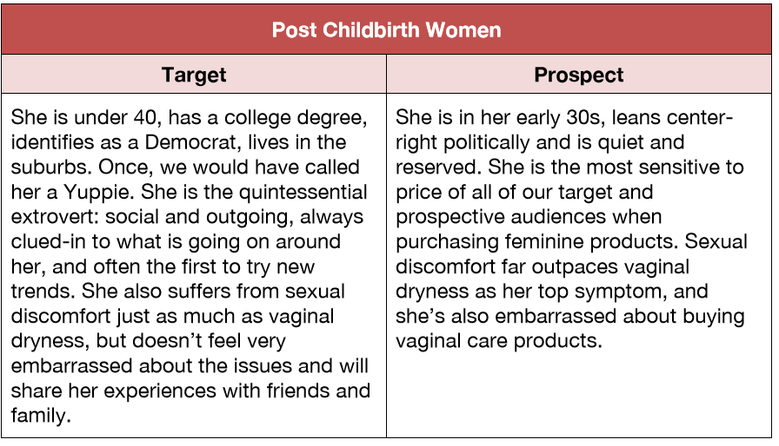

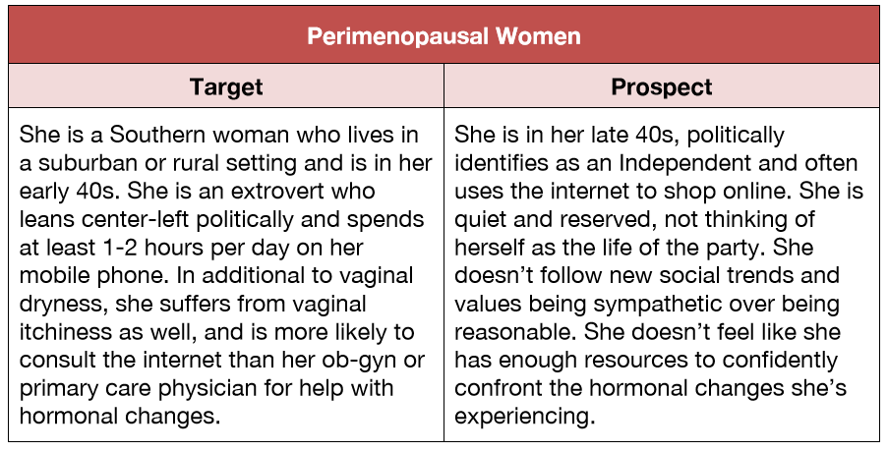

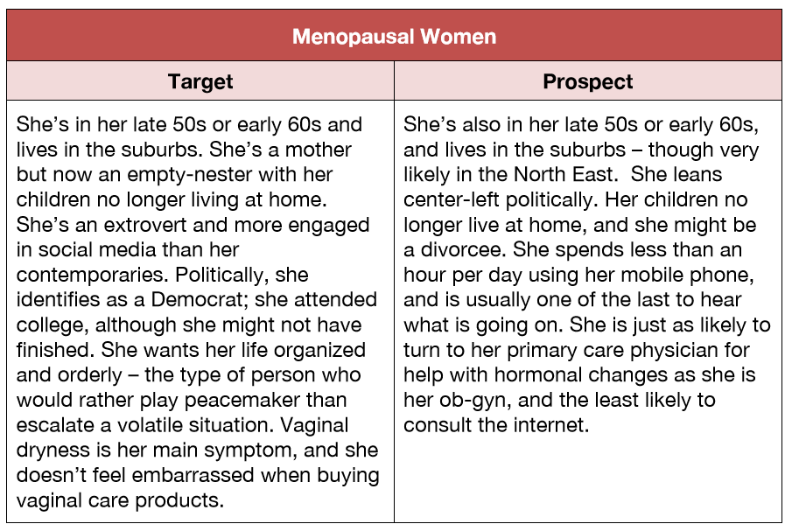

Our customers have found relief from our products as seen in a few of the **testimonials** we’ve collected here:

*Thank you. Thank you. I had tried multiple other products and hated the fact that I was putting chemicals in my body. Finally a solution that cares about my health.*

Susan Davis, Kansas

*Love the system. It works! No clumping, no side effects. Really does feel like my own moisture. Best product I’ve ever used.*

Geena West, Seattle

*I am a practicing internist. In comparison to other lubricants, Very Private Intimate Moisture is smoother, less irritating, and much easier to remove with only a small amount of water. I have found that it is in every way a superior product and recommend this lubricant highly.*

Gerald W Labiner, MD, F.A.C.P. Clinical Assistant Professor of Medicine, UCLA School of Medicine

*My experience with your product has been excellent. I far prefer the product to KY Jelly and other gel-type lubricants as it is a great deal more natural and leaves no residue. In fact, it is the closest thing to a woman’s own natural moisture. I have recommended Very Private to many of my patients suffering from vaginal dryness because the product is safe and instantly restores their natural moisture. My patients report that they are very satisfied with the product because it works instantly and feels so completely natural.*

Richard Bank, MD

*This system changed my life. No more painful sex. Thank you. Incredible.*

Yvette Norris, Los Angeles

*Ugh, Menopause hit and no more sex with my husband. It was just too painful. I tried Replens and KY and neither helped. I tried the Very Private system and changed my life. I now have no pain at all during sex and you’ve reenergized my marriage!*

Ellen Paine, San Francisco

**Some additional opportunity stats that underscore latent need and market opportunity:**

* 43% of ALL women experience some kind of sexual dysfunction with 34% of those women experiencing very painful sex due to vaginal dryness.[i]
* Between 17 and 45% of post-menopausal women find sex painful.[ii]
* Nearly nine in 10 women experience pain the first time they have sexual intercourse after childbirth. Almost 25% still report painful sex 18 months later.[iii]
* Women account for 93% of overall consumer spending on OTC pharmaceuticals.[iv]
* The boomer/senior market already accounts for more than 50% of CPG spending, ringing up more than $200 billion in the last year alone. Segment growth is outpacing industry average, and, by 2020, annual CPG spending by boomers and seniors will surpass $230 billion.[v]
* In the US, the intimacy health category generated more than $870 million in sales with the highest growth coming out of the personal lubricant ($213.4 million, up 2.9%) and emergency contraceptive ($253.2 million, up 12.3%) sectors.[vi]
* The analysts forecast global personal lubricant market to grow at a CAGR of 7.1% over the period 2014-2019.[vii]

## **3.3 The Competition**

Our competition spans providers across the personal care industry – from lubricant and feminine moisturizer providers (e.g. KY Jelly, Astroglide, Replens) to feminine cleansers (Summers Eve, Vagisil).

As our product roadmap expands, contenders will include deep body moisture providers (e.g. Aveeno, Eucerin), deodorant providers, and incontinence providers (Depend, Poise).

### **3.4 Competitive Advantage**

While there are multiple other intimate moisture/lubricants and body wash providers in the market globally, no one has squarely targeted the female audience in a health and wellness context – nor have any of the brands aimed to build education and start a dialogue around the hormone story. Nor, do any of our immediate competitors in the lubricant/moisturizer space and/or feminine cleanser markets offer a 2-step solution to vaginal dryness and changing pH that seeks to protect both external and internal areas of the vaginal.

Our current 2-product solution set offers a two-step solution: First use Very Private™ Intimate Moisture to moisturize and soothe the pain of dryness and weakening tissue, both externally and internally. Second add the Very Private™ pH Balanced Body Wash into daily routine to cleanse, balance and prevent undoing the moisturizing in step one.

​We aim to differentiate the Very Private line of products by building a brand that is specifically for women and the only female intimate moisturizer/lubricant that is both FDA cleared and OBgyn.net approved. Additionally, our line is further differentiated as it answers an unmet need in the marketplaces: a two-step process that lubricates externally, protects and moisturizes internally, and then cleanses gently without disturbing women’s’ dynamic pH or stripping away moisture.

In addition to the line of personal care products, our eCommerce marketplace will be a destination for this community of women where they can purchase the products, read substantive content pertaining to the life changes they are experiencing and share their own stories.

This demographic is one of the most active on the web but sorely underserved. We see a big opportunity to build the definitive destination for the woman experiencing hormonal changes – all based on educating women on what’s happening in their bodies (and why),while starting a dialogue and community that embraces women in the post-childbirth, peri-menopause and post-menopause phases of their hormone journey.

### **3.5 Regulation**

The Feminina Group carries an FDA 510(k) medical device clearance for it's Very Private™ Intimate Moisturizer/Lubricant, therefore all formula and packaging must adhere to the FDA's strict requirements for products that meet this high standard.

# 4.0 Product Line

**4.1 Our Product**

Whether it’s for your personal pleasure or just daily well-being, we have created the ultimate system that performs like a woman’s own natural moisture

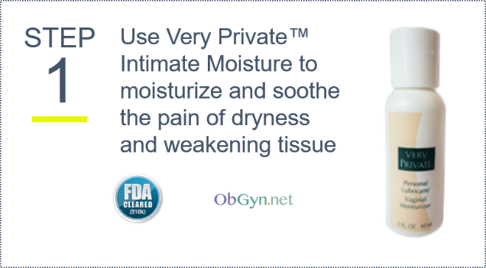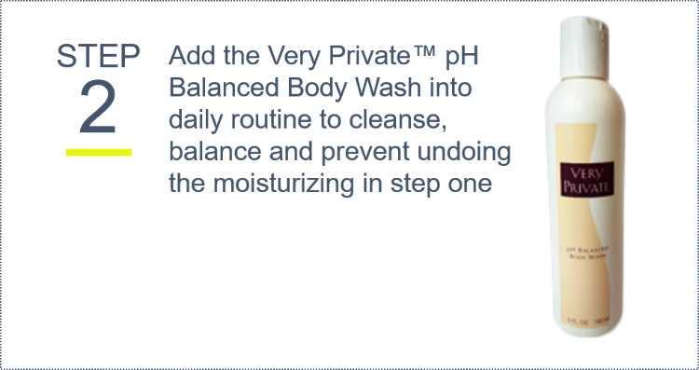

**Why Choose Very Private™ Intimate Moisture?**

*The only all-in-one feminine moisturizer and lubricant with both FDA clearance and OBgyn.net approval*

***Safe***. Premium grade water based completely paraben free. All ingredients are carefully selected and rigorously tested. Intimate Moisture is the ultimate lubricating formula that you can trust with the most private, sensitive part of your body.

***High Performing***. Concentrated with a unique blend of 3 different moisturizing ingredients, Very Private™ Intimate Moisture is #1 at moisturizing and lubricating both before and during intercourse. A little goes a very long way. Bottle lasts up to 40 applications.

***Medically approved***. With both FDA 510(k) clearance for inter-vaginal use and OBgyn.net's "Seal of Approval", it's the #1 choice by medical professionals.

***Reliable***. Intimate Moisture is the perfect accompaniment to your sexual encounter, providing the optimal lubrication every step of the way. Supplies potent, lasting moisture every time.

***Discreet***. Our formula is ultra-concentrated to fill a 2oz bottle that fits perfectly into the palm of your hand. Easy to use and completely discreet. Keep it in your bag for daily comfort.

*The benefits you’ll gain from our intimate moisture:*

* Premium grade water based
* Non sticky
* Long Lasting
* Hypoallergenic
* Hormone free
* pH Balanced
* Replenishes natural moisture
* Clean and non-staining
* Fragrance free
* Silky smooth feel
* Odorless, colorless and tasteless
* Safe for use with latex condoms

**Why Choose The Very Private™ pH Balanced BodyWash?**

Gentle, yet effective ingredients, cleanse, moisturize and soothe the delicate vaginal area. Besides cleansing gently and moisturizing the skin, it contains an anti-fungal as well as an anti-bacterial agent to help protect women from common vaginal irritations.  
 ***Reliable***. Formulated according to strict FDA protocols. Dermatologist and gynecologist tested and approved.

***Safe.*** All ingredients are plant based and rigorously tested. You can trust our formula to safely cleanse the most intimate part of your body.

***Gentle yet Effective.*** Contains both anti-bacterial and anti-fungal agents to help guard your intimate area against common vaginal irritation and infection. Aids in odor control and prevention of yeast overgrowth.

***For sensitive skin***. Formulated to protect sensitive skin. Gently cleanses, soothe and moisturize the most delicate part of your body.

***Moisturizing.*** Washes off silky. Non-drying.

*The benefits you’ll get from our body wash*

* pH balanced to complement your personal ecosystem
* Glycerin Free
* Phthalate Free
* Dye Free
* Treats odor
* Anti-fungal and anti-bacterial
* Dermatologist and gynecologist tested and approved
* 100% Natural

# 

# **4.2 Pricing and Operations**

**Pricing**

We currently price both products (Intimate Moisturizer/Lubricant 2.6 oz, pH Balanced Body Wash 6 oz) at $9.45 USD to retailers. Our products are distributed on Amazon, drugstore.com, and various small boutique medical wholesalers. Consumer pricing for both products range from $14.99 to $15.96, which is controlled by the retailers.

Our profit market is approximately 70% (with no marketing), but as we invest in marketing, staff and infrastructure to build a high-performance manufacturing and distribution business, we anticipate the margin shifting to 40%.

At production levels of 10,000 for each product, including manufacturing and shipping, the Very Private production costs are as follows

|  |  |  |
| --- | --- | --- |
|  | Intimate Moisture | Body Wash |
| Fixed Cost | $2.58 | $2.89 |
| Wholesale Cost | $9.45 | $9.45 |
| Profit | $6.87 | $6.56 |
|  | 73% | 69% |

**Manufacturing**

Our products are manufactured by United Consortium based in Chatham, CA, USA. The lead time for production is 6 weeks based on 10K units. They have the capacity to scale and could build up to 100K units per week.

United Consortium is well-respected in the lotions and cosmetics industry, and serves as an all-in-one lab, manufacturer, and bottler for its clients. All of Very Privates ingredients are sourced through UC and we’ll continue to partner with them as long as the model can scale to our needs.

**Inventory/Fulfillment**

With the majority of existing Very Private™ sales happening through Amazon, we privately manage the fulfillment of product to Amazon’s warehouse locations as part of their vendor contract.

To align with the 3-year forecast, a research effort is underway to secure a cost-effective and efficient Inventory/fulfillment service that is trusted and secure.

**4.3 Product Roadmap**

Our product roadmap is grounded in the changing hormonal needs of women. Over the years, we’ve invested time with medical professionals and researchers studying the impacts of hormonal changes in women starting with age 17 and continuing until the late seventies.

The **hormonal journey** is a phased one, and will impact the female body in the following ways:

|  |  |  |  |
| --- | --- | --- | --- |
| **Menstruation & most active sexual years** | **Pregnancy and  Post-natal** | **Peri-menopause** | **Menopause** |
| Need for vaginal moisture/ lubricant to extend sexual activity. | Post-natal vaginal dryness. | Vaginal & overall dryness, flaking, itchy dry patches. | Vaginal dryness, overall dryness. |
| Residue & intensified odor pattern during ovulation, underarm & vaginal. | Discharge, hormonal fluctuations post natal, moisture re-regulation. | Thinning of vaginal tissue, increased dryness, discomfort during sexuality. | Thinning of vaginal tissue, severe dryness, discomfort, pain during sexuality. |
| Increase in STDs during active sexual years. Need for protection |  | Change in vaginal pH (acidic to alkaline), increased yeast and bacterial infections. | Change in vaginal pH (acidic to alkaline), increased yeast and bacterial infections. |
| Vaginal irritations, redness, tissue swelling, allergies due to active sexuality. Need for prevention, protection. |  | 1st stage incontinence issues, (30% of menopausal women). Little spills when coughing, laughing or sneezing. Irritation, odor issues. | 1st to second stage incontinence issues, more severe irritation and odor issues. |
|  |  | Heavier perspiration & increased odor issues, underarm, vaginal. | Heavier perspiration & increased odor issues, underarm & vaginal. |
| Extending sexuality. Need to add lubrication. | Return normal sexuality, possible dryness. | Loss of libido, need for sexual stimulation & lubrication. | Loss of libido, need for sexual stimulation & lubrication. |

Our product roadmap extends over five years, and will address women's needs as follows:

**Years 2015-2016**

1. Vaginal dryness - existing product is Intimate Moisture, FDA 510(k) medical device clearance​. We'll extend this line with take-along foil packets for single-use.
2. Vaginal cleansing - existing product is pH Balanced Body Wash which provides a vaginal and all-over wash for the body. We'll extend this line with vaginal wipes.
3. Vaginal moisturizer - daily gel for comfort, pre-exercise
4. Vaginal odor elimination - vaginal wipes - both at home and take-along versions.

**Years 2017-2020​**

* Underarm odor elimination - deodorant/antiperspirant/neutralization designed for high-odor days that are unique as a women ages post-menopause years.
* First stage incontinence - wipes that address little spills to eliminate irritating residue. Provide odor neutralization and pH re-adjustment. Partner with a brand that is developing a Kegel exerciser to combat weakening muscles.
* Second-stage incontinence - cleanser that soothes irritated tissue associated with incontinence. At-home bladder leakage cleansing lotion, and take-along individual leakage cleansing wipes.
* Relief of feminine itching - medical salve to relieve external (groin, under breast) feminine itching, burning, and skin irritation.
* Inflammatory solutions - patented ingredient designed to reduce and relieve inflammation in the vaginal, groin, underarm, and under breast areas.

### **4.3 Intellectual Property Rights**

The Feminina Group has exclusive ownership of the Very Private™ Intimate Moisturizer/Lubricant and Very Private™ Body Wash formulas. We have not patented either formula to refrain from publishing the formulas.

We also have registered and trademarked the Very Private™ brand in 8 markets. This brand was developed 10 years ago and we are currently assessing the right brand approach for the market we want to target. Regardless of that outcome, we will continue to protect this trademark for the next few years.

# 5.0 Marketing & Sales

### **5.1 Growth Strategy: Our Go-to-Market**

We believe that if we invest in building share, the repeat-purchase and upsell opportunity of our family of products will become an annuity revenue stream for the long-term.

Year 1 is about getting the engine going. We will build a strong base of believers and users of our products. We'll invest and test on Amazon, drugstore, Alibaba and Flipkart engines, while building our own.

Year 2, is to upsell and engage our customers with new companion products while creating that personal experience through our content engine and direct marketplace.

Year 3, we'll expand to new categories. You saw the list of hormonal changes in our lifetime, and we've got a product roadmap to match - all working on products from the neck down. To maintain the momentum of our “engine” and capitalize on the upsell opportunity of our industry, we intend to release close to 3 products a year.

### **5.2 Refresh Brand, Packaging**

The Very Private™ brand was developed with the notion of discretion. Hormonal changes within a women’s body are unique to each woman and present unwanted changes as the body grows older. Consequently, women desire the upmost discretion in dealing with their personal changes.

Respecting the desire for discretion and style, we also honor that our target audience – today’s post-child birth mothers and 50-year-old women are modern, confident, and demand clean, honest OTC products. We see an opportunity to modernize the existing brand and packaging of our products as something our target audience identifies with. Finding the right balance between discretion, today’s modern woman, and preserving the brand equity that exists is the challenge before us.

The Feminina Group Brand Values:

Feminine, Confident, Intelligent, Empowering, Safe, Clean, Honest, Authentic, Reliable

### **5.3 Promotion**

1. **Third Party Endorsement:**  
   As our research illustrates, the choice of a vaginal lubricant is highly influenced by the medical profession. As a result, we will seek out members from the OBgyn community that can act as advocates, and potentially spokespeople for the brand. This professional advocacy from the OBgyn community will be core to our marketing materials and positioning. We will also create a sample size of the products to distribute to OBgyns to provide to patients as samples.
2. **Contextual Search-Engine-Optimization and Digital Marketing**  
   Our research indicates that one of the top ways today’s woman seeks information for personal care products is Internet Search. With a strong presence on Amazon and drugstore.com, the barrier to quickly gaining awareness of our product within the Health & Beauty category is easy with SEO. Already, our SEO tests on Amazon have yielded a 6-to-1 ROI.  
     
   We’ll build an SEO plan within the online retail environment, as well as invest in Google’s latest ad products to place our brand within contextual content sites, search, and online publications.
3. **Social Media**   
     
   Good content is fundamental to a brand being successful on social media. While hormonal changes are not likely something people share on social media, the platform presents an opportunity for education-sharing and brand-building. It also offers a platform for community-building as evidenced by a comment made in The Feminina Group’s recent Audience Research Study 2015:

*“It wasn't until a friend on Facebook announced that she is going through menopause that I had ever seen so many other women open up about menopause and it was like, oh okay, so I'm not really as alone as I thought I was.” -Anonymous.*

To engage our community and build brand awareness we will establish a presence on Facebook and regularly publish content to FB. This also goes for Twitter. Once we have a range of substantive video content we should also establish a YouTube page. It will be essential however we have a very robust pipeline of content and interesting things to say before we start distribution.

1. **Create a Narrative and Heavily Leverage Earned Media**  
     
   Public relations is going to become a very valuable tool for our brand. Our strategy needs to lean heavily into the topic of the “hormone story” and vaginal dryness in particular (in a very thoughtful fashion) and take advantage of the high media engagement that will generate.   
     
   To do this well, we will need to establish a telegenic spokesperson for the brand who can consistently present our brand values. In addition we should hire or engage and OBgyn who can also act as our third party spokesperson. We will likely utilize this person (or set of persons) in our content strategy and paid media.
2. **Direct Marketing Campaign**  
     
   Given our strategy to build brand awareness quickly, a direct-marketing campaign needs to be part of our promotion formula in year two. The age of our target audience also represents a strong-TV-viewing segment, which is foundational to any DM campaign – likely driven through a network such as QVC or through DRTV.  
     
   Creation production, script-development for telemarketing and customer service support, promotional bundles, digital marketing, inventory/fulfillment, and analytics-based testing will be part of the direct marketing plan to grown brand awareness as well as build share. We anticipate that several rounds of testing and refinement will be required to get the mix of investment in Direct Marketing just right for our brand.  
     
   We believe that if we invest in building share, the repeat-purchase opportunity of our products will become an annuity revenue stream for the longterm.

### **5.3 Communications & Community**

To help both build brand awareness and build our online community, we will need to execute a carefully defined content strategy. (And utilizing Marketo, or Salesforce we can easily track and attribute how various content generated sales leads.)

The personal care needs of woman – especially in the area of hormonal changes - is a rich topic for content creation. To that end, we will reuse, and update where necessary, the existing Very Private blog posts, articles and Q&A’s, as well as develop a network of content providers from women’s groups, medical providers and authorities on the “hormone journey” that starts the dialogue that The Feminina Group intends to be known for. All of this content must be written to offer quality information but be structured with SEO at its core so that we surface prominently in Google.

It will also be important to produce video content that mirrors the written content, so we offer various media where people can engage with our brand. Every piece of video content must also be designed to be passed along and shared online.

The most important part of a content strategy is distribution. So building the Feminina Group Email list is an essential step. Our new web site needs to be redesigned with email sign up prominently displayed, and encouraged in every piece of content we create.

## **5.4 Retail Distribution**

Women accounted for 57% of online shoppers in the US last year and men 43%, according to Experian data shared with BI Intelligence. Some additional interesting stats include:

* 50+ is the fastest growing demographic to move online
* 82% of baby boomers use the web to research health and wellness

In the United States we intend to sell our products online only and through small, independent wholesalers that were early to sign up. It is a habit forming product that is prime for developing a repeat-relationship with our target customer.

While we will build our own eCommerce marketplace and content site, we will also scale the existing business success we have on both Amazon and drugstore.com. On Amazon in particular we have the opportunity to blow out our business by creating a new storefront in HTML5, paying particular attention to product details so they are optimized for search, optimizing feedback so we start to show up higher in the algorithm.

And, as Amazon innovates in delivery methods and ad products, we too hope to ride that wave as a vendor. As evidenced in a recent Comscore study, Health and Beauty products are one of the top products consumers seek out through Amazon quick-turn retail services. 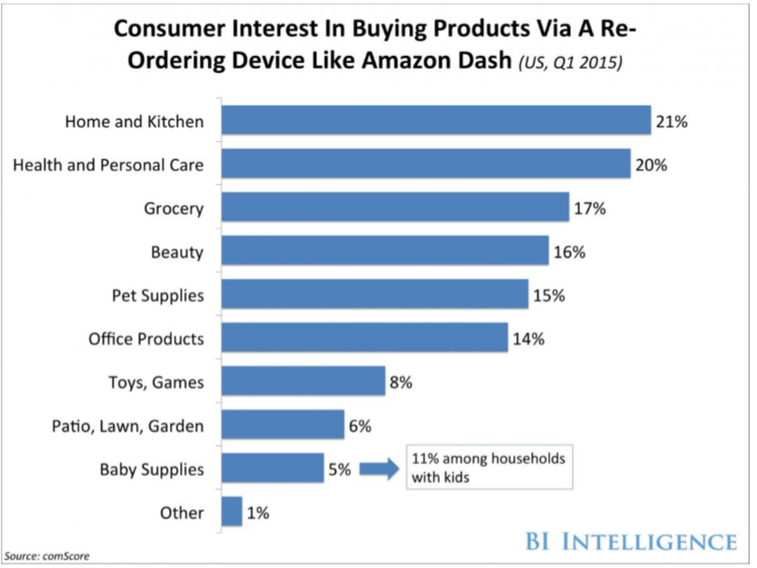

We also need to execute highly effectively on Amazon US so that we can start to distribute our product to Amazon in other countries.

In addition to Amazon we need to look beyond US marketplaces and start a relationship with Ali Baba in China and Flipkart in India.

We should also explore strategic distribution partnerships, e.g. Pharmatronix, in order to get the Very Private line of products in other parts of the globe.

In the first 12 months, we anticipate our distribution mix will be Amazon 65%, Drugstore 10%, Direct 10%, Misc Wholesale 10%, Int'l Onine 5%.

# 6.0 Revenue and Sales Forecast

### **6.1 Profit & Loss (3 Year)**

Our assumptions going into our 3-year model are that we will double the business every year. One of our key competitors – KY Jelly – generated $100M net rev in 35 years as a consumer product (began retail distribution in 1980). In comparison, we believe we can grow to $11M in 3 years with differentiated products and a unique approach to relieving women’s symptoms caused by changing hormones.

What’s not accounted for yet in our 3-yearmodel are the various growth rates of our products. For example, the Body Wash is intended to be used daily, and therefore we anticipate a monthly-to-bi-monthly rate of purchase, whereas the Intimate Moisture/Lubricant is used approximately 2-3 times a week, and with 40 uses per bottle, we anticipate 2-3 purchases a year. Factoring in the 2-step solution usage pattern into our model is something we’ve yet to tackle.

Our efforts to streamline our supply-chain and COGs is ongoing. We hope to optimize and continue to drive-down costs in the model.

The Feminina Group intends to own the leading forum for women regarding their hormone journey via our eCommerce and community marketplace. We have plans to monetize that. That model is not yet accounted for in our 3-year plan.

### 

### **6.2 Cash Flow (12 Month)**

The 12-month cashflow assumes that The Feminina Group will launch with a modernized brand, PR and marketing efforts starting in February. As a result, there is a noticeable jump in sales and expenses during that month that will normalize as we move into May/June.

Logistics-planning is still underway, and we’re actively researching manufacturing, distribution and fulfillment options to accommodate our anticipated growth. As a result, not all costs associated are accounted for within the model specifically. Rather, we’ve called them out in the COGS and overall net revenue.

### 

# 7.0 investment strategy

In Oct 2015, The Feminina Group, Inc. acquired the Very Private™ intellectual property and small inventory of product. In total, the acquisition was $2.5M in preferred stock paid to the founder, Jacqueline Brandwynne.

Early angel investment was also secured in Oct 2015 totaling $435K in exchange for preferred stock.

The Feminina Group is currently raising funds through convertible notes to fund initial marketing investments and talent.

Series A fundraising is slated to begin in March 2015 after a valuation of the company is complete.

# References

*Age and Sex Composition in the United States: 2012*. (2012). Retrieved from US Census Bureau: https://www.census.gov/population/age/data/2012comp.html

Crisler, J. (2004). *From Menarche to Menopause: The Female Body in Feminist Therapy.* New York, London: Routlage, Taylor & Francis Group.

JoAnn E. Manson, M. D. (2010). *Overview of Menopause.* Retrieved from http://www.menopause.org/docs/2012/cg_a.pdf?sfvrsn=2

Johnson, M. (2014, July 10). *Lubricants, Plan B Boost Sales*. Retrieved from Drugstore News: http://www.drugstorenews.com/article/lubricants-plan-b-boost-sales

Johnson, M. (2015, February 9). *Women Want Low Cost, Good Value*. Retrieved from Drugstore News: http://www.drugstorenews.com/sites/drugstorenews.com/files/OTC_020915.pdf

Mikio A. Nihira, M. (2014, November 7). *Female Sexual Dysfunction*. Retrieved from WebMD: http://www.webmd.com/women/guide/sexual-dysfunction-women

Research, L. I. (2014). *Global Personal Lubricants Market 2015-2019.* Infiniti Research Limited.

Salamon, M. (2015, February 5). *Sexual Pain Common After Childbirth*. Retrieved from WebMD: http://www.webmd.com/women/news/20150205/sexual-pain-common-after-childbirth-study-finds

Viamari, S. (2014, June 26). *Aging America*. Retrieved from IRI: http://www.iriworldwide.com/en-US/insights/Publications/Aging-America-(1)

[i] Mikio A. Nihira, M. (2014, November 7). Female Sexual Dysfunction. Retrieved from WebMD: http://www.webmd.com/women/guide/sexual-dysfunction-women

[ii] Crisler, J. (2004). From Menarche to Menopause: The Female Body in Feminist Therapy. New York, London: Routlage, Taylor & Francis Group.

[iii] Salamon, M. (2015, February 5). Sexual Pain Common After Childbirth. Retrieved from WebMD: http://www.webmd.com/women/news/20150205/sexual-pain-common-after-childbirth-study-finds

[iv] Johnson, M. (2015, February 9). Women Want Low Cost, Good Value. Retrieved from Drugstore News: http://www.drugstorenews.com/sites/drugstorenews.com/files/OTC_020915.pdf

[v] Viamari, S. (2014, June 26). Aging America. Retrieved from IRI: http://www.iriworldwide.com/en-US/insights/Publications/Aging-America-(1)

[vi] Johnson, M. (2014, July 10). Lubricants, Plan B Boost Sales. Retrieved from Drugstore News: http://www.drugstorenews.com/article/lubricants-plan-b-boost-sales

[vii] Research, L. I. (2014). Global Personal Lubricants Market 2015-2019. Infiniti Research Limited.