**Capital Region 2016 InnovateHER Finalist**

Sandra Beck

Tidy Tots Diapers, LLC

Tidy Tots Hassle-free Cloth Diapers

24 Rose Lane

Rensselaer, NY 12144

Tidy Tots Diapers, LLC was created in July 2009 in the state of New York

<http://www.tidytotsdiapers.com/>

518-369-4235

[sbeck@tidytotsdiapers.com](mailto:sbeck@tidytotsdiapers.com)

**Submitted by**

Albany Center for Economic Success, Inc. (ACES)

255 Orange St.

Albany, NY, 12210

Destiny Watkins

(518) 436-8586

[Destiny@mycommunityloanfund.org](mailto:Destiny@mycommunityloanfund.org)

Tidy Tots Diapers’ key product is a patented, hassle-free cloth diapering system that includes covers, Hemp blend No Fold Diapers, Boosters and flushable cornstarch liners called Flushies. Tidy Tots Diapers’ unique snap design allows the diaper to be resized to fit babies and toddlers of all sizes while remaining ick free, rash free and leak free.

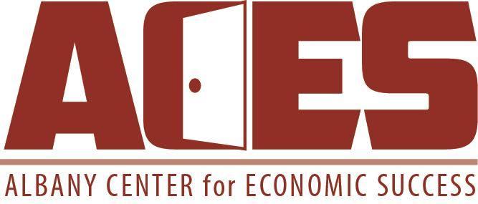

December 3, 2015

Ms. Erin Andrew

Director, SBA’s Office of Women’s Business Ownership

409 3rd Street, SW Suite 6600

Washington, DC 20416

Dear Ms. Andrew,

Please accept this Statement of Support from the Albany Center for Economic Success, Inc. (ACES) for **Sandra Beck, owner of Tidy Tots Diapers LLC**, as the winner of the Capital Region InnovateHER 2016 competition. Tidy Tots best satisfied the SBA’s Challenge Criteria because they are an innovative company that has the opportunity to sell their products globally and they have significantly and positively impacted the lives of women and families. Tidy Tots’ mission is to shape a brighter tomorrow for children, by providing an eco-friendly diaper while inspiring and supporting socially conscious business.

The Real Diaper Association estimates that 27.4 billion disposable diapers are used each year in the United States, accounting for 10% of the waste in U.S. landfills and being the leading cause of ground water contamination. The average baby will use 6,000 disposable diapers in the first 24 months of diapering with each one taking up to 500 years to biodegrade. Cloth diapering became an alternative to disposable diapers in the early 1970’s; however, they have multiple layers and require a cover to keep the moisture in. One of the biggest issues with cloth diapers is that they all require the same cleaning method of scraping the solid waste and pre-soaking the material before washing. In fact, several firms sell a sprayer hose that attaches to the toilet to assist with this. Tidy Tots was able to manufacture a solution to that problem.

After decades of owning and operating a tech company that specialized in manufacturing and wholesale distribution as well as software implementation, Sandra Beck decided to turn her focus to developing a diaper that could have the same durability and flexibility of a disposable diaper with the environmental impact and monetary savings provided by a cloth diaper. With the help of over 100 families, during the course of 6 years, Tidy Tots perfected its “hybrid” diaper design which bridges the gap between disposable and cloth diapers. The company currently has two utility patents and one design patent, with other patents pending both internationally and in the U.S. Sandra’s innovative, hassle-free cloth diapering system will create increased value for women and families. Her product innovations include: a flushable liner (Flushies) that doesn’t need to be soaked or cleaned like typical cloth diapers (**ick free)**, Organic hemp No Fold Diapers and Boosters as well as Flushies made out of cornstarch to prevent diaper rash (**rash free)** and patented covers with water resistant trim, deep gussets and flaps to prevent leaks (**leak free)**. Tidy Tots diapers could save families more than $1500 on their first baby and provide a natural solution to disposable diapers. This product has the opportunity to convert both disposable and cloth diaper users to the Tidy Tots brand. Sandra’s emphasis on making the diapering experience easier and more environmentally friendly proves that she is trying to bring positive change to women and families. Tidy Tots diapers received the award for Best Diaper Set by Baby Maternity Magazine in 2015 and received the Family Choice Award in 2014.

One of Tidy Tots biggest strengths is their potential for commercialization despite market domination by larger firms. Disposable diapers dominate 92% of the entire diaper market with consumers spending approximately $8 billion per year at a growth rate of about 4% per year. Kimberly Clark and Proctor & Gamble are two of the largest brand name manufacturers and their sales account for nearly 80% of the market. The cloth diaper segment produces around $200 million per year with a growth rate of 30% per yr. The biggest companies in this market are bum genius, g diapers, GroVia, however Tidy Tots has managed to create a niche market that borders both market segments.

Currently, Tidy Tots Diapers sells their products in brick and mortar boutiques across the country, online boutique stores, amazon.com and the Tidy Tots Diapers online store. Some of these boutiques include Kelly’s Closet, Green Diaper Store, 716 Baby Boutique, Pure Parenting Shop and a few others. This past October Tidy Tots had a successful launch at an ABC Kids show in Las Vegas, NV and began negotiations with other large distributors that want to carry their product. Some of these include baby good distributors in Canada, a 230 location grocery store chain in the U.S and BuybuyBaby. Sandra’s passion, experience and entrepreneurial mindset have allowed her to make inroads into a market that is dominated by huge companies and create a product that can be sold worldwide while revolutionizing families that live the cloth diapering lifestyle.

Because it fills a need in the marketplace, has a positive and measurable impact on women’s lives, and is already set for wide-scale commercialization, Tidy Tots Diapers, LLC is an ideal candidate for the SBA’s InnovateHER Challenge. Winning this challenge, would help give Sandra the additional capital and publicity she needs to take this triple bottom line business to the next level.

Sincerely,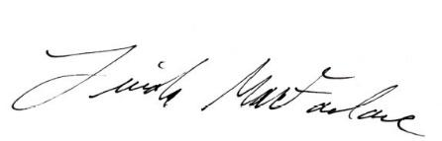

Linda MacFarlane

Executive Director