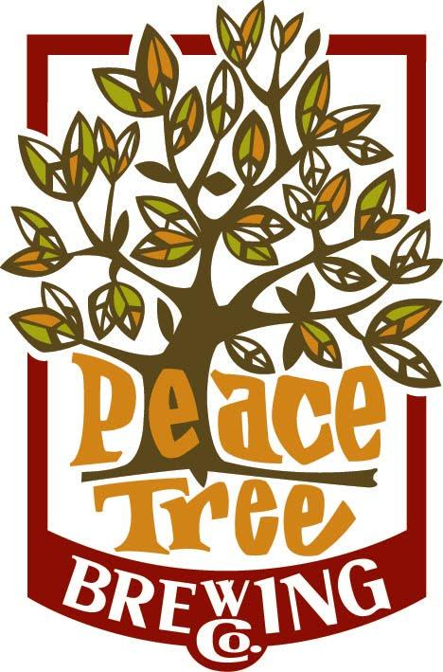

Megan McKay, President

Peace Tree Brewing Company

107 W Main Street

Knoxville, Iowa 50138

[www.peacetreebrewing.com](http://www.peacetreebrewing.com)

641-842-2739

641-230-0468 mobile

[megan@peacetreebrewing.com](mailto:megan@peacetreebrewing.com)

Peace Tree Brewing Company produces a wide variety of high quality, full flavored craft beers that appeal to the seasoned craft beer drinker as well as those new to craft beer. Our brews are distributed throughout Iowa and Nebraska to fine bars, restaurants and retailers or can be enjoyed in our handsome community taproom.