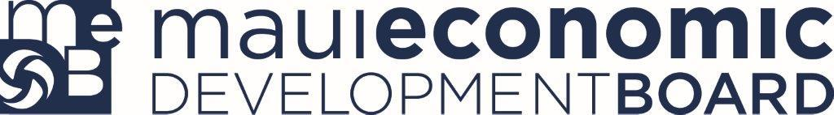

December 2, 2015

Statement of Support

The Maui Economic Development Board (MEDB) enthusiastically endorses Pamela Norris (ICEBUDDY) as the winner of the 2016 InnovateHER Challenge local competition for Maui, Hawaii.

MEDB put on a three day InnovateHER Challenge competition. The first day was a pitch boot camp where participants could hone their presentation skills. The second day was a one-minute pitch competition, which narrowed the field of contestants down to the top ten finalists. The third and final day was a five-minute pitch from the top ten, where Pamela and ICEBUDDY emerged as the judges’ favorite.

The ICEBUDDY System is a portable cooling system that utilizes new technology and innovative features. This storage mechanism consists of two independent modules that can be used individually or integrated to form the complete system. One module is the kosher manufactured QOOLER. It preserves food, medication and other critical temperature sensitive items, such as blood supplies, tissue and organs, by enabling them to remain cool (36°F to 46°F) for 72 hours without the need for ice, power or refrigeration. This is accomplished by the placing the encased, patented, non-toxic coolant gel activated QOOLER in a freezer for three hours. The second module is the QPACK which meets military specifications. The QPACK houses the QOOLER in a special collapsible compartment and also serves as an ice and water storage unit with capacity to transport 10 lb. of ice, 120 ounces of water, or a dozen 16oz water bottles.

This innovative product meets and exceeds all the criteria set out by the Small Business Administration for the InnovateHER Challenge competition.

ICEBUDDY clearly has an impact on the lives of women and families. There are over 100 medications and supplements families use daily that require refrigeration. In fact, product labels from all three U.S. insulin manufacturers recommend that insulin be stored between 36°F to 46°F. Recent disasters like Katrina in New Orleans and the earthquakes in Haiti have

highlighted the importance of being able to preserve medication at controlled temperatures and having a way to store clean, potable water.

Disaster preparedness is a big issue for families. Too often, the lead for emergency preparedness falls on women. ICEBUDDY eases the burden placed on caregivers, eliminating the worry of required refrigeration and enabling clean water transportation and storage when disaster strikes.

ICEBUDDY is ready for commercialization. U.S. and International patent pending applications have been secured. The owners of ICEBUDDY have identified Igloo and Tupperware as their key competition, and have secured Non Disclosure andNon Compete Agreements with both. ICEBUDDY has a working prototype and agreements in place with Injectron and Hy-Ten to manufacture the ICEBUDDY System.

ICEBUDDY fills a new niche in the market that combines the preservation of medication with the capability to store a supply of potable water. It is unique in its ability to transport and preserve drugs and organs at an ideal temperature for three days. A market research study was conducted that identified 26 diverse markets for the product, to include the Military, Insurance Companies, Hospitals, Government Agencies, Assisted Living Centers, etc.

MEDB is pleased to support ICEBUDDY as the winner of the Maui InnovateHER Challenge. Pamela delivered her pitches to a panel of respected local entrepreneurs, and emerged as the clear favorite.   
  
Sincerely,

Gerald Smith  
Maui Economic Development Board