**Tattoo-based iontophoretic-biosensing platform For Non-Invasive Alcohol Monitoring: ‘AlcoTatt’**

Blood alcohol content (BAC) is most commonly used as an indicator of alcohol intoxication. However, blood sample is nominally obtained by invasive means, which gives people pain during sample collection. To overcome this issue, we describe a novel solution to monitor BAC non-invasively in real-time using a wearable tattoo-based biosensor named ‘AlcoTatt’. Based on well-established correlation between alcohol concentration in sweat and blood, the new skin-worn electrochemical biosensor measures transdermal alcohol content (TAC) in induced sweat via iontophoresis to estimated BAC, with the measured data wirelessly transmitted to laptop or mobile device for real-time analysis. The onbody performance of ‘AlcoTatt’ prototype has been demonstrated on human subjects with ingestion of alcohol drinks showing high sensitivity and specificity towards ethanol in sweat. This proof-of-concept study supports the application of a skin-worn tattoo-based wearable electrochemical biosensor for the non-invasive alcohol monitoring.

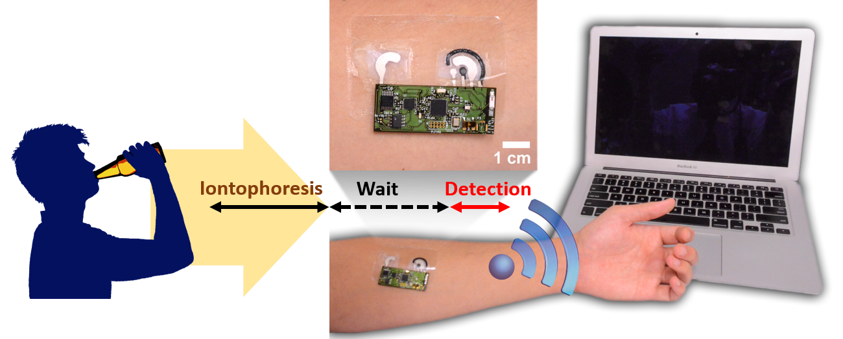

1. **Motivation**

Alcohol consumption leads to harmful consequences such as traffic accidents and degenerated health care. Therefore, accurate measurement of alcohol consumption is important for preventing alcoholism and alcohol abuse and the effectiveness of their treatment. Although many methods has been used for determining alcohol consumption including verbal report measures, biochemical markers, and direct measurements of urine, blood, saliva, breath or sweat, BAC is most commonly used as an indicator of alcohol intoxication. Blood samples are conventionally obtained by invasively pricking a fingers or earlobe, which is a painful process that demands user compliance. For these reasons, there is tremendous interest to find alternative way to measure BAC in a non-invasive, real-time manner.

Recently, our lab developed wearable electrochemical sensors that detect metabolites and electrolytes in a non-invasive way using sweat and interstitial fluid [[Jia 2013](http://www.sciencedirect.com/science/article/pii/S0956566315302876?np=y#bib26)a, Jia 2013b, Juinovart 2013, [Bandodkar 2013](http://www.sciencedirect.com/science/article/pii/S0956566315302876?np=y#bib3), [Bandodkar 2014](http://www.sciencedirect.com/science/article/pii/S0956566315302876?np=y#bib5), [Bandodkar 2015](http://www.sciencedirect.com/science/article/pii/S0956566315302876?np=y#bib6),  [Kim 2015](http://www.sciencedirect.com/science/article/pii/S0956566315302876?np=y#bib30)]. Importantly, these sensors have been integrated directly on flexible temporary tattoo substrates for epidermal sensing applications. Such body-compliant printable electrochemical sensors offer elasticity characteristic of temporary tattoos along with resistance to mechanical stress and compatibility with the non-planarity of the epidermis. Expanding this attractive skin-worn platform towards non-invasive alcohol detection in sweat should benefit wearers comfort and compliance as well as enables continuous real-time alcohol monitoring, which can be useful for monitoring clinical treatment status, individuals who are asked to maintain abstinence of alcohol. Also, the device can be used to verify drinking events, prevent driving under the influence, charging with driving under influence and track recidivism.

1. **Highlights and Innovations**

Currently, breathalyzers are the most commonly used device to indirectly estimate BAC by measuring breath alcohol concentration (BrAC). The instruments calculate BAC by following Henry’s law, which has difficulties in achieving high accuracy because it can be easily affected by humidity, temperature and individuals. BAC also can be estimated by measuring transdermal alcohol concentration (TAC), because the person’s perspiration can contain traces of alcohol when the person consumes alcohol. The Giner TAS V is the wearable prototype to measure TAC by detecting the local ethanol vapor concentration over the skin. However, it showed time delay in peak TAS signal compared with BAC estimated by breathalyzer varying from 30 min to 2 hours [Swift 1992]. Therefore, the development of a new prototype to monitor BAC non-invasively in real-time is highly desired. Buono et al reported well-established correlation between ethanol concentration in blood and sweat during its consumption is with ratio 0.81 [Buono 1999]. An electrochemical system developed recently by Pingarron et al. [Gamella 2014] illustrated the highest level of ethanol in blood and sweat at nearly the same period of time. Yet, this prototype is bulky to carry (not wearable) and requires replacement of electrodes between the iontophoresis and amperometric detection steps.

Herein, we describe a solution to monitor BAC non-invasively in real-time using wearable tattoo alcohol biosensor. Our developed wearable tattoo biosensor provides several distinct advantages and innovations for practical applications as below. It represents the first example of integration of iontophoretic and amperometric-detection system, obviating the need for replacement of electrodes between iontophoresis and detection. The electrodes are fabricated by screen-printed on a wearable tattoo platform, which is easy to fabricate, wear, and remove as well as cost-effective mass-production. Finally, flexible wireless electronics has been incorporated with tattoo electrodes, which enables real-time non-invasive measurements and data transmission to lap-top/mobile device via Bluetooth communication. The flexible skin-worn board offers resistance to mechanical stress from movement of wearer along with compatibility with the non-planarity of the epidermis. Our proof-of-principle on-body demonstrations reveal that the tattoo-based iontophoretic-biosensing platform holds considerable promise for non-invasive glucose alcohol monitoring in real-life situations.

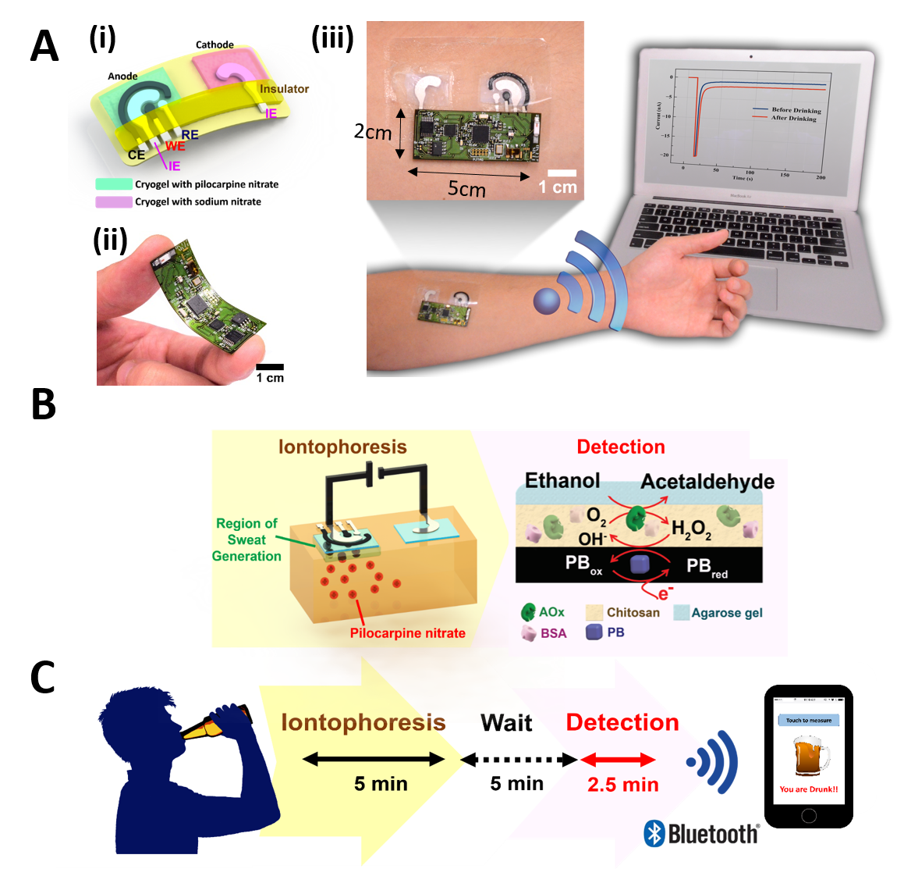

**Figure 1. Tattoo-based transdermal alcohol sensor.** (A) (i)Schematic diagram of iontophoretic-sensing tattoo electrode displaying iontophoretic electrodes (anode and cathode) and sensing three electrodes (working, reference and counter electrodes) (ii) Photograph of flexible wireless electronics (iii) Photograph of Alcohol iontophoretic sensing tattoo device with integrated flexible electronics applied to a human subject. (B) Schematic diagram of constituents in iontophoretic system (left) and enzymatic reaction and chemical modification for ethanol sensing on working electrode (right). (C) Schematic procedures of on-body study of alcohol sensing.

1. **Design and Fabrication**

***3.1. Fabrication and chemical modification process of tattoo sensor***

Patterns for printing the sensor were designed in AutoCAD (Autodesk, San Rafael, CA) and stainless steel plates (12×12 inch.2) were etched to fabricate stencils (Metal Etch Services, San Marcos, CA). Temporary transfer tattoo paper kits were obtained from HPS Papilio (Rhome, TX). A sequence of the silver/ silver chloride (Ag/AgCl) ink (E2141 Ercon Inc., Wareham, MA) and prussian blue conductive carbon (Gwent Group, UK) were screen-printed on the substrate by using an MPM-SPM semi-automatic screen printer (Speedline Technologies, Franklin, MA). As illustrated in Figure 1, the tattoo sensor design consists of iontophoresis, pseudo reference, and counter electrodes (patterned using a Ag/AgCl ink), and the working electrode patterned from Prussian-blue carbon ink. A transparent insulator was screen printed over the surface of the electrode pattern to confine the electrode and contact areas. Each printed layer was cured in oven after printing.

In order to obtain ethanol transducer, the working electrode was then functionalized with the enzymatic layer (BSA, chitosan and AOx enzyme). Then dissolved agarose hydrogel is then casted on the working electrode. Then, prepared PVA cryogels (2.0×1.5 cm2) were soaked in 1% pilocapine nitrate and 1% sodium nitrate and then placed on anode and cathode compartments for iontophoresis, respectively.

***3.2 Evaluation of sensor performance in buffer medium***

The electrochemical performance of the alcohol tattoo biosensor was first tested in 0.1M phosphate buffer (pH 7.0) medium. Chronoamperometric response was measured by stepping the potential to -0.2V (vs. Ag/AgCl) for 60 s after 1 min incubation. The calibration curve was obtained with 3 mM increments of ethanol concentrations up to 36 mM in buffer solution, The selectivity was examined by response of 10 mM ethanol in the presence of relevant electroactive species : 0.2 mM glucose, 10mM lactate, 84 µM creatine, 10 µM ascorbic acid, and 60 µM uric acid.

***3.3 Evaluate the on-body performance of wearable tattoo alcohol biosensor***

The epidermal evaluation on human subjects was conducted in strict compliance following a protocol approved by the institutional review board (IRB) at the University of California, San Diego. Total nine healthy volunteers were recruited for on-body evaluation of the developed sensor under taking alcohol beverages. First tattoo biosensor was transferred on subject’s arm and a set of ethanol detection in sweat is followed to get a current response at BAC 0.00% (‘before drinking’). Experimental time frame for onbody experiments is illustrated in Figure 1C. The set of ethanol detection consists of iontophoresis and amperometry. During iontophoresis process, a constant current of 0.6mA (0.2mA/cm2) was applied through PVA cryogel between the two iontophoresis electrode (anode and cathode) for 5 min to deliver pilocarpine chemical towards skin to induce sweat. After iontophoresis, 5 min of resting was required to give time to generate sweat and amperometric response of ethanol in sweat was recorded at applied potential of -0.2 V (vs Ag/AgCl) for 150 sec, corresponding to the current response at BAC 0.00%. The subject was asked to take an alcoholic beverage (12 oz. of beer or 5 oz. of table wine) and waited for 10 min to let alcohol diffuse in blood stream. One set of iontophoresis/detection cycle was followed to check the response of ethanol in sweat. Along with on-body experiments taking alcohol beverages, three different types of control experiments (without drinking, without enzyme modification, without iontophoresis) were performed. The sensing response towards sweat ethanol was confirmed by testing without drinking alcoholic beverages.

Furthermore, additional onbody experiments are followed to verify correlation between BAC and current response from our tattoo sensor with serial consumption of wine drinks. As described in previous paragraph, same experimental procedure was conducted by repeating two sets of drink and measurement. Before drinking (when BAC is 0.00%), current response was recorded. Then, after 1st drinking, current response was obtained and followed by 2nd drinking and measurement. Each set of measurement cycle is accompanied with simultaneous measurement of BAC using commercial breathalyzer (Alcovisor Mars breathalyzer) to validate our sensor performance in comparison with commercial alcohol sensor.

***3.4 Design and fabrication of wireless flexible printed circuit board***

This work introduces a complete flexible wearable device for non-invasive monitoring of alcohol (Figure 1). The system includes a tattoo-based iontophoresis alcohol monitoring system, as well as a flexible wireless electronic system that transmits the alcohol level information through a Bluetooth low energy (BLE) link (Figure 1, A and B). A BLE-enabled printed circuit board has been designed to implement a prototype for the iontophoresis alcohol biosensor system. The circuit employs a Texas Instrument (TI) CC2541 BLE System-on-Chip for communication and processing. A Texas Instrument LM334, current source, applies 0.6 mA current between cathode and anode electrodes. A Texas Instrument LMP91000 (analog front end for chemical sensing) was used as the amperometric monitoring system for the alcohol sensor. A current of 600uA is applied between the anode and cathode electrodes for 5 minutes. Afterwards, the CC2541 microcontroller disconnects the current source and activates the amperometric chip to measure the amperometric current for a potential cell of -0.2 V. Then, the sensor information is transmitted in a 2-byte format to a Bluetooth 4.0-enabled reciever. A graphical interface has been developed using Python script language to demonstrate measurement results on a desktop or laptop. A Johanson Technology 2.45 GHz chip antenna (2450AT42A100) and impedance matched balun (2450BM15A0002) were employed for wireless transmission. Two 396/397 watch batteries (2 x 1.55 V, 33 mAh each) in series were utilized as a power source, regulated for the electronics via a TPS61220 boost converter and an LM4120 low-dropout voltage regulator.

***3.5 Assembly and characterization of integrated wireless tattoo-based alcohol sensor***

The first prototype of the fabricated flexible printed circuit board assembly, shown in Figure 1A, measured 2 cm x 5 cm. In the flexible PCB design, the holes were selectively plated inside so that the surface copper stays at 0.5 oz RA cu with no plated copper on top. That is in effort to minimize the possibility of cracking the traces while mishandling or bending the flex. Unlike the usual process, in which Polyimide cover layer is used for insulation, due to the complexity of the soldermask openings, LPI is employed to get a good registration. Then, Polyimide cover layer provides extra support for the surface copper when bending.

**4. Results and Discussions**

***4.1. Rationale for iontophoretic-biosensing system of tattoo-based alcohol sensor***

Each pair of alcohol tattoo sensor consisted with iontophoretic electode (anode and cathode) and amperometric sensing electrode (WE, RE, and CE) in anode compartment. Due to integration of both system in one platform, specific electrode design was required. The iontophoretic electrodes are responsible for generating sweat by delivery of pilocarpine drug and thus positioned in the middle of sensing electrode component to provide. And iontophoresis electrodes were covered with cryogel soaked with pilocarpine nitrate and sodium nitrate on anode and cathode, respectively, to deliver the chemicals though skin by applying constant current. The cryogel has large porous structure and biocompatible material offering effective sweat generation without any skin irritation and burning in our preliminary study. For amperometric sensing of alcohol in sweat, screen-printed Prussian-Blue transducer was utilized due to its high selectivity towards hydrogen peroxide, which is product of enzymatic reaction between alcohol oxidase (AOx) and alcohol. AOx was immobilized on working electrode with BSA, chitosan and then covered with agarose gel containing PBS (K+) to provide enough electrolytes to run electrochemistry, especially potassium ion which is crucial ion to keep electron shuttling activity of Prussian-Blue.

***4.2. Determination of alcohol with tattoo sensor in buffer medium***

First of all, the electrochemical performance of the alcohol biosensor was validated in buffer medium over a dynamic concentration range of 0 – 36 mM ethaol, which is physiological level in sweat. Figure 2A displays well-defined chronoampetric response to 3 mM increment (b-m) in buffer solution. The resulting linear calibration plot is shown in the inset of Figure 2A (slope, 0.441 µA/mM; correlation coefficient, R2 = 0.992). Note that human sweat contains various physiological relevant interferents (glucose, uric acid, lactate, ascorbic acid, and creatine), selectivity towards ethanol should be tested for onbody operation and the result is shown in Figure 2B. High sensitivity and selectivity toward ethanol are demonstrated in Figure 2 and these are attributed by efficient chemical modification of alcohol oxidase on prussain blue working electrode and high selectivity of prussain blue transducer towards hydrogen peroxide (product of enzymatic reaction) at low operational potential.

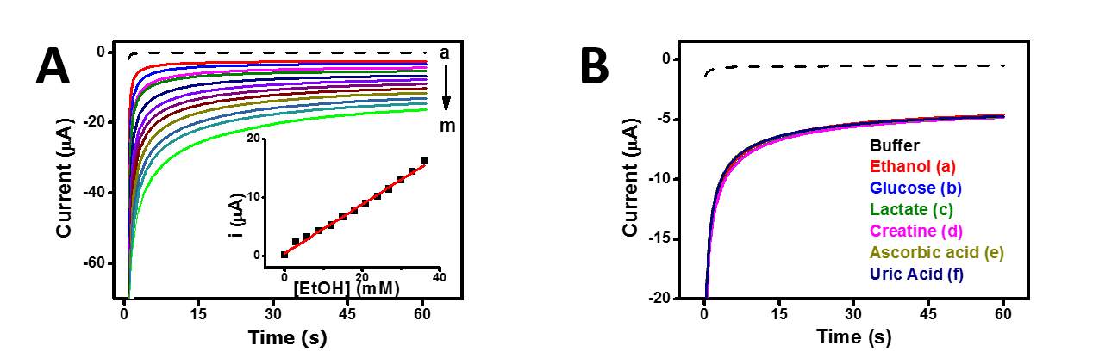

**Figure 2.** (A) Chronoamperometric response of the tattoo-based alcohol sensor to increasing ethanol concentrations from 0 mM(a) to 36 mM(m) in buffer in 3 mM increments (B) Interference study in the presence of 10 mM ethanol (plot “a”), followed by subsequent additions of 0.2mM glucose(plot “b”), 10mM lactate (plot “c”), 84 μM creatine (plot”d”), 10 μM ascorbic acid (plot “e”), and 60 μM uric acid (plot “e”. Potential step to −0.2 V (vs Ag/AgCl). Medium, phosphate-buffer (pH 7).

***4.3. On-body alcohol monitoring on human subject***

After evaluation of the tattoo sensor performance in vitro, we tested on-body operation of alcohol tattoo sensor with human subjects. First, detection ability of the alcohol tattoo sensor is confirmed under consumption of alcoholic beverage. Figure 3A shows onbody results obtained by three different subjects with alcohol ingestion following the protocol described in experimental approach section. Amperometric responses were compared between before and after drinking alcohols, showing distinct current signal increment caused by spike of alcohol level in sweat along with its level in blood over all three subjects. As described, second amperometric response (after drinking) was measured after 20 min of alcohol consumption and BAC is measured at the same time with amperometric measurement. Even though three subjects were asked to take same amount of alcohols, the BAC values and current responses are different among subjects after the given time of period, implying each subject has different digestion rate of alcohol. None of the subjects reported perceptible discomfort during these onbody measurements. Three control experiments (no drinking, no enzyme modification, no iontophoresis) were performed to verify false alarm from onbody results obtained under alcohol consumption. None of control experiments showed current difference. In detail, the data from control experiment without enzyme modification clearly demonstrates high specificity of alcohol tattoo sensor toward alcohol in sweat. And it can be clearly noted from control experiment without drinking that the current response shown in Figure3A is caused by alcohol consumption and performing iontophoresis process doesn’t affect any amperometric current signal, even though remained amount of pilocarpine nitrate has changed due to delivery of pilocarpine. The last control experiments in the absence of iontophoresis also showed no current differences although BAC was spiked up to 0.0018% from alcohol ingestion. It implies that current response shown in Figure 3A are from alcohol in generated sweat by iontophoresis not from other source/environment.

Next, additional onbody experiments are performed to evaluate correlation between BAC (obtained from breathalyzer) and current response from our alcohol tattoo sensor with serial ingestion of alcohol drinks. As illustrated in Figure 4A, first current response was obtained corresponds to BAC 0.00% (before drinking) and followed by two sets of drinking and measurement procedures using same electrode. After 1st alcohol consumption, BAC turned out 0.025% showing distinct current response, and BAC was increased to 0.062% after 2nd drinking with further increased amperometric current signal. The resulting plot between BAC and current value is shown in Figure 4B. The current response displays great linearity toward BAC level (slope, 102 uA/BAC %; correlation coefficient, R2 = 0.999). This implies that the current response are responsible for ethanol level in sweat, which is well-correlated with BAC.

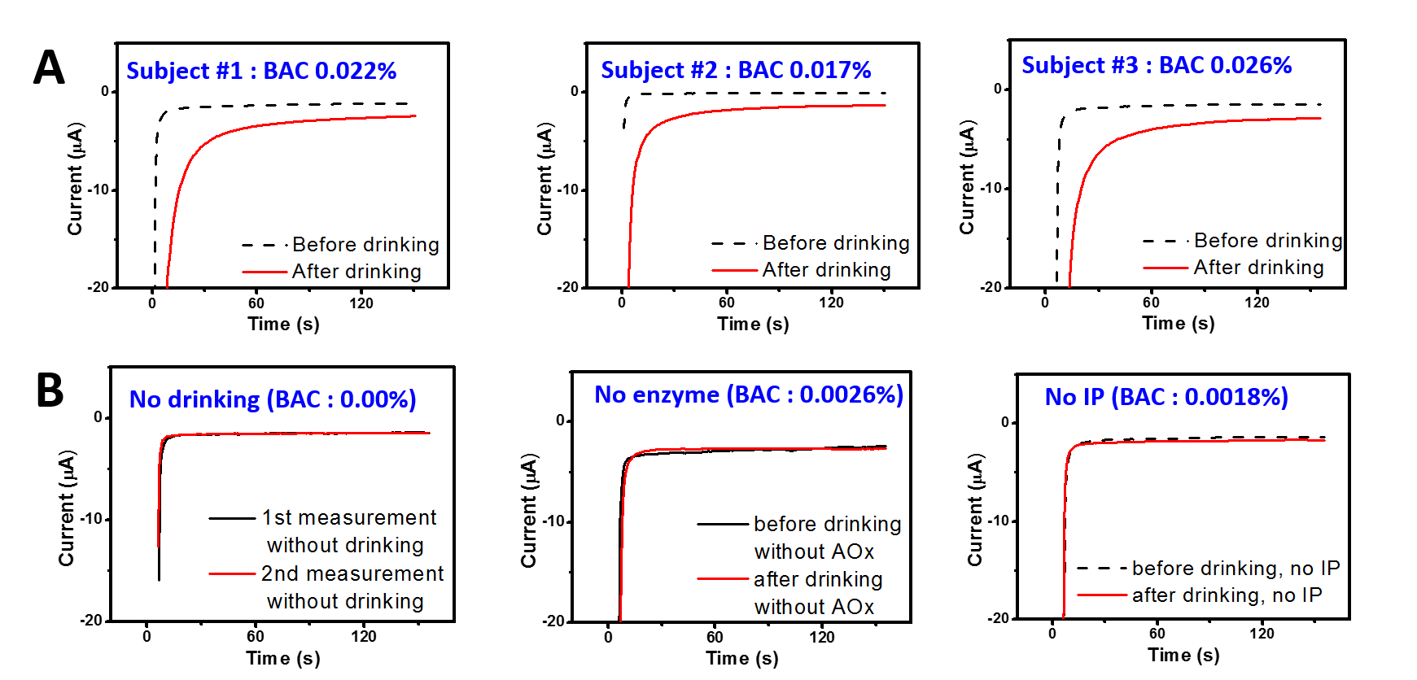

**Figure 3.** Amperograms obtained for noninvasive alcohol detection obtained from human subjects wearing the alcohol tattoo sensor, (A) experiments with consumption of 12 oz of beer measured before and after drinking alcohol beverage (B) control experiments without drinking (left), without enzyme immobilization (middle), and without iontophoresis(IP) (right). Blood alcohol level is obtained by breathalyzer. Potential step to −0.2 V (vs Ag/AgCl).

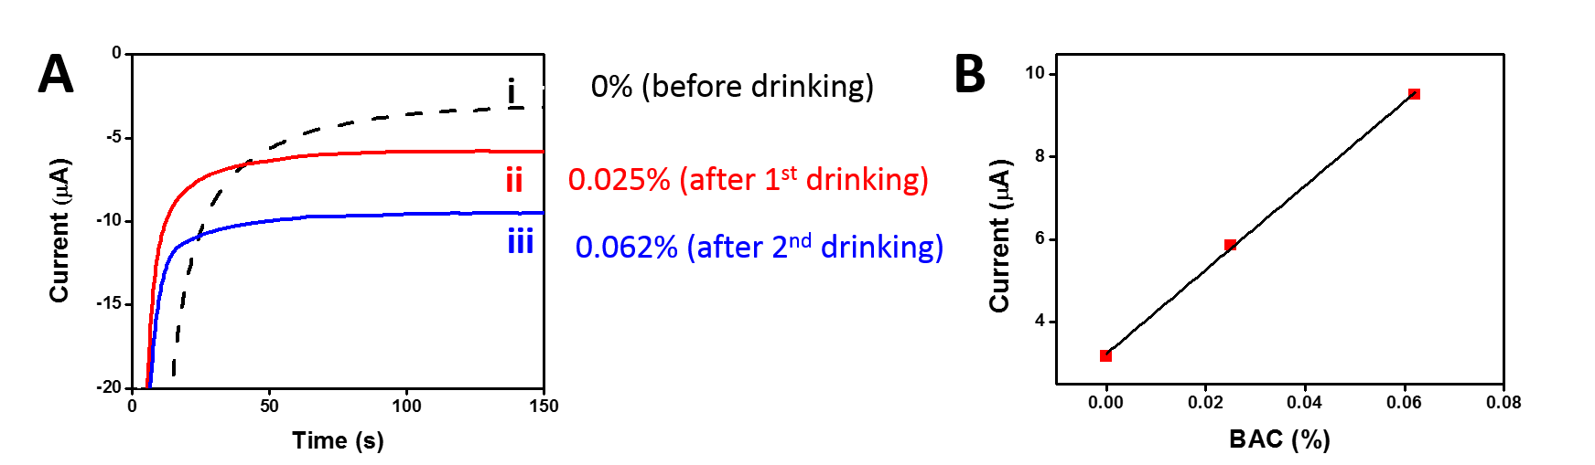**Figure 4.** (A) Amperograms obtained for noninvasive alcohol detection obtained from human subjects wearing the alcohol tattoo sensor showing correlation between BAC level and current response from tattoo biosensor measured before (i, BAC : 0%) and after drinking 5 oz of wine (ii, BAC : 0.0025%) ) and 10 oz of wine (iii, BAC : 0.0062%) ). Blood alcohol level is obtained by breathalyzer. Potential step to −0.2 V (vs Ag/AgCl). (B) Resulting linear plot between current response and BAC level.

***4.4. Characterization of integrated flexible wireless tattoo-based alcohol sensor***

The practical use of wearable biosensors for real-time monitoring has been hindered by the lack of the development of a body-compliant wireless circuit board. For realization of wearable alcohol sensor, a flexible wireless circuitry was custom-made and integrated with our developed sensor (shown in Figure 1A). And its performance was evaluated following the same protocol as previous onbody experiments. A BLE-enabled printed circuit board employed iontophoresis by applying 0.6 mA current and measured amperomtery at -0.2 V for 150 seonds. The current response was sampled with a frequency of 1 Hz) and transmitted in real time via bluetooth 4.0 to a laptop/mobile device and plotted on screen with graphical interface developed using Phython.  The resulting plot was shown figure 5 obtained by wireless transmission showing clear current difference after consumption of alcohol beverage and the data corresponds to previous onbody results obtained from lab-scale potentiostat. This test provides the evidence for the practicality of the wireless alcohol tattoo sensor towards monitoring BAC.

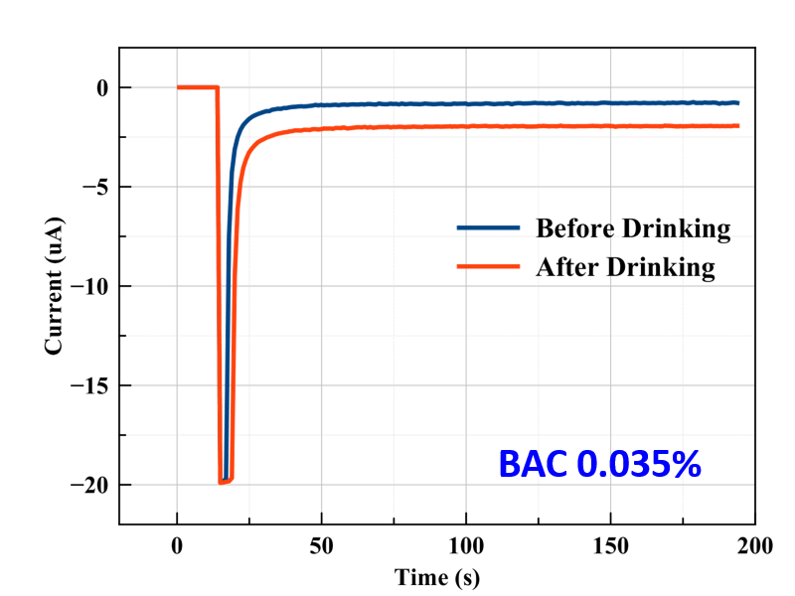

**Figure 5.** Integration of flexible wireless circuit board with alcohol tattoo sensor. Amperograms obtained by the wireless integrated alcohol tattoo sensor from human subjects measured before and after taking alcohol beverage. BAC was confirmed as 0.035% by breathalyzer. Potential step to −0.2 V (vs Ag/AgCl).

**Conclusions**

In this solution, we introduce ‘AlcoTatt’, skin-worn tattoo-based wearable electrochemical biosensor for noninvasive alcohol monitoring. Based on well-established correlation between ethanol concentration in sweat and blood, AlcoTatt measures alcohol concentration in sweat to estimate BAC, allowing non-invasive monitoring of BAC in real-time. The in vitro characterization of the tattoo sensors revealed their ability to detect alcohol in sweat covering physiological range in the presence of common interfering chemical species. On-body evaluation of the tattoo-based iontophoretic-biosensing platform further demonstrated the ability to detect the rise in the ethanol level after consumption of alcohol beverage in a noninvasive fashion. The new tattoo alcohol sensor has been coupled with flexible printed circuit board for wireless data collection in real-time. The solution ‘AlcoTatt’ allows non-invasive, passive and simple monitoring of BAC, which can be useful for checking driver’s ethanol ingestion or individuals who need to keep abstinence of alcohol.

**References**

Swift, Robert M., et al. "Studies on a wearable, electronic, transdermal alcohol sensor." *Alcoholism: Clinical and Experimental Research* 16.4 (1992): 721-725.

Gamella, M., et al. "A novel non-invasive electrochemical biosensing device for in situ determination of the alcohol content in blood by monitoring ethanol in sweat." *Analytica chimica acta* 806 (2014): 1-7.

Buono, Michael J. "Sweat Ethanol Concentrations are Highly Correlated with Co‐Existing Blood Values in Humans." *Experimental physiology* 84.2 (1999): 401-404.

Bandodkar, Amay J., et al. "Tattoo-based potentiometric ion-selective sensors for epidermal pH monitoring." *Analyst* 138.1 (2013): 123-128.

Bandodkar, Amay J., et al. "Epidermal tattoo potentiometric sodium sensors with wireless signal transduction for continuous non-invasive sweat monitoring." *Biosensors and bioelectronics* 54 (2014): 603-609.

Jia, Wenzhao, et al. "Electrochemical tattoo biosensors for real-time noninvasive lactate monitoring in human perspiration." *Analytical chemistry*85.14 (2013): 6553-6560.

Jia, Wenzhao, et al. "Epidermal biofuel cells: energy harvesting from human perspiration." *Angewandte Chemie International Edition* 52.28 (2013): 7233-7236.

Guinovart, Tomàs, et al. "A potentiometric tattoo sensor for monitoring ammonium in sweat." *Analyst* 138.22 (2013): 7031-7038.

Kim, Jayoung, et al. "Wearable temporary tattoo sensor for real-time trace metal monitoring in human sweat." *Electrochemistry Communications* 51 (2015): 41-45.

Bandodkar, Amay J., et al. "Tattoo-based noninvasive glucose monitoring: A proof-of-concept study." *Analytical chemistry* 87.1 (2014): 394-398.