

**TreeHouse**

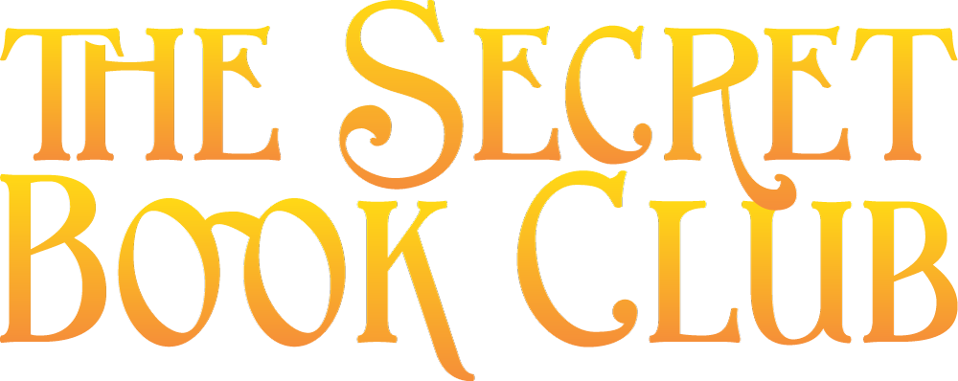

**COMPANY FACT SHEET**

**The Secret Book Club** is a literacy project of Treehouse Books LLC (est. 1978) in Ashland, Oregon. We produce web and mobile applications for children and families that encourage reading, writing and creating through the art of emergent storytelling.

**Purpose** We believe that the stories we tell shape our lives. And that even more powerfully the stories we tell together as a community shape our world.  The Secret Book Club is using storytelling game play to help children and families read and craft compelling stories that can turn our classrooms, businesses and communities into ‘storygames’ that create a better future for us all.

**Product/Services** It is universally acknowledged that most stories follow the classic storyline of the Hero’s Journey, a story arc documented by mythologist Joseph Campbell. The Secret Book Club is a web and mobile based language arts ‘game’ of **1st Person** **storytelling** based on the Hero’s Journey.

Players are guided through monthly story genres that include **Science fiction, Mystery, Fantasy, Poetry** and more to write the stories of their lives and towns.

Each story genre includes an imbedded social skill as part of the gameplay such as

* **Goal setting**
* **Positive psychology**
* **Fitness**
* **Mindfulness practices**
* **Financial literacy** and more.

**The Secret Book Club offerings include:**

* **Our StoryBoard & GameKits** combine the 10 steps of the Hero’s Journey with game mechanics and creative DIY projects.
* **Our Story Games** link life skill games with storywriting.
* **Our Story Events** turns fitness, mindfulness, goal setting and creative projects into collaborative competition (similar to team sports)

Our applications are membership based, giving children their own 'portal' into the Secret World of imagination where they write their story, share with other storytellers, collect objects from the story and post their artwork and creative projects

**Customer problem:** Children are disappearing into books and videogames and not engaging with their real life. We call it the 'Pied Piper' syndrome of entertainment — where imagination becomes an ESCAPE from reality; especially pertinent when children and families feel overwhelmed in a rapidly changing world of too much information, too much challenge — even too much opportunity. The most sensitive and creative children can end up living more in their imagination rather than in their lives.

**Our Solution:** Transform Imagination into ENGAGEMENT.

The Secret Book Club transforms children from passive consumers of stories written by others into active creators of their own stories. Our StoryGames and DIY projects bridge the gap between the **invisible world of imagination** and the **visible world of our daily lives.**

Secret Book Club intends to do for storytelling and writing what the video game Minecraft has done for videogame play.  Our experience has shown that, as with Minecraft, with the right tools and scaffolding, children can create and share their own stories with themselves as the active agents.

**Over the course of a 12 month membership our Secret Book Club families will:**

Learn the **creative story process of the Hero's Journey**, the journey of taking an idea and creating it in the real world

* Identify the story they want to tell: their **top dreams, priorities and goals**
* Understand their character **motivations** and the personality arc that shapes their actions
* Learn **teamwork** and collaboration
* Focus and **expand their physical and mental energies**
* **Develop creative habits** that will unleash their creativity
* **Connect with a community** in pursuit of similar goals and dreams

**Market:** Children ages 8 – 14 and their families

In 2013, there were nearly 74 million children younger than 18 in the United States and $15 billion was spent on videogames. (170 million American consumers play video games, and 60% of them spend money to do so according to  Forbes magazine and the market research company NPD Group 2013)

Today’s book publishing market for children ages 8-14 is dominated by fantasy-based hero journeys (including more than half of current books on the New York Times Best Seller’s List and the Harry Potter series, the best selling book series in history.)

Minecraft. a videogame about building anything the user can imagine, is the top selling video game of all time ( 42 million units sold as for 2014 and 241,920,000 users log-in each month according to statistics shared at Minecon and reported by GameFront)

Children and families residing in Ashland, Oregon and families who visit the Oregon Shakespeare Festival comprise our initial test market. Upon completion our market will expand to middle school classrooms across the country and the Home School Market

**Sales/Marketing Strategy:**

Go to market strategies include:

* ***Pilot Program in Southern Oregon School District*** work with Ashland High School (also Siskiyou School and The Big Idea project pending agreement) to test our software and game mechanics
* ***Pay-it forward campaign through Kickstarter, Facebook & other social media outlets*** creatively engage schools and communities in a 2 for 1 sponsorship program to fund scholarships for at risk youths.

The Secret Book Club merges Facebook, YouTube and other social media with real world community landmark locations as story settings that include independent book stores, community organizations and educational support organizations.

Our long term plans include leveraging our software platform to license the Secret Book Club platform to schools, libraries, publishers and authors, giving them the ability to create and curate their own stories.

**Business Model**

**The Secret Book Club** is a subscription site. Our membership includes:

**1)** Online Storygames and retail Storygame kits.

**2)** Per story, or per location agreements will be available for schools, organizations, communities and authors.

**3)** Merchandise to support the creative process provide the third leg of our revenue model with curated product lines that tie in with the various story genres including science fiction, mystery, action adventure, historical fiction and more.

Supplemental financial streams are event and StoryGame sponsorship.

**Revenue Model**

**Cat 1)**  Secret Book Club Membership (quarterly/annual)

**Cat 2)**  Secret Book Club Game Kit Subscription (monthly/annual)

**Cat 3)**  Secret Book Club Platform (Schools, communities, and organizations)

MONTHLY $10 online membership/$39 online membership plus DIY Kits*

ANNUAL $100 online membership/$399 online membership plus DIY Kits*

**OTHER POTENTIAL STREAMS OF INCOME**

**Sponsorship**= community ‘games’ features sponsorship and underwriting opportunities for local businesses, groups and organizations

**Competitors:**

Our competitors are:

1. Creative children’s social networks like **DIY** and **Storybird**
2. Young Maker Kit providers like **Kiwi Crates, Owl Crates** and **Geek Fuel**
3. ***826 National’s* Pirate, Superhero, Time Traveler supply stores**

Our advantage: We transform **Passive Consumers into Proactive Creators focusing their creativity into their real lives** with our

1. all inclusive reading, writing and creativity tools
2. life relevant story play
3. local social networking and
4. real life community-building events
5. Integration with schools and community

**Current Stage** We have been testing The Secret Book Club with children in Ashland, Oregon, playing monthly storygames in their community. Based on learnings from working with this group, we are developing a minimally viable product (MVP) that will allow children to sign up and begin writing their shared stories. This ﬁrst product will not only allow us to live test our collaborative storytelling functionality, but will allow The Secret Book Club to generate revenue from membership fees. We will test market the application in Ashland using social media and outreach to local community through alliances with Ashland School Foundation and outreach beyond the valley through Whyville, the first virtual learning environment for children (7.5 million subscribers) founded by partner Dr. Jim Bower.

**Investment** Initial development cost of our web based application is $15,000 and we expect costs for the ﬁrst year of operation to be $30,000. We anticipate being able to launch our ﬁrst revenue-generating product by the end of Winter 2016. Our target is to have two hundred beta testers through our beta phase in Ashland, which will run for six months before expanding our marketing efforts to a regional and national audience. Revenue potential in the ﬁrst three years is $500,000 annual in memberships, $250,000 in merchandise sales and $1.5 million dollars in platform licenses. Because of the nature of our software-as-a-service approach, our costs do not scale linearly with growth, allowing us to grow proﬁtably, quickly with a small team focused primarily on customer service with minimal ongoing development costs. The Secret Book Club will be looking for investment of $500,000-$1,000,000, post beta phase, to help the company scale and meet the expected growth and demand.

**TEAM**

**Jane Almquist & Cynthia Salbato** (STORY & COMMUNITY GAME PRODUCERS) As curators of [**TreeHouse Books**](https://www.facebook.com/Tree-House-Ashland-Oregon-114452391921328/)**,** a 36 year old childrens bookstore, we’ve produced 14 storygames, 9 DIY kits and countless community events between us.

[**Robert Head**](https://www.linkedin.com/profile/view?id=7197997&locale=en_US&trk=tab_pro) (TECHNOLOGY) Rob has worked with some of the biggest companies in the world including Amazon and Pivotal Labs, as well as smaller startups. His technical and game development skills will make our Secret Book extraordinary!

[**Shannon Bodie**](https://www.linkedin.com/in/bookwisedesign) (ART DIRECTION) The founder of BookWise Design, Shannon has specialized in books and publishing for over 20 years.

[**Dr. James Bower**](https://en.wikipedia.org/wiki/James_M._Bower) (ON-LINE LEARNING & ENGAGEMENT) is the founder of [Whyville.net](http://whyville.net/) the FIRST virtual learning world for kids. Under Jim's guidance Whyville continues to be one of the leading sites for innovation in game-based learning.

**Alan Parowski** (CURRICULUM) Founding curriculum developer for [Tree Frog Treks](http://www.treefrogtreks.com/) and owner of Liftoff Events, Alan is celebrated for his spectacular real world events. He recently turned his creativity to developing cutting edge curriculum for high schools.

[**Dr. Matthew Beers**](https://www.linkedin.com/pub/matthew-beers/4/592/16a) (TECHNOLOGY SUPPORT) Matt has been leading development teams around the world but his real passion is for creating tracking tools and features that improve our lives. His expertise will be especially appreciated by teachers when they use the Teacher Desktop that makes it easy for them to assist their students.

**Our Milestones**

**100s of weekly club meetings** since 2012

**14 Secret Book Club StoryGames produced**

**7 community event** games since 2012

**14 children** have brought **businesses** to the marketplace in 2 rounds of our entrepreneurial storygame.

**4** Secret Book Club **Game Kits** prototyped

Whyville comes on as Project partner with 7.5 million subscribers in Fall 2015

$24,000 raised at our combined Monster Dash & Monster Ball StoryGame event for Ashland Schools Foundation

3 reading competitions amongst the Ashland School District, awarding copies of the featured book for the StoryGames of Care of Magical Creatures, Fairy Tale Theater and Wizard Academy.

**Produced 14 Secret Book Club Storygames including**:

Apr ‘14 Time Travel Portal at Ashland Springs Hotel   
May ‘14 Mysterio's Monkeymind Museum at Scienceworks  
June ‘14 Fairy Tale Theater at Oregon Shakespeare Festival   
Sept ‘14 Superhero Academy at Ashland YMCA

Oct ‘14 Monsters Ball at Historic Ashland Armory

Nov ‘14 Mythic Muse Marketplace at Ashland Art Center

Dec ‘14 No Place Like Gnome in downtown Ashland

Feb ‘15 Power Pet Prom in downtown Ashland

May ‘15 Wizard Academy at TreeHouse

Jul ‘15 Superhero Bootcamp

Aug ’15 Fairy Tale Theater

Sep ’15 Muse Marketplace (See Financials Below)

Oct ’15 Monster Ball

Nov ‘15 Treasure Bazaar

**Produced Prototypes of our Secret Book Club Kits**

Secret Book Club planner and journal series   
DIY kits including: Wizard Academy, Muse Marketplace, Gnome in the Home

**OUR TIMELINE**

**2015**

* **November** Kickstarter Campaign
* **December**: Launch Gnome for the Holidays Storygame with commissioned Gnome Doors in downtown Ashland, Gnome in the Home Kit

**2016**

* **January** : Time Travel Tower and Software alpha release (pending successful Kickstarter) Begin pilot program with Ashland High School Catalysts Students  
  **February**: Care of Creatures with Kits and launch of guided Gnome Door tour of Ashland
* **March:** Wizard Academy and Kit with launch of school application.

**SEMPTEMBER FINANCIALS**

