**Financial Proposal**

**Business Plan**

**Brobe International LLC, dba Brobe**

***submitted by:***

**Allison Schickel**

**5116 Allamanda Dr.**

**Austin, TX 78739**

FINANCIAL PROPOSAL

**EXECUTIVE SUMMARY**

**Brobe International, LLC** (hereinafter the “Brobe”), domiciled in Austin TX, was launched by founder Allison Schickel in 2011. The Brobe manufactures and markets niche women's bras, robes, and ancillary products for 1) female cancer patients and 2) nursing moms. These products are classified as lounging apparel under ***NAICS Code 315240***.

**The Brobe** requires an immediate $350,000 in financing to aid and foster scaling the company’s revenue growth in 2016 and to position the company for acquiring venture equity capital in 2016 and 2018. The capital will be used to finance inventory, marketing and distribution, and staffing expenditures.

To date since launch, Ms. Schickel has bootstrapped the company’s growth coupled with a modest $40,000 private loan and a $20,000 business line of credit. Accordingly, revenues have been modest with Ms. Schickel wearing all hats from CEO, to CFO, to Production Mgr, to Marketing, to Sales and Order Processing, to Shipping, and Customer Relations. Demand however is far outpacing available inventory. Cash Turnover is low with extensive lag time required for order placement, manufacturing, and shipping and distribution with overseas manufacturing in China. Consequently, Ms. Schickel has been engaged with successful C-Level executives prominent in the women’s apparel industry to craft and execute a business model that results in equity capital returns of between a minimal of 10-20X within 5 – 7 years.

Extensive primary, secondary, and third-party research indicates that, given the relative recession proof market for the Recovery Brobe (female cancer patients) and the growing market for the Mommy Brobe (nursing moms), developing the Brobe brand through strong channels will be key to market penetration and expected market disturbance. At this time there is no direct competition for either Brobe products. Developing a high quality product with a strong brand and a high-touch customer experience will be key to growing and sustaining market shares. Indirect competition is limited at best with improvised “duck tape” measures.

Ms. Schickel has provided sweat equity with no compensation taken since the company launched in 2011. Her ability and willingness to invest in the launching of this business is further strengthened by the lack of personal financial dependence on business profits during the early years of the business.

**Table of Contents**

**I. INTRODUCTION**

**II. PRODUCTS**

**III. MANUFACTURING**

**IV. MARKET ANALYSIS**

A.**Industry Trends**

**1.Recovery brobe**

**2.Mommy Brobe**

* 1. **Description of Total Market**
  2. **Target Market**

D**. Documentation of Demand**

* + - 1. **Published Statistics**
      2. **PO**

E **Analysis of Competitors**

* 1. **Product Differentiation**

1. **SALES STRATEGY**
   1. **Pricing Policy**
   2. **Distribution**
   3. **Promotional Effort**

**1.Personal Selling**

**2.Sales Promotions**

D. **Customer Convenience**

1. **MANAGEMENT**
   1. **Personal history of founder**
   2. **Duties & Responsibilities**
   3. **Compensation**
   4. **Available Resources**
   5. **Advisors**
2. **FINANCIAL ANALYS**

**I. Introduction**

Brobe International LLC (Brobe) is located in Austin, TX. Brobe is an L.L.C formed in July of 2011.It is operated by its founder, Allison Schickel, who has the entrepreneurial spirit and drive combined with a business savvy sense to bring this product to market. The Brobe is categorized as women's lounging apparel.It offers easy, functional support for breasts through a sports bra that also connects to a robe.

Allison came up with the basic concept of the Brobe, a luxurious robe with a built in bra attached to it, and then decided to take it upon herself and make one for her own use. After realizing this product worked she didn’t expand on her idea for 10 years After a friend underwent a double mastectomy and three reconstructive surgeries after recovering from breast cancer. After realizing the lack of functional yet feminine products for women with breast cancer, Allison decided to create something that would give women the dignity they deserve. Women fighting breast cancer should feel empowered to live beautifully during an otherwise traumatic time. And that’s how the Recovery Brobe was born.

Shortly afterward, a new group of women raised their voices. Nursing mothers expressed their desire for a functional and comfortable robe to wear while nursing their newborns in the hospital and at home. As a result, we launched the Mommy Brobe in 2013. Designed with a detachable bra and luxurious fabric, this robe captures the essence of our mission: ***Empowering women by giving them the strength to live beautifully.***

Since launching The Brobe has won numerous awards including winner of the national contest through the Dallas Market Center’s 2012 “Next Big Thing” contest in Dallas, TexasWe also won the Austin Chronicles “Best Of” for Recovery in 2013, a finalist for the ABJ Profiles in Power for 2012, 2014, and 2015 as well as a finalist for 2 RISE awards in 2013 in Austin, Texas.

**II.Products**

There are 300,000 new breast cancer diagnoses each year. That equates to 1 in 8 women. In years past women have had to tape the post op drains to their skin, tie a shoestring around their waist to hang the drains on, or pin it under a big bulky front closure shirt, a truly humiliating experience in the worst of times.

**Recovery Brobe**- This product is designed for women who have undergone a mastectomy OR have had breast reconstructive surgery. It is made out of 93% Nylon 7% Spandex. The robe is lightweight with ¾ sleeves and reaches just above the knee in length. What makes this Brobe so unique is that the bra that is made out of 90% cotton, 5% lycra and 5% jersey. It has pockets that are built in the bra that could hold a prosthetic breast or ice packs. The robe has pockets in the inside of the robe to hold the fluid for drainage but can also support the weight of the fluid from the drains. Brobe International, L.L.C has a patent pending status for the Recovery Brobe.There have been many garments that have been made for women who are breastfeeding as well as women who have received a mastectomy and reconstructive surgery but none of them are in the form of a robe and or nightwear. This is the first. 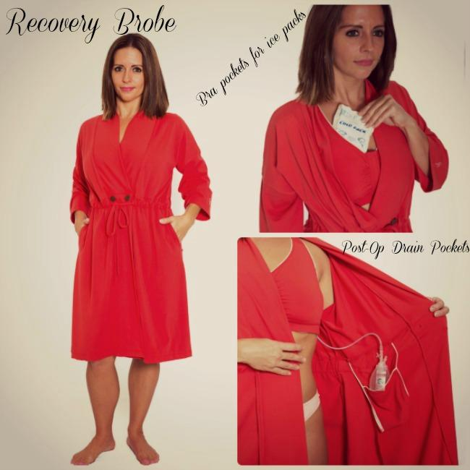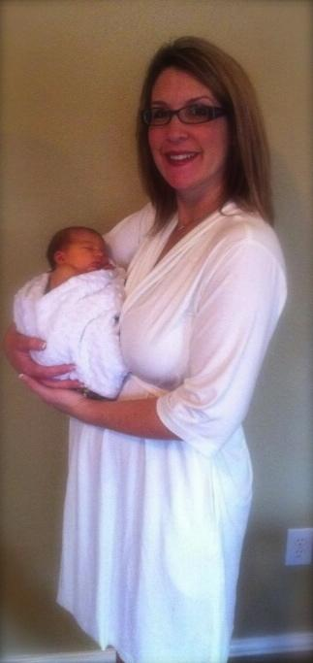

**Mommy Brobe**- This is designed for the new mom while at the hospital or after bringing the baby home. It is made out of 93% Nylon 7% Spandex. The robe is lightweight with ¾ sleeves and reaches just above the knee in length. The bra has an easy access flap on the bra that makes it easy and comfortable while nursing your baby. The Mommy Brobe was available for online sales in July 2013.

The size chart is not based on a certain cup size but sized S, M, L, XL, XXL based on the width around the chest.

**III.MANUFACTURING**

To create each type of Brobe, we have used manufacturers in the USA and China. In 2011 Allison worked personally with a local seamstress in Austin, Texas to design the pattern and test the functionality of each type of Brobe. She hired a broker out of NY to help fulfill her first order. The manufacturer who produced the first round of Recovery Brobes was based out of Shanghai. To ensure and guarantee the best quality possible, Allison checks in every garment that is shipped from China to New York or LA before being shipped to the distribution center in Austin, Texas. In 2012 Allison tested a US manufacturer based out of Dallas making the first production of Mommy Brobes.

The main objective is to keep costs low as well as overhead. We have secured a manufacturer out of China that has brought our cost below 50% of what our original product costs. The new Brobes are being brokered through Gilbert Yang from Houston, TX . The Chinese manufacturer weaves, dyes and sews the garments. Mr. Yangs main responsibility is Quality Control of the fabric, hang tags, labels and shipping as needed for the Brobe. Currently production time is 45-60 days out and shipping takes another 28 days by water, then another week by truck. We eventually would like to open a small manufacturing and distribution center based in Austin, Texas. This would provide jobs to the economy as well as cut costs in shipping from overseas. Eventually everything would be under one roof for a faster turn-around time for our customers.We also believe in continuous development of our product. We have already been asked about more colors, styles, and fabrics for both Brobes.Eventually we will start expanding a global apparel line of Allison Schickel and move into other garments with built in support capabilities. These items include night gowns, pajamas, lingerie, tank tops and active apparel and swimwear.

**IV.MARKET ANALYSIS**

Brobe currently focuses on two (2) markets. The recovery market for breast cancer patients and the Maternity Market for nursing mothers. Below are tables indicating how many women are diagnosed every year in the US with breast cancer (invasive and non-invasive), the number of reconstruction surgeries performed over the last 5 years. More than 250,000 are diagnosed every year in the United states with breast cancer. About 42% of women receive immediate reconstruction where others wait on reconstruction for different reasons. Overall, 93% of women end up getting reconstruction surgery.

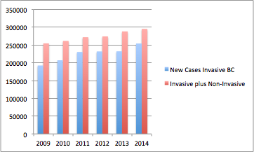

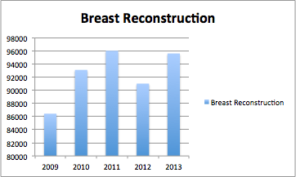

A. Industry Trends

1.Recovery Brobe- According to BreastCancer.org, 12% of women will develop breast cancer every year. That equates to 1 in 8 women every year. According to the American Society of Plastic Surgeons report tumor removal and breast reconstructive surgery was in the top 5 procedure trends. Surgery, either a mastectomy or a lumpectomy is usually the first line of attack against breast cancer. WorldwideBreastCancer.com states “The most prevalent cancer in the world today is breast cancer.” In 2013, 1.5 million people worldwide were told they have breast cancer.

1.2 Mommy Brobe- Nationwide in 2010, under the direction of the Centers for Disease Control and Prevention, the National Immunization Survey (NIS) of the infants who were now 19-35 months of age:

* 75% were breastfed at birth
* 43% were breastfed at 6 months
* 22% were breastfed at 12 months
* 33% were exclusively breastfed at 3 months
* 13% were exclusively breastfed at 6 months

According to the Global Data Bank on Breastfeeding, in 2012 the WHO (World Health Organization) covered 94 countries and 65% of the world’s infant population (less than 12 months). Based on the latest data, it is estimated that 35% of these infants are exclusively breastfed between 0-4 months of age. Data for the Americas show that ever-breastfed rates are high in some vs other countries. In some countries where the advantages of breastfeeding have been widely publicized and where the Baby-friendly Hospital Initiative has begun in earnest, breastfeeding rates are actually increasing, e.g. Australia, Canada, China, and USA.

2. In 2011 the Brobe entered the market by introducing the Brobe, a new concept to the public. The Susan G. Komen Foundation exhibited the Recovery Brobe prototype to a group of women who had undergone single mastectomies. As one woman tried the Recovery Brobe on, tears welled up in her eyes. At that moment, Allison knew she had to launch the Brobe into production and distribution. After 3 years of significant sales, the Brobe is now in the growth stage of business.

B.Description of Total Market

In 2013 there were 5 million breast augmentations, reductions, tummy tucks, and liposuction in the US. 250K women were diagnosed with breast cancer and 4million babies were born.

C.Target Market

Theoretically, if everyone who was in these markets bought a brobe, it would be a 1 Billion in revenue.We believe that the Brobe can penetrate total 5% of the undergarment/loungewear market with current and future products.

|  |  |  |
| --- | --- | --- |
| **Plastic Surgery** | **Breast Cancer** | **Maternity** |
| **5 Million** | **250 K** | **4 Million** |

Breast cancer, plastic surgery, and pregnancies are at the highest they have ever been. The Brobe is not a trending product. It is a recession proof product that will always have a place in the market. Brobe will be the major supplier for women who are nursing, have breast cancer or just need a little extra support while at home.

D.Documentation of Demand

1.Published Statistics

<http://www.breastcancer.org/symptoms/understand_bc/statistics>

<http://www.cancer.org/cancer/breastcancer/detailedguide/breast-cancer-key-statistics>

<http://ww5.komen.org/BreastCancer/MastectomyTheSurgicalProcedure.html>

<http://www.who.int/nutrition/databases/infantfeeding/en/>

<http://www.ibisworld.com/industry/maternity-wear-stores.html>

<http://www.startribune.com/business/160080995.html>

E. Analysis of Competitors

Brobe is in a very unique position of having no direct competitors that offer a similar product. Within the garment industry you will find many different types of robes as well as bras for all different occasions and body types. However, none of them can rival the functionality of having a bra built into the robe with nursing access for the Mommy Brobe as well as built in drain pockets for the Recovery Brobe. The Brobe offers an easy to use, functional, stylish, well designed yet comfortable garment. While there are no direct competitors at this time, as with any new and novel ideas, direct competition is soon to follow. We are optimistic that Brobe will retain its first to the market advantage much like SPANX and Pillow Pets. Following these two concepts, an authentic product that is opulent as well as dependable backed by a company that is based on providing superior customer service and high quality will be the keys to success.

1. Product Differentiation

The Brobe will fill three different markets for the next two years. Those markets are breast cancer patients(also pancreatic cancer, thyroid, open heart surgery), plastic surgery patients, and nursing mothers. Among the Recovery and maternity/nursing industry there have been people/companies that produced products filling some of the needs of the customer or patient. Brobe has a patent pending status for a Utility patent and two design patent pending Brobe is also trademarked.Brobe’s advantage over other lounge wear products is the functional design in these special garment. Specifically the Recovery Brobe which includes a built-in bra that fastens with Velcro and contains pockets specifically designed for a prosthetic breast and/or ice packs. This is the first garment on the market that also includes hidden pockets to hold the post-operative drains. Our price of $94 is very competitive with other regular robes. Our customer service and attention to detail has already stood out with our customers and delivery time is very fast.

**V. Sales Strategy**

1. PRICING POLICY

The Brobe is a luxurious lounge wear garment designed for many women throughout different stages of their life. Most robes range in price from $75-$200. During the “Proof of Concept” years various pricing models were tested/tried to determine our customers spending levels.

In 2012 the Recovery Brobe sold for $139. We decreased the price in 2013 to $129 and$ 99 for the Mommy. In 2014 we lowered our sales even more to $88 for the Recovery and $68 for the Mommy. In 2015 we will sell both Recovery for $94 and Mommy at a $89 price point.

B.DISTRIBUTION

Brobe is sold via multiple distribution channels. : 90% of sales come from the E-Commerce site that find the Brobe organically via Google searches. The Brobe also sells on other online retail sites such as Amazon, CureDiva, 4Wellness, Etsy, Milk and Baby, Zulily.com and Steals.com.

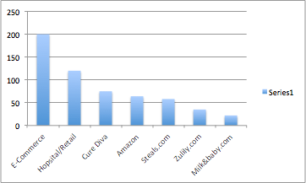

The customers are not specific to any age. Some customers are looking for a gift, others are newly diagnosed or new mothers looking for something comfortable and functional.

In 2015 we have start engaging with 2 distribution companies. Amona for the Recovery Brobe and Lori’s Gift’s for the Mommy brobe.

1. Other similar products are sold through a distributor or online
2. The next shipment of Brobes will be available in October 2015

C. PROMOTIONAL EFFORT ADVERTISING/RADIO, TV/TRADE SHOWS

Brobe sales strategy is to work with a major PR company to strategize a national marketing and social campaign. We would like to be on specific news/TV programs that focus on Breast Cancer Awareness month such as the Doctors Show, Ellen, Good Morning America, and CNN.

We also would like to be featured on QVC for 2016 Mothers Day special and October for Breast Cancer Awareness month. We would like to be in at least 2 big box retailers by mid 2015. These retailers include Nordstrom, Neiman Marcus, Buy Buy Baby or Pea in the Pod. We also plan on gaining more exposure with the major cancer hospitals like the Mayo Clinic. Currently we are already selling into MD Anderson and Breast Cancer Centers of America. We also will be in at least 4 trade shows next year including ABCKids, TX Society of Plastic Surgeons, Atlanta trade show and New York trade show.

1. PERSONAL SELLING

Brobes prides itself on not only providing a quality product but the best customer service possible. Here is just a couple reviews on the customer service.

“Dear Allison,Thank you. thank you. thank you! Just got the Recovery Brobe, thanks for your concern and prompt attention.There are a lot of special people out there and you are one of them.” -Susan, Santa Fe, NM

“The super customer service  went above and beyond to get my recovery garment to me on time for my mom's hospital's discharge. My mom LOVES it!! She said she is never taking it off. So thanks so much!!!”- Carol Dallas, Texas

In 2015 we hire a marketing group to work part time on social media and online advertising. Our goal is to land 100 new accounts in 2016 with each account conservatively purchasing 50 Brobes. We will also hire 3 outside sales rep that has a background in the industry. This person will have the experience and knowledge to take the Brobe in the big big stores as well as QVC/HSN.

3.SALES PROMOTIONS

Brobe sells product at a discounted rate to online retailers that offer “deals” to their followers. Currently we have one PO from an online retailer for 300 Mommy Brobes. During the months of May, Aug,and October we will offer some type of coupon or free shipping. In January 2015 we did started working with one fo the nations top baby bloggers,BabyGuyNYC for a flash giveaway and promotion. BabyGuyNYC has a following of 400k and has been featured on numerous talk shows and magazines. Within 30 minutes of his posting about the Mommy Brobe I had made back the initial $750 investment for a total of 32 sales with in an 9 hour period. Brobe was one of the highest shared products on his Facebook page with over 1000 shares, 5000 comments and over 5000 likes. BabyGuyNYC is now wanting to do a promotion for the Recovery Brobe as well. We are in talks about dates right now.

1. CUSTOMER CONVENIENCE

Customers can purchase online 24/7 and the order will be shipped within 24 hours of purchase. We take every major credit card and Paypal. The convenience of purchasing online increases sales and over 50% of americans purchase online now.

**VI MANAGEMENT PLAN**

1. PERSONAL HISTORY OF FOUNDER

Allison was born in Fort Worth, Texas. She attended college in Austin, Texas as well as Santa Barbara, California. Allison always had aspirations of becoming an actor but soon realized that was not the path for her. Ms. Schickel embarked and found her niche in sales before inventing the first Brobe prototype in 2004 holding on to this little secret for 7 years. Due to the desire to help other people, Allison and her mother launched her first company Senior Work Solutions in 2008. However, the falling economy took a toll on the business and Allison decided to make her dream a reality with the production of the Brobe. Two key attributes Allison lives by is common sense and a good product. In life and in business she always trusts her gut and knows she will persevere no matter what obstacles life throws her way. Allison Schickel is married to Matt Schickel a paramedic for the City of Austin. They have a 12 year old daughter Mackenzie and 3 year old daughter Monya.

B.DUTIES & RESPONSIBILITIES- Allison is currently the CEO. Allison realizes that in order to grow her company to the multi million dollar business she knows it can be, she must hire. For future hires Brobe will bring on strategic partners and managers.

COO / CFO -reports to the CEO and serves as an integral member of the senior management team. As the COO, the candidate provides the leadership, management and vision necessary to ensure that the company has the proper operational controls, administrative and reporting procedures, and people systems in place to effectively grow the company to ensure financial practices while and operating efficiently. As the CFO, the candidate will be responsible for developing, monitoring and evaluating overall corporate strategy with the CEO and leaders of business units with emphasis on bottom line performance, working capital and enhancing shareholder value. This position will provide useful financial insights to help make better decisions about formulating and executing strategy.

Inside Sales Manager- Brobe currently has one independent sales rep. Her name is Eve Turner and she has been in the intimate apparel industry for 25 years. Her background is working with top players int he industry including Susan Nethero( Brobe potential advisor) and Sarah Blakely Creator of Spanx. Eve will attend trade shows and independently call on accounts to help promote and sell the Brobe. She already has interest with 1 major cancer hospital in Atlanta and four other mastectomy boutiques.

Social Media and Marketing Specialist- The Social Media Specialist role is responsible for the ongoing management and growth Brobe’s social media presence in alignment with business strategies and direction. Responsible for developing content across owned and earned social channels. This could include blog posts, tweets, status updates, pins, photos and videos. Creates, manages and grows business presence across social media channels, including, but not limited to blogs, Twitter, Facebook, Pinterest, LinkedIn, youTube and Instagram.

Warehouse Manager- Maintains receiving, warehousing, and distribution operations by initiating, coordinating, and enforcing program, operational, and personnel policies and procedures.Controls inventory levels by conducting physical counts; reconciling with data storage system.Maintains warehouse staff by recruiting, selecting, orienting, and training employees.

C. COMPENSATION

Ms. Schickel does not take a salary. All the money the Brobe brings in goes back into the business for growth. Her husband works 70-80 hours a week picking up overtime on top of his regular schedule to provide for their family. For each executive management position hired, compensation will be driven by the company's performance results commensurate with the profitability of the company.

1. MENTORS & POTENTIAL ADVISORS

Since launching in 2012 Ms. Schickel has made great strides to come in contact, meet, receive advice and introductions from some very high level business men and women. Ms. Schickel continues to keep these individuals informed about the Brobe, however they are not part of her advisory board yet. Among these individuals are Gay Gaddis- CEO of T3 Advertising and Chair of C200.Today, T3 is the largest independent advertising agency owned by a woman in the country, with offices in Austin, New York and San Francisco. Organized as a marketing and creative "think tank", T3 works with clients including UPS, Phillips 66, WhitePages, MetroPCS, Which Wich Superior Sandwiches, Allstate, 7 Eleven and NRG/Reliant. Gay an active advertising industry spokesperson and entrepreneurial advocate, involved in speaking, blogging and mentoring opportunities, among others.

Susan Nethero- an Entrepreneur, Investor, Keynote Speaker and Marketing Strategist, who is passionate about new business development and professional mentorship of entrepreneurs.Entrepreneur/ Founder of Intimacy Specialty Stores

Susan’s entrepreneurial experience in marketing, strategy and business development with Intimacy spanned a 20 year commitment where she built a specialty lingerie chain of 18 stores in major markets across the USA and grew revenues to 38 million in Sales. Laurie Ann Goldman-former CEO of Spanx, A High-growth, global fashion intimates and apparel company that transformed the sleepy shapewear industry into a thriving business. Carole Hochman- Carole Hochman is perhaps the single most influential woman in the intimate apparel and sleepwear business in the U.S. today.

A designer and industry pioneer, Carole Hochman has been designing intimate apparel for more than 30 years. The Carole Hochman Design Group manufactures not only the unsurpassed Carole Hochman brand of sleepwear, loungewear and daywear, but also owns OnGossamer and the licenses to several exceptional lingerie and sleepwear collections including Oscar de la Renta, Ralph Lauren, Jockey and Betsey Johnson.

E. ADVISORY BOARD

Danielle Pruitt -CEO Chalk Inc & Yoga City, Austin, TX

Ashley Hatcher- Past President of Archer Innovations, Atlanta, GA

Jenny Kriengal- Retail and Business strategy Consultant, Austin, TX

Barbara Rodgers,Executive Director at Austin Advertising Federation, Austin, TX

Patti Rogers,Founder & CEO, Rallyhood ,Austin, TX

Teri Hill, CEO T.H Enterprise, Austin, TX

Holly Deleon, Vice President - Sales & Services at LearnPad, Inc, Austin, TX

JoAnne Brunner- Business mentor

1. PERSONNEL

Gilbert Yang, (manufacturing) Houston, TX.

Lucas Mikeska, patent attorney, Houston, TX.

Debbie Skaskus, bookkeeper, Austin, TX.

Digital Media Marketing, Austin, TX

**VII FINANCIAL ANALYSIS**

**Financial Analysis**

The Brobe is positioning for significant high growth and market penetration driven by securing both debt and equity capital as it scales to become an industry leader over the course of the next five (5) to seven (7) years.

Assumptions in place for projected financial performance for the period 2015 – 2019 are as following:

1. Securing immediate Financing of $350,000 seed
2. Securing Equity Capital injection of between $1,000,000-$3,000,000 round A
3. The Brobe continues to be the market leader for both the Recovery Brobe and Mommy Brobe, post first to market with a compelling business model
4. Formation of a strong executive team comprised of undergarment industry leaders
5. Securing and developing strong distribution channels in the wholesale market
6. Execution of economies of scale in business model in both manufacturing and distribution channels as volumes scale
7. The Recovery Brobe is relatively recession proof
8. Continued market growth for expectant and nursing moms

Starting in 2015 the business model focuses more on growing wholesale accounts with accounts receivable (A/R) in terms of 60 - 90 days.

The Brobe currently shows in the financial projections a high C/A. This is due to A/Rs of 90 days(non cash current asset) on top of 90 days to acquire inventory- accounting for low cash turnover.

|  |  |  |  |
| --- | --- | --- | --- |
| **2015** | **2016** | **2017** | **2018** |
| Bootstrap | Seed funding of $350k | Factoring 317k | Round A Securing $1-3M |