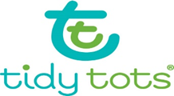 

Tidy Tots® is a start-up company founded in Rensselaer, New York, an area widely known as Tech Valley. The business manufactures a "hybrid" cloth diaper and is positioned to revolutionize the diaper industry. Tidy Tots Diapers’ key product is a patented, hassle-free cloth diapering system that includes covers, Hemp blend No Fold Diapers, Boosters and flushable cornstarch liners called Flushies. Tidy Tots Diapers’ unique snap design allows the diaper to be resized to fit babies and toddlers of all sizes while remaining ick free, rash free and leak free.

Tidy Tots’ mission is to shape a brighter tomorrow for children, by providing an eco-friendly diaper while inspiring and supporting socially conscious business. Tidy Tots diapers can save families more than $1500 on their first baby and provide a natural solution to disposable diapers. This product has the opportunity to convert both disposable and cloth diaper users to the Tidy Tots brand.