Business Plan



**General Company Description**

Company Goals and Objectives: To have our product, TidyCup become the industry standard for how female patients collect a mid-stream urine sample. We plan to achieve this by setting specific annual goals which are discussed in more detail in the Marketing section of this plan.

Our product will be marketed to outpatient clinics, physician’s offices, urine cup manufacturers and pharmaceutical companies whose focus include prenatal, pediatrics, and women’s urological concerns.

The disposable, one-time use TidyCup fits into category of Feminine Hygiene Products, a category that has historically proven to be a growth industry, and will continue to do so. The global market for Feminine Hygiene Products represents one of the rapidly growing segments in the FMCG (Fast moving Consumer Goods) category and is projected to reach US$15.2 billion by 2017. The growth is mainly fueled by intense competition, product innovations and rising health and hygiene awareness among women. In addition, growing affinity for physically active lifestyles, higher disposable incomes and technological advancements is expected to open up a plethora of opportunities for the market in the long run.1

Due to this growth, there exists an opportunity for TidyCup to become the industry standard for collection of regular and midstream urine samples from women. In the U.S., the manufacture of medical supplies and devices includes 12,000 companies with combined annual revenue of about $50 billion. Demand in this segment is driven by population demographics and advances in medical knowledge. Large and small companies can compete successfully in this industry by specializing in a particular market segment and by utilizing low-cost manufacturing of low-technology, one-time use products such as latex gloves, gauze sponges, etc. TidyCup is a low-tech product that can be produced inexpensively for use by a particular demographic.

Our company will succeed because our product, TidyCup, brings added value to the end-user and is an improvement on the current sample collection method. We have a core belief that in the year 2016, female patients should be able to collect a mid-stream urine sample without urinating on their hands or risking introducing contaminants into the sample.

I bring over 30 years of direct patient care healthcare experience to this venture, including 4 years as a Hospital Corpsman in the U.S. Navy. In addition, I bring a strong desire to bring to market a product that has been overdue and is becoming essential to our health.

TidyCup is structured as a corporation.

**The Product**

TidyCup is a patented, one-time use disposable specimen collection product specifically designed to assist women patients in the neat and sanitary collection of a mid-stream urine sample. A mid-stream urine sample (or “Clean Catch”) is a specific type of sample that requires the patient to collect the middle, or “mid-stream” portion of a sample while discarding the first and last portions of the sample. The mid-stream portion of a specimen is optimal as it is least likely to contain sediment and outside contaminants. Contaminant and sediment-free samples are important for accurate testing and patient diagnoses.

**The Problem**

The current method of collection of this type of specimen requires the patient to stop and start the urine stream, marksman-like placement of the specimen cup, and passing of the urine cup in and out of the urine stream, all while the patient is hovering over the toilet seat.

This results in urine being deposited throughout the collection area (restroom floor), on the hands of the collector (patient or healthcare worker), and on the outside of the specimen cup. Very often female patients find themselves in the doctor's office restroom, hovering precariously over a toilet seat, holding a strategically-placed, dripping urine cup in one hand, trying to reach the paper towel dispenser with the other hand, and contemplating her next move. Additionally, female patients are sometimes asked to void into secondary container such as a urine hat, if the healthcare worker feels that the patient will have difficulty collecting a sample. The secondary container is then poured into a specimen cup. This method of course defeats the point of trying to obtain a “clean catch” as it provides more of an opportunity for outside contaminants to be introduced into the sample.

**The Solution**

Patented TidyCup is innovatively designed to be used with a standard specimen cup. The activation of the pull-tab allows the female patient to discard the first portion of the sample, collect the middle portion of the sample, and discard the last portion of the sample as well as any overflow neatly and quickly. TidyCup reduces the messiness and unpleasantness associated with collecting a mid-stream sample (ie. spills caused by misplacement of the specimen cup, patients having to stop and start the urine stream, passing the cup in and out of the urine stream). TidyCup decreases the likelihood of introducing contaminants into the sample which could impact test results. With TidyCup there is no need for secondary containers. TidyCup’s unique design is especially advantageous for elderly, obese, pediatric and pregnant patients. In the physician’s office or other outpatient lab, TidyCup decreases the amount of valuable time healthcare workers spend cleaning restrooms between patients instead of providing healthcare services.

TidyCup can be manufactured from paper or injection-molded plastic. We intend to manufacture TidyCup domestically. A manufacturer has been identified and is listed under the “Supplier” heading in this business plan.

**The Market**

Global Industry Analysts, a leading publisher of off-the-shelf marketing research has stated the following regarding the global market for feminine hygiene products:

*“The global feminine hygiene market is highly consolidated with major players enjoying sizeable market shares. Industry bigwigs such as Procter & Gamble, Kimberly-Clark and Johnson & Johnson dominate the international market. Other noteworthy players include SCA Hygiene Products, Uni-Charm Corporation, Lil-lets Group Limited, Playtex Products Inc., and Kao Corporation among others”.*

*“The global market for Feminine Hygiene Products represents one of the rapidly growing segments in the FMCG (fast moving consumer goods) category and is projected to reach US$15.2 billion by 2017. The growth is mainly fueled by intense competition, product innovations and rising health and hygiene awareness among women”.* The report continues, “*The feminine care market is experiencing a transition from cost-focused hygiene products towards convenient products, which offer extended functionality. Quality and performance are the two leading criteria modern woman look for in a premium product offering value added protection. Women, the world over, are patronizing organic, biodegradable and eco-friendly products that are safer not just on the skin, but also to the environment.”1*

According to surveys conducted by the U.S. Department of Health and Human Services there were over 973 million visits to office-based physicians and hospital outpatient departments in 2005. Females comprised 60% of those visits. One or more screening and diagnostic services were ordered nearly 90% of the time. A urinalysis was the third most frequently ordered diagnostic test. Because the scope of our research was limited, these figures do not include any freestanding ambulatory surgery centers, Department of Veterans Affairs medical offices; or industrial, occupational or institutional clinics although these facilities are considered to be a part of Tidycup's customer base.2

A urinalysis is the third most ordered diagnostic test and yet one of the last types of laboratory tests to see changes in the areas of automated testing and improved collection methods. Countless studies and articles have recognized this issue which is best summarized by Mariano Yogore, MD., director of Chicago’s Stroger Hospital of Cook County, the Adult Emergency Services Testing Center is one of the largest in the nation. This facility serves 120,000 patients each year. One-third of those patients submitted urine samples for testing. Regarding the current specimen collection process Dr. Yogore states, “Contamination due to improper collection, especially with females, is an ongoing problem.” He adds, “It is reflected in the need for repeat specimens.”3

A College of American Pathologists (CAP) Study conducted in 20064 found that of 14,739 samples submitted, 18% were contaminated. At some of the participating institutions, the percentage was a high as 41%. The study found that laboratories themselves typically have a stricter measure of what constitutes a contaminated sample than was used in the study. Incredibly, by their ***own measurements*,** about 10 percent of the laboratories in the study had at least 50 percent contamination rates, significantly higher than the 41 percent peak reading using the study definition. Dr. Bruce A Jones, senior staff pathologist at Henry Ford Hospital in Detroit, stated "Their own criteria result in a higher percentage of contamination than the study did, which means that for the actual, real-world application for patients, [contamination rates are] even higher". Problems at the point of collection were cited as one of the main reasons for contamination.

Specimens that are rejected due to contamination lead to re-collection and re-testing. This increases costs (material, healthcare and laboratory personnel), delays in diagnosis and treatment, risks for poor patient outcomes, patient safety and patient dissatisfaction. In addition, any metrics that are dependent upon patient outcomes will be directly connected to Medicare/Medicaid reimbursement due to the implementation of the Affordable Care Act.

For these reasons, the incentive for improving the method of urine specimen collection for women is especially important to our target customer since contaminated specimens have a cost in terms of both effective patient treatment and monetarily.

Beyond the very important need to collect better quality samples, TidyCup also addresses the “Yuck” factor currently associated with collecting urine specimens. In an interview of 102 women between the ages of 18 and 75 who had ever collected a urine sample using the current method, nearly 100% of respondents stated that they would prefer to use TidyCup instead. We assume that our target demographic is also interested in providing a value-added experience for their patients.

**Marketing Plan**

As a patented product that provides a vast improvement on a current process and provides the opportunity for a less contaminated sample, TidyCup is a product that is poised for success in the current market.

TidyCup is a product that lends itself to co-branding. Up until the moment a woman uses a TidyCup, it is the perfect opportunity for direct marketing, unlike the current specimen cup.

With that in mind, we plan to offer licensing opportunities to those corporations demographics that target of female patients ages 8 and older. Co-branders could also sponsor Pilot Studies for TidyCup. The pilot studies would offer our customers the opportunity to try a new product at no initial cost to them.

**2.** TidyCup’s dissimilarity to current products. Educating the end customer on the use of a new product will be a bit of a learning curve, however, the fact that the pull-tab concept has long been in use successfully in various other medical settings should greatly aid in meeting this challenge.

**3.** TidyCup is designed to be used with a specimen cup. Customers may be reluctant to pay extra to give their female patients a better experience, but TidyCup will give more accurate results and can provide costs saving by reducing restroom clean-up time, less retesting/recollection of samples, and not having to purchase secondary containers which can cost up to three times as much as a specimen cup.

**Customers**

We have two customer groups that will purchase a TidyCup: 1) The end-user group which consists of female patients aged 8-and up who are ambulatory and generally in an outpatient setting, and, 2) Outpatient clinics and physician’s offices (both civilian and military), urine cup manufacturers, pharmaceutical companies whose focus include prenatal, pediatrics, and women’s urological concerns and any other companies interested in co-branding opportunities. TidyCups will be sold primarily to outpatient clinics, physician’s offices, etc. and made available to female patients in those arenas, however we are open to the possibility of making TidyCup available directly to female patients.

**Competition:**



**Niche:**

Our product, TidyCup will be marketed to healthcare and healthcare product manufacturers who want to provide their customers with an improved method of collecting a less compromised urine sample and to women who are interested in collecting a mid-stream sample without urinating on their hands.

**Strategy:**

Our strategy will consist of marketing directly to our customers and end-users through various media such as social media, print advertising in relevant trade magazines and a sales force consisting of our own medical representatives. The advantage of marketing to the end user is that they are most likely to request this product and assist in driving the demand for it. Our goal is to let customers know that this is a product that is available. Problems with collecting this type of sample are universal to women and is also one of women’s most embarrassing secrets. Because of this, we want to let the end-user know that this product is available and will put an end to the disgusting way that this type of sample is currently collected. In other words, they “need” TidyCup. Our product is currently being marketed as “The Clean Simple Solution”

**Sales Forecast:**

According to the National Ambulatory Medicine Care Survey 2009 Physician Office Visits & Emergency Department Visits5, there were over 500 million physician and emergency room visits by females age 15 and older in the U.S., with a urine sample being the third most ordered test. Our sales forecast below are based on this conservative figure:

Best Guess Worst Case

2016 

**Suppliers:**

TidyCup can be manufactured from paper or plastic, depending upon customer preference. The following manufacturers are companies with which TidyCup has established business relationships with and who will be able to manufacture our product:



Plastic Manufacturer: Paper Manufacturer:

Hi-P of North America

880 W. Winchester Rd. Ste 116

Libertyville, IL 60048

**Startup Expenses and Capitalization**

We are asking for $250,000 to be used as follows:

Product:

Plastic TidyCup amount: 125,000 Cost: $21,250

Paper TidyCup amount: 125,000 Cost: $62,000

Pilot Studies amount: 5 Cost: $50,000

Other Cost: $16,250

Marketing Cost: $100,000

Total $233,750

We will give 10% equity.

Find out more about TidyCup on Youtube at: <https://www.youtube.com/watch?feature=player_detailpage&v=bGZGLR6a4wM#t=0>

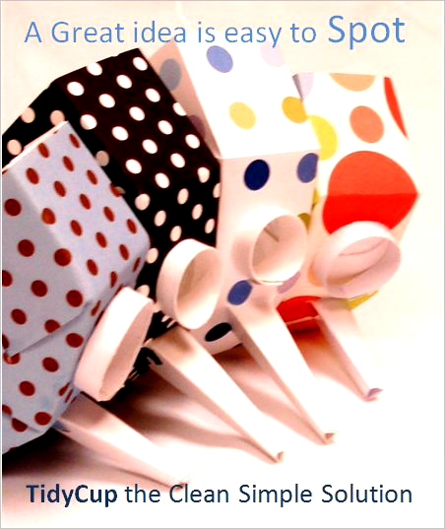 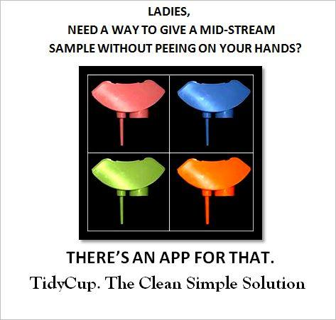

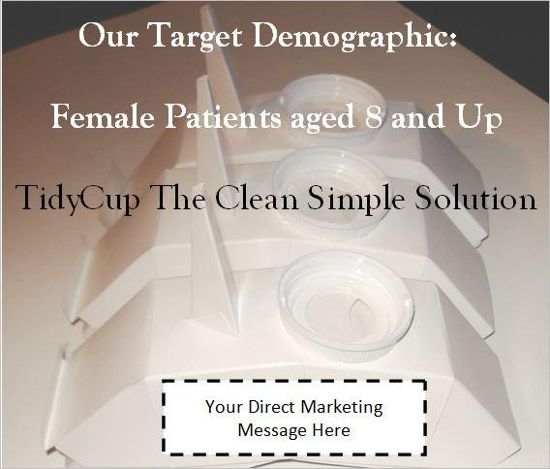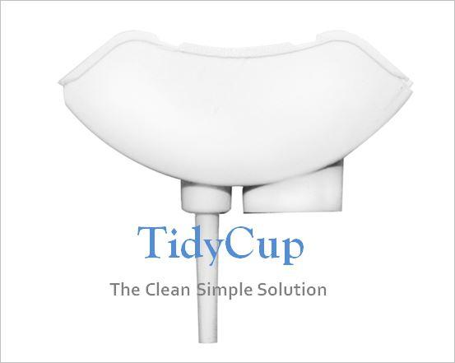

Appendices

Market Research Studies

**1**”Feminine Hygiene Products: A Global Strategic Business Report”,by Global Industry Analysts, Inc. January 6 2011

**2** National Ambulatory Medical Care Survey: 2005 Summary, Number 387 June 29, 2007. Donald K Cherry, M.S.; David A. Woodwell, B.A.: and Elizabeth A. Rechtsteiner, M. S.\par Centers for Disease Control and Prevention, National Center for Health

**3** Cap Today, “Urinalysis finally catches up”, September 2002. Written by William Check, PhD

**4** Taken from the article “Cloudy or Clear? Best forecasts of urine cultures”, written by  Ed Finkel. Study conducted by Leonis G. Bekeris, MD chair of the Department of Pathology at Phoenixville (Pa.) Hospital; Bruce A. Jones, MD, senior staff pathologist at Henry Ford Hospital, Detroit; and Paul N. Valenstein, MD, president of Laboratory management Associates, Ann Arbor, Mich, and chair of the CAP Quality Practices Committee.