**Phase 1: 2016 Local Market Launch-Syracuse**

Revenue Model: $80/month/user for 15 minutes phone call and 30 mins training plan

Assumptions:

1. Customer Growth rate at 10% starting with 50 users. (See Appendix A for user channel break down)
2. All Users are charged with $100/Month with first 100 user discount at $65/month
3. Payroll is estimated by hourly wage, amount of time with trainers, average 40 hours/week for full time trainers.
4. Benefits are estimated at 25% of employee wages.
5. Increase in Developer Wages is at the increase % of next 3 months revenue growth start from $20/hour and 20 hours/week capping at $3500/month
6. Grants and Sponsorship comes from Centerstate CEO program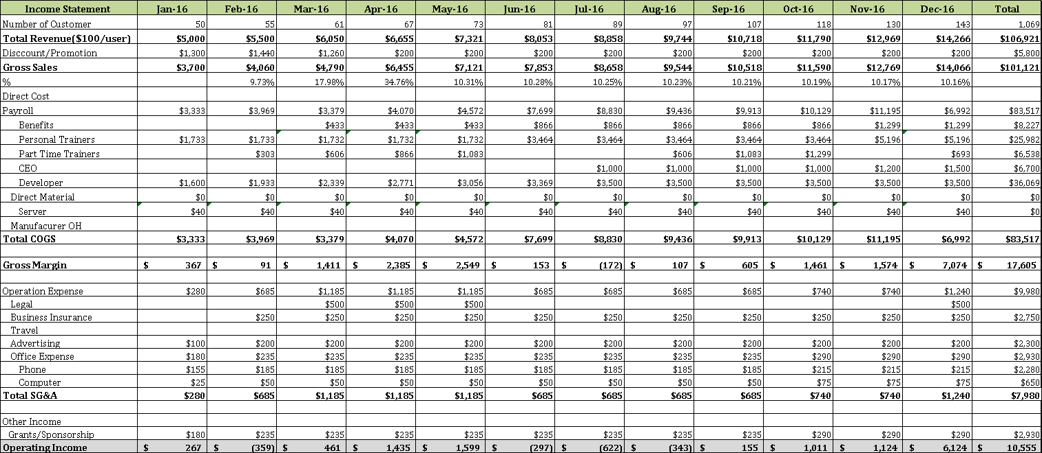

**Phase 2: 2017 App Launch and Regional Expansion**

Revenue Model

* Phone+App: $80/month
* App: $40/month

Assumptions:

1. Expansion rate of cities are at average 2 cities/year for phone+app services starting

2. App user growth rate at 9%/month (see Appendix C for Growth Rate for users)

3. Expense takes in 78%of Revenue for the first year followed by increase growth with 10% decline a year each

4. Adjusted Population weightage reference to American average city population as compared to Syracuse (144,669) to average (427,419)

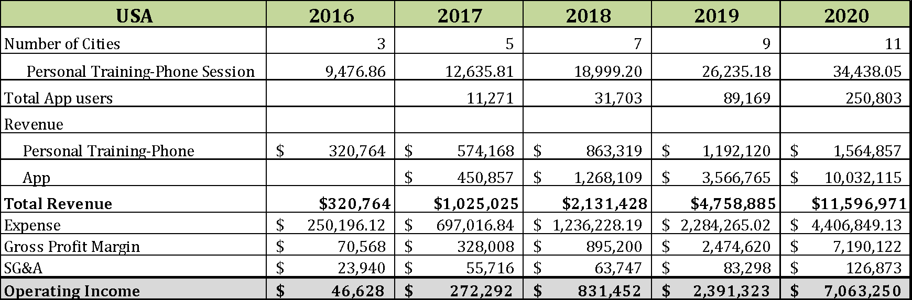

**Revenue Trend, Startup Cost and IRR**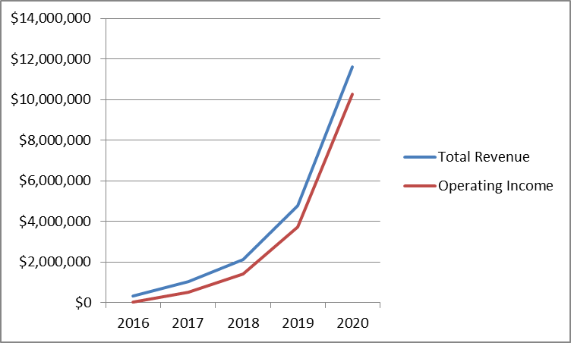

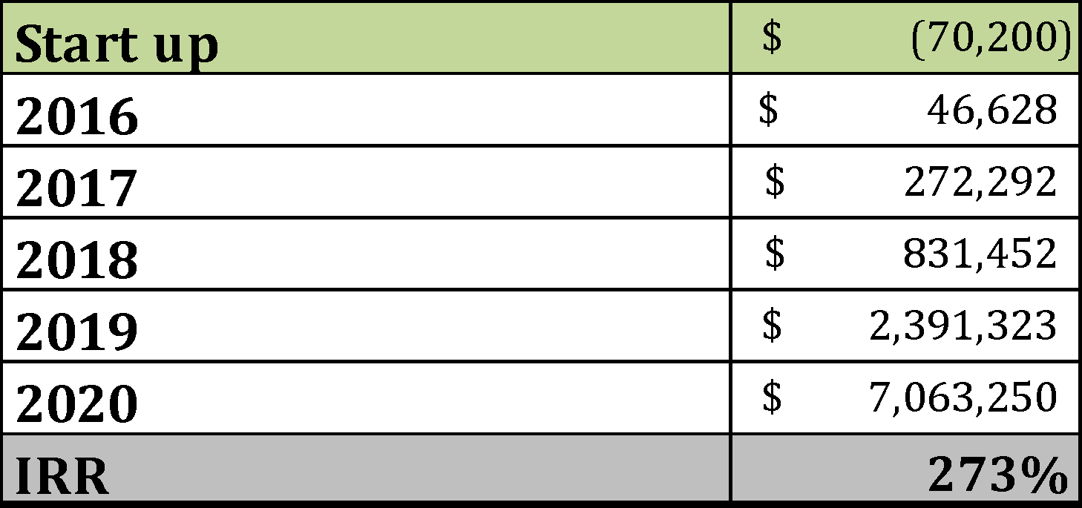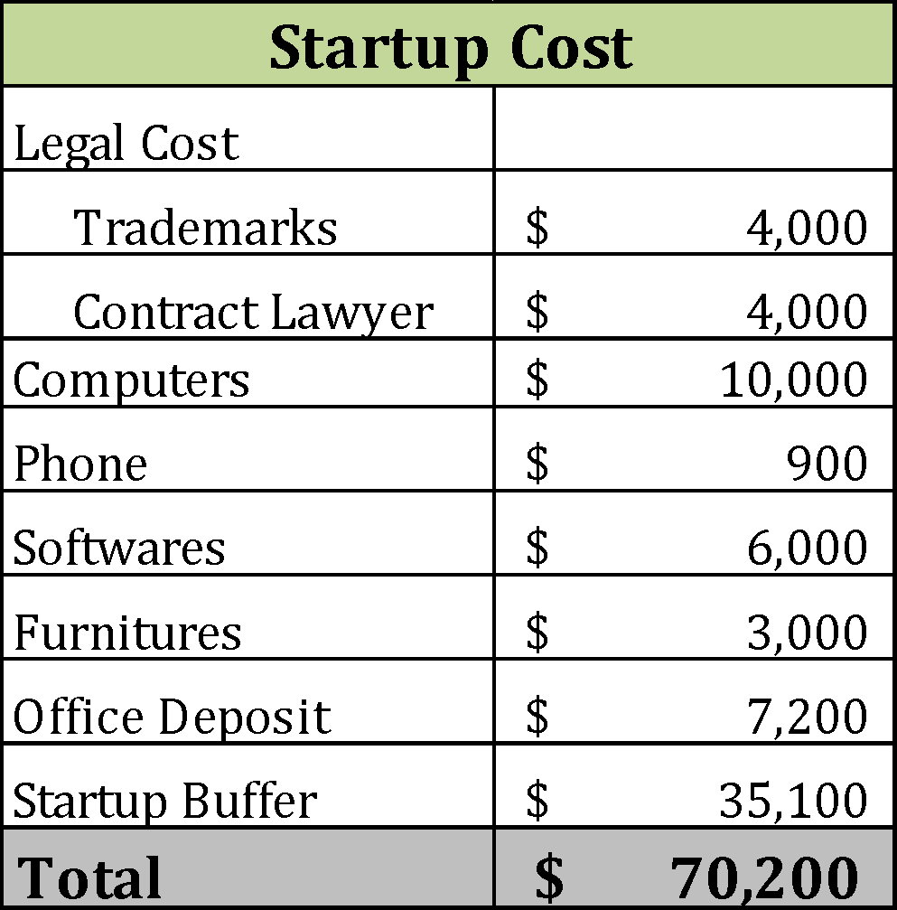

**Appendix A: Customer Channel Details**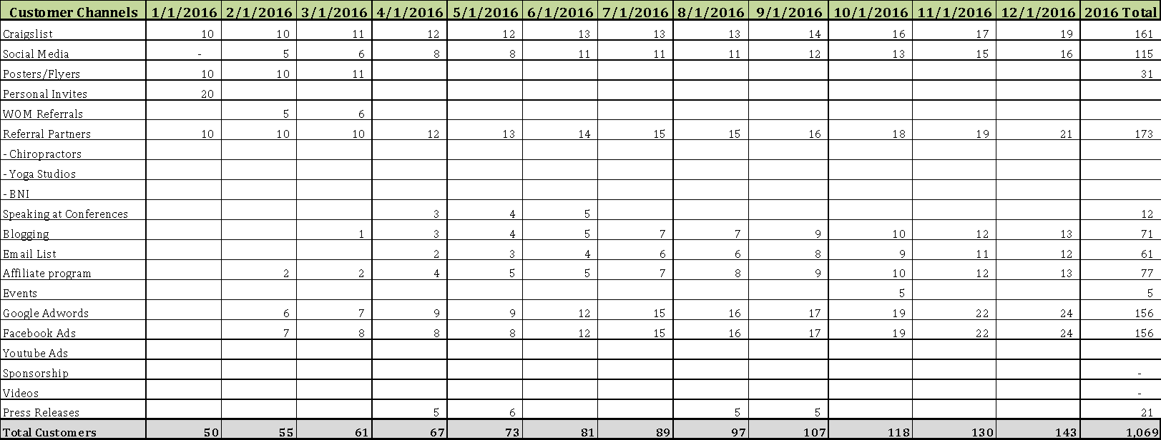

**Appendix B: Cash flow statement 2016**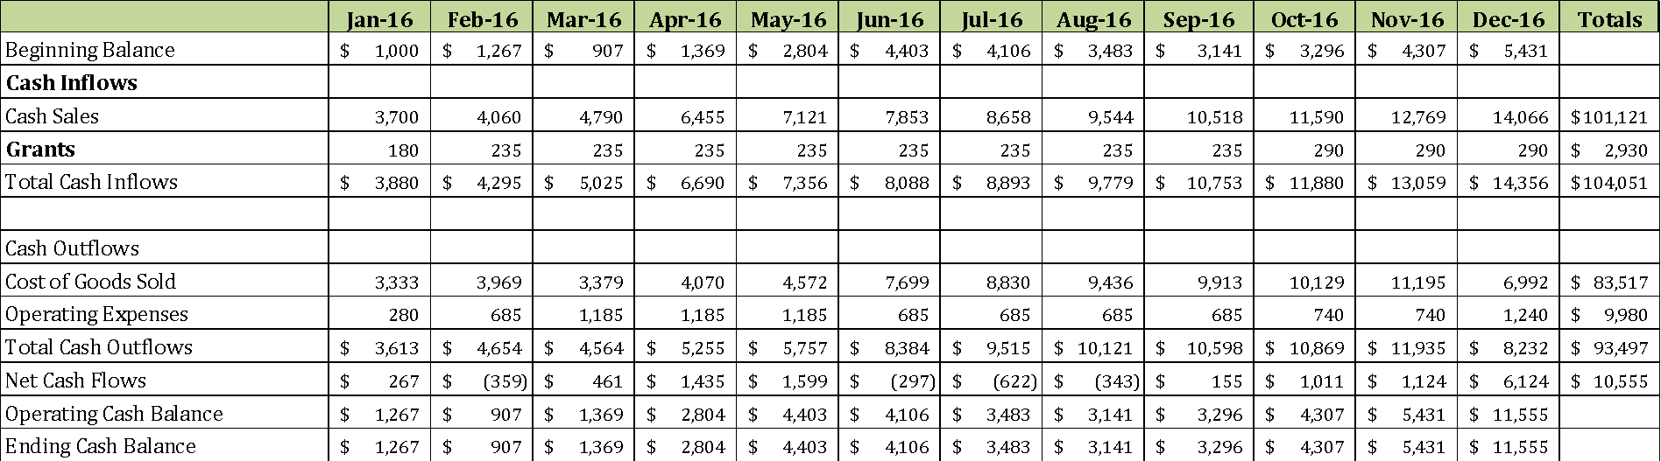

**Appendix C: App User Growth**

