Business Plan

Zuvaa, Inc.

[www.Zuvaa.com](http://www.zuvaa.com)

10/9/2015

For more information please contact:

Kelechi Anyadiegwu

Founder & Chief Executive Officer

Kelechi@Zuvaa.com

732.979.5495

Table of Content

Executive Summary

Problem

Solution

Business Model

Management Team

Company background

Market opportunity

Product

Business Model & Pricing

Content Package

Customer Service + Manage Storefront

Fulfillment

Manufacturing

Financials

Customer Acquisition Strategy

Collaboration with Bloggers

Storytelling

Community

Social Media

Influencer Marketing

Digital Marketing

Customer Acquisition Cost

Competitive Analysis

Ask

Use of funds

Conclusion

# Executive Summary

**Zuvaa, Inc** is the premier online marketplace for African Inspired Fashion and Design. Using community, content and social commerce we are revolutionizing the way people shop for African Fashion and Design around the world. Since launching in May, 2014, we’ve made significant traction to our vision with over $400,000 in revenue and over 3000 customers from countries around the world. We’ve also helped the 100+ vendors on our platform significantly grow their business’; on average each vendor has doubled their sales since joining Zuvaa.

## Problem

The problem we’re solving at Zuvaa is multi-sided, on one hand consumers all over the world are demanding African prints and fashions but don’t have access to authentic pieces. On the other hand, local fashion designers on the continent don’t have the tools to sell and market their products to a global audience; as it would require them to build an ecommerce store-front, drive traffic to the site through online-marketing and fulfil the orders by shipping them across the globe.

## Solution

The Zuvaa marketplace is disrupting the global fashion industry by enabling African fashion designers to easily sell their products. Consumers from around the world can now shop the latest African fashion at the click of a button. With a focus on content and community the Zuvaa platform provides consumers with a unique customer experience that engages them around the design process behind each piece and educates them on the cultural origins of each design.

## Business Model

The Zuvaa platform has 2 main revenue streams; commissions on sales made through the platform as well as a la carte fees for premium services such as marketing, fulfilment, product photography and inventory management.

## Management Team

Kelechi Anyadiegwu is the sole Founder and CEO of Zuvaa. She has a background in social media marketing and online community building as well as user experience design. Growing up as a Nigerian in the US, Kelechi found it difficult to find modern and trendy African inspired fashion; she created Zuvaa to marry her love for African culture with her skills in digital marketing and user experience design. Kelechi is a an advocate for women empowerment and believes empowering women to build sustainable businesses can transform Africa’s economy.

# Company background

**Zuvaa, Inc** is a Delaware C-Corp incorporated on May 2nd 2013. Our mission is to empower African fashion designers with the tools they need to grow their businesses. Our goal is to leverage the growth of the African Fashion industry to benefit local communities on the continent of Africa. Since much of the fabric is sourced from the continent, our vision is to see an increase of manufacturing done on the continent and bring mass appeal to the African Fashion Industry. We want people all over the world to be able to identify these prints and know where they come from.

# Market opportunity

African fashion is projected to be a $15 billion dollar industry by 2020[1]. In western economies e-commerce has been the key driver of growth in the fashion industry as it accounted for over 20% of all apparel sales in 2014. The global demand for African fashion is at an all time high, due to international coverage of the African fashion industry by major media powerhouses such as Elle, Vogue and Harpers Bazaar. In recent years many large fashion houses along with fast fashion retailers have started to take notice of African prints and textiles. These textiles were seen in the collections of fashion houses such as Burberry and Gucci and on the shelves of retailers such as H&M and Zara. Outside of high fashion and fast fashion, online demand for African prints is growing rapidly. As you can see in the Google Trends search report for the keyword ‘African Print’ there has been a dramatic increase in interest in African Print since 2013.

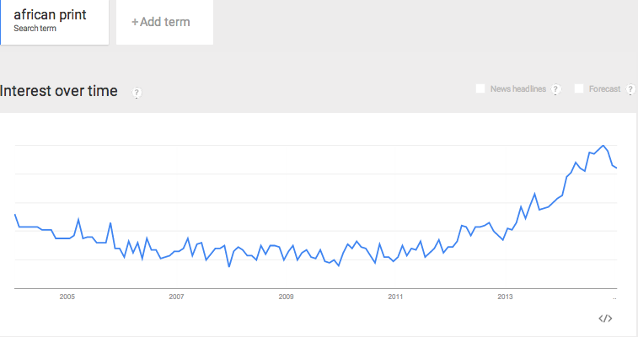

As the African fashion industry grows in international demand and coverage, local African designers and retailers are seeking to use e-commerce to serve this global audience thirsty for authentic African fashion. However the challenge is most local designers don’t have the resources to manage online store-fronts and drive traffic to their websites. They also struggle with the logistics to fulfil international orders. Our goal at Zuvaa is to catalyze the global demand for African fashion by empowering African designers with the tools and resources they need to sell to a global audience and scale their businesses.

# Product

**Zuvaa.com** is the premier online marketplace for African Inspired Fashion and Design. Zuvaa.com caters to two distinct customers, African designers (vendors) looking to sell to a global audience and consumers from around the world who want to shop authentic African fashion. The Zuvaa marketplace is carefully curated, so that consumers know they are getting the best quality pieces.

Our platform allows vendors to set up virtual storefronts where they can sell their items. We provide vendors with a dashboard to facilitate:

* Inventory management
* Customer relations and support
* Analytics to better understand their customers demographics and online behavior
* Marketing tools to boost the visibility of their products on Zuvaa.com and social media channels
* Fulfilment tools to aid the logistics of shipping their products

In addition to the dashboard we offer premium services to our vendors, these services will be detailed in the next section.

# Business Model & Pricing

Our revenue model includes a 15% commission on all sales along with monthly subscriptions for value added services. We also charge one-time insertion fees for vendors to boost the visibility of their products on the marketplace.

The table below shows the different subscription packages vendors can choose from and the services included.

|  |  |  |  |
| --- | --- | --- | --- |
|  | General Package | Content Package | Managed Storefront Package |
| Monthly Fee | **$15** | **$35** | **$55** |
| Social Media Posts (1 per week) |  | **X** | **X** |
| Sponsored Newsletter (1 per month) |  | **X** | **X** |
| Homepage Feature |  | **X** | **X** |
| Items added to all categories |  | **X** | **X** |
| Managing your online storefront |  |  | **X** |
| Handling your customers |  |  | **X** |

## Content Package

For $35 per month, we will offer vendors the opportunity to advertise via our social media networks (one post per week), have a dedicated monthly newsletter, have an image on the homepage and participate in our stylist program. As part of this content package, we will partner with bloggers who will serve as stylist for Zuvaa. Under our Stylist program, vendors will have the opportunity to send their pieces to bloggers to style and photograph for them.

Stylists will be required to style these pieces and take photos in them and post to blog or social media channel within 2 weeks of receiving the item. Photos taken by stylists will also be used as product photos on Zuvaa.com. In exchange bloggers will receive free items and Zuvaa will get the publicity.

## Customer Service + Manage Storefront

For $55 per month, Zuvaa will handle customer service for vendors who do not have the time nor capacity to do this. Zuvaa will serve as the main point of contact for these vendors and will handle everything from questions about products to sending tracking information. Zuvaa will also manage the store fronts of vendors. Zuvaa will upload and make edits to items. Zuvaa will also write up product descriptions for vendors.

**Future services**

## Fulfillment

In an effort to further support artisans on the continent of Africa, Zuvaa also offers a fulfillment services. This will allow vendors who are on the continent of Africa, where it is currently extremely expensive to ship globally, to ship from the Zuvaa fulfillment center in the United States. This will give Zuvaa an opportunity to further tap the talent that exists on the continent of Africa, while still satisfying consumers with low shipping costs and fast delivery.

For this service, we will outsource the fulfillment process using Shipwire and have all the products housed in the warehouse in Philadelphia. The cost for this service will depend on the volume of sales from the vendor. In the basic package we are estimating 33 sales ($5,000/$150 per sale). This would cost about $150-$200 per month using Shipwire services. Zuvaa would charge $300 per month for this service. The vendor would just need to send their pieces to the Zuvaa team and the Zuvaa team would take care of all the fulfillment process. Zuvaa will charge $600 and $900 for the Mid-Level and Premier levels respectively.

## Manufacturing

Starting in the year 2016 we will work with the Mako Organization in Ghana, to work with tailors in Ghana who will create collections for our vendors. Through this service, we will train local women on how to manufacture (sew) the apparels and upon completion of the program give them jobs as seamstresses in our factory.

We found that as many designers are growing their businesses through the Zuvaa Platform, they are no longer able to meet the growing demand. Working with manufacturers on the African continent will create a service for vendors that will allow them to manufacture their collections in bulk in lieu of the made to order option. As demand in the marketplace continues to grow this will also grow the jobs created on the African continent. As this Zuvaa marketplace grows and scales, we plan to see this cycle grow and scale as well.

# Financials

To date we’ve done over $200,000 in revenue and our revenue is growing 45% month over month.

|  |  |
| --- | --- |
| **Income Statement for the Year Ended October 31st 2015** | |
| Sales | $470,155 |
|  |  |
| Revenue from commissions | $70,523 |
| Revenue from premium services | $18,900 |
|  |  |
| Total Revenue | $89,423 |
|  |  |
| Administrative Expenses | ($7,500) |
| Marketing Expenses | ($7,433) |
| Operational Expenses | ($3,302) |
|  |  |
| Total expenses | ($18,235) |
|  |  |
| **Profit Before Tax** | **$71,888** |

|  |  |
| --- | --- |
| Key Statistics For Year Ended October 31st 2015 | |
| Items sold | 3,121 |
| Avg price/item | $88.70 |
| Items Purchased | 4574 |
| Avg order size | $129.47 |
| Avg Month-Month Sales Growth | 45% |
|  |  |
| # of vendors | 105 |
| Avg monthly sale/vendor | $804.16 |
| # of items/vendor | 8.75 |
| Vendor growth rate | 233% |
|  |  |
| ROI Marketing | $27.73 |

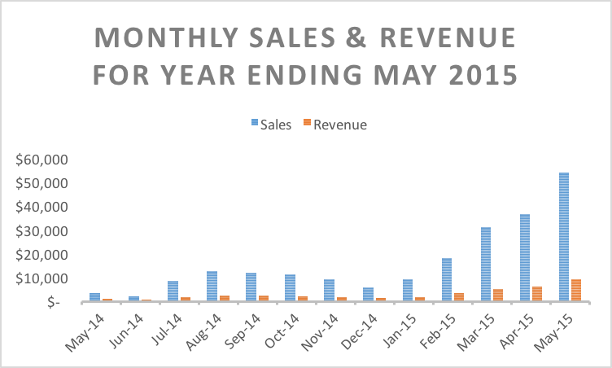

Based on our financial performance in our last fiscal year, we believe we can sustain a 15% month-month growth. The table below shows our financial projections.

|  |  |  |  |  |
| --- | --- | --- | --- | --- |
| Year Ending | May 2015 | May 2016 | May 2017 | May -2018 |
| Sales | $215,101 | $1,801,819 | $9,640,184 | $50,000,000 |
| Revenue | $39,506 | $353,893 | $2,550,595 | $7,500,000 |
| Expenses | -$18,235 | -$356,415 | -$981,570 | $3,000,000 |
| **Net  Income** | **$21,272** | **-$2,522** | **$1,569,025** | **$4,500,000** |
|  | **Actual** | **Projected** | **Projected** | **Projected** |

# Customer Acquisition Strategy

Our main driver of sales has been the community we have built and the love they have for the Zuvaa brand. Using social media, more specifically Instagram - we have built a community of women who are excited to shop authentic African inspired pieces that are bold, vibrant and classy.

Two important aspects of the community we are building are the influencers (stylists and fashion bloggers known by members in our community) and the content they create. The content they generate excites our community, easily makes them want to share designs from Zuvaa and tell their friends about the unique pieces found in our marketplace.

## Collaboration with Bloggers

Using pieces in our marketplace, we collaborate with fashion bloggers to create beautiful imagery from our designs that will engage people all over the web. Fashion Bloggers will be sent samples from our store to style and photograph the pieces. These pieces will then be used for imagery on the Zuvaa website and for promotions on distribution channels.

Collaborating with Fashion bloggers is an essential part of our store and of business model. We bring on a team of fashion bloggers who will act as stylists for Zuvaa. By acting as stylists they will be tasked with creating vibrant and engaging imagery. In order to capitalize on their networks, all fashion bloggers/stylists with Zuvaa will have a certain social media following and Klout score. When they style pieces from Zuvaa, they will also post to personal blogs to drive traffic from. All referrals from blogs are tracked to ensure these bloggers are also bring conversions to our store.

## Storytelling

On each product page, there will be stories about the designers and their process for the customer to further engage with the item they are about to buy. These stories are essential to our marketing strategy because they will be sharable. Visitors on the site will be able to share these stories to their social media networks in an effort to inspire others around them. This is important for Zuvaa, because it brings traffic back to our site. We want out customers and potential customers to feel connected to the brands. As part of these stories, we will share inspiring thoughts, quotes and stories. This stories will come complete with images, previous design collections, sketches, etc.

## Community

Community will be heavily emphasized on our platform. We want women who shop in our store to feel like they are part of a growing movement. They are part of a movement to grow the Africa Fashion industry and the movement to support emerging female designers and small business owners. This type of language will be found throughout the site. It will be found in the stories each pieces and/or fabric comes with and it will be found throughout Zuvaa social channels as well.

## Social Media

Social Media will be the center of where we focus our community efforts. Using mainly Instagram and Facebook, we use these communities to talk with our customers, ask them their opinions and get more of an idea of the pieces they would like to see in our store. We are taking a ground up approach to fashion retail so that we can make sure to offer items that our community really wants and to make them feel involved in the buying process. We feel making them involved will instill a sense a trust between us and our customers.

## Influencer Marketing

By connecting with influential people in fashion and entertainment industry, we will send them pieces from our marketplace to wear for events and photoshoots. Influencers we pieces are sent to will be chosen strategically and will be influencers women in our community look up to. Not only will this create buzz around Zuvaa as this type of content is picked up by magazines and other publishers, but it will also excite our customers as they see their favorite celebrity wearing pieces from our marketplace.

## Digital Marketing

We will set aside an marketing budget to spend on digital marketing initiatives. These digital marketing initiatives will include, Facebook marketing, Google ads, and retargeting. As a high proportion of women we target are on Facebook, Facebook’s target marketing tools, has been a great way for attracting new customers. We have also had success in retargeting as well as Google ads. through testing on these platforms we plan to maximize our use to acquire customers.

## Customer Acquisition Cost

|  |  |
| --- | --- |
| **Medium** | **Cost/ monthly** |
| Stylist/Blogger Program | $0 |
| Bloggers | $500 |
| Ads on Blogs | $500 |
| Social Media | $0 |
| Facebook Ads | $200 |
| Content Marketing | $0 |
| Total marketing spend/month | $1200 |
| Monthly Revenue | $35,000 |
| ROI on marketing | 30X |

We will rely heavily on word of mouth and earned media to bring this customer acquisition cost down.

# Competitive Analysis

Our major competitors are Etsy, Ebay and ASOS Marketplace. These are all alternative marketplaces our vendors may choose to work with. Zuvaa differentiates itself by focusing solely on empowering African Fashion designers with the tools they need to scale and serve a global audience. Below is a competitive analysis that compares Zuvaa Etsy, Ebay and ASOS Marketplace.

|  |  |  |  |  |
| --- | --- | --- | --- | --- |
| **FACTOR** | **Zuvaa** | **Etsy** | **Ebay** | **ASOS Marketplace** |
| **Products** | African Inspired | Handmade | Everything | Apparel and Fashion |
| **Quality** | High Quality and curated | Not Curated | Not Curated | Curated |
| **Selection** | 100’s of items | Very large marketplace - hard to find items | Very large marketplace - hard to find items | Large variety of fashion items |

Zuvaa is distinct from these other marketplaces in that, our marketplace is specifically target at African Inspired pieces. That would include

● Designs made with African Fabrics

● Designs inspired by the continent of Africa

People who will come to our marketplace come specifically for unique prints. These are prints that you won’t easily find large retail stores. While many of these marketplace do carry African inspired pieces, consumers will trust our brand as they know Zuvaa only stocks the highest quality pieces.

# Ask

We’re seeking $600,000 to further development of our online platform and hire key people to help us grow the business. This will enable us to automate many of our services which will streamline our operations and increase our monthly growth rate. With this funding we will achieve our 12 month sales target of $1.8M.

## Use of funds

|  |  |
| --- | --- |
| Technology Development | $200,000 |
| Salary for key hires (Marketing manager, Community manager, Business Development, CEO) | $240,000 |
| Marketing Expenses | $100,000 |
| Operations & miscellaneous expenses | $60,000 |
| Total | $600,000 |

# Conclusion

Our ultimate goal is to make Zuvaa the largest online marketplace for African fashion and design. We plan on expanding our offerings to include art, home wares, men and children’s clothing, and more. By empowering local artisan on the African continent with the tools to serve a global audience, we believe we can make lasting financial and social impact on the African continent.

1. Source: http://www.ventures-africa.com/2014/09/why-smes-rule-africas-fashion-industry/