**MissKit Business Plan**

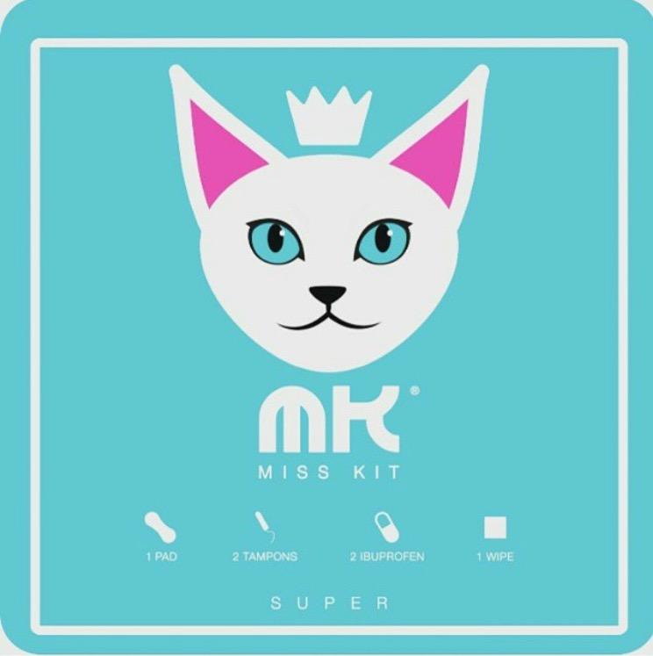

**Executive summary:**

Misskit located in Los Angeles, CA and is owned by Ms. Leital Levy

The company is an LLC started in October 2015.

Misskit delivers a service to women between the ages of 14-49 providing an emergency kit for girls and women during their menstruation time. The kit includes 2 tampons, 1 pad, 2 Ibuprofen and a feminine wipe, conveniently packaged in a small box. While on the go, rather than purchasing 4 separate items, Misskit provides a quick, discrete and inexpensive solution to an unexpected period!

Starting your period suddenly in the middle of the day can be a dramatic experience for any woman. Whether you are at school, work, traveling, or just on the go, having access to a Misskit can easily solve a problem of embarrassment, inconvenience of carrying bulky items or the constraint of a limited budget.

Misskit will be accessible to girls and women on the go. The product will be sold online, but mostly wholesale to retail chains. Misskit will be sold in several locations to include the following:

**High Schools and Colleges,** can sell the product in the nurse’s office, vending machines or at the bookstore.

**Airports**, can sell the product at the gift shops, restrooms and vending machines.

**Convenience Stores**, such as 7-Eleven, Circle K, Stop-n-Go, and gas stations.

**Pharmacies**, such as Rite-Aid, CVS, Walgreens, and Dwayne Reed.

**Retail Chains,** such as Target, Wal-Mart, K-Mart (travel section).

**Additional locations,** such as hotel gift shops, movie theaters, corner markets and the military bases.

Misskit makes sense in this day and age. The product perfectly fits into the mold of a society where everything is fast-paced, accessible and convenient.

**Industry, Target customer, and Competitor analysis:**  
  
Misskit targets females ages 14-49 years old. Even at the dawn of the 21st century, most people have a hard time viewing menstruation as anything other than a dirty, shameful, disgusting secret. We’ve created this product with the youth in mind to eliminate the embarrassment attached to dealing with the details of keeping up with the bloody inconvenience of a menstrual period. Some young ladies live in fear that their life will be over if someone ever sees evidence of their period on their clothes, the furniture or the floor. Misskit was created as a discrete and accessible package to ease those emotions. In addition to the youth, Misskit targets female adults that are “on the go”. These women might not feel embarrassed of their periods anymore, but they certainly don’t like to carry bulky items in their purses everywhere they go. Thus, Misskit is a perfect option for those who want to be safe--and carry the kit in their purse, and for those who unexpectedly get their periods.

Feminine product is a booming industry making billions of dollars every year. Some of the competitors in the industry are Playtex, Tampax, Kotex, and Always. However, none of these tampon brands make any type of travel/ emergency kit. We currently have Misskit at a few convenience stores in downtown Los Angeles, and we have also been accepted by 3 different 7-11 stores. We have presented the product to Rite-aid’s feminine department and were very excited about the product. I believe that with the right marketing plan, Misskit will easily go global.

**Qualifications of owner:** Ms. Levy has owned several businesses in the past including a hair coloring business as well as an import/export dog business. The experience of owning these businesses provided Ms. Levy with the necessary structure and skills to operate Misskit. Currently, she is attending LATTC taking additional business classes to refine her skills.

**Vision statement:**

The company’s vision is to make Misskit a Global brand expanding once the brand name has attained maturity to License the name to other female products serving the same customer base.

The Licensing feature will provide the company with additional revenue streams to use for further expansion of the company.

Phase one would be to establish a profitable business in the United States.

The company would develop a strong infrastructure to support the company with experienced consumer product specialists.

The company will expand by ensuring that the company can be self-funded through profits thus not being leveraged by debt.

Phase two would be to expand the brand to other parts of the world through a Distributorship program roll out.

During phase three, the Company will expand its growth through product development of new and exciting products serving the same customer base

**Human Resources**:

Phase 1: During phase 1 of the launch of the company. The only employees would be the owner, and one full-time employee in charge of administration, customer service and sales administration.

Phase2: The company will interview candidates to develop a “team” with the experience and personality to bring on board as the company expands and has the money to pay for the talent the company requires to grow.

**Management team**

**Leital Levy (CEO)**- running the company and overseeing operations.

$40k a year (salary first year) + health insurance and expenses (travel, clothing etc)

**Sales Administrator** – Will manage the Sales Wholesale Representatives Retail programs, E-commerce catalogs and all other avenues of distribution The Administrator will have global sales experience (Salary $25.00 per hour).

**Operations Manager** - The Operations Manager will manage the day to day operations of the company including financial reporting to management , Human Resources, and Production logistics ( Salary $35.00 per hour)

**Customer Service team** - 3 people (Salary $18 per hour) handles all customer service issues, answering phones and emails, managing the Web Site sales.

**Shipping Manager**- Managing the inventory and shipping to customers. (Salary $15.00 per hour)

**Bookkeeper** - Part time will be responsible to organize all company Invoices for shipments and Invoices for Accounts Payable. Will submit monthly financial reporting to company management (Salary $40.00 per hour)

**Clerks** -2- 3- clerks (floaters) responsible to fill in to support areas of the company where there is too much work to avoid overtime and keep the company efficient and effective (Salary $12.00 per hour)

**Independent Sales Representatives** – The Company will hire territory Independent commission Sales Representatives in the (6) major trading regions of the country who are experienced selling this category of consumer products have a woman based sales rep team.

**Marketing Plan**

The market size: Grocery Stores – 638,338; Convenient Stores – 152,794; Big Box Retailers – 8,042; Drug Stores – 19,128 = Total of 818,302 doors.

The goal for Misskit is to sell 1%of the market size. Estimated demand for Misskit is unlimited as there currently no competition providing this product.

Trends in Market demonstrate that more women are travelling for business and pleasure and once the product has been properly marketed the product will be part of a women’s essentials for her purse, or backpack

Growth Potential

In its early stages, Misskit the product be marketed through social media (Twitter, Facebook, and Instagram)., and the Sales Team As the company grows, and funds permit the company will place Misskit ads in Cosmo Magazine, Women’s Health, People magazine, or any magazine that targets women. The Company will also intend to have Misskit television commercials and shows, as well as YouTube ads.

As the company develops, the company will have a Marketing Director in house focusing on marketing the product, putting out promotions, Tweets, Instagram pictures and working on putting our name out in the world. We would also like to make a Misskit app tracking a woman cycle and reminding her when to take her birth control, also telling her the closest location where she can get it from her location. We can also do a monthly subscription through the app for women to receive Misskit when their period is about to come. This is also a good way of using technology to market the brand and be beneficial to women who sometimes forget (guilty!). Misskit would like to be at trade shows nationwide.

The company will also take part in women’s events to promote the brand and become part of the women’s identification of Misfit as a vital member in the women’s wellness community.

Marketing campaign and budget will be to develop a relationship with a consumer products Public Relations company and endeavor to request a proposal for phases from launch to maturity.

The company will endeavor to implement as much as possible ideas shared that the company can afford.to do until funds ate available to hire an in house Marketing Director

Estimated costs will be determined for Phase two and Phase three to support “Brand” identification and goals and funds available.

**Sales Plan and Budget:**

In order to introduce Misskit we will find Independent commission consumer products Sales Representatives to sell Msiskit to retail outlets across the country. The cost of the endeavor will be to attend Trade Shows and pay for Booth space, and advertising expenses to support the sales effort. The company will give the Sales Representatives an aggressive commission plan, commensurate with industry standards.

Sales are projected by using 6 major territories in the country as the base of the Plan and knowing that in each city there is one retail outlet who can purchase Misskit products.

**Operations and Development Plan**

Phase 1: The Company will be outsourcing production in the United States to control quality, and logistical capacity to meet customer orders.

Currently Misskit has contracted with The Bix COOP manufacturing company in Southern California to produce its products.

Being USA made protects the company from product liability and ensures Quality Control.

Phase one of the Operations Plan. At the time the company has orders beyond its capacity to fill the company will contract with a Fulfillment company to supply the service.

The Company will have only two employees at time of launch. The owner and one administrative clerk.

They will be tasked to set up the books and records of the company, start the sales program and ship orders.

In addition establishing relationships with the Bank and outside management team: Accountant, Attorney, Insurance Broker and Consultant.

The owner will interview candidates noted in the Human Resources section to ensure at the time of need the company will have the proper candidates ready to come om board as the need and money is available for each new employee hire.

This method of preparation ensures the best candidates are available when the company is ready for additional employees.

**Critical risks**  
Misskit faces the risk of competing with larger companies. Strong competitors might copy the idea and use better distribution channels as well as stronger marketing and advertising channels to sell the product. However, once Misskit becomes a household name, we intend to collaborate with a big corporation in order to help propel the business and prevent the risk of “unfair” competition.

**Financial plan**

Initial financing plan will be to start with the $40,000 available through the competition.

At the same time the company will endeavor to investigate funding through investors who can see the potential of the company.

The cost of production would be a third of the cost of the product. Another third would be put into marketing and advertisements in magazines, bill board, commercials, social media, third party public relations companies, celebrity endorsements. The final third would be profit and human resource purposes. Right now our costs are $1 per unit. Once we get our investment we can get our costs cut more than half $0.40 per unit. We plan to wholesale each box for $1.50 which is more than 300% profit margins.

**Critical risks**  
Misskit faces the risk of competing with larger companies. Strong competitors might copy the idea and use better distribution channels as well as stronger marketing and advertising channels to sell the product. However, once Misskit becomes a household name, we intend to collaborate with a big corporation in order to help propel the business and prevent the risk of “unfair” competition.

**Appendix of supporting documents.**

Misskit is an LLC

Misskit has a sellers permit.