**BUSINESS PLAN**

**RDC Systems, LLC**

**Turbo Trash**

**Deja Castro, Owner**

**30141 Antelope Rd. D755**

**Menifee, Ca 92584**

[**Deja@RDCsystems.com**](mailto:Deja@RDCsystems.com)

**951-679-1847**

**The Truth about Women and Trash**

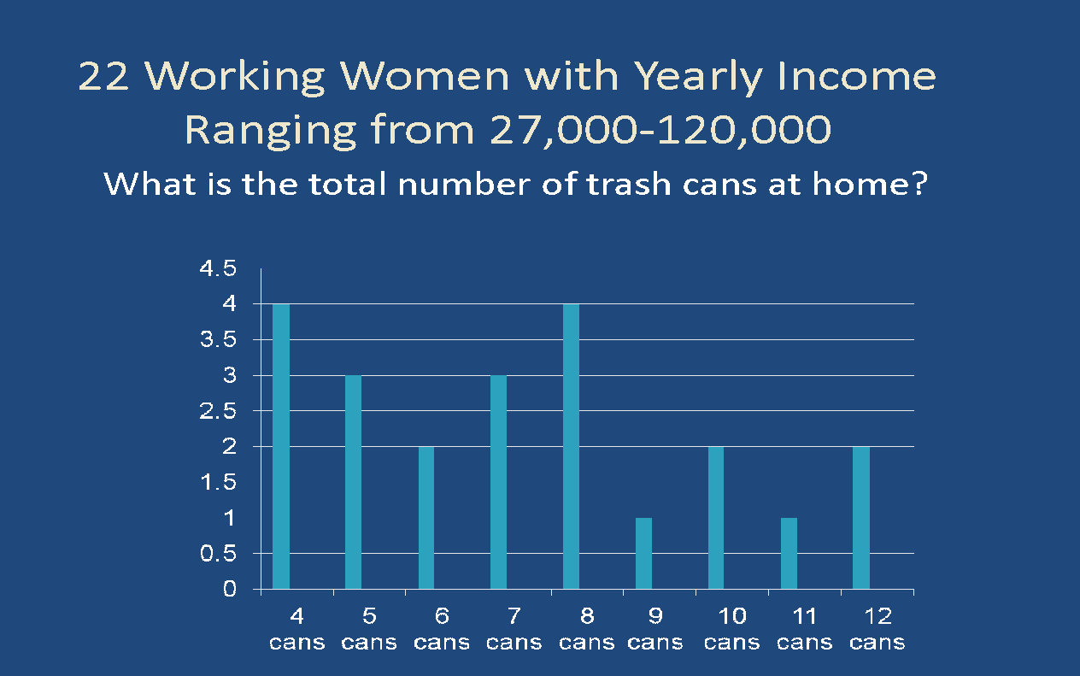

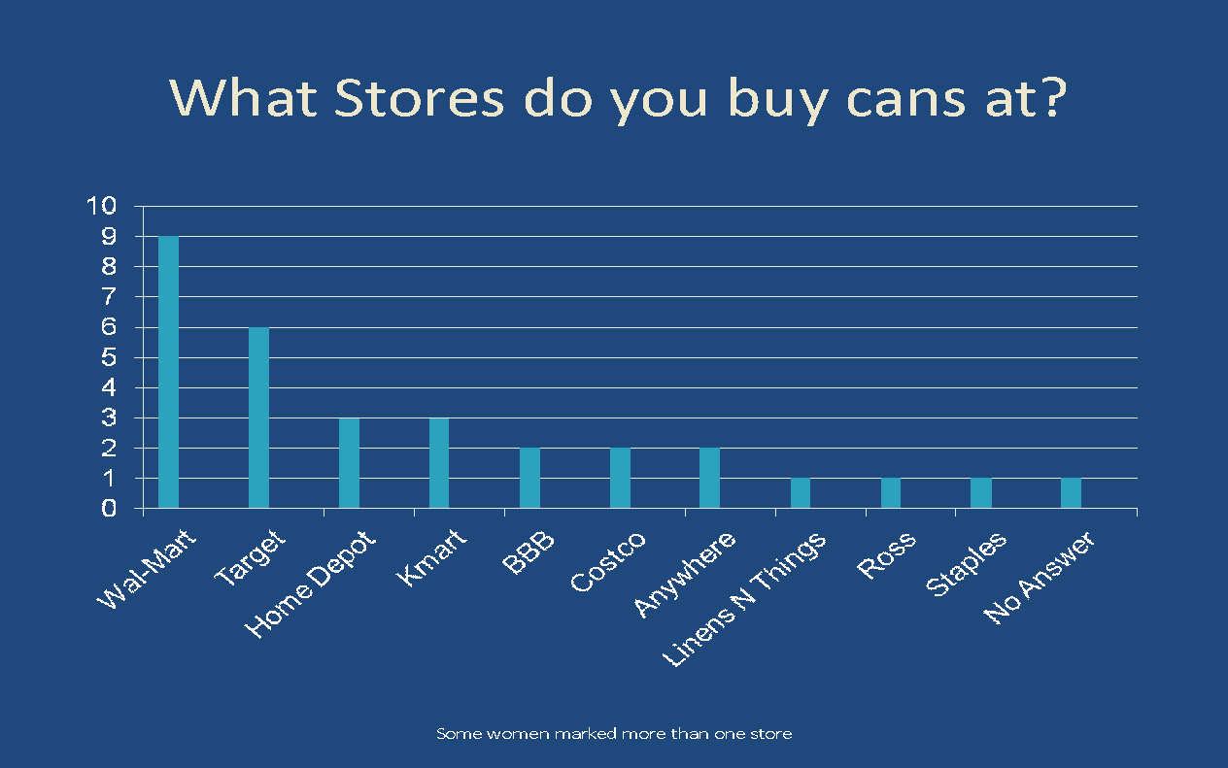

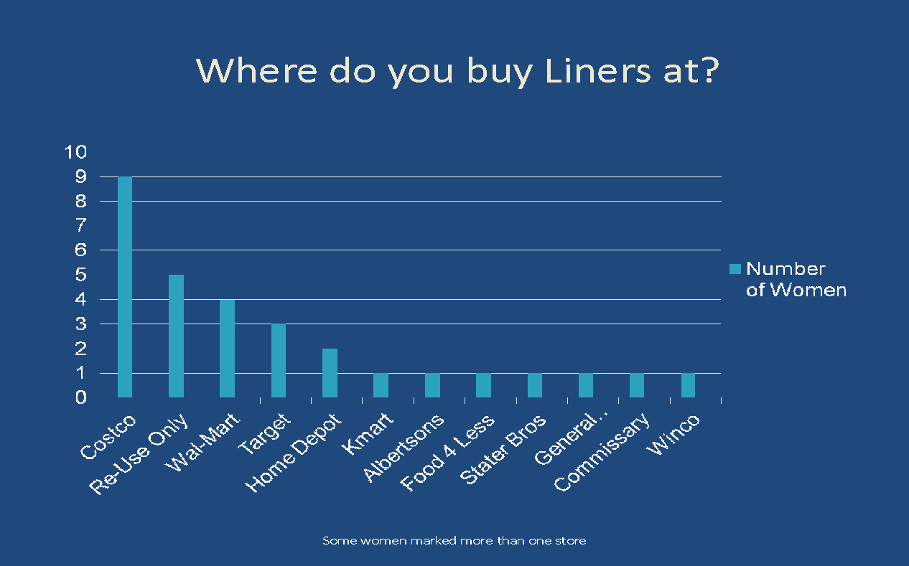

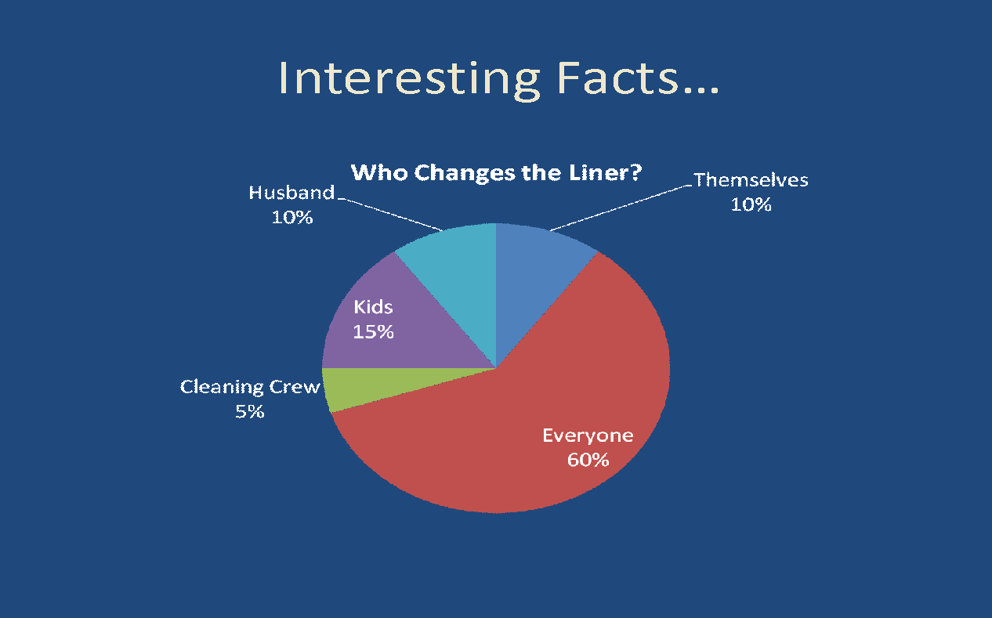

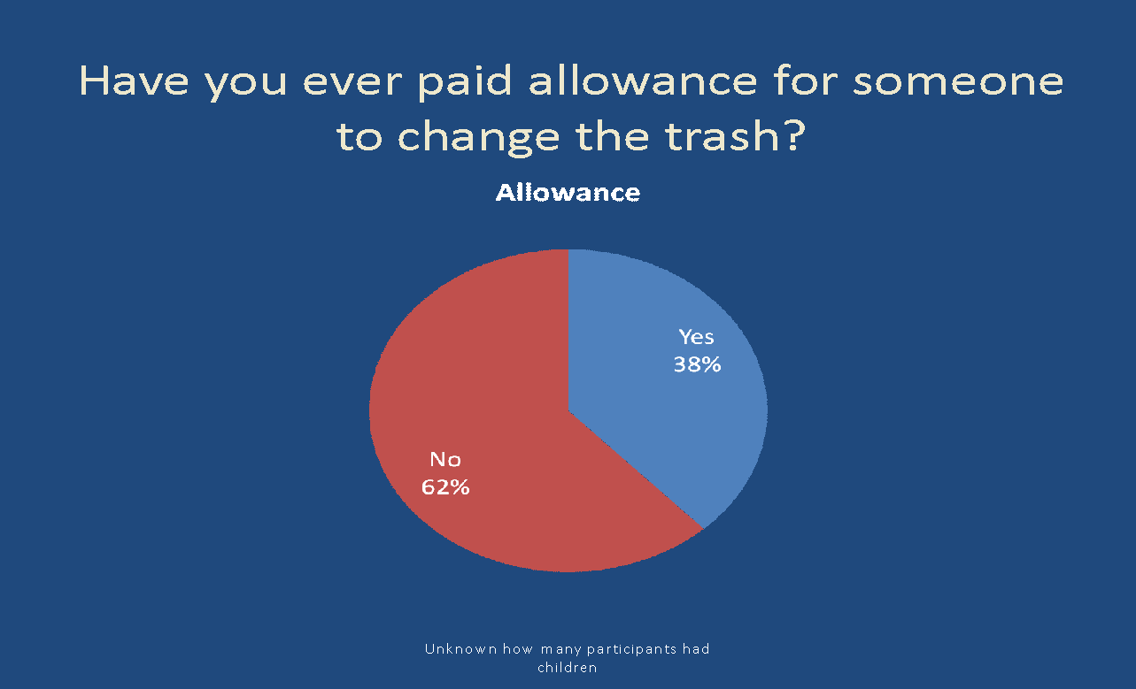

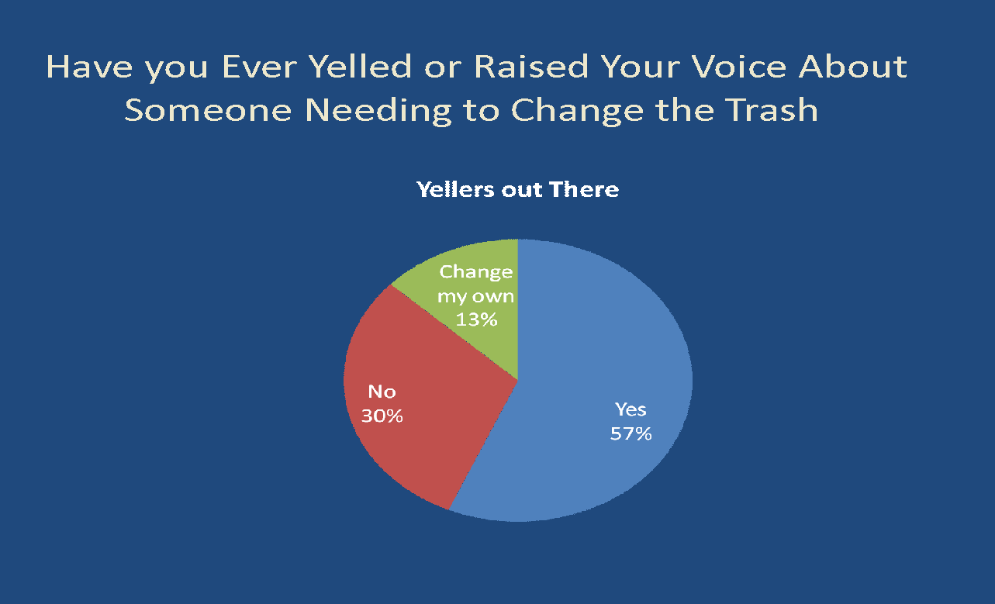

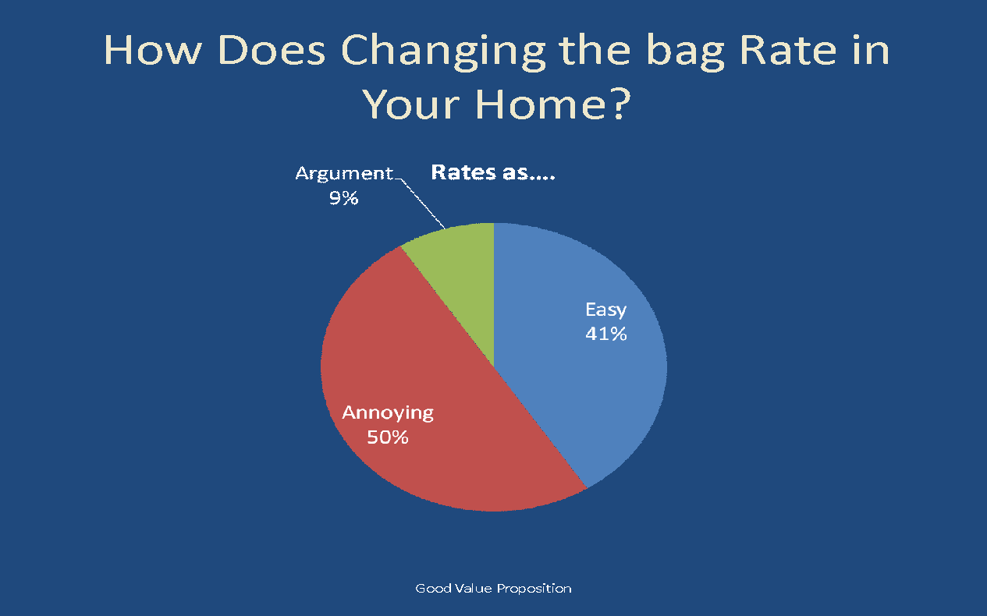

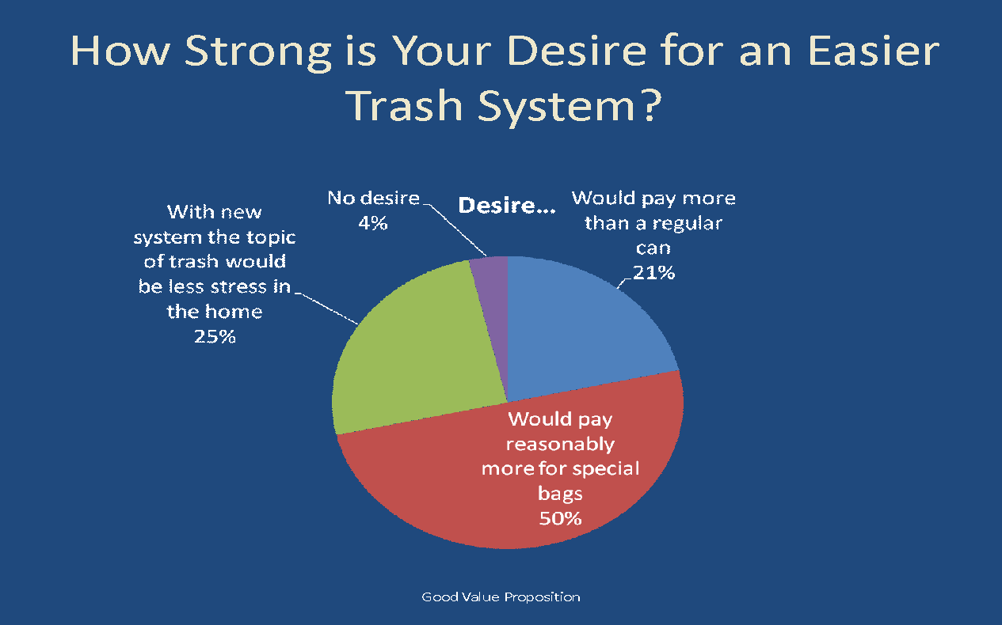

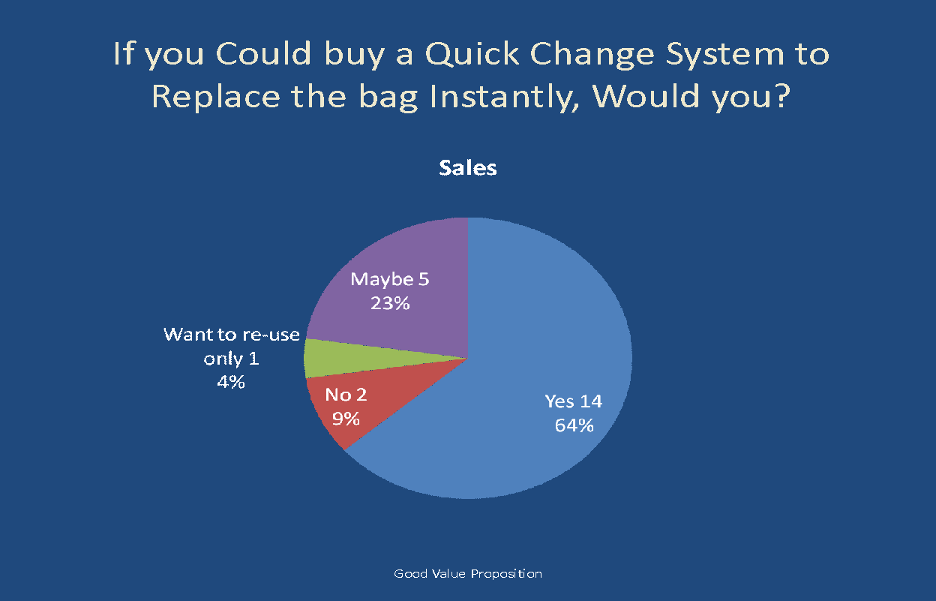

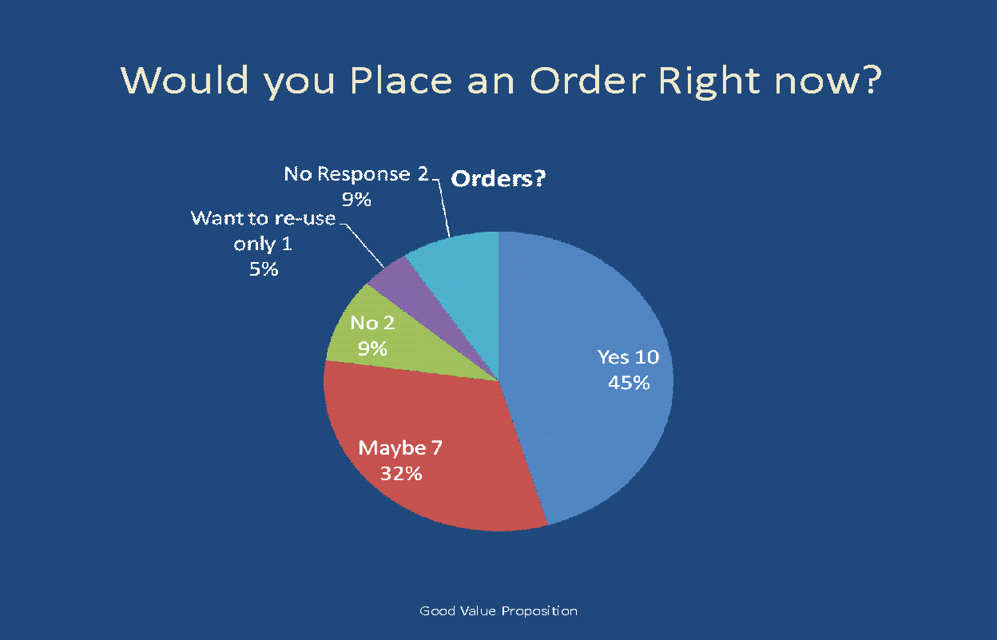

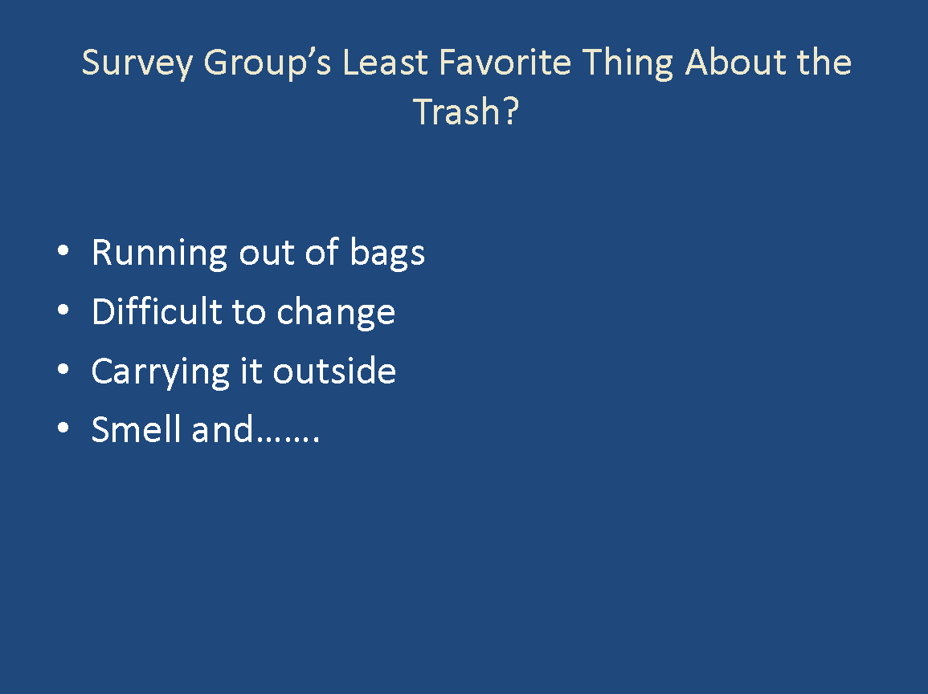

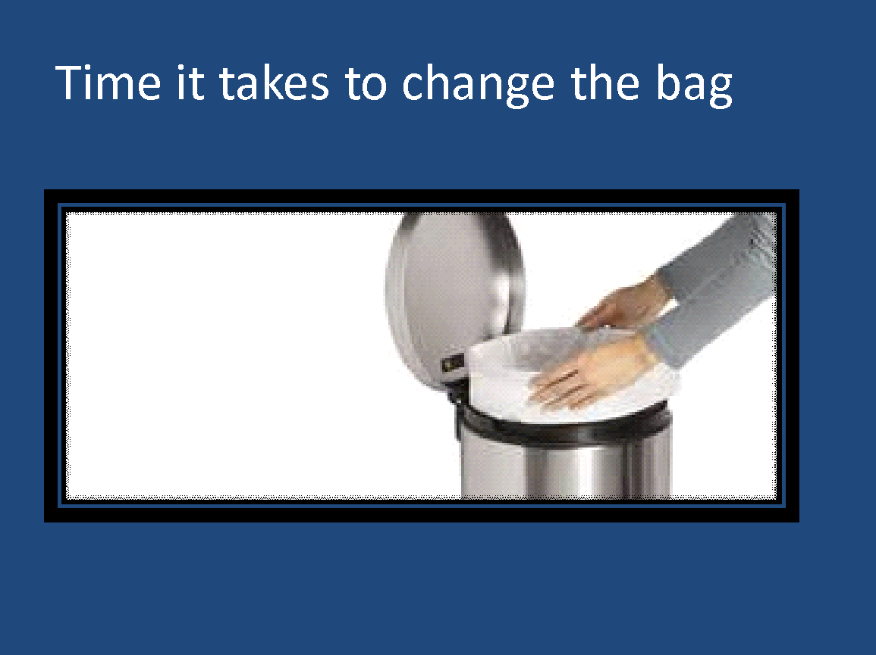

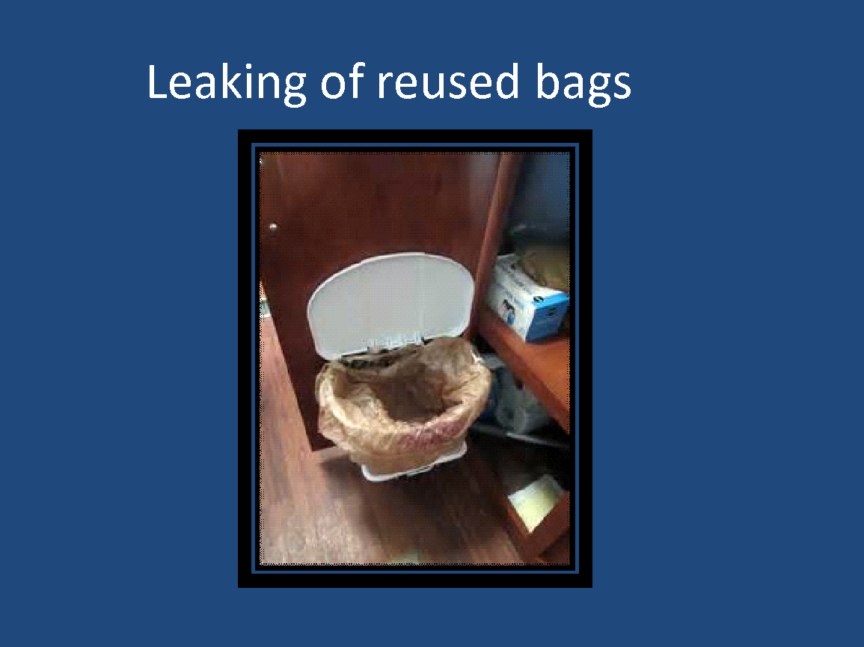

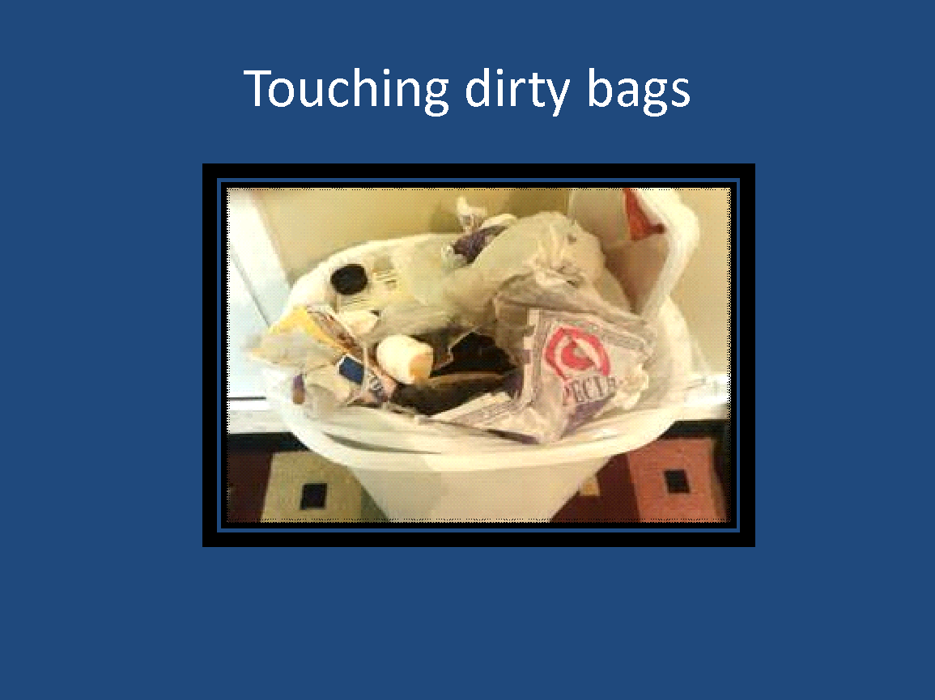

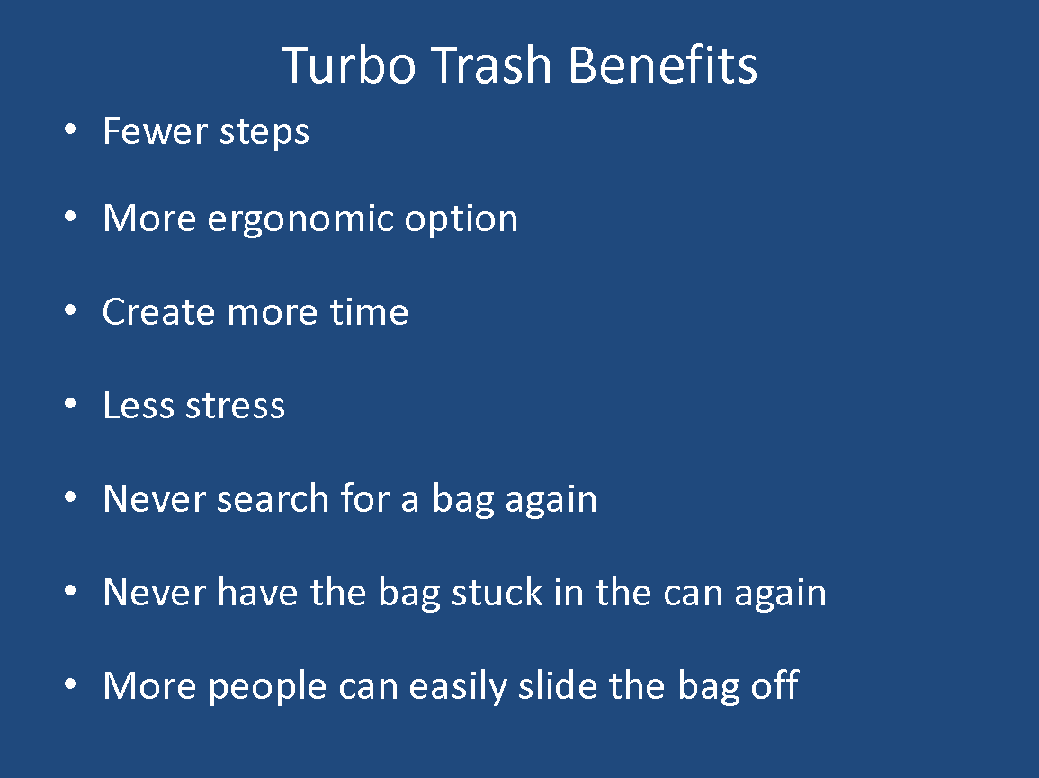

**First go to this link to watch the demo of how the inside of the trash can functions. There are several models that are being patented but this is the inside functional parts of the trash can if the exterior is removed. Go to:** [**https://www.dropbox.com/s/sdpad6dzwrrkemd/short%20clip%20of%20bag%20changing.wmv?oref=e&n=144620706**](https://www.dropbox.com/s/sdpad6dzwrrkemd/short%20clip%20of%20bag%20changing.wmv?oref=e&n=144620706) **(if problems email** [**dejascastro@yahoo.com**](mailto:dejascastro@yahoo.com) **for a link to be sent)**

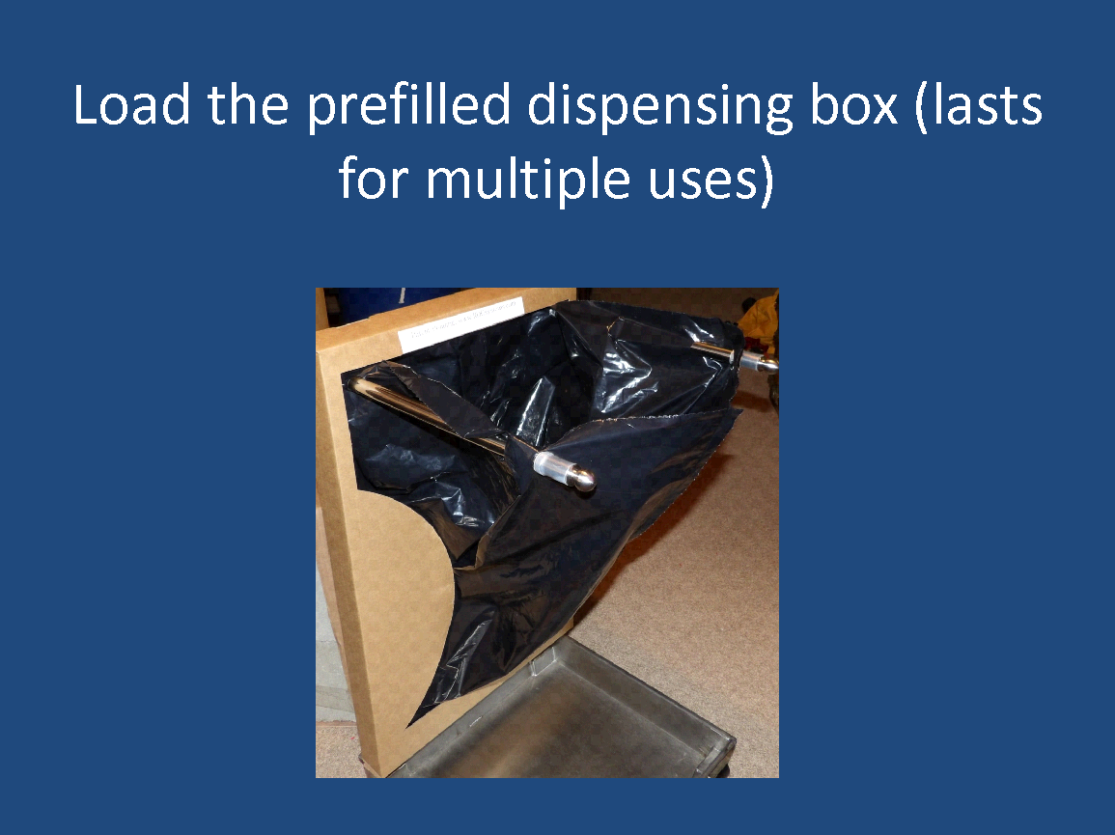

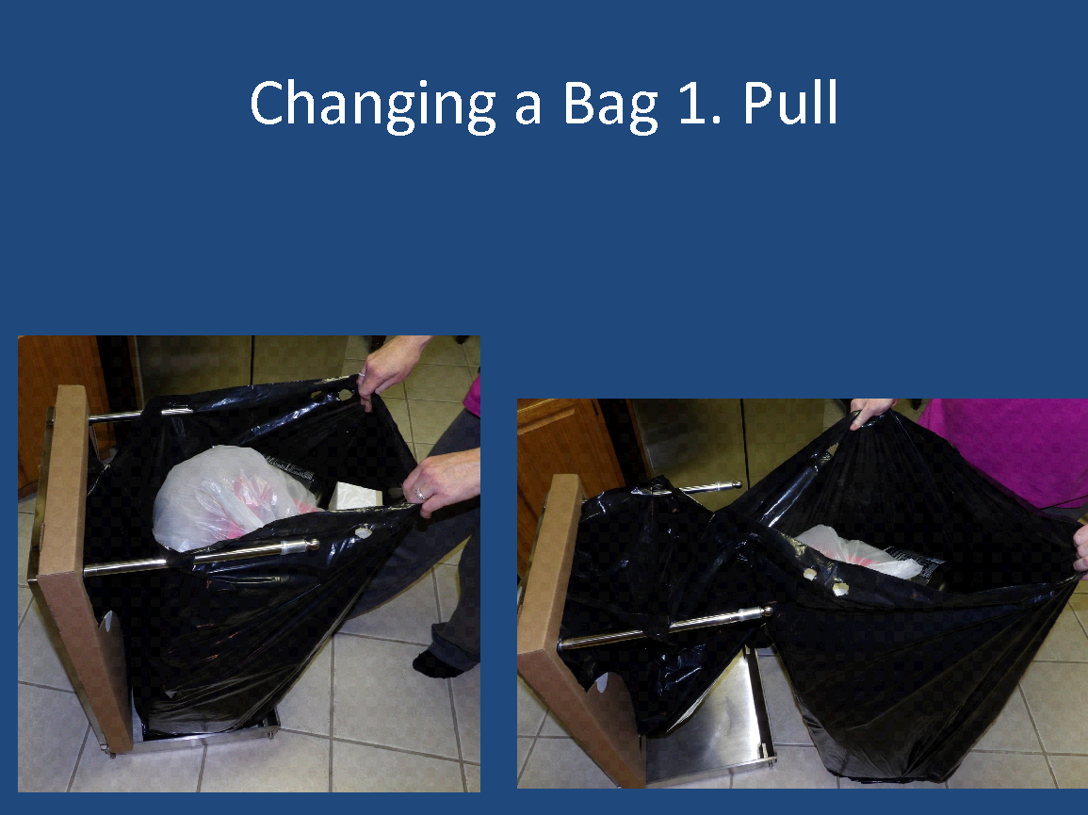

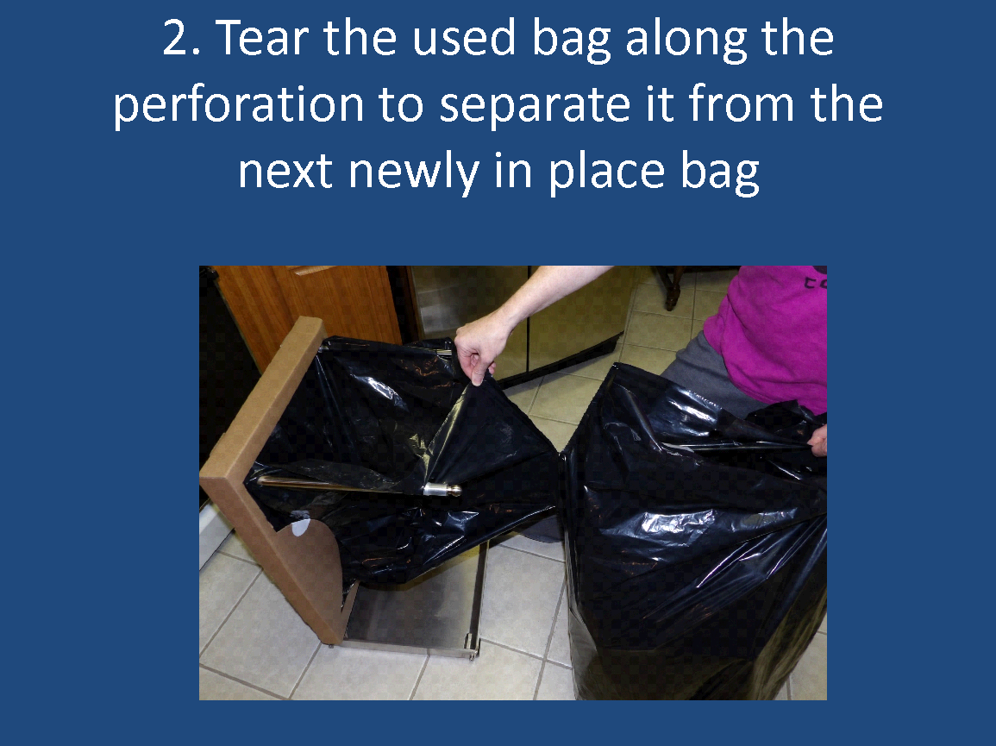

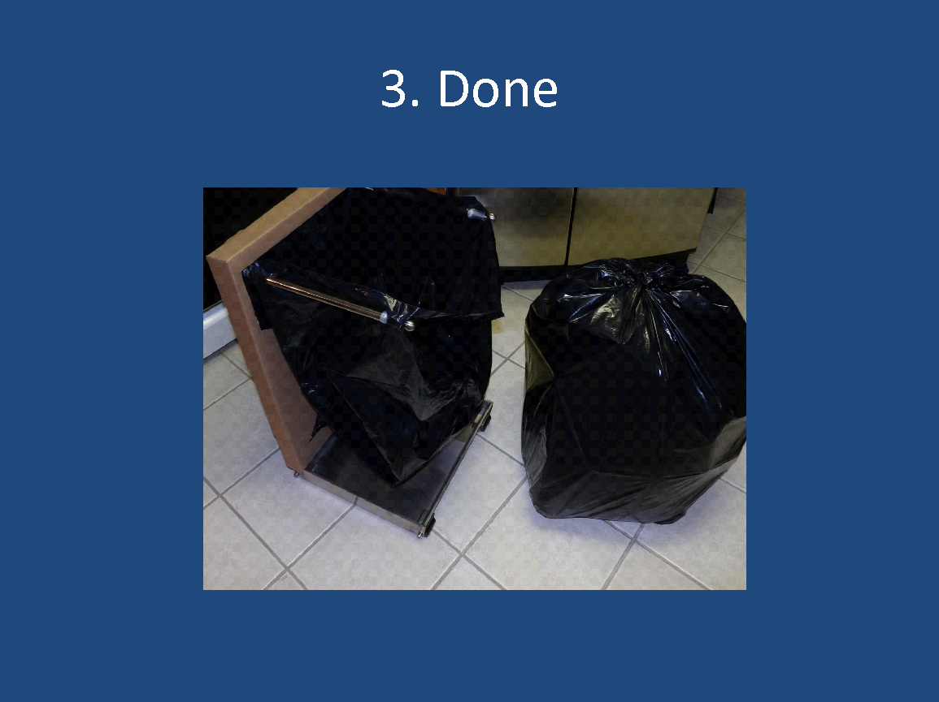

**This model would be placed inside a cabinet but most models are made for the household use, camping use, custom kitchen cabinetry “hidden trash” concept, see artwork of potential embodiments.**

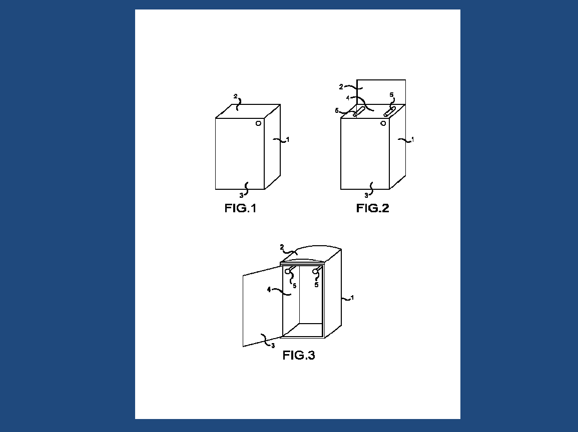

**Kitchen trash can of any type of material with door to access the hidden bars**

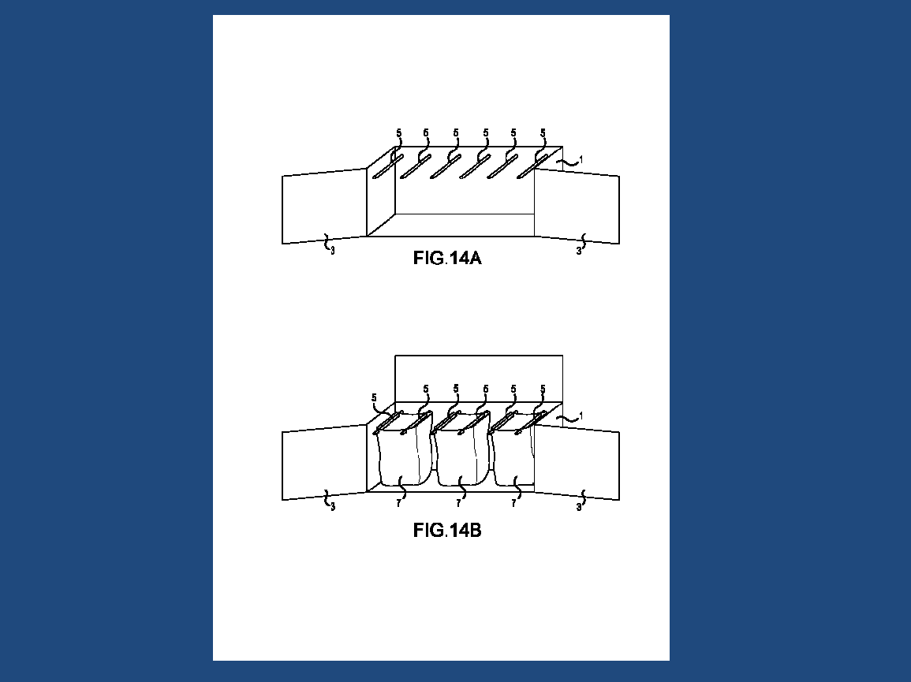

**This is for people who want a receptacle that has recycling, trash, and compost if desired with the same fast changing bag concept**

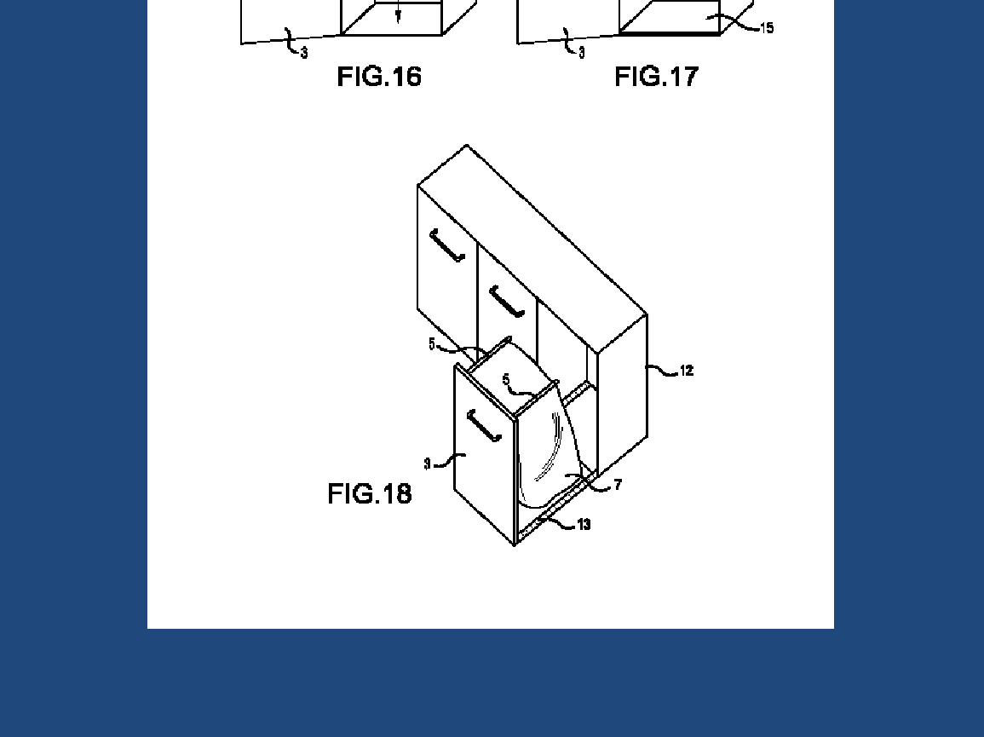

**This is the bar concept being installed in any home cabinet in the kitchen or bathroom to convert it into a hidden receptacle that uses the boxed bag dispenser with no need for a can**

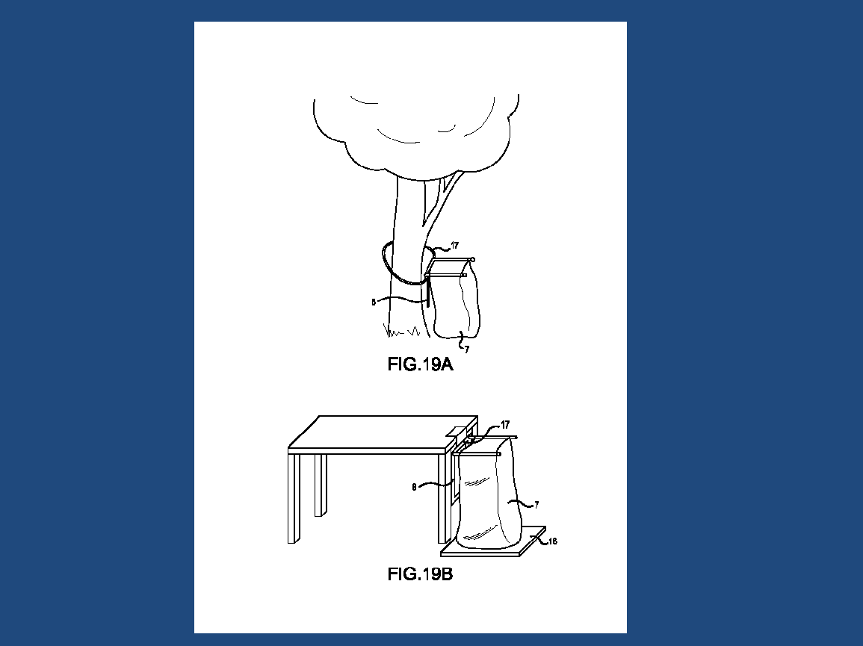

**This is a family’s dream of a portable, collapsible version of the bar system than can attach by any means to picnic tables, fences, pop up tents, tail gates, etc. to be able to use the box bag dispensing system without cans while on the go- it has a lid and drip tray if desired**

**Product:**

RDC Systems has patented bags that will evolve the trash changing process. With patent pending innovative receptacles and these new bags in place, every time someone removes a full trash bag the next new bag will be in position instantly. The main attraction to this new trash system is the time and energy it saves. Minutes become seconds literally. The ergonomics of the trash removal are now horizontal versus vertical so the potential for back injury is reduced. It is easier for people of all ages to remove the bag from the receptacle.

**Customers:**

There are over 123 million homes in the United States alone. People do not like this chore and just like Swiffer made a chore very easy and has over 37 million customers, this product will become a favorite among all ages.

**What Drives Us?**

Developing attractive receptacles with custom bags people love using. We create a value for people by saving them time, energy, hassle, risk of injury, and allow them a fast way to change trash with minimal life disruption. Imagine a family where no one leaves the can empty after removing the bag and walking away.

**Mission Statement:**

To make trash changing fast, easy, and fun. To enable people who may have disadvantages physically to be able to change their trash again.

**Principal Members:**

Deja Castro, Owner

Richard Castro, Owner

Tibor Nagy- Engineer, Advisor

Jay Goth- Tri Tech, SBA Consultant

Andrea Hence Evans, Attorney

**Legal Structure:**

LLC

**Industry:**

Trash/ Waste Industry- Home Solutions, Cleaning

**Customers:**

300 million + people in the United States who have trash cans

**Competitors:**

Rubbermaid, Hefty, Better Homes, etc. They use the standard can with regular bags either connected top to bottom by perforation or single use bags pulled loosely out of a box. All require a person to position the bags around the rim one by one.

**Competitive Advantage:**

Utility patent granted on the special tear and toss style bags with international rights reserved. Patents pending on the different style receptacles that hold the special tear and toss bags, and a patent in process for the dispensing package that fits onto the receptacle.

**Product:**

Trash receptacles available in various embodiments

Tear and toss style refill bags

Pricing Structure Estimates:

Receptacle for kitchen- cost $35 Retail- $159

Trash bags 30 a box- cost $2.50 Retail- $10

**Product Stage:**

Functional prototypes of receptacle, packages, and tear and toss bags

**Intellectual Property:**

Granted Utility Patent: Perforated tear and toss style bags

International rights reserved

Pending patents on: Various Receptacles designed to hold the special bags, and pending on the packages

**Growth Strategy:**

Primary: License the IP rights

Secondary: Work with distributors/ wholesale, sale direct via ecommerce

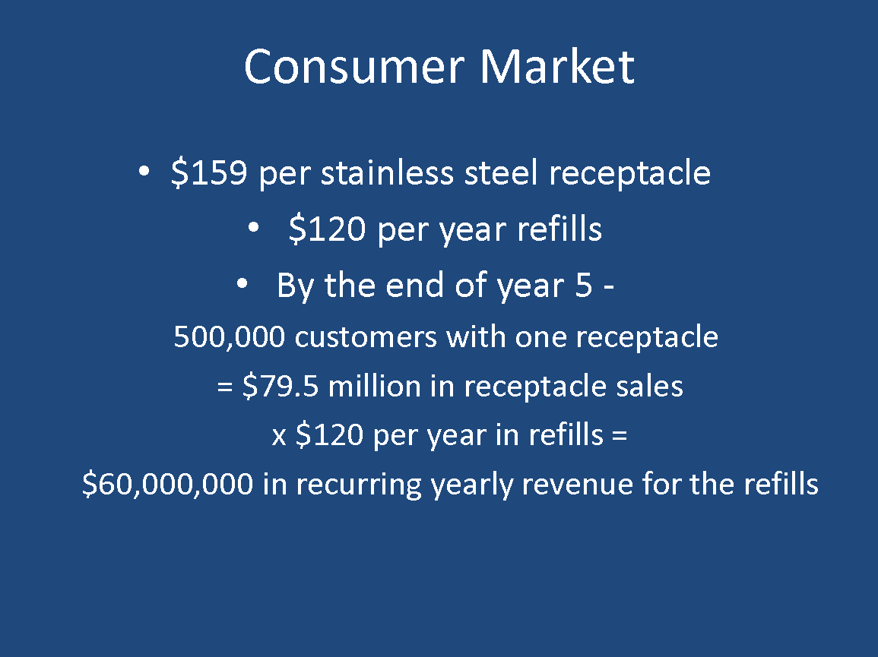

**Financial Assumptions:**

Company is ran from home

Owners do not collect a paycheck

Company is bootstrapped entirely as of date (3.5 years)

Money is used to complete patent protection- Utility patents with international PCT in process

Primary objective is the protect the invention and license it for royalties

**Financial Projections with 5% licensing with Consumer Products Manufacturer with R&D, Marketing, Manufacturing, and Distribution in place**

|  |  |  |  |
| --- | --- | --- | --- |
| **Licensor Profit** | **Year 1**  **Start up with licensee no sales/ product development** | **Year 2**  **With advertisement and distribution provided by licensee**  **150,000 customers one receptacle each, monthly refills purchased** | **Year 3**  **With continued advertisement and expanded distribution provided by licensee**  **500,000 additional customers one receptacle each and recurring refills monthly along with 150,000 customers from year 2** |
| **5% of gross sales of receptacles** | 0 | 1,192,500 | 3,975,000 |
| **5% of gross sales of**  **Special bags recurring revenue** | 0 | 900,000 | 3,900,000 |
| **Total royalties** | 0 | 2,092,500 | 7,875,000 |

|  |  |  |  |
| --- | --- | --- | --- |
| **Licensor Expenses** | **Year 1 (upcoming)**  **Licensor patent fees** | **Year 2**  **Licensee covers all fees and extensions internationally for all patents** | **Year 3**  **Licensee covers all patent expenses.** |
| **Patent Bag** | 25,000 | 0 | 0 |
| **Patent Package** | 4,000 | 0 | 0 |
| **Patent Receptacle** | 12,000 | 0 | 0 |

**The Future:**

This system includes the bag, the package, and the receptacle that all work in harmony to produce an easy and fast trash changing experience. While the consumer will enjoy the many benefits and be a faithful customer out of convenience, the commercial market will flock due to the money savings. This product will easily hit the commercial fast food markets, the industrial market, and create the ability for employees to change several receptacles in the time it use to take for one. People will not be bothered any longer while eating in a dining room at a fast food place due to the long smelly trash changing episode that is happening near them. Turbo trash has been long overdue and just like Swiffer it will make fans out of many people. Not everyone mops and dusts….but everyone makes trash!