Optimizing handheld sequencing technology for rapid detection of AMR for clinical decision-making

Tim Ford and Steve Hamner, UMassachusetts Amherst

Rita Colwell, Manoj Dadlani and Nur Hasan, CosmosID

Jennie Ward-Robinson, Areana Quinones and Linda Cleboski, PAHO Foundation

Michael Franklin, Montana State University

***Executive summary***

Antimicrobial resistance (AMR) is considered by many to be one of the most serious pandemic health risks today. There is a particularly acute problem in the Latin American and Caribbean regions (LAC), where access to diagnostic tools may be limited or non-existent. Advances in miniaturization of sequencing tools and ultra-fast bioinformatics analysis provide new opportunities to develop rapid, accurate, reproducible and actionable monitoring tools for both pathogen detection and the presence of genes that convey antibiotic resistance. We propose the development of a handheld diagnostic tool that combines “state-of-the-art” technologies with some of the most advanced bioinformatics tools available today for rapid clinical decision-making, that is both applicable for use in a fully equipped clinical laboratory and in a LAC rural, mobile or backpack clinic.

***Proposed in vitro diagnostic, development approach, challenges, and risks***

This proposal describes a collaboration between UMassachusetts Amherst, CosmosID, the PAHO Foundation (PF) and Montana State University to combine commercially available, miniaturized sequencing equipment by Oxford Nanopore Technologies with state-of-the-art bioinformatics tools developed by CosmosID, and optimize the analysis for both pathogen and antimicrobial resistance gene detection. Optimization will begin in Step 1 using commercially available clinical samples spiked with AMR bacterial isolates, and continue in Step 2 using de-identified clinical samples obtained from PF’s partner clinics in the LAC region, where AMR resistant infections have already been diagnosed and validated by traditional approaches to antimicrobial susceptibility testing. Control samples will be obtained from patients served by the same clinics that do not present with AMR infections.

*Sequencing platform*

Oxford Nanopore Technologies MinION device is described by the manufacturer as the “only portable, real time device for DNA and RNA sequencing.”

The MinION is attached to a laptop computer and generates 5-10Gb of DNA sequence data that is streamed in real time to allow almost instantaneous analysis. This handheld device weighs under 100g and is ideally suited for field use without the constraints of a laboratory environment. The instrument is commercially available and development of new applications is supported through an active, online “Nanopore” community (https://nanoporetech.com/products/minion; see supporting letter, Appendix 1).

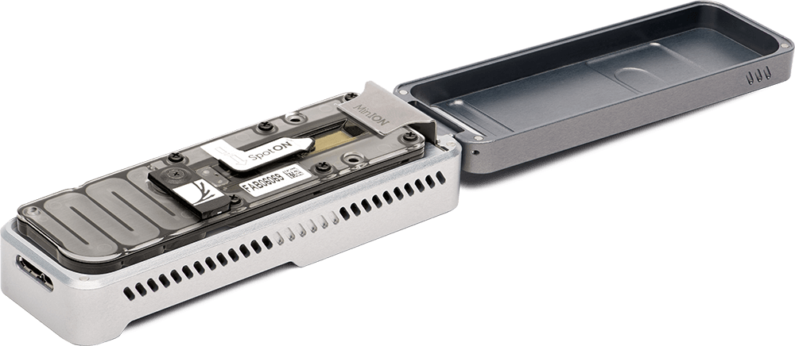



The technology shows tremendous promise, but work needs to be done to optimize the process for routine clinical use and for the field. A recent report by Schmidt and co-workers in the UK demonstrated the use of the MinION for identification of bacterial pathogens and antimicrobial resistance directly from heavily infected clinical urine and a healthy urine sample spiked with 108 MDR *E. coli.*  The challenges described by the research team, include 1) the need to remove human DNA to improve bacterial sequence yield, 2) the use of heavily infected urines in order to produce enough bacterial DNA for sequencing, 3) poor distinction between allelic variants, and 4) the fact that a gene may be present does not imply resistance. In addition, the MinION cells are essentially single use, and the cost is high at $500-$900 a cell. There is now an option for mulitiplexing of 12 samples, reducing per sample cost, which will extend turnaround time.[1]

Oxford Scientific Technologies are constantly innovating in the area of sample preparation, sequencing accuracy, and costs savings. They have just released an updated MinION flow cell with faster, more accurate reads. In the area of sample preparation, their VolTRAX™ system is a “rapid, programmable, portable, disposable sample processor,” designed to rapidly prepare samples for the MinION with minimal user interaction. The company introduced this device to their community base in December, 2016. In addition, in Summer 2017, they will be releasing the Zumbador, a pen-sized device that combines sample and library preparation and directly delivers DNA into the sequencer flow cell.  Around the same time, they anticipate releasing the SmidgION, which is a smart phone-powered sequencer that is smaller than the MinION. All this innovation, while in need of extensive field-testing and optimization, together with improvements in multiplexing, is expected to lead to a rapid, field-ready instrument that we anticipate will eventually be affordable for routine clinical use.

*Bioinformatics platform*

Oxford Scientific Technologies is producing instrumentation that will allow for rapid generation of sequence data from clinical samples. The key to an effective tool for clinical use is bioinformatics analysis of these data that is sufficiently rapid, accurate and sensitive to provide practitioners with reliable information to inform critical healthcare-related decisions, especially in field application.

The CosmosID software platform provides microbial identification at the subspecies/strain level and AMR and virulence gene characterization from raw, unassembled WGS sequence reads. It uses high performance bioinformatics algorithms as well as curated databases to provide rapid, accurate identification. For clinical samples, analysis can be done on a laptop computer or in the web cloud to provide results in minutes.

CosmosID’s Genbook database has over 65,000 microbial genomes. Furthermore, Genbook has antimicrobial resistance and virulence gene databases with 4500 sequences. The databases are populated from many sources, including public reference databases such as NCBI, ENA, PATRIC, CARD, ARDB, and VFDB, and are updated on a regular basis. Additionally, when reference sequences are collected for an update, they undergo a rigorous curation process to remove contaminated and erroneous sequences. An example of a CosmosID AMR analysis is shown in table 1.

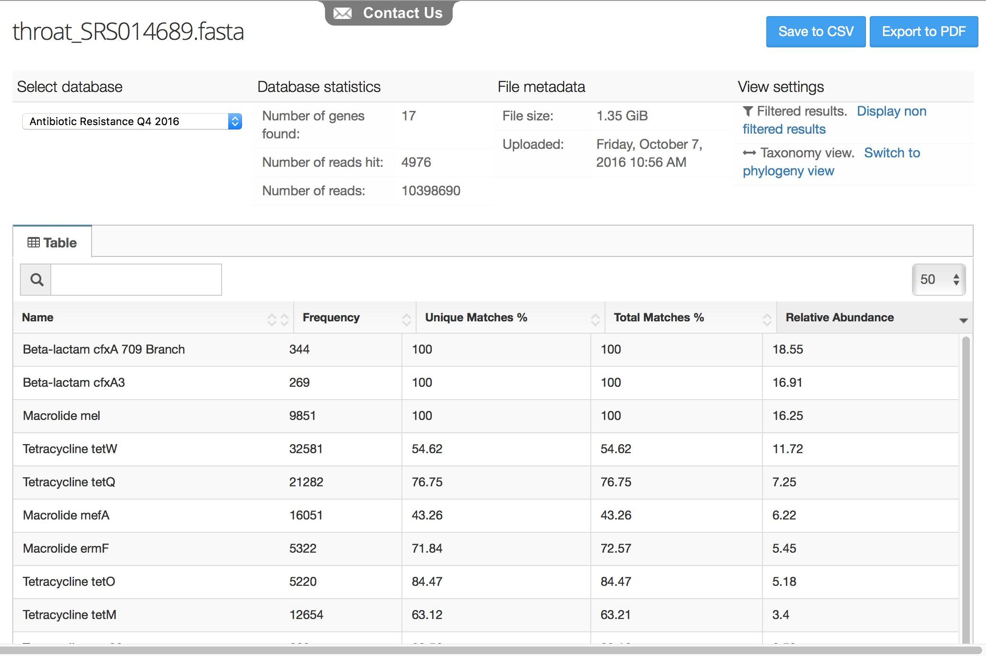



CosmosID is actively developing new tools to keep up with the new advances in sequencing technology. An algorithm, specifically designed for Oxford Nanopore data, has been developed. 

*Development approach*

Step 1 of this program will focus on the integration of the CosmosID platform with the MinION platform. For this part of the work, pooled clinical samples of normal urine will be obtained from Lee Biosolutions Inc., (Maryland Heights, MO) and will be spiked at varying concentrations with known microorganisms. Initial work will focus on carbapenem-resistant *Enterobacteriaceae*, available from the American Type Culture Collection (ATCC, Manassas, VA). As the work progresses, urines will be spiked with mixtures of CDC’s AMR threat level pathogens, also available from ATCC, and depending on the pathogen of interest, other clinical samples will be obtained from Lee Biosolutions Inc., i.e., normal saliva for MDR TB.

Most of the work will focus on optimizing the interface between the MinION sequence reads and the CosmosID cloud-based bioinformatics analysis for specific pathogens, their relative abundance and correlating specific pathogens with AMR potential. As different lineages of the same microbial species can confer different AMR patterns, our algorithm utilizes pairwise sequence similarities of the resistome gene, single nucleotide polymorphism signature, and/or flanking sequences aided by long MinION reads to identify both the specific resistance gene and the specific agent within the entire microbial community carrying the resistance gene.

CosmosID’s software uses a high-performance data-mining algorithm to provide fine-grained resolution of the composition of a metagenomics sample that is highly specific to the subspecies and strain levels.[2],[3]

*Challenges and risks*

A critical challenge is to develop a methodology with sufficient sensitivity to detect low levels of AMR pathogens that present a significant health risk. Both the hardware and software methodologies are constantly being refined and improved to meet this challenge. Our expectation is that at the very least, a system can be developed that can target one of the 18 drug-resistant bacteria of highest concern at a time, even if the complete microbiome in a clinical sample remains difficult to evaluate due to presence of human DNA or other confounding factors.

*Human subjects*

Human subject approval will not be required for this work, as method development will be conducted on de-identified, pooled clinical samples obtained from Lee Biosolutions Inc., spiked with ATCC AMR pathogens.

*Inclusion of women, children and minorities*

Not applicable as above. Clinical samples supplied by Lee Biosolutions Inc., may be from single males, females, children or pooled. At this point, no selection criteria will be used as we will be ordering the samples simply as biological matrices and will select specific products based on availability and price.

**“State-of-the-Art” statement**

***(1) Approaches currently in use***

Traditionally, antimicrobial resistance has been detected indirectly in vitro by antimicrobial susceptibility testing, which detects antimicrobial resistance in individual bacterial isolates.[4] There are limitations to this approach in that pathogens are never in “pure culture” during the course of an infection. The severe disadvantage of this approach is that it relies on the pathogen’s ability to grow in culture, including nutrient and time constraints that culturing implies.

PCR and hybridization techniques have opened up the possibility of direct detection of AMR genes in clinical samples, but the data obtained by these methods require caution in interpretation because presence of a gene does not imply expression. Our advances in molecular biology and bioinformatics over the last several years have made both sequence-based and function-based metagenomics increasingly popular for describing the microbiome in a wide range of both clinical and environmental samples and in screening, for example, for specific proteins involved in antibiotic resistance.[5],[6],[7]

Current research approaches use bioinformatics analysis of nucleic acid information prepared by shotgun sequencing using advanced instrumentation. As such, the techniques and analysis are both expensive and time consuming, and although bench top instrumentation now exists for focused applications such as Illumina’s MiSeq system,[8] the procedures can hardly be considered portable and adaptable for field use, i.e., rural clinics where the needs are greatest.

***(2).*** ***How the methods and measures proposed will outpace/outperform current advancements***

There are currently no methods for rapid, onsite assessment of antimicrobial resistance. The combination of Oxford Nanopore Technologies MinION (or later, SmidgION) sequencing platform, together with the Oxford Nanopore VolTRAX system (or later, Zumbador), currently under development for automated sample preparation, will provide rapid, real-time DNA and RNA sequence information that can be obtained in the field. CosmosID then provides the cloud-based platform to analyze the sequence data to rapidly profile microbial communities, including pathogens, their relative abundance and the presence of anti-microbial resistance genes.

***(3).*** ***A useful tool for rapid clinical decision making***

Information on AMR for clinical samples can be obtained in six hours or less, allowing clinicians the ability to make rapid treatment decisions. The potential to identify all microorganisms, antibiotic resistance and virulence genes in one clinical sample in real time post-sequencing is unique and will lead to a much more effective diagnosis for patients with multiple infections. The ability to assess whether non-pathogenic microorganisms present a potential risk through harboring AMR, will also be important for designing a program of patient care.

***(4).*** ***Provide potentially quantifiable improvements beyond existing capabilities***

The algorithms used in the CosmosID approach are unique, allow accurate identification of all pathogens to subspecies and strain level, with comparative analyses achieved through algorithms, heat maps and principal component analysis. Currently, there is no easily field-deployable methodology that can achieve this level of resolution, accuracy and actionable data to allow for rapid clinical decisions.

***Step 2***

Step 1 will benefit from significant matching funding from Ford’s new position as Chair of Environmental Health Sciences at UMass Amherst, where funding has already been allocated for purchasing Oxford Nanopore Technologies instrumentation. The major costs associated with this award, if successful will be additional equipment as needed, Lee Biosolutions Inc., ATCC, and other related lab supplies, and bioinformatics refinements. Once step 1 development is completed, we anticipate working with PF to identify areas of critical need where further application of the technology can be most appropriately tested with clinical samples.

The following process for successful completion of step 2 is proposed:

1. Refining the methodology will continue in tandem with any further developments by Oxford Nanopore Technologies in, for example, miniaturization, portability for sample processing, library development and sequencing.

Timeframe:

* continuous

2. PF is leading the development of a multisector initiative to support LAC countries to contain and combat antimicrobial resistance. PF is currently working with health ministries, hospitals and clinics throughout the region to broaden the understanding of current issues and build the case for action for AMR in the region. A key focus for this initiative is to document and share the current status of AMR, the challenges and resource gaps. To this end, surveillance methodology is needed to evaluate the extent of AMR throughout the region.

Agreements will be developed between PF and clinical affiliates in the region to share de-identified clinical samples from patients where AMR outbreaks are occurring and control groups where no AMR infections are apparent. PF’s intention is to work with both low-income countries such as Haiti, and with countries with more fully developed healthcare systems such as Argentina, which has already completed an AMR national plan, and Columbia. Specific countries/communities that will be involved in this project are not yet identified as PF has only just begun its AMR initiative over these last several months. A high level summit is anticipated in summer 2017, where agreements will be finalized.

Samples will be identified only in relation to specific diagnoses conducted using current methodologies available to clinicians at the time. All results will be carefully compared with more traditional AMR diagnostics for quality control, which may include automated systems and Illumina sequencing.

Timeframe:

* Specific PF partnerships established with hospitals/clinics in the region: January 2017 - September, 2018 (due date for Step 2 submission)
* Testing and refinement of CosmosID bioinformatics/Nanopore technologies: December 2018 – January 2020
* Validation of results using more conventional methodologies and comparison with original diagnoses: December 2018 – January 2020
* Analytical performance report and Step 3 preparation: Fall 2019

*Human subjects*

Human subject approval will not be required for this work, as testing will be performed for method development purposes only, on excess routine clinical samples from both AMR pathogen-infected patients, and patients who test negative for AMR infections. These samples will be obtained directly from clinical laboratories from the LAC region that have established a prior agreement with PF. The results of specific clinical tests to determine presence of pathogens and/or AMR will be provided with each sample, otherwise all samples will be de-identified.

*Inclusion of women, children and minorities*

Not applicable as above. The only selection criteria at this stage is to obtain clinical samples from an approximately equal number of AMR infected and non-infected subjects from a range of different LAC communities.

1. Schmidt K, Mwaigwisya S, Crossman LC, Doumith M, Munroe D, Pires C, Khan AM, Woodford N, Saunders NJ, Wain J, O'Grady J, Livermore DM. Identification of bacterial pathogens and antimicrobial resistance directly from clinical urines by nanopore-based metagenomic sequencing. J. Antimicrob.Chemother. (2016)doi: 10.1093/jac/dkw397
2. Hasan NA, Young BA, Minard-Smith AT, Saeed K, Li H, Heizer EM, McMillan NJ, Isom R, Abdullah AS, Bornman DM, Faith SA, Choi SY, Dickens ML, Cebula TA, Colwell RR.Microbial community profiling of human saliva using shotgun metagenomic sequencing. PLoS One. 2014 May 20;9(5):e97699. doi: 10.1371/journal.pone.0097699.
3. Ponnusamy D, Kozlova EV, Sha J, Erova TE, Azar SR, Fitts EC, Kirtley ML, Tiner BL, Andersson JA, Grim CJ, Isom RP, Hasan NA, Colwell RR, Chopra AK. Cross-talk among flesh-eating Aeromonas hydrophila strains in mixed infection leading to necrotizing fasciitis. Proc Natl Acad Sci U S A. 2016 Jan 19;113(3):722-7. doi: 10.1073/pnas.1523817113.
4. Coyle MB (ed). Manual of Antimicrobial Susceptibility Testing. American Society for Microbiology. 2005.
5. Fluit AC, Visser MR, Schmitz F-J. Molecular Detection of Antimicrobial Resistance. Clinical Microbiology Reviews. 2001;14(4):836-871. doi:10.1128/CMR.14.4.836-871.2001.
6. Barišić I, Schoenthaler S, Ke R, Nilsson M, Noehammer C, Wiesinger-Mayr H.

   (4). Multiplex detection of antibiotic resistance genes using padlock probes. Diagn Microbiol Infect Dis. 2013 Oct;77(2):118-25. doi: 10.1016/j.diagmicrobio.2013.06.013. Epub 2013 Aug 12
7. Card RM, Warburton PJ, MacLaren N, Mullany P, Allan E, Anjum MF. Application of Microarray and Functional-Based Screening Methods for the Detection of Antimicrobial Resistance Genes in the Microbiomes of Healthy Humans. Aziz RK, ed. PLoS ONE. 2014;9(1):e86428. doi:10.1371/journal.pone.0086428.
8. Miller RR, Montoya V, Gardy JL, Patrick DM, and Tang P. Metagenomics for pathogen detection in public health. Genome Med. 2013; 5(9): 81. Published online 2013 Sep 20. doi: 10.1186/gm485. PMCID: PMC3978900