**Child Day Care Services Business Plan**

**Academy of Blessings Day Care**

# Table of Contents

1. **Executive Summary**……………………………………..………………………………………….........….3
   1. Objective Mission
   2. Keys to Success
2. **Company Summary**....................................................................................................4
   1. Company Ownership
   2. Start Up Summary
   3. Company location and facilities
3. **Services**……………………………………………………………………………………………………..…………8
   1. Service Description
   2. Competitive Comparison
   3. Sales Literature
   4. Fulfillment
4. **Market Analysis Summary**………………………………………………………………………………….9
   1. Market Segmentation
   2. Target Market Segment Strategy
      1. Market Needs
   3. Service Business Analysis
      1. Main Competitors
5. **Value Proposition** ……………………………………………………………………………………………..11
   1. Competitive Edge
   2. Marketing Program
      1. Marketing Program
   3. Promotion Strategy
   4. Price Strategy
      1. Sales Forecast
      2. Sales Program
   5. Strategic Alliances
6. **Web Plan Summary**……………………………………………………………..……………………………….15
7. **Management Summary**.....................................................................................................15
   1. Organizational Structure

8.0 **Appendix**

1. **Executive Summary**

Academy of Blessings Day Care® aims to give the children in attendance a safe haven to be creative and inspired. Unlike our competitors in the area, we offer care for infant through age twelve all in one place.

Academy of Blessings Day Care is a privately held corporation run by its owner, Leslie Robertson; Leslie has over fifteen years in the customer care industry and six years as a learning facilitator.

I am new to the Kingsport area and saw a need for a new type of daycare, raising two children I found it very difficult for children in different age ranges to be cared for under the same facility/ care center. While interviewing major franchised childcare facilities I witnessed inadequate level of care as well as no Prekindergarten curriculum was offered. The location was also problematic; there are no childcare facilities in the Rock Springs area and surrounding who offer transportation to and from John Adams Elementary. Surveying parents in the area, I found others felt the same as I, this neighborhood needs a facility. I will support the daily operations as the campus director for the first six months.

With inflation continuing to rise each year, the typical American family now requires dual or supplemental incomes. This trend has created a need for quality child care services. The population growth rate in Kingsport, Sullivan county in 2010-2014 was 2.41%/yr and has increased each year steadily, leading me to anticipate expanding market potential for this industry in our local area. Academy of Blessings Day Care® will compete well in our market by offering competitive prices, high-quality child care services, and leading-edge educational programs, and by maintaining an excellent reputation with parents and the community we serve.

Academy of Blessings Day Care® will initially focus on the Edinburgh Channel and the surrounding Rock Springs subdivisions which range from low to median income families. Our target customers are dual-income, mid-income families who value quality child care we provide for their children, ages 1 year to 12 years.

We are expecting to open for business in August 2017, starting with an initial enrollment of 50 children and continuous additions throughout the year. We project healthy revenues by the end of the first year and expect to nearly triple that by the end of 2018. Our biggest operating expenses will be compensation at industry standard rates for our highly-qualified personnel, and loan payments on our facility improved for our purposes during the start-up period. I would like to grow into two facilities, eventually, but growth is planned conservatively, financed from existing cash flow as we go. We anticipate a net profit beginning in our second year. We are seeking an amount in the form of an SBA loan or investors.

**1.1 Objectives**

* Sales are increasing to almost double by the end of Fiscal 2017.
* Maintain a high raw gross margin by the end of Fiscal 2018.
* Open the second campus by the end of Fiscal 2018.

**1.2 Mission**

Academy of Blessings Day Care® is a start-up daycare and will dedicate its efforts and resources toward ensuring top-rated care, coupled with a high-quality activity based learning environment tailored for children in their age groups.

**1.3 Keys to Success**

The keys to success for ABDC are:

Marketing: differentiating ABDC is the caregiving and educational services from traditional daycare offerings and interest activity programs.

Service quality: offering an outstanding level of care in which the children and parents are treated with respect and dignity.

Reputation: maintaining a highly regarded reputation for excellence in care giving, in which word of mouth will self-promote our business.

Profitability: controlling costs and managing budgets by company goals, adhering to strategic business plans for growth and expansion and reinvesting the business and its employees.

1. **Company Summary**

Academy of Blessings Day Care® - will be located in Kingsport, TN.

Premier Care Giving Services

An Activity Based, Children Structured Curriculum

Advanced Technology and Developmental Programs

Community Advancement and Involvement

The Rock Springs location will be a remodeled 4000+ square foot facility in the Royal Acres subdivision minutes from the elementary school John Adams and will be developed strictly meeting department of children services quality care and meeting the unique ABDC design standards.

* 1. **Company Ownership**

Academy of Blessings Day Care® is a privately-held limited liability, owned in majority by its founder and president, Leslie Robertson.

* 1. **Start-up Summary**

The daycare founder Leslie Robertson will oversee fiscal responsibility, employing an independent CPA for financial oversight.

The estimated start-up costs for ABDC will be **$700,000;** With **10% interest** on a **10-year term** with 1st payment starting February 01, 2018 and $120,000 balloon payment at the end of the loan term.

The loan term will render 120 monthly payments of **$8,664.74** with approximately **$ 2,831.41** toward the principal balance and **$ 5,833.33** toward interest each month rendering the total interest: **$459,769.13** and total payable **$1,159,769.13**

As reflected in the table below, the estimated start-up costs for KCC will be $700,000. An anticipated $100,000 SB Grant will be used as working capital. Future expansion and growth strategy will be self-financed.

**Start-up**

|  |  |
| --- | --- |
| Start-up Funding | 700,000 |
| Funding Expense | Projected Expense Balance |
| Facility Purchase  (Will include the Facility and the owner home in listing MLS# 367717) | $300,000 |
| Trash Removal from the Purchased Business | $10,000 |
| Contractor | $50,000 |
| Construction | $100,000 |
| Wiring and Electrical Paneling | $20,000 |
| Plumbing | $20,000 |
| HVAC system installation | $50,000 |
| Kitchen Equipment | $15,000 |
| Technology | $10,000 |
| Classroom Equipment | $30,000 |
| Misc. (Insurance etc.) | $100,000 |
| Planned Investment |  |
| Owner – Robertson Cash | $5000 |
| Owner- Robertson Credit Line | $0 |
| Total Planned Investment | $5000 |
| Total Funding | $705,000 |

I am using my funding for licensing, registration fee, etc.

I would also be willing to put the home and the business up as collateral for the funding

* 1. **Company Locations and Facilities**

Academy of Blessings Day Care® will begin with one location - a newly remodeled facility at 2395 Rock Springs Rd. This location is minutes away from the elementary school John Adams Elementary School.

* County: SULLIVAN
* Subdivision: Royal Acres Sec No 1
* Annual Taxes: $102,103
* Year Built: 1976

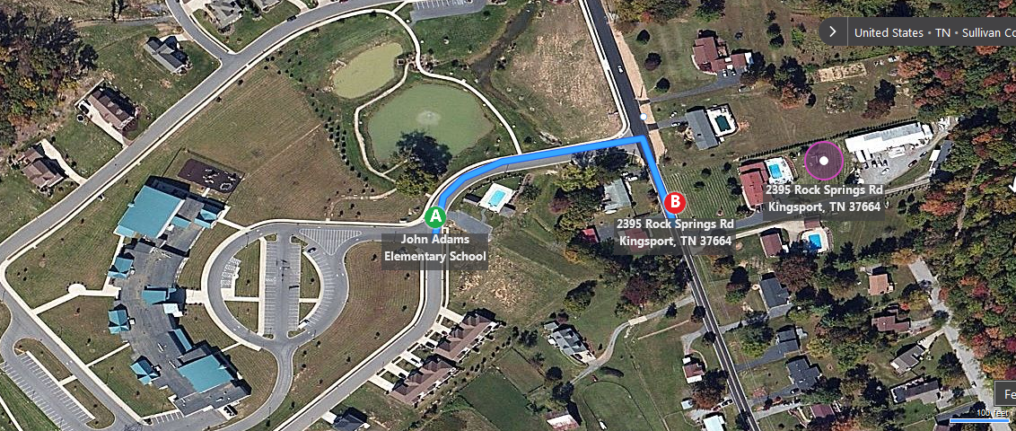

4000 +/- SQ. Ft. commercial building is presently operating as Tri-City Door and Kpt. Awning & Siding, All this on 2+ acres will be remodeled, and this facility will offer a library area for quiet study and tutoring. A computer room and game room will also be available for the school aged children. The facility will feature a cafeteria/kitchen area.

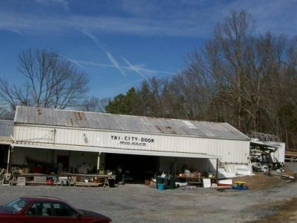

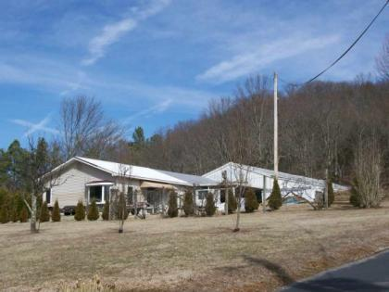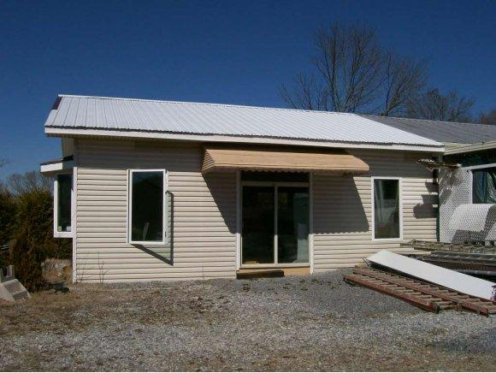

Adjacent to the location is a playground which will be updated with vibrant paint colors and new additions.

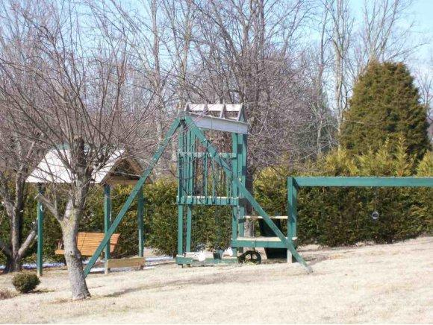

The property also offers the owner’s home which will allow the availability for longer hours of operation to accommodate non-traditional work schedules.

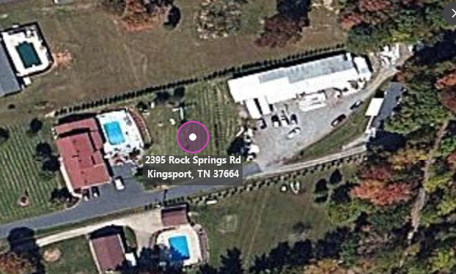

1. **Services**

Academy of Blessings Day Care® offers upscale child care services for kids ages 1year to 5 years and 1st through 5th grades.

* Regular operating hours will be 6:00 am to 9:00 pm, Monday through Friday– with observance of all major holidays and two recertification days per year
* ABDC will offer live streaming to the parents whom would love to see their children at play as well as to ensure their children are receiving the utmost quality of care. (Additional charges apply for this feature)
* Morning snack, breakfast, lunch, afternoon snack and dinner will be provided.
* Summer Camp will be available for school agers offering weekly field trips
* Snow day drop-in care
* Bible study, sewing, simple cooking, and gardening classes
* On-staff nurse will be available
* After School tutoring and homework help
* Our developmental programs will reinforce basic social, listening, independence and motor skills.

**3.1 Service Description**

Upon its opening, Academy of Blessings Day Care® will offer four basic services:

Full-time Child Day Care

Part-time/After School Care (including drop-off and pick-up)

Drop-In Care (Payment due at the time of Drop off)

**3.2 Competitive Comparison**

The child care selection in Kingsport, TN is very scarce for school age children. As a parent with a toddler and a school-ager, it is very difficult to find a facility that will accept both age groups. There are no other child care facilities in this immediate neighborhood. In the surrounding areas, there are a couple church based facilities, but they do not offer transportation to and from John Adams elementary school or do not accept children that go to the school altogether. The majority of the daycares in the surrounding area have a closing time at the latest of 6:00 pm.

Academy of Blessings Day Care® will differentiate itself from its local competitors by offering an alternative to these traditional day care approaches.

The Academy of Blessings Day Care® market strategy is based on providing an activity based learning environment. We will offer communities of professional caregivers with the credentials to enhance not only a child's early social and motor skills but also their expressiveness through art and nature hikes.

Academy of Blessings Day Care® will be located in a child-centric neighborhood, which has already shown a need and interest for child care services.

**3.3 Sales Literature**

A copy of the Academy of Blessings Day Care® informational brochure is attached in an appendix at the end of this document.

**3.4 Fulfillment**

The key fulfillment and delivery of services will be provided by the campus director, licensed campus instructors, and staff workers. The core value is the professional strength and staff experience, certifications, education and hard work.

1. **Market Analysis Summary**

Academy of Blessings Day Care® offers services which are essential in today's fast-paced, dual-income world. As an increasing number of families have become dependent on two incomes, the need for quality child care has skyrocketed.

**4.1 Market Segmentation**

Academy of Blessings Day Care® has a focus on meeting the local community need for child care services within the 10-mile radius of Royal Acres subdivision. Students will be taken in on either a full-time or part-time basis.

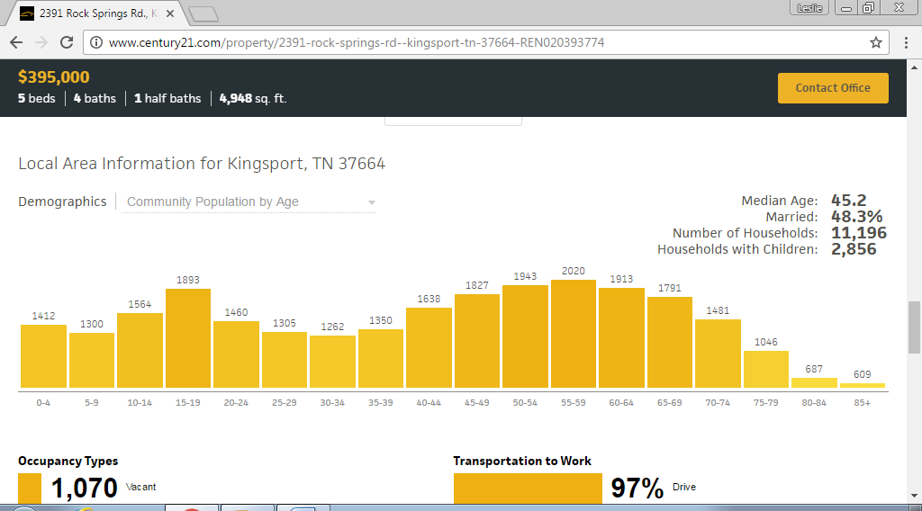

Information via Century 21

**Full-Time Working Couples**

The daycare will establish a significantly large, full-time, regular client base to establish the healthy, consistent revenue base which will ensure the stability of the business. Customer and community relations are paramount, as it is imperative to keep the parents pleased to maintain their children in the daycare.

**After School Care**

Another large segment of the business will be in the after school care market. The client base will provide a higher profit for the daycare since instructor-to-student ratios are greater than it would be for younger students. These students will require more educational services, by offering tutors, and homework help ABDC will support those needs.

**Part-Time Workers/Drop-Ins**

Part-Time employees and Drop-Ins will comprise less than 5% of the revenues. While this market is not a primary focus, sufficient flexibility to handle this market is critical to the local 'word-of-mouth' marketing strategy.

**4.2 Target Market Segment Strategy**

The target market for Academy of Blessings Day Care® is full-time working couples. Referral marketing and community open house days will be the primary types of marketing strategies utilized. Maintaining and enhancing its reputation with families and in the community will be crucial in obtaining the planned market share growth of this target market.

**4.2.1 Market Needs**

With inflation continuing to rise each year, the typical American family now requires dual or supplemental incomes. This trend has created a need for quality child care services. We do not see this model changing in the foreseeable future. In fact, based on the growth in the Kingsport area, specifically the Royal Acres communities, we expect the need to increase.

**4.3 Service Business Analysis**

Academy of Blessings Day Care® is in the child care services industry, which includes several models:

1. Licensed Child Care Facilities: Business facilities that offer child daycare services.
2. Family Child Care Homes: Individuals that offer child daycare services in their homes.
3. Specific Interest Based Programs: Businesses that provide a specialized instruction such as gymnastics, martial arts, and athletics.
4. Church Child Care Facilities: Religious organizations that offer child daycare services in their communities.
   * 1. **Main Competitors**

Catholic Church Day Care:

Strengths: Large church congregation. Already established in the market.

Weaknesses: May not appeal to customers of different religious beliefs.

Boys and Girls Club and YMCA:

Strengths: Already established /schools offers hours of availability until 7:00 pm

Weaknesses: Location in reference to this neighborhood.

Family Child Care Homes:

Strengths: "Personal" service; at home atmosphere

Weaknesses: Capacity - only allowed a certain number of children. Non-professional stigma.

**5.0 Value Proposition**

Academy of Blessings Day Care's® value proposition is quite clear and quite easily distinguished from others in the market. We offer uniquely superior child care services, as measured by the curriculum and activities offered, experience and educational level of the instructors, community involvement, and family theme.

**5.1 Competitive Edge**

We start with a critical competitive advantage: no competitor in our market is offering our concept with the live streaming feature. We will be transparent in our staff with introductions and background available on the website. We will also host parent teacher conferences and preschool graduation ceremonies. We will offer our staff monthly employee of the month awards and class room competitions to boost moral.

**5.2 Marketing Strategy**

Marketing in the child care industry depends largely on reputation and referral. At Academy of Blessings Day Care®, that reputation will start within our community bolstered by our involved commitment to those we serve.

**5.2.1 Marketing Programs**

Catered open houses, we will be one of our ways to reach out to our community. We will also develop and maintain partnerships with local businesses that cater to the needs of children. Our pre-opening effort will include an application fee waiver, funfest showcase, and back-to-school vendor spot.

Prior to opening, the facility will partner with the school to offer a childcare alternative due to the extended wait list and understaff. Based on the market reaction to the drive, these services may be altered to meet the needs of the community.

**5.3. Promotion Strategy**

We will depend on client referrals, community exposure and direct mail campaigns as our main way to reach new clients.

1. **Advertising**-- We will be using direct mail campaigns, pre-enrollment drives, and local community newspaper advertising to launch the initial campaign.
2. **Direct Mail**--We will send quarterly direct mail campaigns to the housing developments in a 10-mile radius of the campus.

**5.4 Pricing Strategy**

Academy of Blessings Day Care® must charge appropriately for the high-end, high-quality educational and caregiving services we offer. Our revenue structure has to support our cost structure, so the salaries we pay to assure quality services must be balanced by the revenue we charge.

We will be price competitive in the market we serve; however, we will not subscribe to the "low price leader" concept. The quality of our service will support the prices we charge.

**Pricing:**

|  |  |  |
| --- | --- | --- |
|  | Full Time 8-10 hours daily | Per Week |
| 4 months – 1 year old |  | $150 |
| 1 – 3 years |  | $125 |
| 4 – 5 years |  | $100 |
|  | Part Time 4-7 hours daily | Per Week |
| 4 months – 1years |  | $125 |
| 1 – 3 years |  | $100 |
| 4 – 5 years |  | $75 |
|  | Drop-In Care | Daily (Must call At least one hour ahead to ensure staffing) |
| 4 months – 1year |  | $50 |
| 1 – 3 years |  | $50 |
| 4 – 5 years |  | $50 |
|  | Before/ After School | Per Week |
| 4 – 6 years |  | $75 |
| 6 – 12 years |  | $50 |
| All School Agers | Summer Camp (One-Time Activity Fee of $85) | Per Week  $100 |

A late fee of $10 will be assessed after the third tardy of five minutes and $10 per each additional five-minute time segment.

Drop-In Care (3.59 hours or less daily) would be a straight rate of $50 per week

**5.4 Sales Strategy**

Academy of Blessings Day Care® will sell specialized programs. We will also be active in the community, building a solid reputation with parents and the community. By succeeding in these areas, we expect to begin seeing an operational net profit in month six of the 1st year, while increasing enrollment by 20% monthly for the first 8 months and gradually after that, until our maximum allowed capacity.

.

**5.4.1 Sales Forecast**

The following table and chart give a run-down on forecasted sales. For the first eight months of operation through the year 2020. Academy of Blessings Day Care® has assumed a conservative enrollment because school, aftercare and child care placement has already taken place for the school year and most parents will be comfortable with their current arrangements. Consequently, we expect initial enrollment to be far less than anticipated future year levels.

Going into years 2 and 3, we expect that our presence will be known, convenience factor considered and we will then be a considered as a choice in January 2018. In the fiscal year 2018, 90% of full enrollment is assumed respectively.

**Sales Forecast**

|  |  |  |  |
| --- | --- | --- | --- |
| **Year** | **F/T Rate Total** | **Total Units** | **Total Sales** |
| **2017**  **(Aug – Dec)** |  |  |  |
|  | $36,000 | 60 | $85,500 |
|  | **P/T Rate Total** | **Total Units** | **Total Sales** |
|  | $13,500 | 32 | $36,900 |
|  | **D/I Rate Total** | **Total Units** | **Total Sales** |
|  | $50 | 20 | $1000 |
|  |  |  | $123,400 |
| **2018** |  |  |  |
|  | **F/T Rate Total** | **Total Units** | **Total Sales** |
|  | $375 | 60 | $342,000 |
|  | **P/T Rate Total** | **Total Units** | **Total Sales** |
|  | $300 | 32 | $147,600 |
|  | **D/I Rate Total** | **Total Units** | **Total Sales** |
|  | $50 | 40 | $2,000 |
| **(May-July)** | **S/C Rate Total** | **Total Units** | **Total Sales** |
|  | $100 | 30 | $36,000 |
|  |  |  | $527,600 |
| **2019** |  |  |  |
|  | **F/T Rate Total** | **Total Units** | **Total Sales** |
|  | $375 | 70 | $408,000 |
|  | **P/T Rate Total** | **Total Units** | **Total Sales** |
|  | $300 | 37 | $171,600 |
|  | **D/I Rate Total** | **Total Units** | **Total Sales** |
|  | $50 | 50 | $2,500 |
| **(May-July)** | **S/C Rate Total** | **Total Units** | **Total Sales** |
|  | $100 | 40 | $48,000 |
|  |  |  | $630,100 |
| **2020** |  |  |  |
|  | **F/T Rate Total** | **Total Units** | **Total Sales** |
|  | $375 | 70 | $408,000 |
|  | **P/T Rate Total** | **Total Units** | **Total Sales** |
|  | $300 | 37 | $171,600 |
|  | **D/I Rate Total** | **Total Units** | **Total Sales** |
|  | $50 | 50 | $2,500 |
| **(May-July)** | **S/C Rate Total** | **Total Units** | **Total Sales** |
|  | $100 | 50 | $60,000 |
|  |  |  | $642,100 |

This projection doesn’t include before and after school projections or the projected revenue from parents choosing to enroll in the live streaming software.

**5.4.2 Sales Programs**

Sales programs will include incentives for obtaining quarterly financial and enrollment goals, probationary period completion, passing county inspections and maintaining perfect attendance. Customer services awards will be provided for those employees who best exemplify the mission of Academy of Blessings Day Care® and exceed customers' expectations.

**5.5 Strategic Alliances**

Academy of Blessings Day Care® will form professional alliances with parents to volunteer. We will also try to work with the local senior citizens to volunteer with the partnership with these two demographics this will assist will child to adult ratios as well as community outreach. We will also partner with John Adams Elementary in announcing childcare alternative.

**6.0 Web Plan Summary**

The Academy of Blessings Day Care® website will be the virtual business card.

It will showcase the campus, curriculum and weekly/ Monthly activities and calendar for the daycare. It will also provide meet the instructors, online projects posted by the students, parent announcements and online payment. Lastly, the website will include enrollment for live streaming. The Academy of Blessings Day Care® website will be simple, yet classy and well designed.

**7.0 Management Summary**

The opening management team of Academy of Blessings Day Care® will consist of the founder, a silent partner, a campus director and administrative assistant to be named at a later date, as the center grows additions to the instructional staff will be made over the next three years or as dictated by enrollment.

**7.1 Organizational Structure**

Academy of Blessings Day Care® depends on the founder Leslie Robertson

**Management Team**

The management team will be named at a later date.

**Personnel Plan**

The following table summarizes our personnel expenditures for the first three years. We believe this plan is a fair compromise between fairness and expedience and meets the commitment of our mission statement.

The yearly figures in the second and third year are assumptions for the Rock Springs location only. The numbers reflect 100% enrollment, a full staff of instructors and a 0-1% payroll increase each and state required-certifications.

**Personnel**

|  |  |  |  |  |
| --- | --- | --- | --- | --- |
| Personnel Plan |  |  |  |  |
|  | 2017 | 2018 | 2019 | 2020 |
| Owner | $12,500/1 | $30,000/1 | $30,000/1 | $30,000/1 |
| Campus Director | $12,500/1 | $32,000/1 | $32,000/1 | $32,500/1 |
| Executive Assistant | $12,500/1 | $31,000/1 | $31,000/1 | $31,500/1 |
| F/T Instructors | $ 7,500/5 | $18,000/7 | $18,000/7 | $19,000/7 |
| P/T Instructors | $ 4,200/5 | $10,000/5 | $10,000/5 | $10,000/7 |
|  |  |  |  |  |
| Total People | 13 | 15 | 15 | 17 |
|  |  |  |  |  |
| Total Payroll | $96,000 | $269,000 | $269,000 | $297,000 |

**8.0 Appendix**

**Sample Brochure**



**Milestones**

The accompanying table highlights important start-up milestones, with dates, completion status, responsible parties and budgets for each. The milestone schedule indicates our emphasis on planning for implementation.

What the table doesn't show is the commitment behind it. Our business plan includes complete provisions for plan-vs.-actual analysis, and we will hold quarterly follow-up debriefing to advise the variance and course corrections.

**Milestones**

|  |  |  |  |  |  |
| --- | --- | --- | --- | --- | --- |
| **Project** | **Expected Date** | **Actual Date** | **Completion Date** | **Budget** | **Final Cost** |
| Funding Expense |  |  |  |  |  |
| Facility Purchase  (Will include the Facility and the owner home in listing MLS# 367717) |  |  |  | $300,000 |  |
| Trash Removal from the Purchased Business |  |  |  | $10,000 |  |
| Contractor |  |  |  | $50,000 |  |
| Construction |  |  |  | $100,000 |  |
| Wiring and Electrical Paneling |  |  |  | $20,000 |  |
| Plumbing |  |  |  | $20,000 |  |
| HVAC system installation |  |  |  | $50,000 |  |
| Kitchen Equipment |  |  |  | $15,000 |  |
| Technology |  |  |  | $10,000 |  |
| Classroom Equipment |  |  |  | $30,000 |  |
| Misc. (Insurance etc.) |  |  |  | $100,000 |  |
|  |  |  |  |  |  |
|  |  |  |  |  |  |

|  |  |  |
| --- | --- | --- |
| Ratios for Daycare Centers in Tennessee State | | |
| **Age of Children** | **Child: Staff Ratio** | **Max Group Size** |
| 6 weeks | 4:1 | 8 |
| 9 months | 4:1 | 8 |
| 18 months | 6:1 | 12 |
| 27 months | 7:1 | 14 |
| 3 years | 9:1 | 18 |
| 4 years | 13:1 | 20 |
| 5 years | 16:1 | 20 |
| 6 years | 20:1 | NR |
| 7 years | 20:1 | NR |
| 8-9 years | 20:1 | NR |
| 10 years and older | 20:1 | NR |