|  |  |  |  |
| --- | --- | --- | --- |
| **Company Info** | | **Technical POC** | |
| Name: | HM InnoWiz, LLC | Name: | Dr. Mohit Jain |
| Address: | 22 Northfield Avenue  East Brunswick, NJ 08816 | Phone: | 732-309-0858 |
| Email: | mohit.jain@hminnowiz.com |
| **N2N System Description** | | | |
| Title: Automatic Nail-to-Nail Fingerprinting Device | | □Software Solution (uses conventional sensor)  X Hardware/SW Solution (custom hardware and software) | |

# 

# **IARPA Nail-to-Nail Challenge Registration**

## All Stage 1 Registrations need to be submitted to Challenge.gov by **March 17, 2017**

Abstract: We plan to construct a device that can acquire Nail-to-Nail fingerprint without any need of operator. The device allows a fast method to obtain the whole fingerprint with no inconvenience to the subject and does not pose any safety hazard. Additionally, it does not use any proprietary software or hardware component. The basic premise of the device is that the user will apply pressure on a bendable polymer strip, using his/her finger. This will allow the strip to form a Nail-to-Nail enclosure around the finger, and hence form the fingerprint on the surface of the strip.

System Diagram: We propose an automated system for nail-to-nail fingerprinting, where only interaction the user will have is by inserting his/her finger in the machine. **Figure1a** and **1b** shows the front and the top view of the device, respectively. **1** is a bendable strip, which is connected to the flippers **3** on each side. The flippers **3** are mounted on the base plate **8** by the hinges **11**. The flippers **3** are also connected to the side walls **9** by springs **4**. The stoppers **12** are there to prevent the flippers **3** to get pulled towards the side wall **9**. The camera **2** is mounted overhead of the bendable strip. The finger printing powder delivery and cleaning components, **5**, are supported by front support, **10**, and back support, **11**. The each component in **5: 5a, 5b,** and **5c** are moved by stepper motors **6**. The each component in **5** is moved back and forth from the front support, **10** and back support **11** by riding on the screw rods **7**. All the operations in device are controlled by micro-controllers and computer. **Figure 2** shows the perspective view of the device.

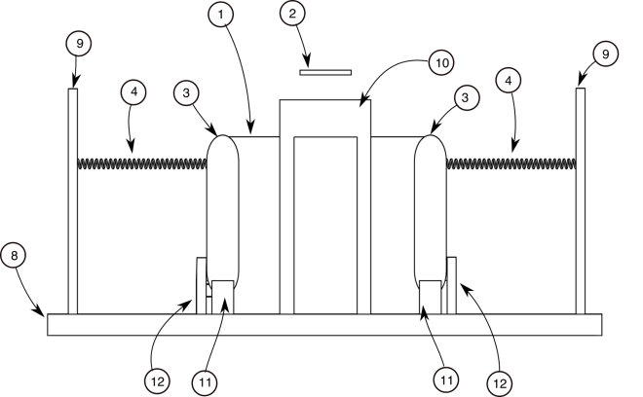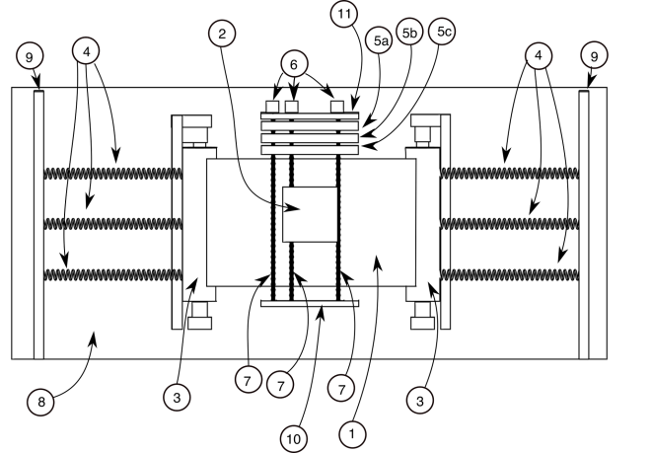

**(a) (b)**

**Figure 1:** Views of the proposed machine after removing cover: (a) front; and (b) top

Concept of Operations: Figure 3 shows the operation of the proposed machine. The subject will place his/her finger on the bendable strip, and press it down (Figure **3(a)**). The strip will descend, along with forming a tight contact around the finger and forming nail-to-nail fingerprint on the bendable strip (**3(b)**). Once the subject lift his/her finger, the strip goes back to its original position, but with the nail-to-nail fingerprint on the surface of the strip (**3(c)**). Subsequently, fluorescent magnetic power will be applied using magnetic powder applicator (**5c** in Figure 1b), that will pass over the strip using a screw rod and a stepper motor. Behind that will be an electromagnet (**5b** in Figure 1b) to remove excess powder. At this stage the fingerprint will be visible in the presence of UV light, and an image will be taken using a camera mounted overhead. Finally, the strip will be whipped using a cleaning solution, such as isopropyl alcohol (IPA), that removes fingerprint. Initially, the solution will be dripped on the top of the area, where fingerprint is formed, followed by wiping it with a roller (**5a** in Figure 1b). The roller will be made of foam and will transverse across the bendable strip using screw, connected to a stepper motor. The stepper motors will be controlled by microcontroller and motor controllers, while the camera will be controlled by a computer. Another option is that the bendable strip is stored is in the form of a roll. This allows a section of the strip, in front of the camera, to be moved after each fingerprinting and expose a fresh untouched section for new fingerprint. This will remove the need for cleaning the strip. The movement of the strip can be controlled by a stepper motor.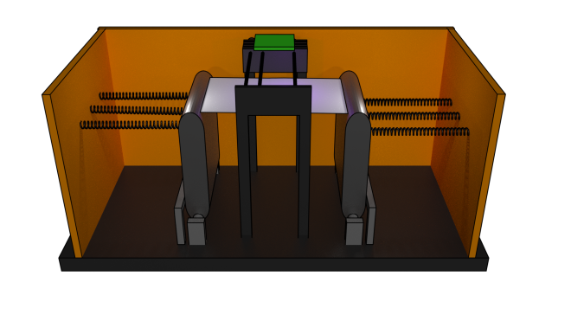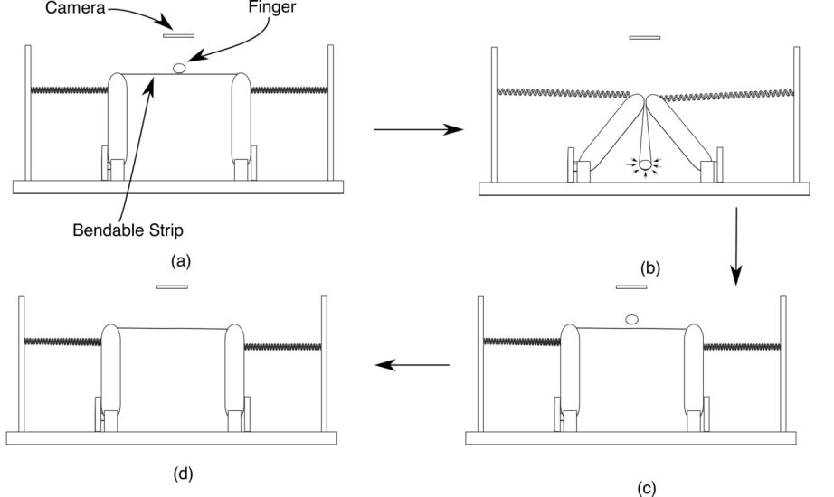



Anticipated Equipment: We will use Raspberry PI as computing device as it not only provides program to take image and slot to connect camera but also has input-output pins to control stepper motors using motor controller. Other components are stepper motors, UV LED, and mechanical components described above.

Devices: *Creating New Device*

Matchers  
*A)Which Matcher will your team use for the* ***tenprint*** *to* ***tenprint*** *comparison? Please select one:*

*__X__ Government ___ Custom ____ Not Sure*

*B) Which Matcher will your team use for the* ***latent*** *to* ***tenprint*** *comparison? Please select one:*

*_X___ Government ___ Custom ____ Not Sure*

Safety Assessment: We don’t envision any safety concerns for the user, during the fingerprinting process.

Innovation: To the best of our knowledge, this is the first time a device with such a configuration has been proposed for fingerprinting. Accordingly, we have filed a provisional patent to protect the intellectual property.